Location
Bucyrus, Ohio

Facility Type
Solid Waste Landfill,
C&DD Landfill

Client
Crawford County Commissioners
Santek Environmental Services

Services Provided
- Engineering Design and Permit Application for Vertical Site Expansion
- Phasing Permit Alterations
- Geotechnical Investigation and Slope Stability Analyses
- Title V Air Emissions Permitting
- Regulatory Compliance Calendar
- Bid Documents and Construction Management
- Construction Inspection and Quality Assurance
- Construction Certification Reporting
- Soils Pre-qualification

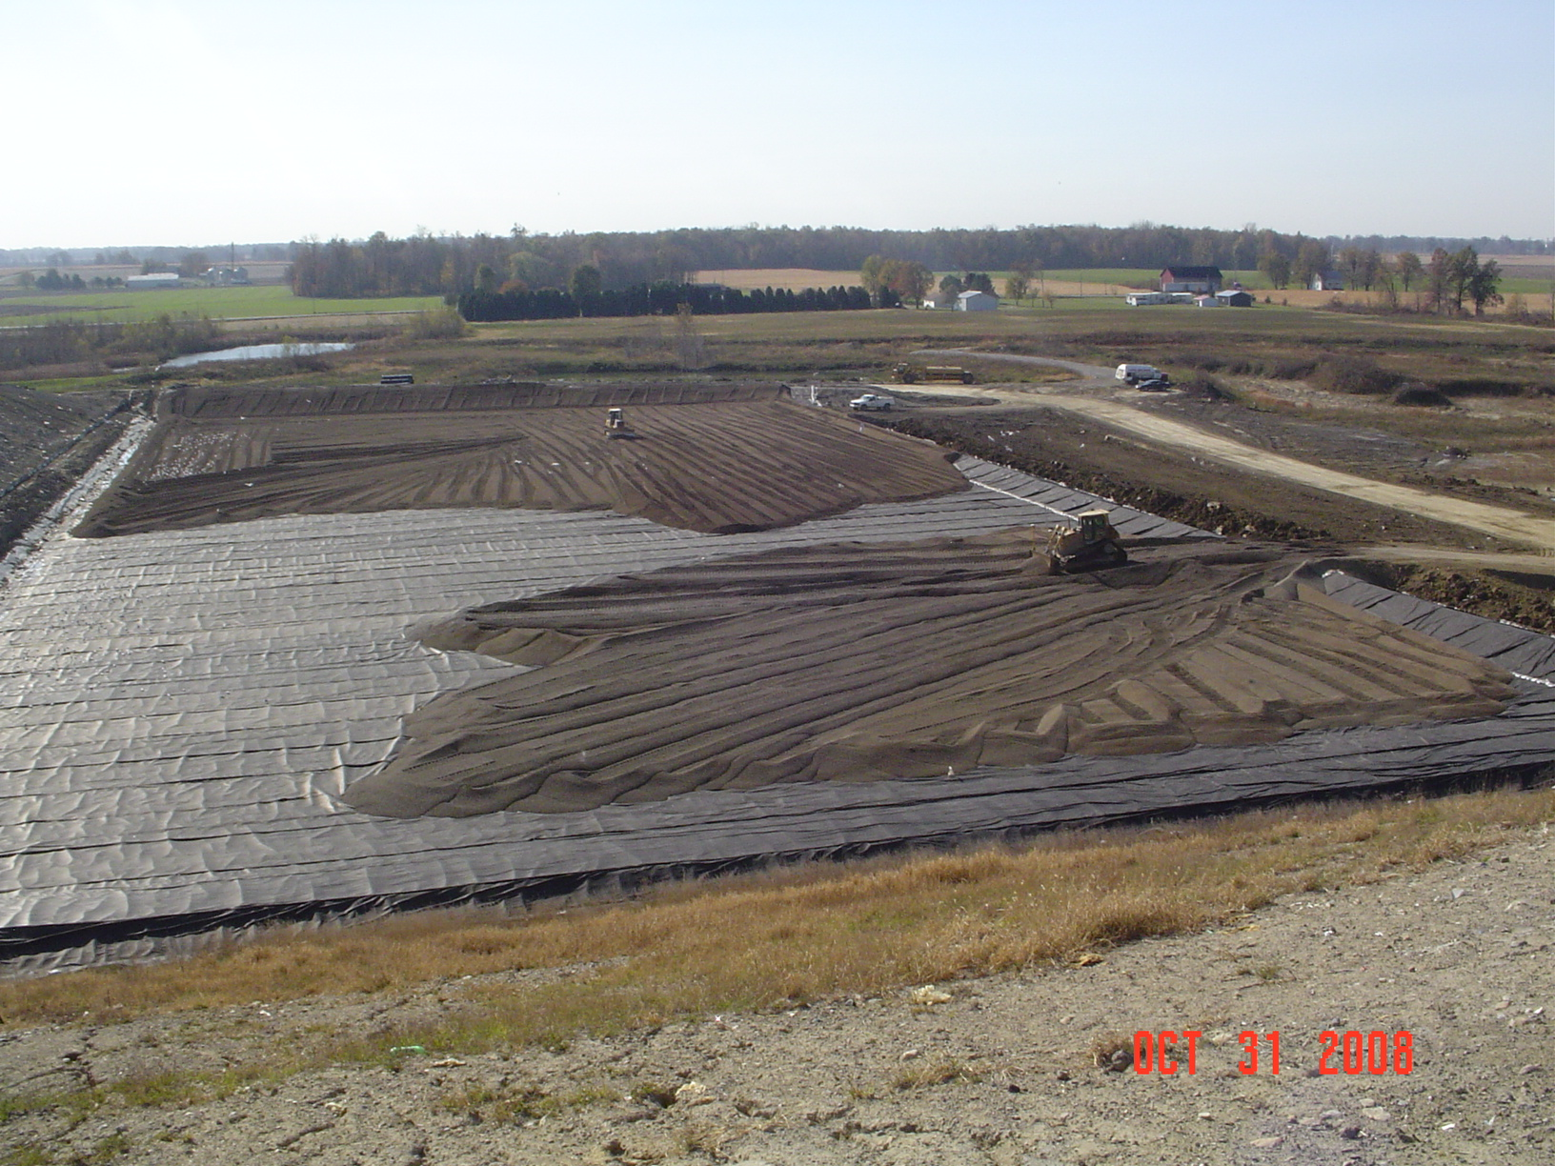
New Cell Construction

Project Descriptions
NPE has provided soils pre-qualification, construction quality assurance and certification services for the following projects:

Phase 5A (2010) – 6.7 acre base liner system for MSW landfill

Phase 3B (2008) – 5.0 acre base liner system for MSW landfill

Unit A, Area 2 (2008) – 2.8 acre cell for C&DD landfill

Unit A, Area 1 (2007) - 2.7 acre cell for construction and demolition debris landfill

Phase 3A (2006) – 6.0 acre base liner system for a MSW landfill

NPE has provided engineering design services for the following permitting projects:

- Permit for Landfill Lateral and Vertical Expansion (2013 – 2015)
- Preparation of a PTI Application for a 35 acre contiguous lateral and 15 acre vertical expansion of the MSW Landfill.
- Permit for Landfill Vertical Expansion (2008 – 2009)
Preparation of a PTI Application for a 47 acre vertical expansion of the MSW landfill.
- Phasing Alteration Request (2008)
Preparation of an alteration request to improve site revise phasing.
- Slope Stability Analyses (2006 – 2008)
Slope Stability analyses for interim waste grades.
