Two-Way Virtual Programming
Staff Checklist for Two-Way Zoom Meetings, including Child-Safe Security Controls
YMCA OF SAN FRANCISCO
__________________________________________________________________________

INSIGHTS FOR CHROME BOOK USERS
Zoom functionality on Chrome Books is unique – if you are a Chrome Book User, review these resources:
- Getting Started on Chrome OS
- Configuration
- New Updates for Chrome OS
- Zoom Rooms

BEFORE THE MEETING
- Sign-in to https://zoom.us and Start your meeting
- Check your Security Settings (from the Control Panel)
  - Lock Meeting – Disable (unless all confirmed participants are present)
  - Waiting Room - Enable
  - Screen Share – Disable (unless a participant requests ability to share)
  - Chat – Enable
  - Rename Themselves – Disable (Co-Hosts and Hosts can rename participants)
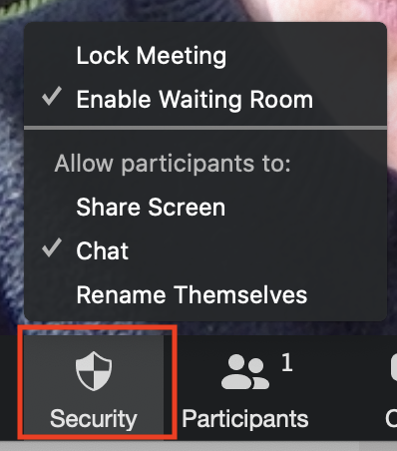
- Open your Chat panel
  - Select the option for Participant can chat with host only
  - Participants can now chat with the Host or Co-Hosts privately
  - Participants cannot chat with other participants privately or publicly
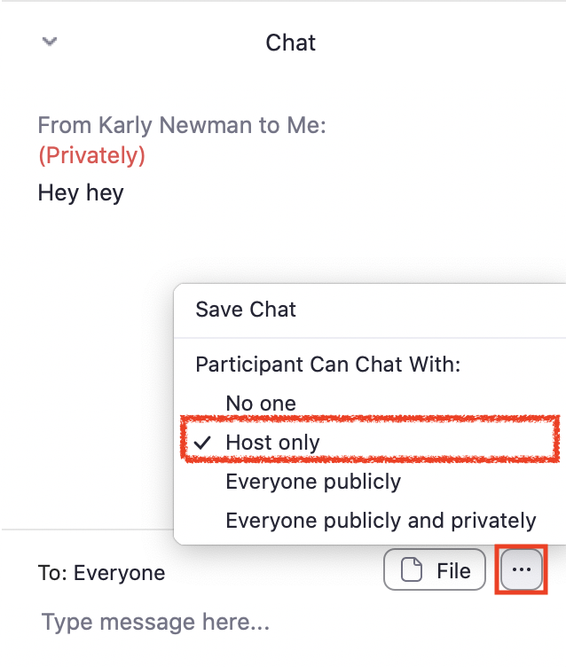
- Assign Your Co-Hosts
  - Hover over the participant you’d like to assign as Co-Host
  - Select Make Co-Host
  - The Co-Host now has all permissions of the Host, except:
    - Cannot create or edit polls (but, they can start polling)
    - Cannot assign Closed-Captioning (but, they can enter Closed Captions)
    - Cannot promote participants to Hosts or Co-Hosts
    - Cannot assign participants to breakout rooms
    - Cannot end the meeting
- Open your Participants panel to:
  - Chat to participants in the waiting room
  - Admit participants from the waiting room
  - Rename participants to use their full student name
  - Mute/Unmute all participants

DURING THE MEETING

- Begin every meeting with Virtual Etiquette / Ground Rules
  - <Program Managers can include standard program protocols here>
- Review Panel Control with Participants
  - Mute/Unmute Sound
  - Stop/Start Video
  - See Participants List (participants can raise their hand from this setting)
  - Chat
  - Share Screen (disabled in child-safe meetings facilitated by YUSF)
  - Record (disabled in all meetings facilitated by YSF)
  - Reactions (includes Thumbs-Up and Applause)
  - Leave Meeting
- Include Icebreaker / Warm-up
  - Allow for Host, Co-Host and Participant Introductions
  - Use Polls to provide trivia questions or a “well check”
  - <Program Manager to populate additional instructions for program staff here>

- Program Delivery Best Practices and Instructions
  - <Program Manager to populate additional instructions for program staff here>

AFTER THE MEETING
  - <Program Manager to populate additional instructions for program staff here>

