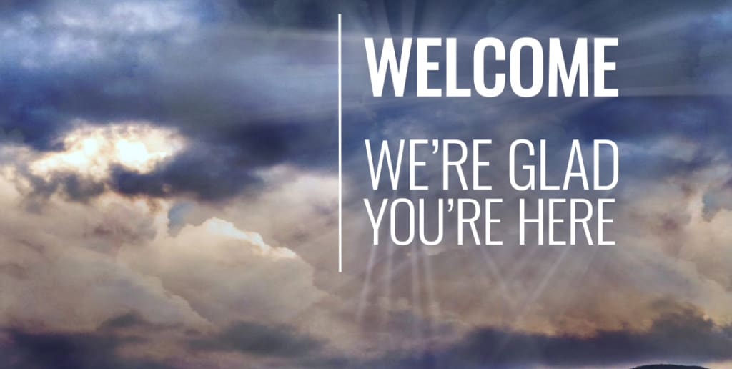
In This Issue
ISSUE
June
2022

CCUMC NEWSLETTER
Pg. 1 Pastor’s Corner
Pg. 2 Save the Dates & Bible Studies & Small Groups
Pg. 3, & 4 Church News
Pg. 5 Keeping You Informed
Pg. 6 Vacation Bible School for 2022
Pg. 7 Vacation Bible School Pre-Registration
Pg. 8 VBS Decorating Work Bee
Pg. 9 A.R.K. Wrap Up Party
Pg. 10 Calendar for June 2022
Pg. 11 Church Information

I write this Pastor’s Corner with a sad heavy heart because there have been three mass shootings in the month of May within days of each other. On May 14, 2022, there was the mass shooting in Buffalo New York at a Tops Friendly Markets store, a supermarket in the East Side neighborhood. Thirteen people – eleven of them black and two white – were shot, ten fatally All ten who died were black. As of May 23, one of the injured remains hospitalized in stable condition. This shooting was a racial hate crime towards Black people.
On May 15, 2022, in Laguna Woods, California, at the Geneva Presbyterian Church, which hosts the Irvine Taiwanese Presbyterian Church's Sunday services. The majority of the congregation present on that day were Taiwanese American. One person was killed, and five others were injured, four of them critically. Again, another racial hate crime because the shooter who is Asian didn’t like the Taiwanese people. This shooting took place after services, he fired inside the church while the members ate lunch after a morning service.
On May 24, 2022, an 18-year-old forced his way into at Robb Elementary School in Uvalde, Texas, and opened fire, killing 19 children and 2 teachers, and wounding about 17 others. Earlier that day, he shot and wounded his 66-year-old grandmother who remains in critical condition at the time of this writing. All the children were between 8-10 years old.
These three mass shootings have one element in common and that element is EVIL and this is the type of EVIL comes from one source the Evil One, Satan himself. All three shooters were full of such an evil hatred that killing their fellow human beings meant nothing to them. Two of these shooters in Buffalo New York and Uvalde Texas were 18 years old. The Irvine Taiwanese Presbyterian Church's shooter was 65. Every Holy Week we read from the book of Luke and John how Satan entered Judas and Judas betrays Jesus, again we see evil at work, i.e., Satan himself. We do not have a “violence” problem as some say, we are dealing with what we have sown.
As disciples of Jesus Christ, we have for the sake of “Causing No Harm” silenced our witness as to who it is that is the answer to the evil in the world, and the hope of the world, Jesus Christ. If we put into practice and tell others about the two greatest commandments, ‘Love the Lord your God with all your heart and with all your soul and with all your mind.’ This is the first and greatest commandment. 39 And the second is like it: ‘Love your neighbor as yourself.’ There is very little to no room for evil to enter in. If we put into practice and tell others to put into practice, Jesus Christs commandment, “So in everything, do to others what you would have them do to you, for this sums up the Law and the Prophets.” Again, there is no room for evil to get a foothold if we who call ourselves disciples of Jesus Christ follow his commands and teach others to follow his commands. Let us resolve to remain silent no longer for fear of what the repercussions might be.
When I have us recite the Lord’s Prayer every Sunday, I take comfort that as a family we all pray, deliver us from the evil one, for each other. Pray for the families who are suffering from these shootings and when you feel that you don’t know what to pray remember Romans 8:26, “In the same way, the Spirit helps us in our weakness. We do not know what we ought to pray for, but the Spirit himself intercedes for us through wordless groans.”

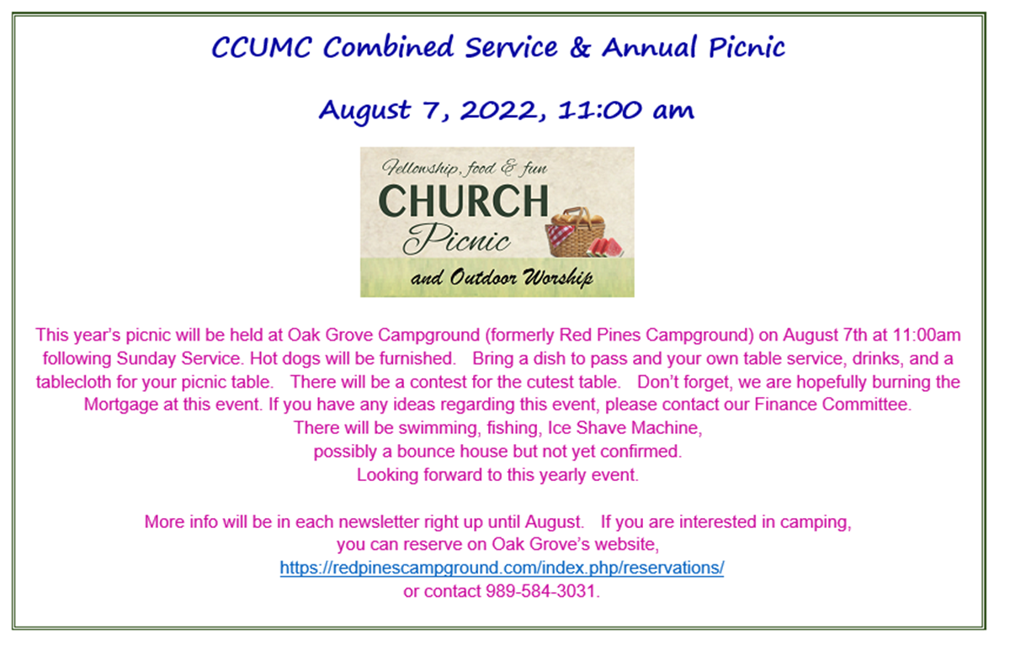

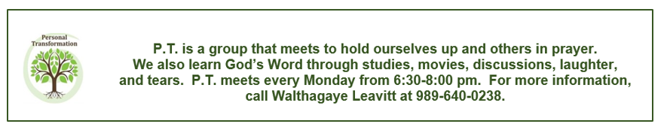
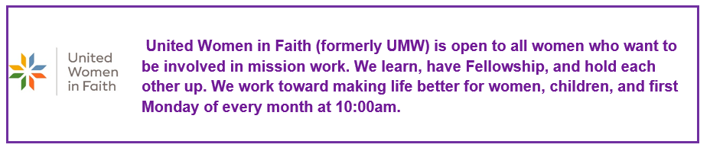

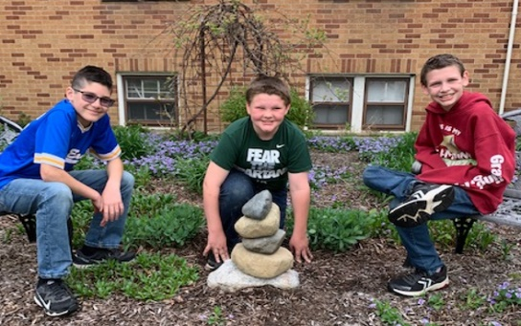
We raised an Ebenezer to the Lord (a memorial to His faithfulness through all the ups and downs of this ministry in Carson City). As the mortgage is paid off in the Fall, may He give us new vision, opportunities, and creative ideas for ministry in our community and beyond for the future!

On behalf of the Finance Committee, we would like to thank all the participants who contributed to the successful Scrap Metal Drive. We were able to raise $1704.00. It would not have been possible without all your help.

Thanks again. CCUMC Finance Committee

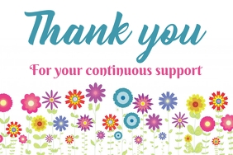

Lutheran Quilt Day by WalthaGaye Leavitt
Since I have learned so much about the Lutheran Quilt Ministry, I decided to go visit one of their days to really see what it is all about. I arrived as they were just getting started. There were 2 stations set up. A bag is pulled from a box which contains a backing, a lining and a top. This is spread out on a table and the edges are turned over for zig zagging when tied. Then the “holey” sheet is placed which designates where the ties go. With long pieces of crochet cotton, thread is placed and the next person cuts and knots the thread. When done- it is given to someone at the sewing machine who finishes the edges. There were 2 sewers and 6 tiers and much laughter and discussion. By the time I left at 2:30 the women had over 20 quilts made. They were excited to top their usual amount and ended up getting 31 quilts made by 6:30pm. With the snow folks back and an extra sewer- they were able to accomplish more. What a fun day I had. Their next quilt day is 24th if you want to help or just go see.

Mid-West Mission Distribution Center by WalthaGaye Leavitt

Mid-West Distribution Center is a depot of the United Methodist Church. They collect the kits and supplies that many of us make. They also collect used items that many third world countries can use like billboard tarps, older fire equipment, health supplies like walkers, potty chairs, shower chairs, canes, and crutches. Many United Women of Faith make birthing kits, personal dignity kits, layette kits, sweaters and clothes for younger kids, school kits and of course flood buckets. These are then sent to countries far and wide when needed or requested. It is an amazing place that all should visit. They have beds available for those interested in staying for a few days to work.
I went a few years ago and want to go again. Or we can make the rice meal bags here and get them out to the Center. There is a $2.00 fee/bag made which includes the ingredients, gloves, beard and hair nets, and equipment to seal the bags. One line of 8-10 people can make 175 bags/hour, and anyone can do this. There sit down and stand-up jobs as well as runners and sealers. Each meal consists of white rice, protein/vitamin powder packet, dehydrated vegetable packet and soy flour. I interested…please let me know. What a blessing to others that would be as well as ourselves. Working to help others is not work- it is a calling and a privilege. Many hands make light work.

United Methodist Community House
UMCH turns 120 this year. There are many plans to update and improve the original building and to build a childcare center across the street. They are adding childcare spaces as this is one of the areas of extreme need in this area of Grand Rapids. Plans for this building have gotten delayed by COVID, but groundbreaking is expected this fall. More space means more programs that can be offered for all ages.
This summer, many kids will have the opportunity to attend the Summer Adventure Club. Keller Foundation is matching gifts so that this summer Adventure Club will impact twice as many kids. They will be spending time on a farm and riding horses, going to splash pads, and developing friendships as well as learning confidence, resiliency, independence while being in a safe place.
If you want to donate to this wonderful place- please see WalthaGaye

Carson City United Women in Faith Updates by WalthaGaye Leavitt

The women met on Monday May 9th for a salad potluck. When the meal was over, we heard what Lynn Riggs had to say about what her church does to ease the troubles of the world. Many from the Lutheran church meet monthly to make quilts which go to gathering sites and eventually around the world. They make about 20 per month using donations and materials bought. They use crochet cotton (the bigger gauge) blankets, robes, towels, sheets, mattress pads and fabrics to make the quilt and lining. The object is to make it useful, durable, and warm. The donations can be given to the Lutheran Church or to WalthaGaye or Roberta who will see that it gets to them. They usually meet on the last Friday of the month from 9am to 9 pm.
The Frontier Picnic was discussed. It was decided that we will have hot dogs, sloppy joes, potato salad, coleslaw, baked beans, and pies. RADA Cutlery will also be sold as well as whole fruit pies. The money raised goes to the church mortgage and bills. This is an opportunity for anyone and everyone to get involved. A person can come join us anytime during the 9 am prep time to 2 pm clean up time. Come and lend a hand!
Plans for fall: September 12 meeting will be the World thank offering so that we can complete our 5th channel of giving before the new date of October. That will be at 11am with own brown bag lunch. October meeting will be October 3, 2022, at 10am. The program will be “Learning about us” which is different members telling a short bio of ourselves.
November 7, 2022, at 5:30pm will be the “Come Eat with us” open to everyone who would like to listen to Glen Walker playing some tunes on his saxophone. It is a potluck meal with some fun and fellowship and not much business.

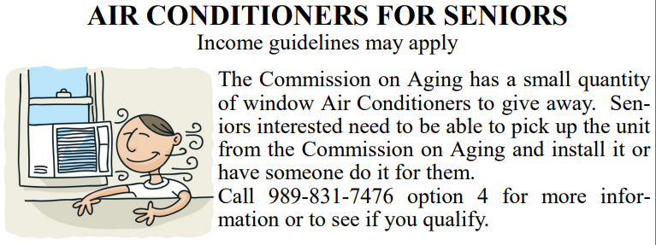
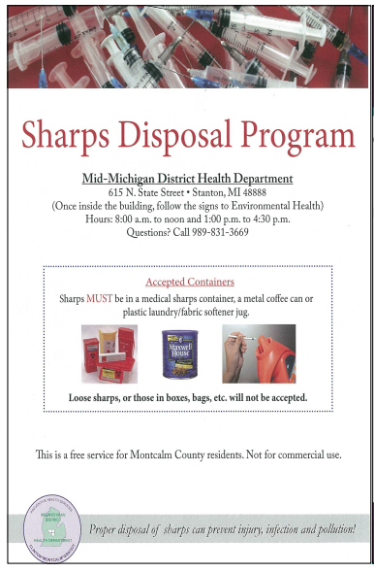
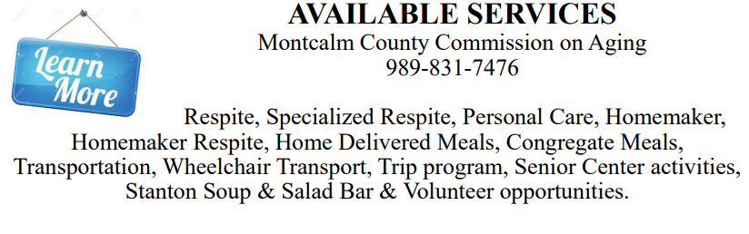
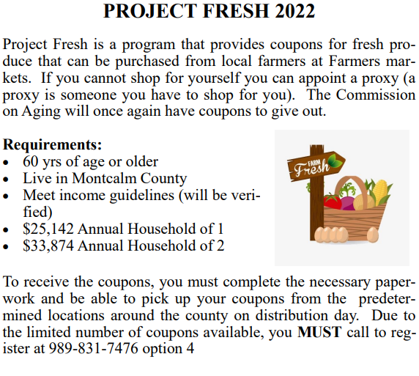

Vacation Bible School - 2022
Monumental
Celebrating GOD’s GREATNESS

“Celebrating God’s Greatness,” the theme for this summer’s VBS is scheduled for Sunday through Thursday evenings, July 17 – 21, 2022, from 6:00-8:30 p.m. Those who attended the March 8th meeting chose Psalm 8:1 as the umbrella scripture for the week’s activities.
“O Lord, our Lord, how majestic is your name in all earth.”
All kids, from 3 years through those entering 6th grade, whether your kids, grandkids, friends, and neighbors, are encouraged to attend this amazing week of experiencing God’s greatness through scripture, Bible Adventures, games, Imagination Station, Kid-Vid- Cinema and snacks. In serving others, we will be providing money to purchase school supplies for Native American children in North America.
You can help through prayer as we spread God’s love throughout this area. If you have any of the following supplies to donate, any will be very much appreciated. Possibilities include one small pup tent, and white flat sheets.

VBS Monumental Registration: By pre-registering registration
that first night of VBS flows much more smoothly and our
activities can be on time.

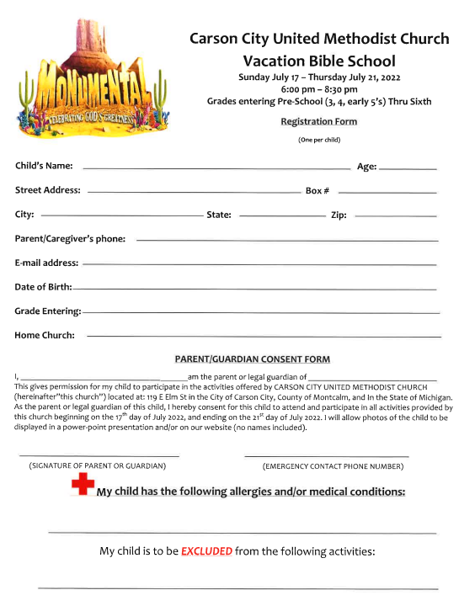

VBS Decorating Work Bee pictures from May 19, 2022.
We gathered in the evening of Thursday, May 19th for our decorating bee in preparation
for July’s V.B.S. Adults and kids enjoyed a creative time together.

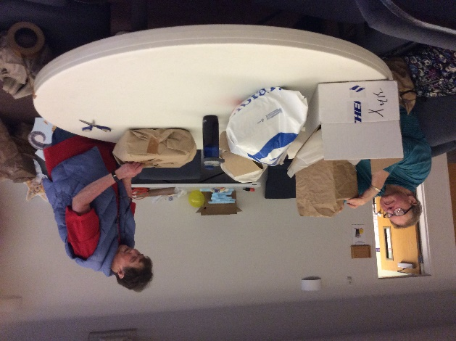
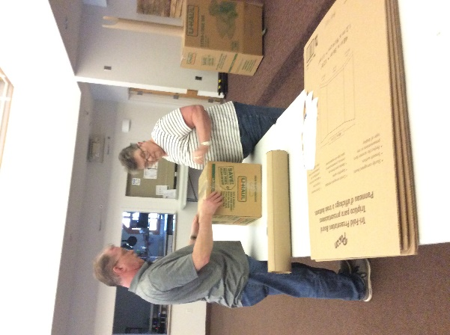

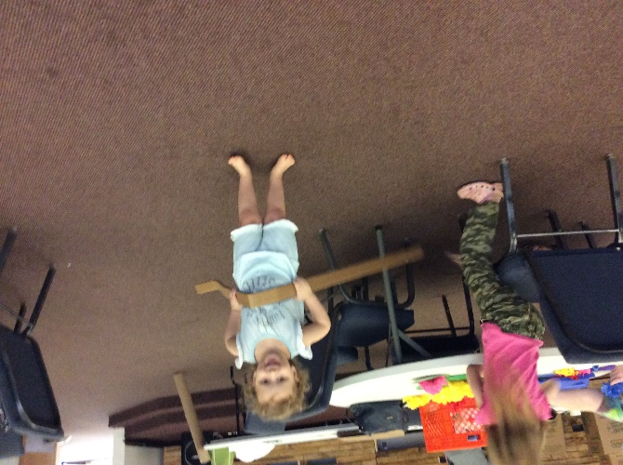
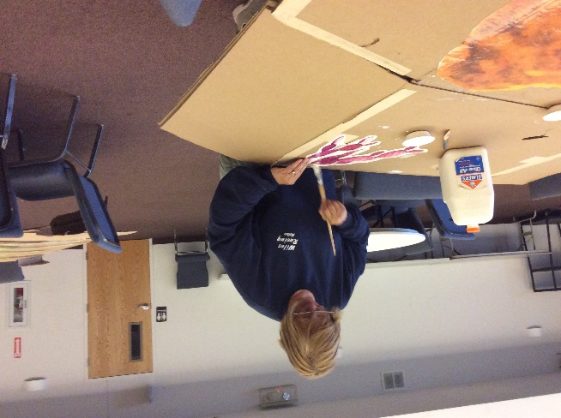
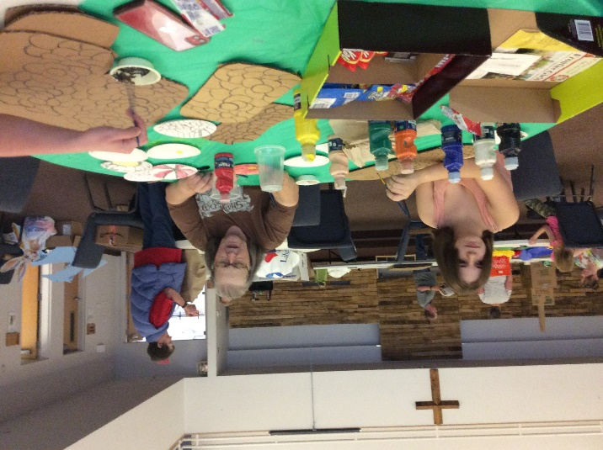
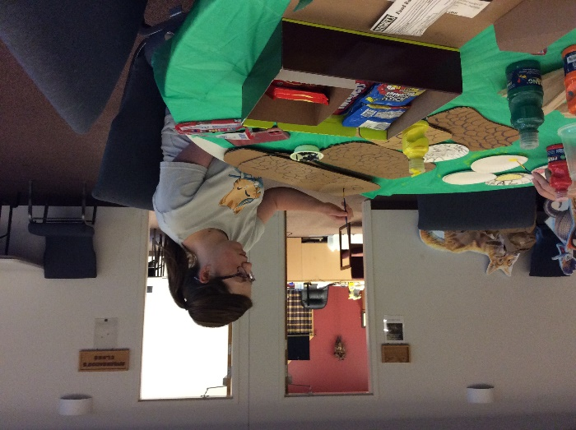

A.R.K. (Armor Ready Knights) Wrap Up Party
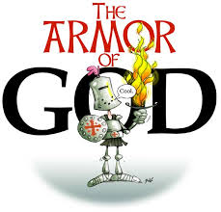
A.R.K.’s wrap up party was held Tuesday, May 24th. Fun was had by all. After having spent the past months learning the many names for God found in the Old Testament, the kids reviewed with matching scriptures and created amazing sidewalk art demonstrating their accomplishments. The umbrella scripture for our study as “Those who know my name, put their trust in me.” Psalm 9:10a
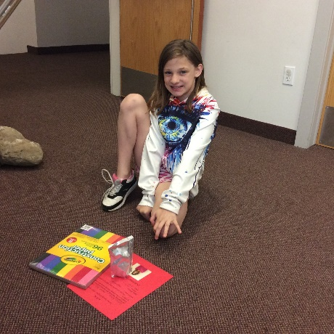
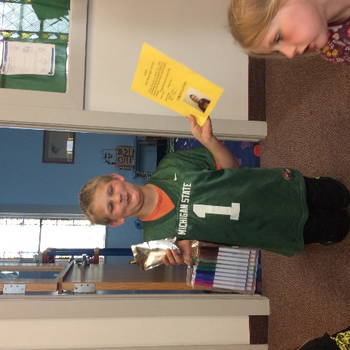
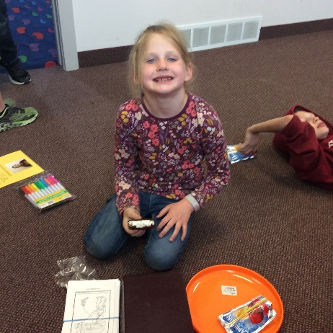
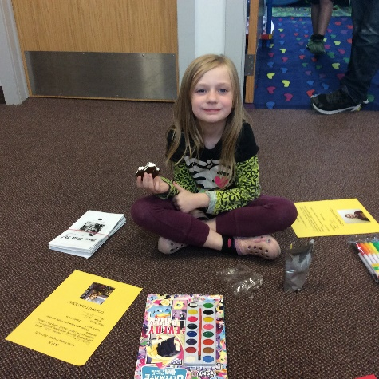
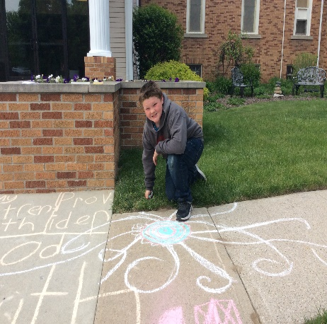
Thanks to Larry and Elaine Nalett, who provided Old Testament story puzzles. The kids teamed up to see which team completed its’ puzzle first. Prizes, certificates, and snacks completed our time together. A.R.K. will resume in September.
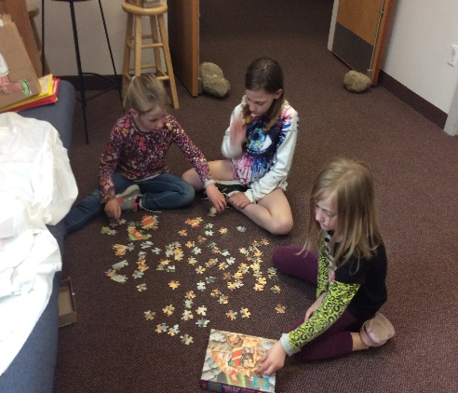
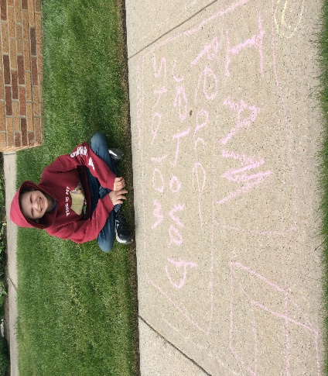
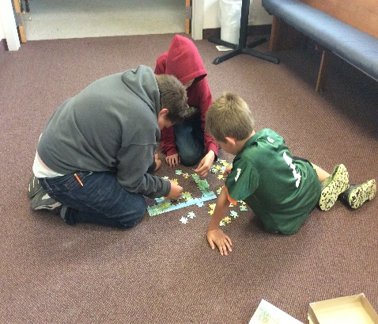
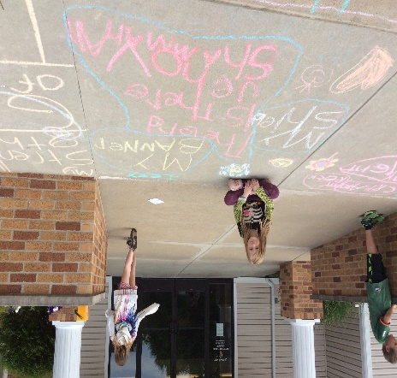

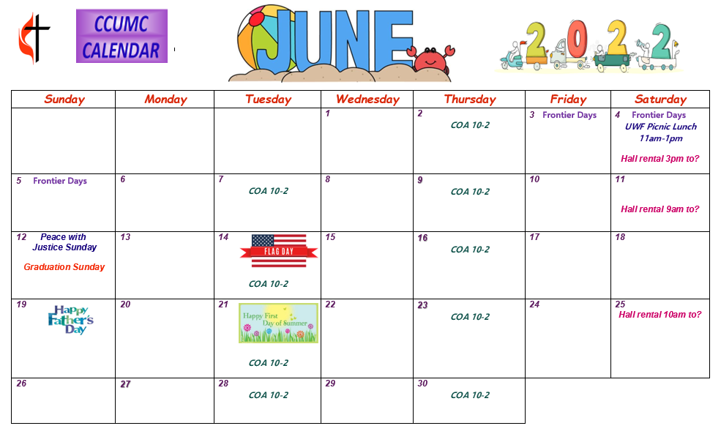

Schedule’s subject to change – contact office for more information”

Stay connected! Follow us on:

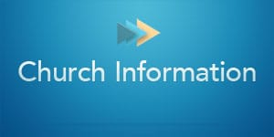

Join Us Each Sunday

Worship Services 10:30 am

(masks are optional)
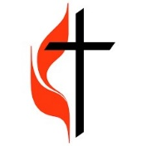

Carson City United Methodist Church
Phone: 989-584-3797
Email: carsoncityumc@gmail.com
Website: carsoncityumc.com
Office Hours: Monday to Thursday, 9:00 am-Noon
After hours by appointment
Pastor: Ian McDonald (906) 322-5318
Secretary: Bonnie Seaman (989) 763-1674

Weekly Sunday Bulletin now available on our website
at www.carsoncityumc.com

Online giving available: Website: http://www.carsoncityumc.com/donate.html

