+ FIRST CONGREGATIONAL CHURCH
An Open and affirming congregation of the
United Church of Christ, Saugus, Massachusetts
Service of Worship & Baptism 10 a.m.
4th Sunday after Pentecost, Father’s Day, June 17, 2018
*Indicates for those who are able to, please stand.
Bold print indicates congregational response.
NCH = New Century Hymnal (black cover)
HOP = Spiral bound cover

Greeters are Marilyn Panico and Cheryl Panico.
Scripture Reader is Cheryl Panico.
Coffee Hour Host is Ann Kennedy.
Deacon of the Month is John Gilmore.
Program covers are dedicated to the memory of Sandy Cogliano by her good friend, Ann Kennedy, on the first anniversary of Sandy’s passing on June 17, 2017.

PRELUDE Rebecca Harrold
WELCOME & ANNOUNCEMENTS Rev. Martha Leahy
LIGHTING THE PEACE CANDLE “Surely the Presence” HOP 74
Surely the presence of the Lord is in this place;
I can feel his mighty power and his grace.
I can hear the brush of angel’s wings,
I see glory on each face;
surely the presence of the Lord is in this place.

CALL TO WORSHIP (“God, we’re here!”):
L: O God, maker of all that is beautiful…
P: Jesus gave us seeds to plant of your love and peace.
L: In this time together, touch us, teach us, inspire us…
P: to sow those seeds through our ministries…
L: so that all may share in Creation’s abundance…
P: to make real your promise…
L: that no one should know scarcity...
All: and everyone deserves to share equally in the richness of your world.

*OPENING HYMN: “For the Fruit of All Creation” NCH 425

*PRAYER OF CONFESSION (“God, we’re sorry): Gracious God, you are indeed generous. You give us the gifts of the spirit which enable us to have so much. We forget, however, that we have been recipients of other people’s generosity. Believing that what we have is ours, we forget that all we have is yours. Forgive us. Help us to remember that being made in your image, we should be as generous as you are. Amen.

CHORAL RESPONSE: “Thy Word” HOP 92

Thy word is a lamp unto my feet and a light unto my path. (2x)

*ASSURANCE OF PARDON (“God forgives us”), in unison: Thank you, Loving God, for planting the seeds of forgiveness deep within us, so that our generosity of spirit will create a more harmonious world, giving birth to peace on Earth. Amen.

*GLORY TO GOD “Holy, Holy, Holy” NCH #277
Holy, holy, holy, God the Almighty! Early in the morning we praise your majesty./ Holy, holy, holy! Merciful and mighty/ God in three persons/ blessed Trinity!

SACRAMENT OF BAPTISM (see insert)

*BAPTISM HYMN: “Child of Blessing” NCH 325

SCRIPTURE: Mark 4:26-34 (SP710, LP1558)
(SP=Small print Bible; LP=Large Print Bible)

MESSAGE: “Planting Seeds” Rev. Martha Leahy

PRAYER INTRO: “Sanctuary” HOP 135

Lord, prepare me to be a sanctuary/pure and holy,

tried and true./With thanksgiving, I’ll be a living

sanctuary for you.

PASTORAL PRAYER & LORD’S PRAYER
Our Father, who art in heaven, hallowed be thy name.
Thy kingdom come, thy will be done, on earth as it is in heaven. Give us this day our daily bread; and forgive us our trespasses, as we forgive those who trespass against us; and lead us not into temptation, but deliver us from evil. For thine is the kingdom, the power and the glory forever. Amen.

PRAYER RESPONSE: “Take My Life & Let it Be” HOP 129 Take my life and let it be/Consecrated Lord, to thee./ Take my hands and let them move at the impulse of thy love/ At the impulse of thy love.

OFFERTORY INVITATION, (“God, we give back”), in unison:
Generous God, Jesus’ teachings give us many seeds to sow in this community and beyond. It is, however, through offering our own time, talent, and treasure, that we can nurture these seeds, so all may know the harvest waiting for them when they follow Jesus’ Way. Amen.

OFFERTORY: “Praise to the Living God” NCH 8
*DOXOLOGY: NCH #778 lyrics; NCH 780 tune
Praise God from whom all blessings flow;
Praise God all creatures here below;
Praise God for all that love has done.
Creator, Christ and Spirit, One. Amen.

*PRAYER OF DEDICATION FOR OUR GIFTS & PLEDGES (“God bless our gifts”), in unison: You have been exceedingly generous to us, O God. We return a portion of what we have to you in grateful thanksgiving. Bless our offerings that they will nurture the seeds of hope and healing in this community and beyond. Amen.

*CLOSING HYMN: “Sent Forth by God’s Blessing” NCH76

*COMMISSION AND BLESSING (“God, we will try”), in unison:
Holy God, we will try to sow seeds of hope and peace along the paths we travel, so all may know the promise of the gospel is real and within reach for all of us. Amen.

BENEDICTION, (“God, please bless us”) in unison:
L: O God, maker of all that is beautiful…
P: Jesus gave us seeds to plant of your love and peace.
L: In this time together, you have touched us, taught us, inspired us…
P: to sow those seeds through our ministries…
L: so that all may share in Creation’s abundance…
P: to make real your promise…
L: that no one should know scarcity...
All: and everyone deserves to share equally in the richness of your world.

(Please wait for Deacons to extinguish candles before exiting.)
POSTLUDE Rebecca Harrold

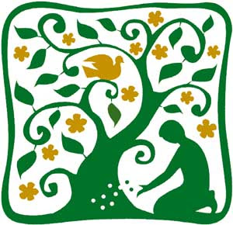

PS Bible Ministry.com
“Planting Seeds”
Service of Worship & Baptism
4th Sunday after Pentecost
Father’s Day, June 17, 2018
First Congregational Church, United Church of Christ
300 Central Street, Saugus, MA 01906
Rev. Martha Leahy, Pastor
Office 781-233-3028 Cell phone 617-763-7354
Carolyn Davis, Secretary
Rebecca Harrold, Music Director
E-mail address: uccsaugus@verizon.net
Website: http://1stchurchsaugus.org
Facebook: https:www.facebook.com/uccsaugus
Healing Circle: https://facebook.com/healingcirclesaugus

The Parable of the Growing Seed

Mark 4:26-34 (NIV)

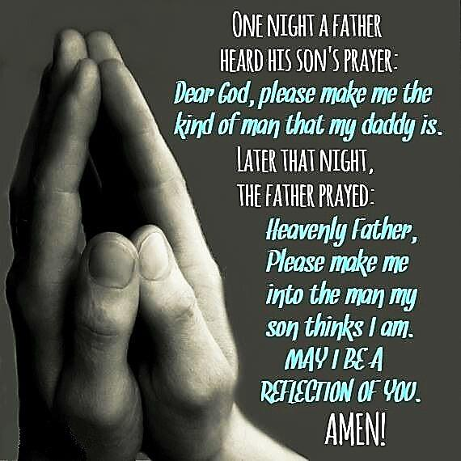
²⁶ Jesus said, “This is what the kingdom of God is like. A person scatters seed on the ground. ²⁷ Night and day, whether they sleep or get up, the seed sprouts and grows, though they do not know how. ²⁸ All by itself the soil produces grain—first the stalk, then the head, then the full kernel in the head. ²⁹ As soon as the grain is ripe, they put the sickle to it, because the harvest has come.”

The Parable of the Mustard Seed
³⁰ Again Jesus said, “What shall we say the kingdom of God is like, or what parable shall we use to describe it? ³¹ It is like a mustard seed, which is the smallest of all seeds on earth. ³² Yet when planted, it grows and becomes the largest of all garden plants, with such big branches that the birds can perch in its shade.”
³³ With many similar parables Jesus spoke the word to them, as much as they could understand. ³⁴ He did not say anything to them without using a parable. But when he was alone with his own disciples, he explained everything.

THE SACRAMENT OF HOLY BAPTISM
for Jamieson Michael Sullivan
Godparents are Tina & Sean Flynn

OPENING WORDS
L: Baptism is a moment in the Christian community when we recognize the grace of God living in each newborn creation. God offers us the possibility of transformation, a continuing process of renewal of body, mind and spirit, which takes place within faith communities. So it is that parents and guardians bring their children into this community to be baptized.

INVITATION & READINGS
L: They were bringing children to Jesus that Jesus might touch them; and the disciples rebuked them. But when Jesus saw it, Jesus was indignant, and said to them,
P: “Let the children come to me, do not hinder them; for to such belongs the realm of God. Truly, I say to you, whoever does not receive the realm of God like a child shall not enter it.”
L: And Jesus took them in his arms and blessed them, laying his hands upon them.

L: Jesus came to John to be baptized by him. But John tried to make him change his mind. “I ought to be baptized by you,” John said. “Yet you have come to me.”
P: Jesus said, “Let it be so for now. For in this way, we shall do all that God requires.” So John agreed.
L: As soon as Jesus was baptized, he came up out of the water. Then heaven was opened to him and he saw the Spirit of God coming down like a dove and lighting on him. Then a voice said from heaven, “This is my beloved Son with whom I am well pleased.”

P: At another time Jesus said: “Go and make disciples of all nations, baptizing them in the name of the Father and of the Son and of the Holy Spirit.”
L: The Sacrament of Baptism is an outward and visible sign of the grace of God. Inasmuch as the promise of the gospel is not only to us but also to our children, baptism with water and the Holy Spirit is the mark of their acceptance into the care of Christ’s Church, the sign and seal of their participation in God’s forgiveness, and the beginning of their growth into full Christian faith and discipleship.

BLESSING OF THE WATER OF BAPTISM
L: Bless by your Holy Spirit, gracious God, this water. Bless by your Holy Spirit this child, baptized this day. Glory to you, eternal God, the one who was, and is, and shall always be, world without end. Amen.

COVENANT WITH GOD AND ONE ANOTHER
L: A covenant is integral to a relationship with God and one another, so today we state the responsibilities of parents, godparents and community to God and this child. As Godparents, do you promise to bring your child into the life of the Christian community to worship, to hear the stories of the roots of our faith, and to be in relationship with other believers as he grows into a faith of his own?
Godparents: We will, with the help of God.
L: Now I ask this congregation, what will be your part in helping this child discover the grace of God?
P: We promise our love, support and care to this child and his family as he lives and grows in Christ’s Church.

ACT OF BAPTISM
L: By what name have you called this child?
Godparents: Jamieson Michael Sullivan
L: Jamieson Michael Sullivan, I baptize you in the name of the Father, and of the Son, and of the Holy Spirit.

WALKING IN FAITH WITH THE NEWLY BAPTIZED
(The Pastor walks with the child through the sanctuary, introducing him to his church family.)

PRAYER FOR THE BAPTIZED
L: Let us pray. Gracious God, giver of life, you have called us by name, and pledged to each of us your faithful love. We pray today for your blessing upon this child, that you will watch over him and guide him as he grows in faith. Remind us of the promises of our own baptism, and renew our trust in you. Make us strong to obey your will and to serve you with joy, through the power of the Holy Spirit. Amen.

GIVING OF GIFTS

