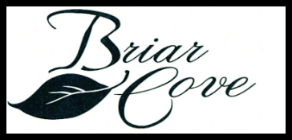

BRIAR COVE PAIRED COTTAGE HOMEOWNERS ASSOCIATION
BOARD MEETING
April 18, 2019 6:30pm
Lake County Public Library, Dyer-Schererville Branch
Agenda
Call To Order – Sue
Pledge of Allegiance – Jay
Ground Rules – Sue
- Wait until presentations are finished to ask questions
Reading and Approval of the January 17, 2019 Minutes - Sue
Treasurer’s Report - Lou
1st American Management Report – Peter
Thank you for Jay’s leadership in the Lighting Program – Sue
Upcoming Spring Activities:
Driveway coating and limited driveway replacement
Tree review – Residents to contact Peter regarding issues with HOA-owned trees.
Stop signs at main entrance – extra traffic due to Main Street Closure
Landscape Committee first meeting set for Saturday April 27 at 9:00am at Sheffield’s Restaurant. The Board is looking for new members to join this group. Please contact Sue Kagy if you are interested. Fran Houts will lead.

Upcoming Meetings and Events 2019
Quarterly Meetings at the Dyer-Schererville Library
April 18, July 18, October 17

Annual Survey
October 21

Annual meeting
November 21

Garage Sale
Preparation Days: August 15-16
Sale: August 17

New Business-Discussion-Adjournment

