Second Sunday of Advent
ELW Holy Communion Setting Two
Sunday, December 4, 2022

Announcements
Gathering
The Holy Spirit calls us together as the people of God.

Lighting of the Advent Wreath Hymn 240 vs 1,2
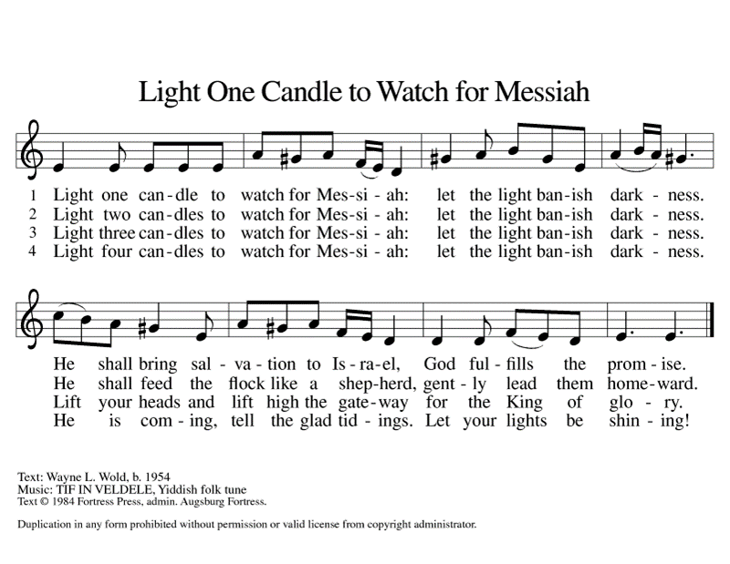
Confession and Forgiveness (ELW p. 116)
Blessed be the holy Trinity, ☩ one God,
who forgives all our sin,
whose mercy endures forever.
Amen.
Almighty God, to whom all hearts are open, all desires known, and from whom no secrets are hid: cleanse the thoughts of our hearts by the inspiration of your Holy Spirit, that we may perfectly love you and worthily magnify your holy name, through Jesus Christ our Lord.
Amen..
Let us confess our sin in the presence of God and of one another.
Gracious God,
have mercy on us. We confess that we have turned from you and given ourselves into the power of sin. We are truly sorry and humbly repent. In your compassion forgive us our sins, known and unknown, things we have done and things we have failed to do. Turn us again to you, and uphold us by your Spirit, so that we may live and serve you in newness of life through Jesus Christ, our Savior and Lord.
Amen.
God, who is rich in mercy, loved us even when we were dead in sin, and made us alive together with Christ. By grace you have been saved. In the name of ☩ Jesus Christ, your sins are forgiven. Almighty God strengthen you with power through the Holy Spirit, that Christ may live in your hearts through faith.
Amen.

Gathering Song Prepare the Royal Highway (ELW 264)
1 Prepare the royal highway;
the King of kings is near!
Let ev'ry hill and valley
a level road appear!
Then greet the King of glory,
foretold in sacred story:
Refrain
Hosanna to the Lord,
for he fulfills God's word!
2 God's people, see him coming:
your own eternal king!
Palm branches strew before him!
Spread garments! Shout and sing!
God's promise will not fail you!
No more shall doubt assail you! Refrain
3 Then fling the gates wide open
to greet your promised king!
Your king, yet ev'ry nation
its tribute too may bring.
All lands will bow before him;
their voices join your singing: Refrain
4 His is no earthly kingdom;
it comes from heav'n above.
His rule is peace and freedom
and justice, truth, and love.
So let your praise be sounding
for kindness so abounding: Refrain

Greeting (ELW p. 120)
The grace of our Lord Jesus Christ, the love of God,
and the communion of the Holy Spirit be with you all.
And also with you.

Kyrie (ELW p. 120)
In peace, let us pray to the Lord.
Lord, have mercy.
For the peace from above,
and for our salvation,
let us pray to the Lord.
Lord, have mercy.
For the peace of the whole world,
for the well-being of the Church of God,
and for the unity of all,
let us pray to the Lord.
Lord, have mercy.
For this holy house,
and for all who offer here their worship and praise,
let us pray to the Lord.
Lord, have mercy.
Help, save, comfort, and defend us, gracious Lord.
Amen, amen.

Canticle of Praise (ELW p. 121)
This is the feast of victory for our God.
Alleluia, alleluia, alleluia.
Worthy is Christ, the Lamb who was slain,
whose blood set us free to be people of God.
Power, riches, wisdom and strength,
and honor, blessing, and glory are his.
This is the feast of victory for our God.
Alleluia, alleluia, alleluia.
Sing with all the people of God,
and join in the hymn of all creation:
Blessing, honor, glory, and might
be to God and the Lamb forever. Amen.
This is the feast of victory for our God,
for the Lamb who was slain has begun his reign.
Alleluia, alleluia, alleluia.

Prayer of the Day (ELW p. 124)
Let us pray.
Stir up our hearts, Lord God, to prepare the way of your only Son. By his coming nurture our growth as people of repentance and peace; through Jesus Christ, our Savior and Lord, who lives and reigns with you and the Holy Spirit, one God, now and forever.
Amen.
The assembly is seated.

First Reading: Isaiah 11:1-10
¹A shoot shall come out from the stump of Jesse,
and a branch shall grow out of his roots.
²The spirit of the Lord shall rest on him,
the spirit of wisdom and understanding,
the spirit of counsel and might,
the spirit of knowledge and the fear of the Lord.
³His delight shall be in the fear of the Lord.
He shall not judge by what his eyes see,
or decide by what his ears hear;
⁴but with righteousness he shall judge the poor,
and decide with equity for the meek of the earth;
he shall strike the earth with the rod of his mouth,
and with the breath of his lips he shall kill the wicked.
⁵Righteousness shall be the belt around his waist,
and faithfulness the belt around his loins.
⁶The wolf shall live with the lamb,
the leopard shall lie down with the kid,
the calf and the lion and the fatling together,
and a little child shall lead them.
⁷The cow and the bear shall graze,
their young shall lie down together;
and the lion shall eat straw like the ox.
⁸The nursing child shall play over the hole of the asp,
and the weaned child shall put its hand on the adder’s den.
⁹They will not hurt or destroy
on all my holy mountain;
for the earth will be full of the knowledge of the Lord
as the waters cover the sea.
¹⁰On that day the root of Jesse shall stand as a signal to the peoples; the nations shall inquire of him, and his dwelling shall be glorious.
The word of the Lord.
Thanks be to God.

Psalm: Psalm 72:1-7, 18-19
¹Give the king your jus- | tice, O God,
and your righteousness to | the king’s son;
²that he may rule your | people righteously
and the | poor with justice;
³that the mountains may bring prosperity | to the people,
and the | hills, in righteousness.
⁴Let him defend the needy among the people,
rescue the poor, and crush | the oppressor.
⁵May he live as long as the sun and | moon endure,
from one generation | to another.
⁶Let him come down like rain upon | the mown field,
like showers that water the earth.
⁷In his time may the | righteous flourish;
and let there be an abundance of peace till the moon shall | be no more.
¹⁸Blessed are you, Lord God, the | God of Israel;
you alone do | wondrous deeds!
¹⁹And blessed be your glorious | name forever,
and may all the earth be filled with your glory. Amen. Amen.

Second Reading: Romans 15:4-13
⁴Whatever was written in former days was written for our instruction, so that by steadfastness and by the encouragement of the scriptures we might have hope. ⁵May the God of steadfastness and encouragement grant you to live in harmony with one another, in accordance with Christ Jesus, ⁶so that together you may with one voice glorify the God and Father of our Lord Jesus Christ.
⁷Welcome one another, therefore, just as Christ has welcomed you, for the glory of God. ⁸For I tell you that Christ has become a servant of the circumcised on behalf of the truth of God in order that he might confirm the promises given to the patriarchs, ⁹and in order that the Gentiles might glorify God for his mercy. As it is written,
“Therefore I will confess you among the Gentiles,
and sing praises to your name”;
¹⁰and again he says,
“Rejoice, O Gentiles, with his people”;
¹¹and again,
“Praise the Lord, all you Gentiles,
and let all the peoples praise him”;
¹²and again Isaiah says,
“The root of Jesse shall come,
the one who rises to rule the Gentiles;
in him the Gentiles shall hope.”
¹³May the God of hope fill you with all joy and peace in believing, so that you may abound in hope by the power of the Holy Spirit.
The word of the Lord.
Thanks be to God.

Gospel Acclamation (ELW p. 124)

Alleluia, alleluia, alleluia, alleluia.
Gospel: Matthew 3:1-12
The holy gospel according to Matthew.
Glory to you, O Lord.
¹In those days John the Baptist appeared in the wilderness of Judea, proclaiming, ²“Repent, for the kingdom of heaven has come near.” ³This is the one of whom the prophet Isaiah spoke when he said,
“The voice of one crying out in the wilderness:
‘Prepare the way of the Lord,
make his paths straight.’ ”
⁴Now John wore clothing of camel’s hair with a leather belt around his waist, and his food was locusts and wild honey. ⁵Then the people of Jerusalem and all Judea were going out to him, and all the region along the Jordan, ⁶and they were baptized by him in the river Jordan, confessing their sins.
⁷But when he saw many Pharisees and Sadducees coming for baptism, he said to them, “You brood of vipers! Who warned you to flee from the wrath to come? ⁸Bear fruit worthy of repentance. ⁹Do not presume to say to yourselves, ‘We have Abraham as our ancestor’; for I tell you, God is able from these stones to raise up children to Abraham. ¹⁰Even now the ax is lying at the root of the trees; every tree therefore that does not bear good fruit is cut down and thrown into the fire.
¹¹“I baptize you with water for repentance, but one who is more powerful than I is coming after me; I am not worthy to carry his sandals. He will baptize you with the Holy Spirit and fire. ¹²His winnowing fork is in his hand, and he will clear his threshing floor and will gather his wheat into the granary; but the chaff he will burn with unquenchable fire.”
The gospel of the Lord.
Praise to you, O Christ.

Is Jesus Enough?

Hymn of the Day He Came Down (ELW 253)
1 He came down that we may have love;
he came down that we may have love;
he came down that we may have love;
hallelujah forevermore.
2 He came down that we may have light;
he came down that we may have light;
he came down that we may have light;
hallelujah forevermore.
3 He came down that we may have peace;
he came down that we may have peace;
he came down that we may have peace;
hallelujah forevermore.
4 He came down that we may have joy;
he came down that we may have joy;
he came down that we may have joy;
hallelujah forevermore.

Creed (ELW p. 126)
I believe in God, the Father almighty,
creator of heaven and earth.
I believe in Jesus Christ, God’s only Son, our Lord,
who was conceived by the Holy Spirit,
born of the virgin Mary,
suffered under Pontius Pilate,
was crucified, died, and was buried;
he descended to the dead.*
On the third day he rose again;
he ascended into heaven,
he is seated at the right hand of the Father,
and he will come to judge the living and the dead.
I believe in the Holy Spirit,
the holy catholic church,
the communion of saints,
the forgiveness of sins,
the resurrection of the body,
and the life everlasting. Amen.

Prayers of Intercession
God, in your mercy,
hear our prayer.

The Lord be with you.
And also with you.

Lift up your hearts.
We lift them to the Lord.

Let us give thanks to the Lord our God.
It is right to give our thanks and praise.

Preface (ELW p. 130)
It is indeed right, our duty and our joy,
that we should at all times and in all places
give thanks and praise to you, almighty and merciful God,
through our Savior Jesus Christ.
You comforted your people with the promise of the Redeemer,
through whom you will also make all things new
in the day when he comes to judge the world in righteousness.
And so, with all the choirs of angels,
with the church on earth and the hosts of heaven,
we praise your name and join their unending hymn:

Holy, Holy, Holy (ELW p. 130)

Holy, holy, holy Lord,
God of power and might,
heaven and earth are full of your glory.
Hosanna in the highest.
Blessed is he who comes in the name of the Lord.
Hosanna in the highest. Hosanna in the highest.

Thanksgiving at the Table (ELW p. 130).
In the night in which he was betrayed,
our Lord Jesus took bread, and gave thanks;
broke it, and gave it to his disciples, saying:
Take and eat; this is my body, given for you.
Do this for the remembrance of me.

Again, after supper, he took the cup, gave thanks,
and gave it for all to drink, saying:
This cup is the new covenant in my blood,
shed for you and for all people for the forgiveness of sin.
Do this for the remembrance of me.

Lord’s Prayer (ELW p. 134)
Lord, remember us in your kingdom and teach us to pray.
Our Father, who art in heaven,
hallowed be thy name,
thy kingdom come,
thy will be done,
on earth as it is in heaven.
Give us this day our daily bread;
and forgive us our trespasses,
as we forgive those
who trespass against us;
and lead us not into temptation,
but deliver us from evil.
For thine is the kingdom,
and the power, and the glory,
forever and ever. Amen.

Come to this table to a meal for now all is ready.

Communion (ELW p. 134)
The body of Christ, given for you.
The blood of Christ, shed for you.
Amen..

Communion Song (ELW p. 135)
Lamb of God, you take away the sin of the world;
have mercy on us.
Lamb of God, you take away the sin of the world;
have mercy on us.
Lamb of God, you take away the sin of the world;
grant us peace.

*Post- Communion Blessing
P) The body and blood of our Lord Jesus Christ strengthen you and keep you in his grace.
C) Amen.

Song after Communion (ELW p. 135)
Now, Lord, you let your servant go in peace:
your word has been fulfilled.
My own eyes have seen the salvation
which you have prepared
in the sight of ev’ry people:
a light to reveal you to the nations
and the glory of your people Israel.

Prayer after Communion (ELW p. 136)
Let us pray.
God for whom we wait, in this meal you give us a foretaste of that day when the hungry will be fed with good things. Send us forth to make known your deeds and to proclaim the greatness of your name, through Jesus Christ, our Savior and Lord.
Amen.

Blessing (ELW p. 136)
Almighty God, Father, ☩ Son, and Holy Spirit, bless you now and forever.
Amen.

Sending Song Hark, the Glad Sound! (ELW 239)
1 Hark, the glad sound! The Savior comes,
the Savior promised long;
let ev'ry heart prepare a throne
and ev'ry voice a song.
2 He comes the pris'ners to release,
in Satan's bondage held.
The gates of brass before him burst,
the iron fetters yield.
3 He comes the broken heart to bind,
the bleeding soul to cure,
and with the treasures of his grace
to enrich the humble poor.
4 Our glad hosannas, Prince of peace,
your welcome shall proclaim,
and heav'n's eternal arches ring
with your beloved name.

Peace (ELW p. 128)
The peace of Christ be with you always.
And also with you.

Dismissal (ELW p. 137)
Go in peace. Christ is with you.
Thanks be to God.

From sundaysandseasons.com.

Copyright © 2022 Augsburg Fortress. All rights reserved.

