**Pre-School Supplies List 2016-2017**

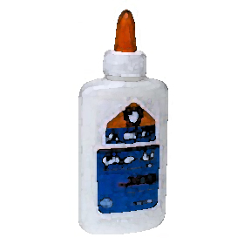1 Change of Clothes (please label)

1 Blanket (please label)

1 Small Pillow (please label)

1 Sleeping Mat (Wal-Mart; please label)

1 Pack of Thick Classic Markers (washable)

1 Box of Beginner Crayola Crayons

1 Pack of Construction Paper (multi colored)

1 Elmer’s Glue Stick (or more)

1 Pair of Blunt Scissors (please do not label)

1 Box of Gallon Ziploc Bags

2 Solid Color Plastic Pocket Folders (please do not label)

2 Chubby Beginner Wood Pencils (please do not label)

2 Boxes of Tissues (or more)

2 Rolls of Paper Towels (or more)

2 Containers of Clorox Wipes

1 Backpack

j0232760