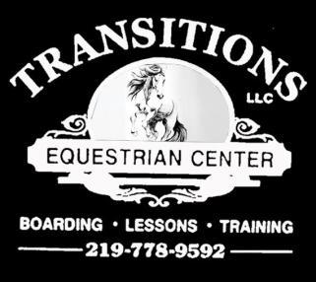

2022 Transitions Equestrian Center Open Show Series
Saturday – April 30th ~ May 28th ~ June 25th ~ July 30th ~ Aug 27th ~ No Show In Sept ~
Halloween Fun Show Oct 29th
Sign up starts at 8:00 a.m. - Show starts at 9:00 a.m.
Entry Fees: $5.00 a class Horse Rental- $5.00 a class

1. Mares Halter 15 min. Break - Tack Change
2. Geldings Halter 25. Barrel Racing
3. Pony or Mini Halter 26. Pole Bending
4. Color Class 27. Egg and Spoon
5. Pee Wee Halter 28. Musical Plates 6. Pee Wee Showmanship 29. Toilet Paper Partners 7. Showmanship 13 & under 30. Bareback Horsemanship
8. Showmanship 14- and up 31. Ride a Buck 9. Dressage Showmanship Bring your own buck, Winner takes all!!
10. Worst Showmanship 32. Freestyle- Dressage/Liberty/Trick/Reining
33. Long Line or Driving in hand (no cart)
15 min. Break - Tack Change 34. Drill Class ~ 2 Riders and up to l2 Riders
11. English Pee Wee Lead Line Classes 32, 33 & 34 are performed to music and
12. English Equitation W/T costumes chosen by the rider. Anything Goes!! 13. English Equitation W/T/C
14. English Pleasure W/T
15. English Pleasure W/T/C
16. Jumping Class - 2 ft. Outside horses must show proof of vaccines.
17. Jumping Class – 2' 6” to 3ft. If you are planning on using a lesson horse we STRONGLY
recommend signing up for your class in advance.
Lunch Break Pot luck for lunch, please sign up bring a dish to pass.
18. Western Pee Wee Western Lead Line
19. Western Equitation W/T Transitions Equestrian Center
20. Western Equitation W/T/C 2525 E. 850 N.
21. Western Pleasure W/T La Porte, In 46350
22. Western Pleasure W/T/C
23. Relatives Ride W/T For More Details Please Contact us at:
(Parents and Siblings- Lead Line is Welcome) (219) 778 - 9592
24. Cart Class

- Dressage classes will be offered during the show, please sign up in advance to receive a scheduled ride time.
- Please write the test you will be riding on your sign up sheet
- No show clothes or mane braiding/banding required.
- Total Points will be added at the end of show for Grand Champion and Reserve High Point Ribbons!! ~

