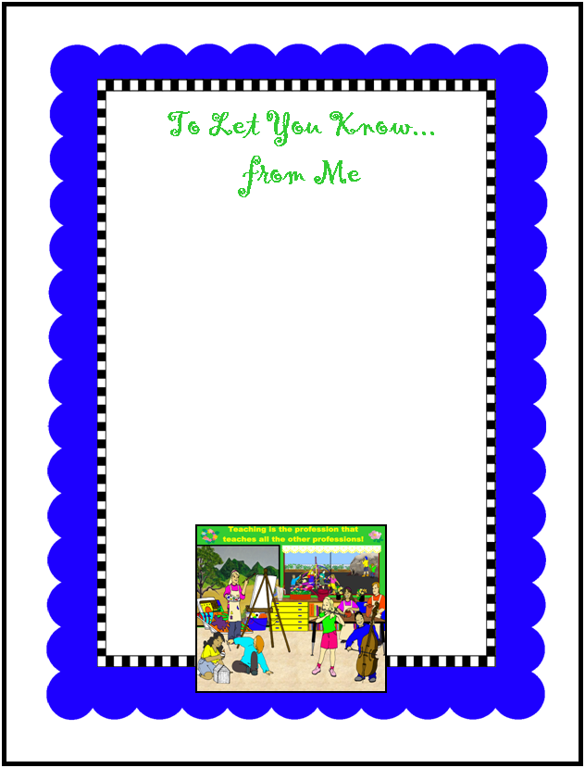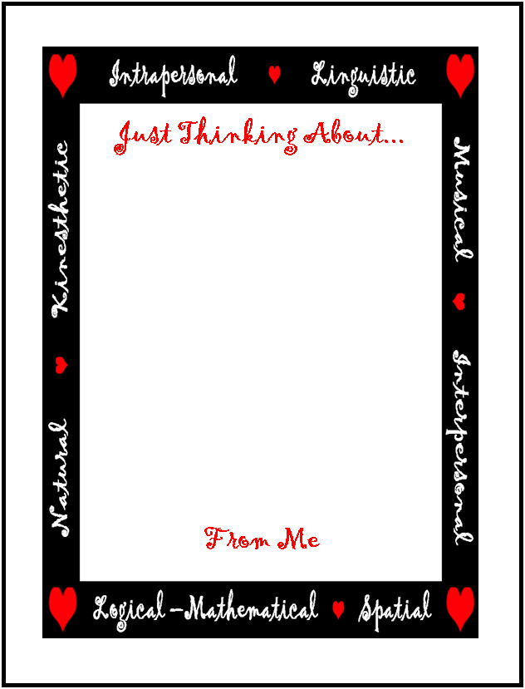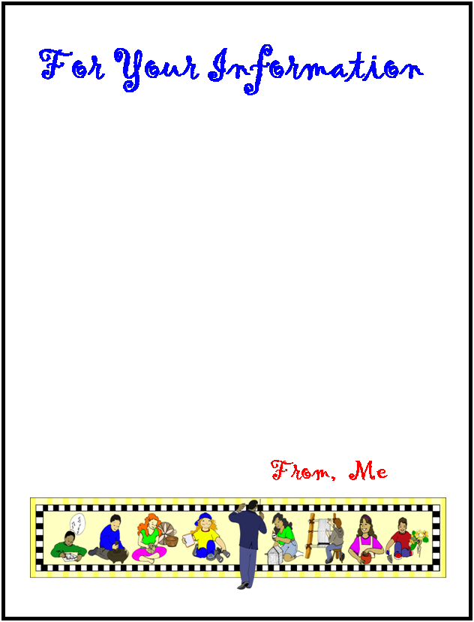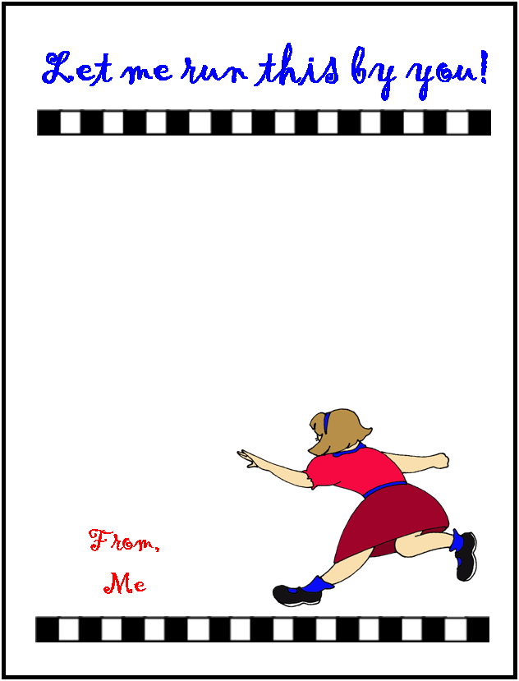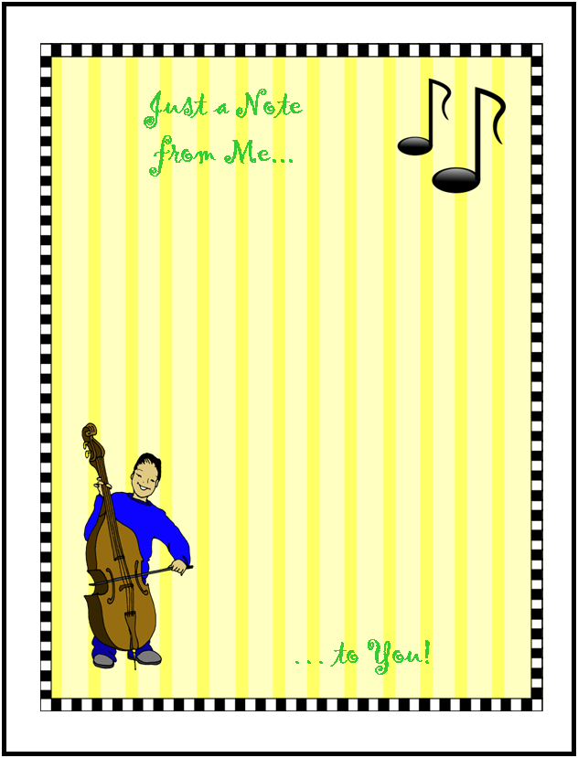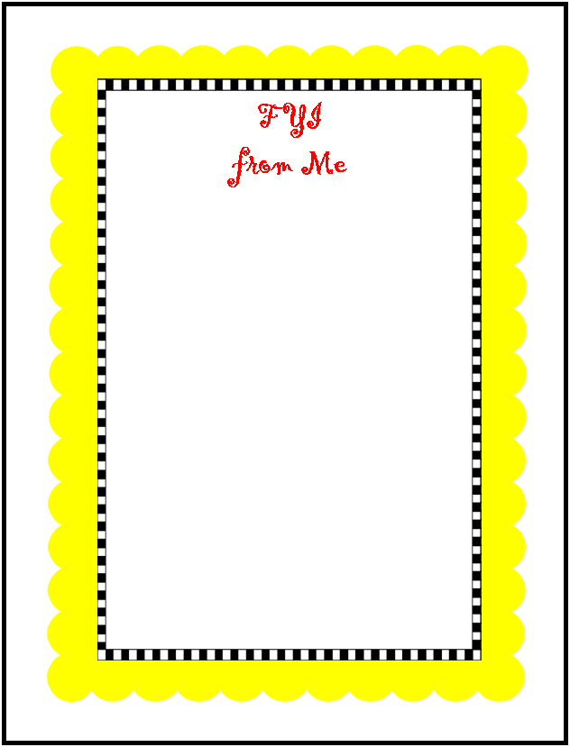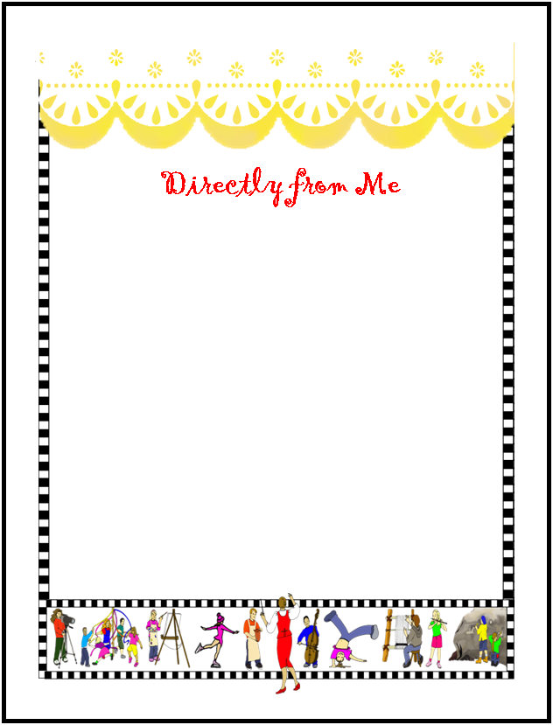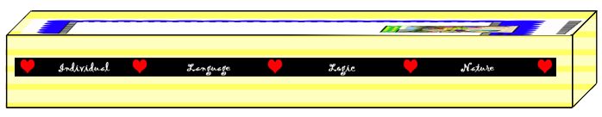
The Artful Classroom,
Note Paper and Holder
Teachers write lots of notes for lots of different reasons. Here are a couple pages of blank notepaper for you to personalize and enjoy. Just select the word “Me” and type your own name. Then run off a bunch of pages, cut the sheets at 5.5 inches (horizontally) and 4.25 inches (vertically), and you’ll have a stack of notes to use throughout the year, themed on the Artful Classroom.

Pages 4 and 5 have a handy little box you can make to hold your notepaper on your desk. Run pages 4 and 5 back-to-back on heavy white drawing paper, cover stock, or tag. Laminate. Cut on the solid lines. Fold on the dotted lines. Bend up to form a box. Staple or tape the end flaps.

Blessings on your teaching year! May it be the best ever!
© 2011 Integreat! Thematic Units
www.thematicteacher.com

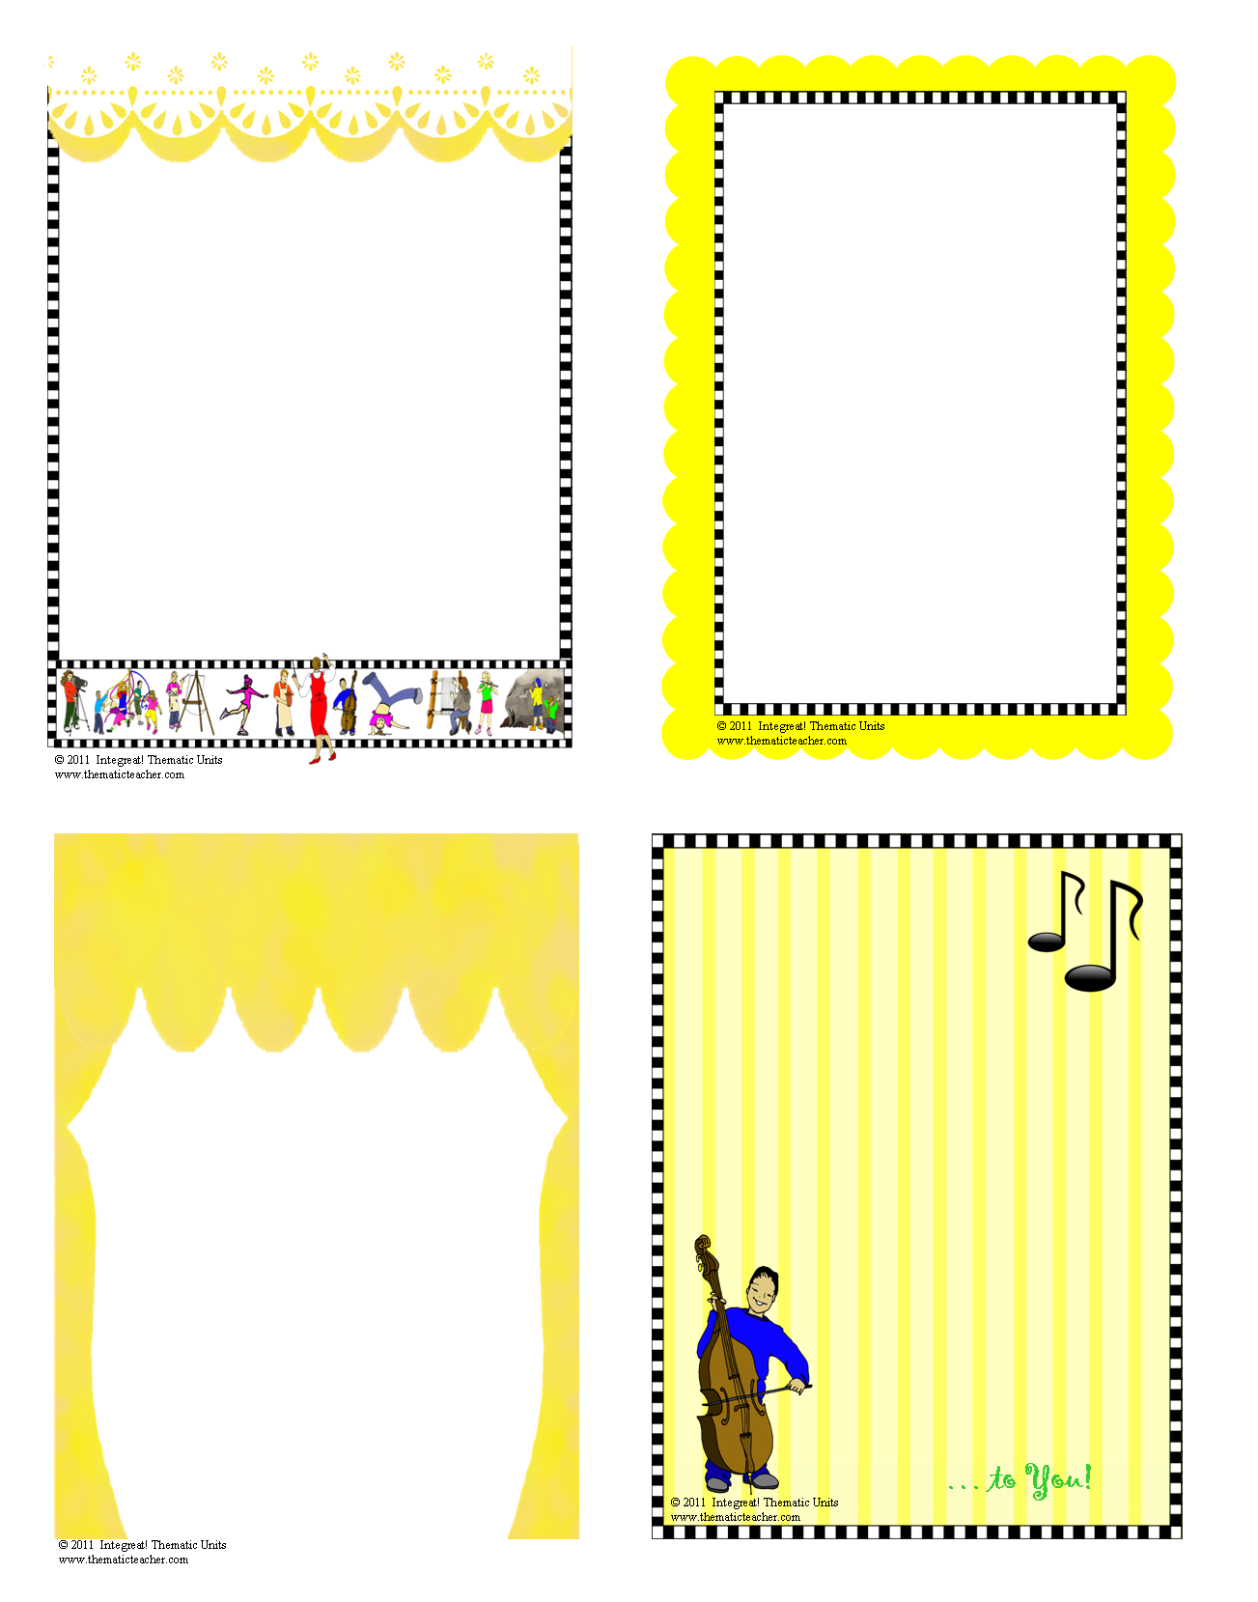
… to You!
© 2011 Integreat! Thematic Units
www.thematicteacher.com
Just a Note
from Me...
© 2011 Integreat! Thematic Units
www.thematicteacher.com
Directly from Me
© 2011 Integreat! Thematic Units
www.thematicteacher.com
FYI
from, Me
© 2011 Integreat! Thematic Units
www.thematicteacher.com
And now, right here, on our stage...
From, Me
Just a Note
from Me...
Directly from Me
FYI
from Me
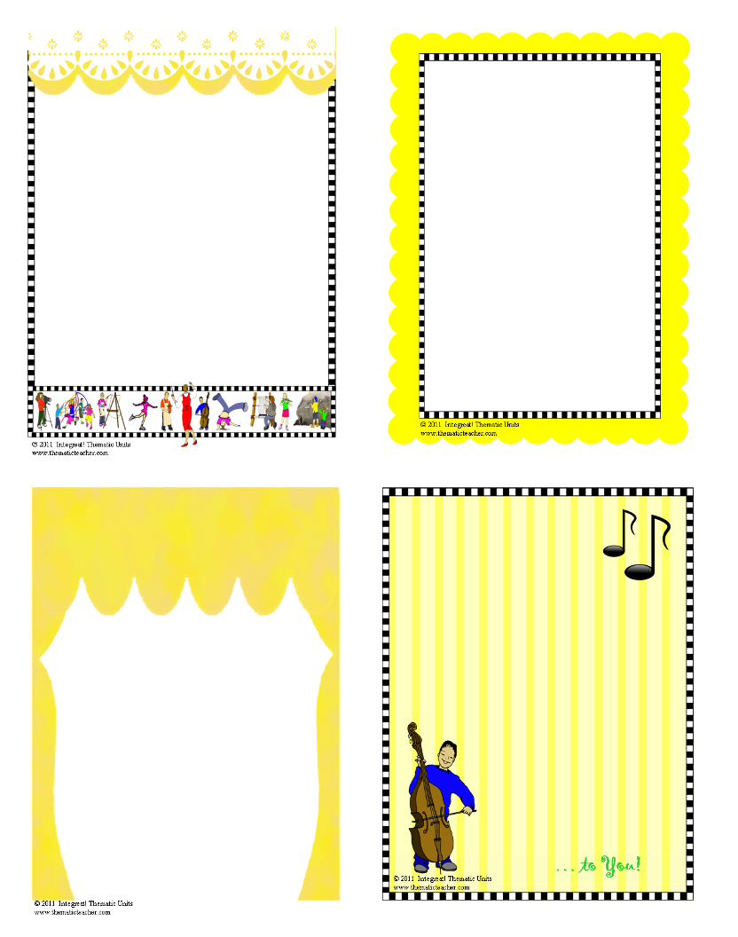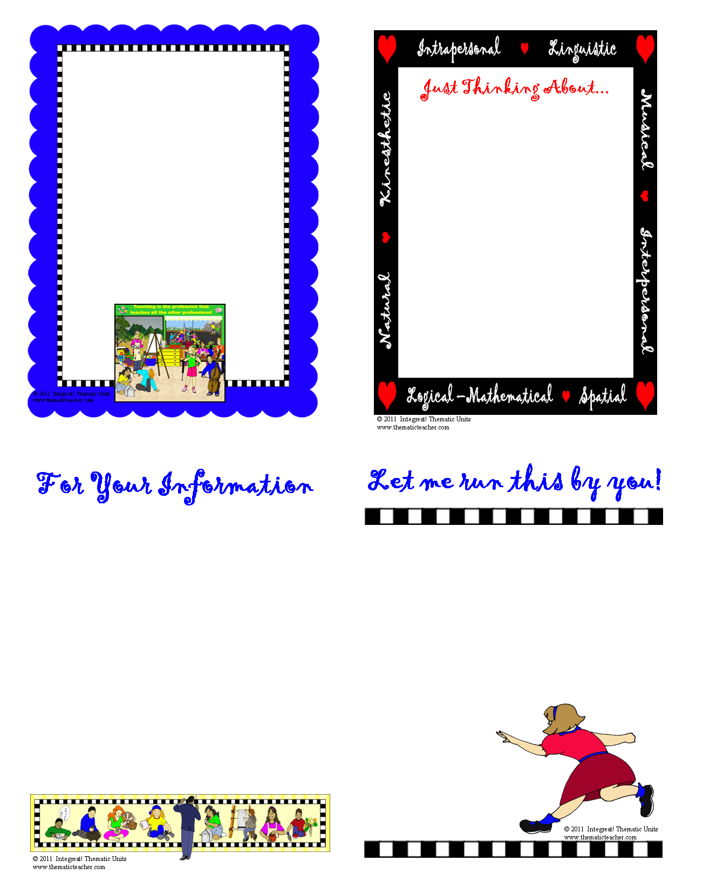
Just a Note
from Me...
Directly from Me
FYI
from Me
Me…
Announcing
From Me
From,
Me
From, Me
To Let You Know...
from Me

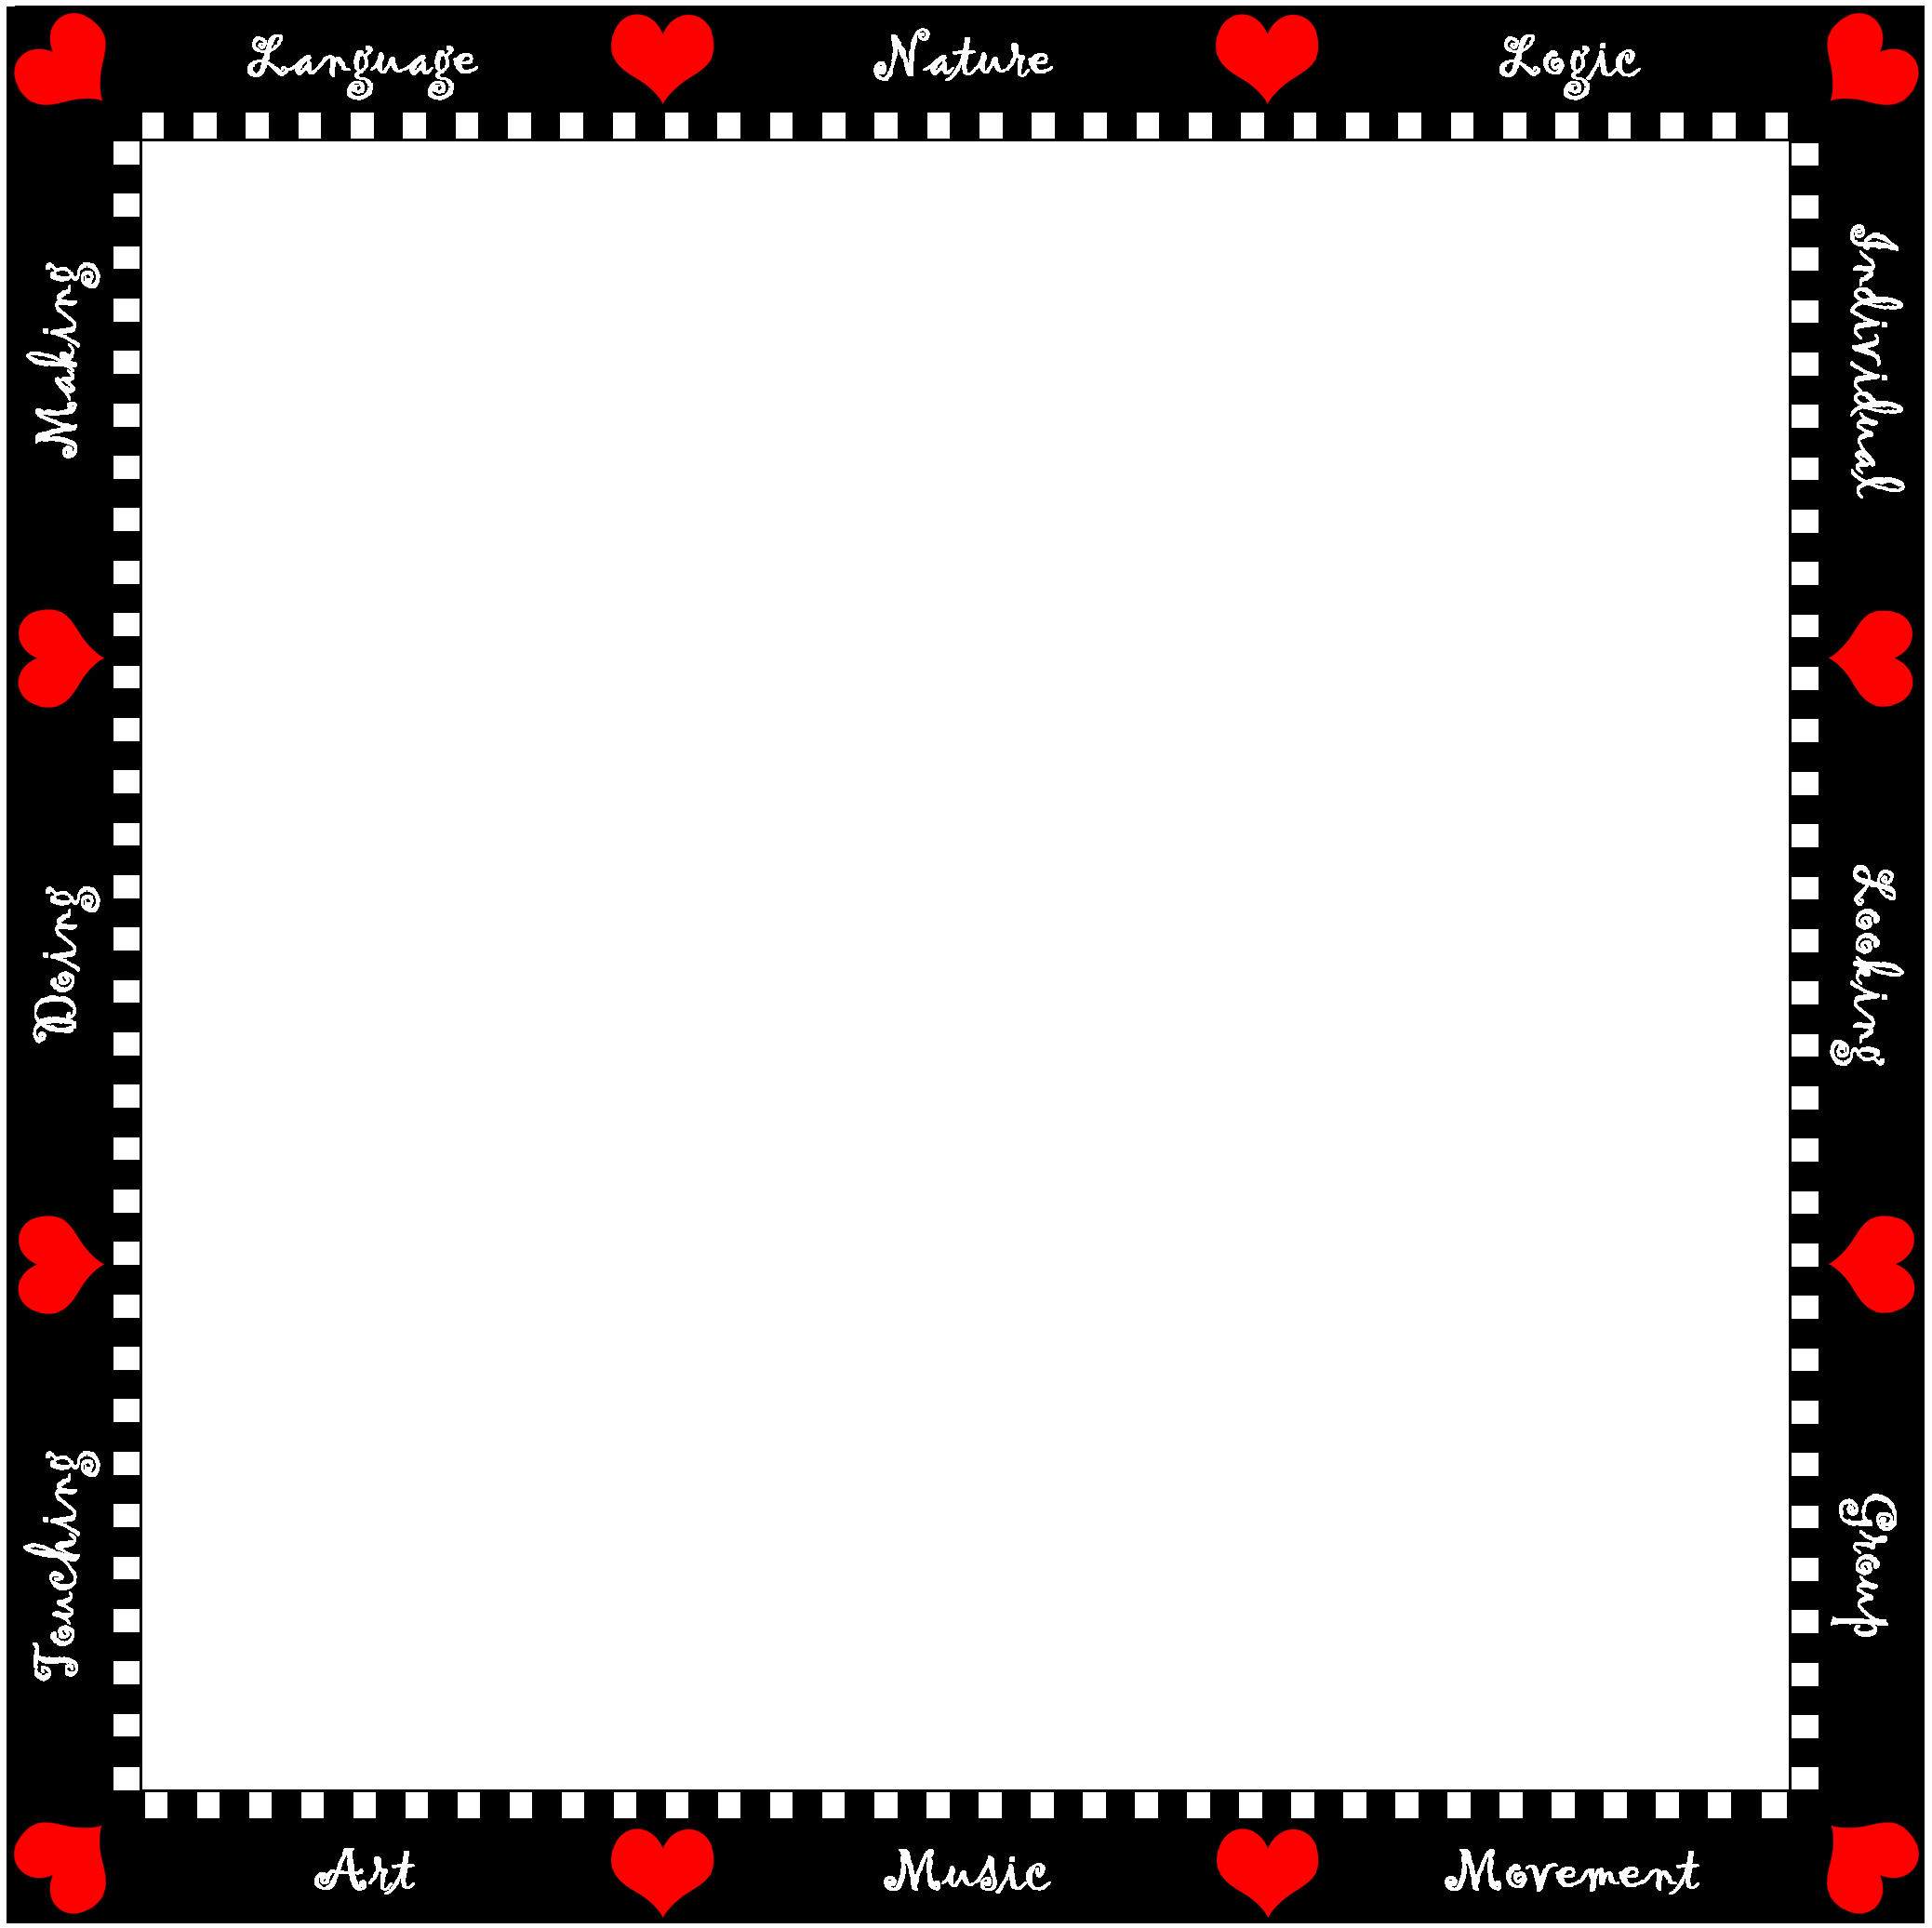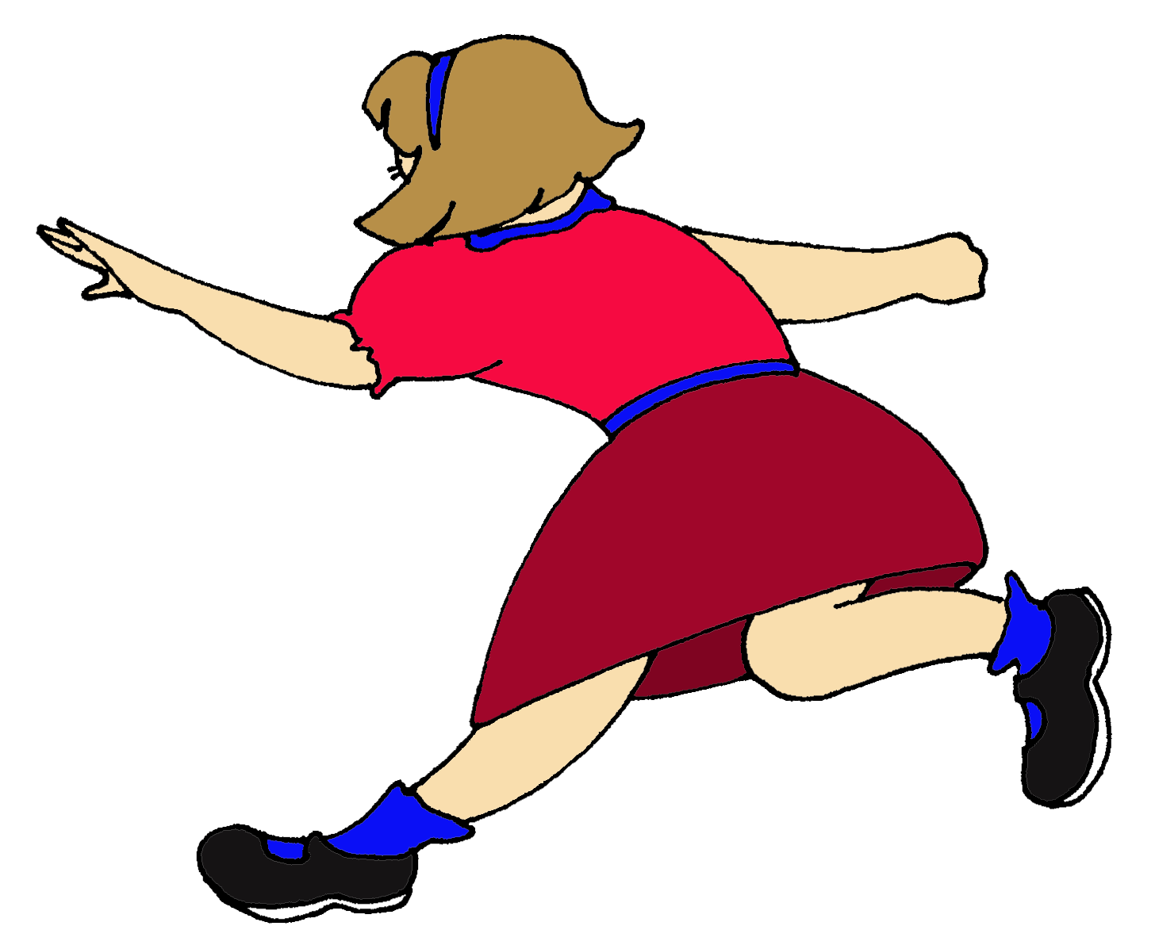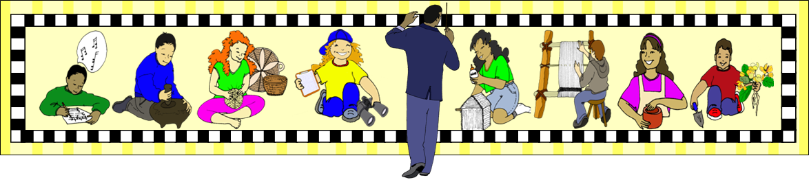
Just Thinking About...

© 2011 Integreat! Thematic Units
www.thematicteacher.com
From, Me
Let me run this by you!
© 2011 Integreat! Thematic Units
www.thematicteacher.com
From,
Me
For Your Information
© 2011 Integreat! Thematic Units
www.thematicteacher.com
From, Me
© 2011 Integreat! Thematic Units
www.thematicteacher.com
To Let You Know...

from, Me
Just a Note
from Me...
Directly from Me
FYI
from Me
From Me
From,
Me
From, Me
To Let You Know...
from Me
Just a Note
from Me...
Directly from Me
FYI
from Me

From Me
From,
Me
From, Me
To Let You Know...
from Me
From Me
From,
Me
From, Me
To Let You Know...
from Me
Run pages 4 and 5 back-to-back on heavy white drawing paper, cover stock, or tag. Laminate. Cut on the solid lines. Fold on the dotted lines. Bend up to form a box. Staple or tape the end flaps.
© 2011 Integreat! Thematic Units
www.thematicteacher.com

