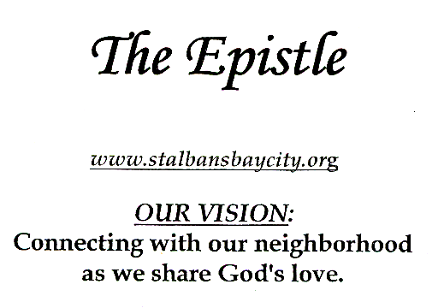

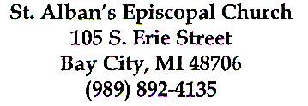
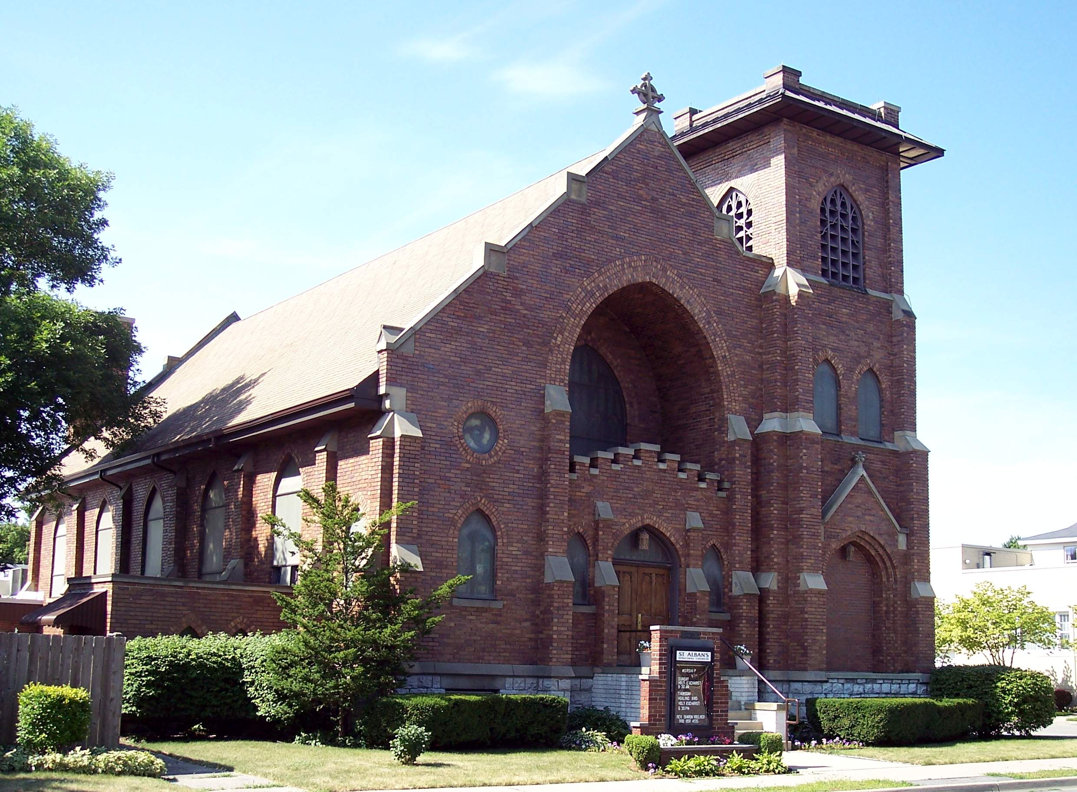

January
2014
CHARLEY’S CORNER
Hi. I’m Charley.
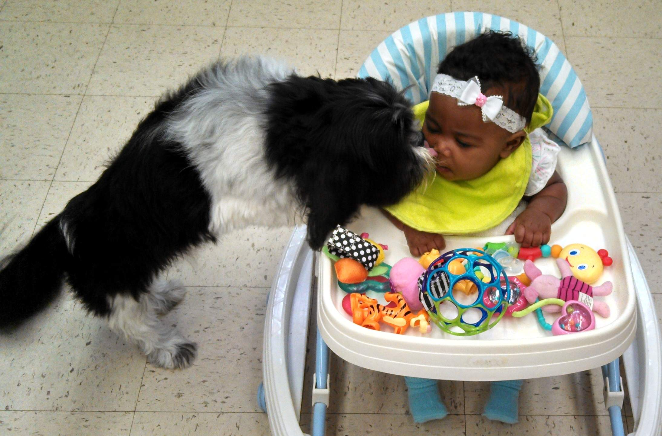
This has been a really busy time…I haven’t seen so much chaos and confusion since Mom and I packed up all our stuff and brought it to our new house! But despite all the noise and carrying on, I made myself comfy in my bed in the office and listened to everyone talking [with one eye closed, you know]. It was all about “Christmas.” That must be some really big deal!
Well, I guess it is. There were so many people who came into the office. That really interrupted my nap time, but after all, it is my job to greet everyone and make them feel welcome and I was very happy to do that.
Then one day I went up to the church with my Mom and I was purely astounded by what I saw!! Red flowers were everywhere…a Christmas tree with white lights and red bows was up…green stuff with lights and red bows was wrapped around the big opening at the top of the stairs…yes, those stairs that I don’t like. And pretty white flowers were on the shelf under the big window with Jesus in it. And then there was a little barn with statues in it…that seemed to be really special. Wow!
I wondered why all of this was going on. I’m sure I didn’t understand what Mom was explaining except…I kept hearing the word “love.” I know that word and it makes me feel good all over. I wonder if what I do makes people feel good all over. Love is a great thing…we need more of it!
Charley

A View from St. Alban’s
Mother Sharon Voelker

Christmas is officially over. Just take a look around…the decorations are gone, the mall is becoming quiet, kids are back in school…the gifts we received have been put away. Only a few weeks ago we were running at full speed to get all our holiday shopping done and to finish our preparations before the Big Day was fully upon us. Now what do we do? Our days seem to be a little empty.
Maybe now would be a good time to settle into a comfortable place and think about what Christmas really means to us. What lessons have we learned during this Christmas season, and how can we apply what we have learned? As Christians, we are taught that the greatest lesson is love. That’s what is it all about. God showed love for us by giving us the gift of his son…to be one of us…to show us the way.
Looking out the window today, I see the sun shining brightly, the wind gusting mightily, and I hear the sound of the snow crunching. It is cold out there! I thank God that where I am sitting it is warm and I don’t have to go out there unless I want to. But what about those unfortunate people who are huddled someplace trying to get out of the harsh wind and cold?
It is easy to take our blessings for granted. We usually don’t pay much attention to the things we don’t see…the homeless, for example. Maybe we should try to give them some comfort. It’s not that difficult. A donation of a blanket…a warm jacket…socks [especially socks at this time of year]…warm hats and gloves. Loving others is the Christian way and how better to love than to give a gift of warmth to someone who desperately needs it?
Maybe St. Alban’s family should start a socks drive…what do you think? I’m ready…are you?



New St. Alban’s Phone Directory

As many of you are aware, a company called Lifetouch is putting together a new directory for St. Alban’s. There is no fee to have your picture taken – just for participating, you will receive a complimentary 8”x10” portrait and a free church directory! There is, of course, an opportunity to purchase additional portraits, but there is no obligation to do so.
You must sign up to have your pictures taken at a certain time, and sign-up sheets are available on the round table in our parish hall. (You can also sign up by clicking the appropriate link on our website, www.stalbans-baycity.org) Photographers will be at our church on Friday, January 17th from 2-8:30pm and on January 18th from 9:30am-4pm. If you have questions, make sure to pick up a portrait guide at the sign-up table!
Lifetouch encourages you to bring meaningful items to your portrait session. A hat? Pin? Scarf? Musical instrument? Bible? Sports gear? Whatever you want! You can even bring your pet with you to your portrait session.

Help us make this directory complete! It won’t be the same without you!



Historical Plaque for St. Alban's
Elaine Kirkpatrick

The history of St. Alban's as a part of the Bay City historical picture is very fascinating.
Because of this I am a committee of one exploring the possibility of having our church building included in the National Register of Historic Places. This project is not a short term project but entails much research.
Collection of oral history from our members, collection of pictures, historical information and details of architectural elements are part of the informational gathering. I will attempt to keep our congregation informed of my progress. Our members can help this project by gathering pictures, thinking of stories and other historical information that could be part of this project.


What’s happening around Bay City in October?
By Katie Curtis

As your new Community Liaison, I’m writing this column for The Epistle in order to keep everyone up-to-date on the interesting events happening in the Bay Area. When I moved home, I found it hard to keep checking many different resources to find activities; so it is my hope to make this column a one-stop shop that lists all the famous, infamous, and little-known events happening around you.
In order to make this column a wonderful resource, however, I’ll need YOUR input! Please tell me if you know of any upcoming events I should include in my next column. My phone number is 450-1290 and my email is KLCurtis32@yahoo.com, and maybe we could even organize St. Alban’s trips to these fun events together in the future.

It’s finally 2014! You’ve celebrated the new year, you’ve made resolutions and promises, and now you’re looking for something to do in the community during these cold months ahead. Here are some exciting winter events you should definitely investigate.

John F. Kennedy Exhibit
Jul 1, 2013 - Jan 31, 2014
Frankenmuth Museum
Take an in-depth look at the life and presidency of John F. Kennedy and the tragedy of his death. Books, photos, articles, and artifacts from the Presidents life will be presented in this exhibit.
Website: www.frankenmuthmuseum.org
Contact: Ammiee Kotch
Email: fhaoffice@airadv.net
Phone: 989-652-9701

"Richard Hunt, The Art of This Century" exhibition
Throughout January
Marshall M. Fredericks Sculpture Museum, SVSU, Saginaw
Museum Hours: 11:00 AM - 5:00 PM
Phone: 989-964-7125

Temple Theater Presents: Sunday Family Matinees
Dec 20, 2013 - Feb 16, 2014
Temple Theater, Saginaw
Temple Theater is proud to present Family Sunday Matinee Movies. We will continue to add movies and the starting lineup consists of: E.T. on January 19, Back to the Future on February 2, and Somewhere in Time on February 16. All movies will be held on Sundays at 2:00 pm. The ticket cost is $5.00 in advance or day of the show. Seats are all general admission. Doors open one (1) hour prior to show time. Tickets are available for purchase now; in person, over the phone, or at www.templetheatre.com. And organ music will be played a half hour before the show provided by Temple Theater Organ Club!
Website: www.templetheatre.com
Contact: Box Office
Email: templetheatre1927@gmail.com
Phone: 989-754-7469

Winter Reading Program: Chill Out & Read
January 6 - March 1
Alice and Jack Wirt Public Library, Bay City
This program is for all the branches of Bay County Library System (Wirt, Sage, Auburn, Pinconning). Read or listen to 5 books, complete an entry form, and turn it in at any public service desk by Mar 1 for a chance to win a prize in a drawing!

Hello, Dolly! Starring Sally Struthers
January 7, 7:30pm
The Dow Event Center, Midland
Winner of ten Tony Awards including Best Musical, HELLO, DOLLY! is one of the most enduring Broadway classics. Emmy Award winning Sally Struthers (All In the Family, Gilmore Girls) stars as the strong-willed matchmaker Dolly, as she travels to Yonkers, NY to find a match for the ornery "well-known unmarried half-a-millionaire" Horace Vandergelder.
Phone: 989-759-1330

Knit & Crochet Night
January 8, 6pm
Sage Branch Library - Bay County Library System
Knit and Crochet Night happens on both Jan 8 and Feb 12, 6-7:30 pm, and it is open to Grade 4-Adult. No registration required!

Japanese Tea Ceremony
January 11, 2pm
Japanese Cultural Center and Tea House, 527 Ezra Rust, Saginaw, MI 48601
Traditional Japanese Tea Ceremony with presenters wearing authentic Kimono. Guest will taste Matcha Tea and Japanese sweets after a informative talk and the tea ceremony is presented.
$8.00 per person, reservations suggested.
Phone: 989-759-1648
Second Saturday: "Sledding to Victory"
January 11, 1pm
Historical Museum of Bay County, Bay City
Join Dr. Douglas Sharp as he shares his experiences as a member of the bronze medal-winning bobsled team at the 2002 Winter Olympics in Salt Lake City. Dr. Sharp has had a long career in sports, competing in the pole vault while a student at Purdue University, and winning a Big Ten Championship. While trying to qualify for the Olympic Trials in 1996 in pole vault he sustained an injury, and his trainer encouraged him to try the bobsled, leading to a four-year career on the sled. Dr. Sharp also served in the U.S. Army in artillery and with the World Class Athlete Program. He is currently a chiropractor with Maillette Family Chiropractic in Bay City! The event is free (donations are encouraged), so get there early to snag a seat!
Phone: 989-893-5733

Genealogy Classes: Discover Your Roots
January 11, 9:30am
Alice and Jack Wirt Public Library, Bay City
Genealogy Classes at the Wirt are sponsored by Bay County Library System and the Bay County Genealogical Society Programs. Classes are held in the Wirt Public Library Computer Lab. Registration required; registration is easy – just call the number below!
Phone: 989-893-9566, ext. 2200

Lunch & Movie
January 15, noon
Alice and Jack Wirt Public Library, Bay City
Registration and lunch fee required. Call Debbie with the Bay County Division on Aging at 895-4100. This January’s movie is “Lincoln” (2012, Rated PG-13, starring Daniel Day-Lewis)

Sage Library's 130th Birthday
January 16, 5:30pm
Sage Branch Library - Bay County Library System, Bay City
Join the Bay County Library System for a very special birthday celebration! Sage Branch Library turns 130 on Thursday, January 16. On this day, you and your family are invited to a free open house at this beautiful branch located at 100 E. Midland St. in Bay City from 5:30 to 7:30 pm. Featured events and entertainment include harpist Karen Parelius, balloon animals and magic tricks with Joel Tacey, cake and beverages, photos with a life size Flat Henry, adult and teen ‘I Spy’ with a chance to win a gift card, children’s ‘I Spy’ for a prize from the treasure chest, and a special Sage birthday prize for children in attendance!

Tail Waggin' Tutors
January 18, 2:30pm-3:30pm
Alice and Jack Wirt Public Library, Bay City
Register to read to a therapy dog! 15 minute slots available.
Phone: 989=893-9566, option 5

Treasures of Taiwan
January 20, 7pm
State Theatre, Bay City
The Bay City Noon Optimist Club presents their Travel and Adventure Film Series.
Ticket Price: $8
Phone: 989-892-2660

Winter Lego Club
January 22, 4:30pm-6pm
Sage Branch Library - Bay County Library System
Winter Lego Club (Grades K-6) Join us for Lego building fun at the library! Make your own unique Lego creations—builder’s choice! We supply the Legos and you supply the imagination. Event is free but registration is required.
Phone: 989-892-8555 option 5

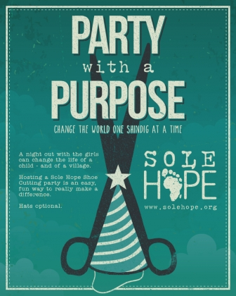
Come join in the fun on January 21st , 2014 from 6pm to 9pm
We will be making shoes for children in Uganda. Most children don’t have shoes there and an insect called a Chigger burrows deep into their feet . This causes them to have sores and sometimes amputations.
All we need is some old jeans, quilting batting, and scissors. Everyone should bring their own drink. Sloppy Joes and chips will be provided. If you would like to bring a something to add to the meal, please, don’t. We would rather you bring some essentials that we could send for medical supplies to Uganda (antibacterial ointment, band-aids , rubbing alcohol) or bring some money to add to the pot. It costs $10.00 to ship and complete the shoes in Uganda. It a living wage given to someone in Uganda to do this and provides shoes for the children.
If you can’t give any money at this time, we understand. Please, come anyway and enjoy the food, conversation , and doing what comes naturally to us at St. Albans- giving back to God what he has so graciously given to us.

January 12 Special Offering for Haiti

A special offering for Haiti will take place on January 12th throughout The Episcopal Church to commemorate the fourth anniversary of the devastating 2010 earthquake. As directed by Executive Council, the offering will aid the Diocese of Haiti in rebuilding Holy Trinity Cathedral in Port-au-Prince.


Good Books
Read anything you’d like to share and don’t mind if you get it back? Place books for any age on the bookcase in the main hall outside the Parish Hall. If you find something you find interesting, take it home and read it. Bring it back or pass it on.



Who’s There?

To everyone who uses a key to enter the church no matter who you are or when it is,
If you did not have to disable the alarm you know there is someone else in the building. As a matter of courtesy, find them and tell them you are there.
THIS IS VERY IMPORTANT!


Labels for Education

We have applied to be a participant in the Campbell's, 'LABELS FOR EDUCATION' program. If approved there will be a collection bin placed in the Parish Hall. So, please save your Campbell's labels. http://www.labelsforeducation.com/

BIRTHDAYS/ANNIVERSARYS

JANUARY FEBRUARY
Mother Sharon 01-03 Rev. Charles (Chuck) Curtis 02-02
Heather Grochowski 01-04 June Wisniewski 02-04
Kimberly (Kim) VanTifflin 01-04 Alyssa Clark 02-08
Joan Sinke 01-10 Marsha Brinks 02-09
Katie Lynn Gault 01-11 Pauline Fox 02-09
Kenneth Cormack Gault, Jr. 01-11 Debbie Fox 02-13
Thomas (Tom) Firth 01-12 Nathan (Nate) VanTifflin 02-15
Michael Snyder 01-14 Karen Nelson 02-15
Rev. Charles & Montie Curtis’ Anniv 01-17 Jayne (Montie) Curtis 02-22
Rev. Nancy Steele 01-18 Kay Owen 02-22
Bill & Joan Wilson’s Anniv. 01-20 Louise Conklin 02-23
Janice Spurlock 01-24 Eva Anderson 02-24
Larry Nelson 02-25


PRAYER LIST

Rachal R, The SanClemente Family, King Family, Kelly C., Loretta M, Sue M, The Boli Family, Tina & Mary, Cassandra R, Melinda, Grey S, William C, Jessie U, Barbara K, Beth B-M, Rev. Frank Davenport, Charles V, Montie C, Marge D, Pat P, Lindsey S, Robert K, Bob M, Art F, Mark T, Randy H, Kay O, Katie H, Chanda K, Bev. R, Jay A, Ray R, Gary F, Jim M, Christine C, Pat H, Ramie, Bobbi R, Jen S, Warren S, Brad L, Charlotte & Lannon P, and for those known only to God.

OUR ARMED FORCES

For Richard P who is serving in Afghanistan. For Chris L who is in the Netherlands. For Scott K who is in England. For Alexis O. who is serving in the Persian Gulf. For Brian L, Caleb K, Jessica C, Brad W, V Stephen C, Tyler V, Sam K and Kevin K who are now stationed in the U.S.

We read this list each Sunday during the Prayers of the People. It is printed here so you may include these persons in your own personal prayers. If you would like to add yourself or someone you know, there is a form on the credenza just inside the Erie Street entrance or you may call the office.

St. Alban’s Cooks!

This area is for those of us in our congregation that would like to share recipes. You know who you are! There are more than a few dishes out there that are favorites of many. If you would like to share them please do! They can be handed to me on paper or sent to me via Email at moe_the_large@yahoo.com. If you can't seem to find me give it to Anne. She can get it to me.
Thank You
Mike Moranec
Editor
'The Epistle'
St. Alban's



No doubt about it! It's COLD outside. Nothing like a nice hot bowl of soup. The following is a nice hearty sup for those really cold days. Serve it up with a nice grilled cheese and a small tossed salad will make it a full meal.

TOMATO BASIL SOUP
Yield: 1 gallon

3 T. Margarine
2/3 c. diced celery
1 c diced onion
2 16oz. cans diced tomatoes ( I like to use the fire roasted variety here)
2 16oz cans marinara (Best quality you can manage. Chunky style is best)
1 c. heavy cream (may substitute ½ & ½, But regular milk will not work)
½ T. minced fresh garlic (or ½ to ¾ t. powder)
1-1 ½ t. dried basil leaves crushed (or more if you really like the taste of basil)
Pepper to taste
Water
1 # tri-color cheese tortellini, cooked (optional)
…………………..
Melt margarine. Add onion & celery. Lightly saute until vegetables are starting to get transparent.
Add rest of ingredients (except tortellini) and enough water to bring it to 1 gallon total yield. Bring to a boil stirring often. Turn down heat and let simmer 30 minutes
Adjust seasoning.
Adjust water to bring back to 1 gallon. Bring up to heat. Add tortellini at this time.

SHORT NOTES

New E-Mail Addresses
We have new e-mail addresses for office staff.
To reach Anne send to office@stalbanbaycity.org.


Mumbles from Mike

OK!!
I give up.
Where did Fall go?
Seems we never really had a Fall this year. Went from a pretty nice Summer, a few mild days and then it got COLD! Don't get me wrong. I actually kinda like the cold weather. Winter is actually my favorite season (right behind Fall that is). I like the snow and I actually like shoveling snow. The problem is that we usually ease into the cold weather. Oh well. I will take it as we get it.
We have out general meeting coming up at the end of this month. I know of at least one Vestry seat coming open. After 5 years on the Vestry it is time for me to step down. ( I came in as a replacement for someone who had to leave thus the odd number of years). It ha s been an interesting to say the least and I learned a lot during my term. I was part of 2 separate search committees for a pastor, part of the renovation of the rectory, Many other 'bricks & mortar' issues that had to be dealt with and the month to month workings of trying to keep it all together. Oh yeah.. One other thing. Was part of the group that actually saw us end 2011 in the black financially. Something we can all be proud of. I am sure the next member will do a great job. There are many projects going on that need to be followed through on. I am on a number of committees that I will stay on as long as I am needed.
I am also taking on a new project along with Doug Brinks (along with Rev. Chuck Curtis, If we can talk him into it). Between the 2 (or 3) of us I hope that we will have something for the entire congregation. More news on that in the future as we get into it.
Hopefully 'The Epistle' will continue and we can get it back on a regular schedule.
See you on Sunday!

Notes from the Friendship Circle
by Montie Curtis

After many months of working with parishioners and carpeting people, the new carpeting is now in the lounge! We in the Friendship Circle wish to thank everyone who helped with this project, especially Elaine Kirkpatrick and Northeastern Paint and Floor Covering Supply (Bay City). When you are in the church, come and see it. It looks great!
We also want to thank anyone who had anything to do with our December 2013 bake sale! Whether you were a baker, a purchaser, an organizer, or on the clean-up crew, we very much appreciate your time, energy, and dollars. You made this a fabulous bake sale. We made over $1,000! Yea!!!
With some of the proceeds from our bake sale, we have made an agreement with Frank Lewandowski to clean, strip, and re-wax the floors of our parish hall, including bathroom floors, and staircases going up to the church and down into the undercroft. This will happen on Friday, January 10, and Saturday, January 11. Frank will be working with Dave, our sexton, on furniture relocation.
In January, February, and March, our group will be leading the parish, once again, in gathering non-perishable food items for the Bay County Emergency Food Pantry Network. Brown grocery bags will be handed out the first Sunday of these months to those in church. We are asking that you take them home and fill them as best you can and bring them back the last Sunday of the month to be blessed and distributed to the Network. (Please don’t worry if you can’t fill them full.) In April, we shall be doing the same thing BUT collecting paper products and personal toiletries.
Those in church may have noticed that we have boxes placed near the drinking fountain in the parish hall marked “Soles 4 Souls.” We are collecting any color jean material there to work on a project helping to make soles for footwear. The reason for this is to help people in Africa who have no shoes get some, and fight the terrible chigger problem there. We invite everyone in our congregation to come for free pop and pizza on Tuesday night, January 21, 6-9 pm., with their scissors, to help us cut out patterns for the shoes. Afterwords, we then send the cut outs to this organization “Soles 4 Souls”, they will put them together and see they are distributed to those in need in Africa. Please come. We shall put up a sign up list so that we have an idea of how many pizzas to order. If you forget to sign up, come anyway; we’ll have enough.
I almost forgot – the next Ladies Lunch Bunch gathering – is Tuesday, January 14, 1 pm., at the Mandarin House. All women in the parish are invited.
Please call Rose Youngstrom, 684-7731, to RSVP.
Best wishes for a Blessed New Year. Thanks again for everyone’s participation and help.
Shalom.



Winter is the king of showmen,
Turning tree stumps into snowmen
And houses into birthday cakes
And spreading sugar over lakes.
Smooth and clean and frosty white,
The world looks good enough to bite.
That's the season to be young,
Catching snowflakes on your tongue.
Snow is snowy when it's snowing,
I'm sorry it's slushy when it's going.
~Ogden Nash

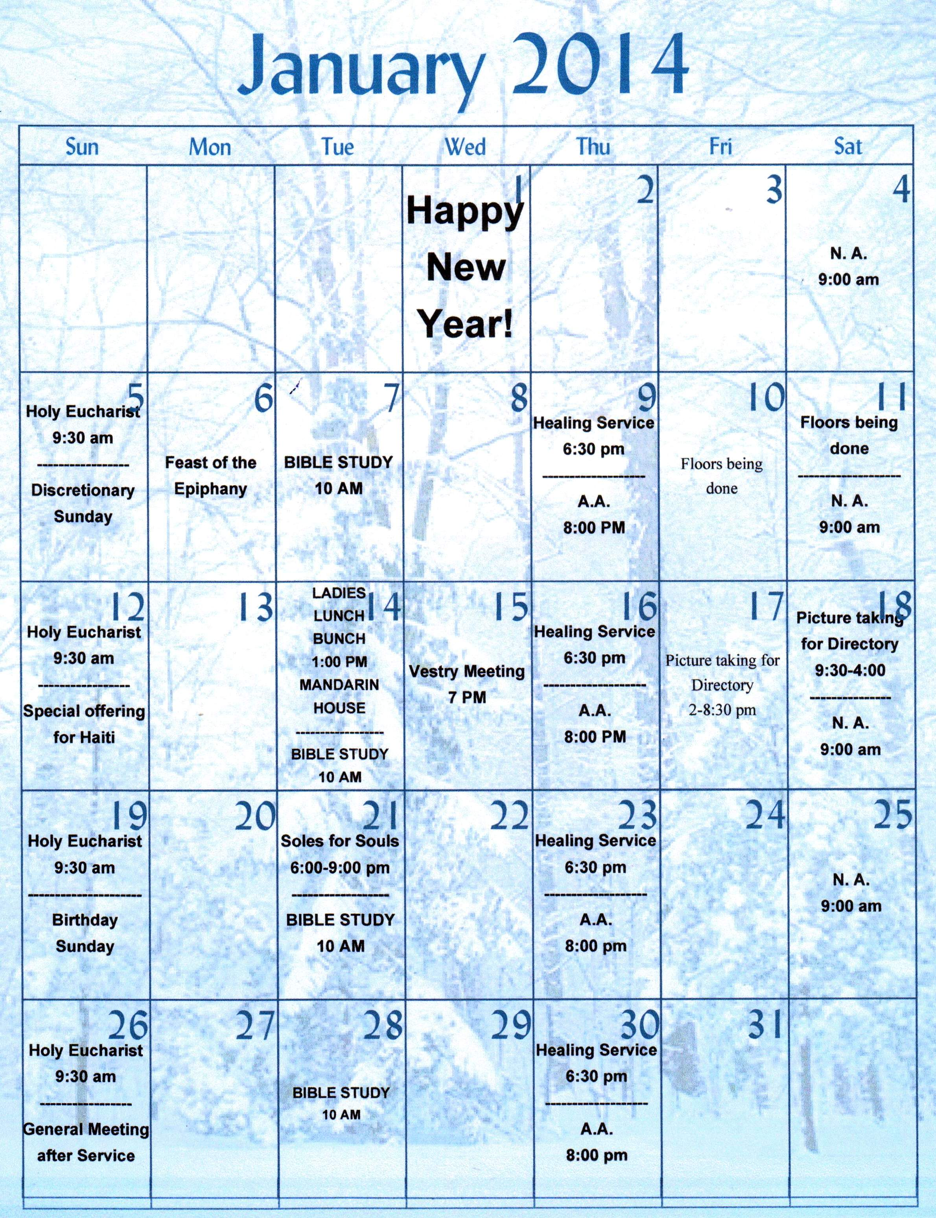

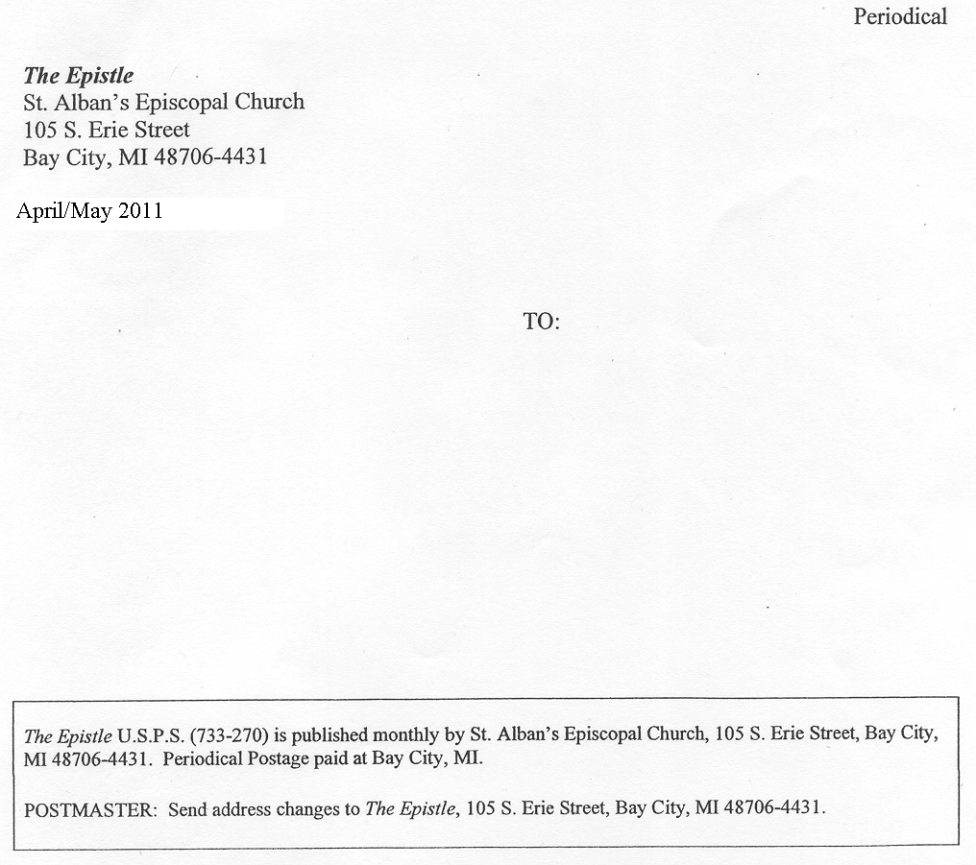

JANUARY
2014

