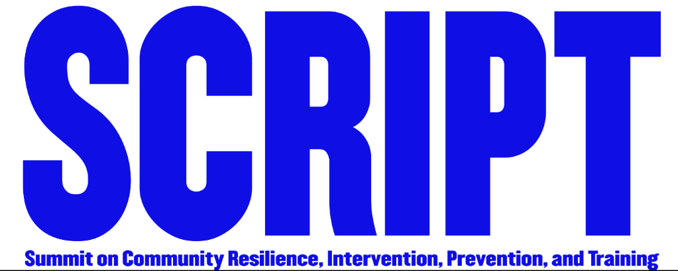

Programing Schedule at a Glance
Tuesday, July 17th
Room | Name | Title | Format | Time
Yosemite Hall | Moderator: Debra Warner  Keynotes:  Patricia Duncan | Opening | 1 hour session | 9:00 - 9:50 a.m.
Yosemite Hall | William Hayes | LAPD # MeToo | 2 hour session | 10:00 - 11:50 a.m.
Joshua Tree | Guido Hanejos | Risk Factors of Disclosure | 2 hour session | 10:00 - 11:50 a.m.
Sierra | Andrew Pari | Does This Mean I Liked It?: Experiencing Orgasm During Sexual Assault | 2 hour session | 10:00 - 11:50 a.m.
Catalina | Erica Bragg, Crystal Portillo, & Claudia Perez | Female Child Sexual Offenders: Biased Portrayal in Society & Negative Effects on Male Survivors | 1 hour session | 10:00 - 10:50 p.m.
Catalina | Suzitte Giron, Jacqueline Sandoval, & Laren Vickerman | Male Survivors of Sexual Assault & Harassment in the Media | 1 hour session | 11:00 - 11:50 p.m.
Sequoia | Nathan NéJuan | Thug Child: Grant Me the Serenity | 1 hour session | 10:00 - 10:50 p.m.
Sequoia | Jay Finkleman | Sexual Assault in the Workplace & HR Issues | 1 hour session | 11:00 - 11:50 p.m.
Cabrillo | Andrea Grossman | Internet Crimes Against Children: Detection and Investigative Techniques | 1 hour session | 10:00 - 10:50 a.m.
Cabrillo | Moderator:  Loren M. Hill  Panelist: Chris Anderson, Bill Murray,  Terry Boykins, Michael Levittan | The Media and Male Disclosure | 1 hour session | 11:00 - 11:50 a.m.
AFTERNOON
Yosemite Hall | Moderator:  Brittney Montgomery  Panelist:  Aquil Basheer & Debra Warner | Men Who Committed Violence & Why: A Survivors Apology | 2 hour session | 1:00 - 2:50 p.m.
Joshua Tree | Carol Adkisson | A Case Study: Counseling a Couple Through Relationship Healing from Male Molestation | 1 hour session | 1:00 - 1:50 p.m.
Sequoia | Felicia Reed | How Can I Help Myself to Heal from Trauma? | 2 hour session | 1:00 - 2:50 p.m.
Cabrillo | Michael Levittan | Sexual Harassment and Assault in a “Me Too” World: Guidelines for Women and Men to Keep Safe. | 3 hour session | 1:00 - 3:50 p.m.
Catalina | Patrick Poor | Impact of Physical and Psychological Trauma | 2 hour session | 1:00 - 2:50 p.m.
Sierra | Stanley Green | How Inclusive Are Cultural Narratives of Male Victims of Intimate Partner Violence? | 1 hour session | 1:00-1:50 p.m.
Sierra | Carol Sligh | Overcoming Obstacles and Pursuing Life’s Purpose | 1 hour session | 2:00-2:50 p.m.
Joshua Tree | Nita Watson | Mental and Physical Health – Targeting Anxiety, Depression, and Impulsive Behaviors | 2 hour session | 2:00 - 3:50 p.m.
Sierra | Moderator:  Breanna Lynn  Panelist: Gregory Cannilis, Melissa Duncan, Courtney Crisp & Mallory Behar. | The Invisible Survivor: African American Men & the #MeToo Movement | 1 hour session | 3:00-3:50 p.m.
Sequoia | Christina Hoag & Ken Hartman | Prison & Parole Reform: A Conversation with Kenneth E. Hartman | 1 hour session | 3:00 - 3:50 p.m.
Catalina | Keith Somers | Transcending Trauma | 1 hour session | 3:00 - 3:50 p.m.
Cabrillo | Stanley Green | How Inclusive Are Cultural Narratives of Male Victims of Intimate Partner Violence? | 1 hour session | 3:00 - 3:50 p.m.
Yosemite Hall | Debra Warner | Closing | 1 hour session | 4:00 - 4:50 p.m.

