COMMUNITY COMMITMENT

Southern Maryland Corvette Club (SMCC) has supported a variety of non-profit organizations over the years…some local…some national. Our focus has generally been to help families and support our youth, as they are our future. Some of the organizations to which we have donated include:

The Dr. James A. Forrest Career and Technology Center’s automotive classes. SMCC member’s technical expertise and hands-on demonstrations, when combined with classroom experience, help the students expand upon their automotive technology skills. We have sponsored an essay contest that awards winners with tools and tool boxes. The Club has also donated funds for the purchase of classroom tools and equipment.

Business Education and Community Alliance (BECA) Common Scholarship program. BECA holds an annual fund raiser to provide 25, $1,000 scholarships to graduating high school students. They also partner with approximately 40 local organizations to provide scholarships via their common scholarship application form in which SMCC has participated.
SMCC has also donated to the Saint Cecilia Food Pantry, Toys for Tots, St. Jude’s Children’s Hospital, Wounded Warrior Project and organized Christmas with Santa for a local Head Start program. Each year we choose two or three organizations to support.

MEMBERSHIP

- Complete a membership application
(Available online)
- Be an owner of or have an interest in Corvettes
- Attend one business meeting.
- Upon meeting these requirements, the applicant shall be accepted upon payment of club dues

ANNUAL MEMBERSHIP DUES

Membership year is from Oct 1st to
September 30th of the next year.

For more information on membership, contact Ben Mendoza at: stingrayman@md.metrocast.net


The Southern Maryland Corvette Club (SMCC) monthly business meetings are held on the second Monday of each month at 7 p.m. at:


Leonardtown Commissioners Office
41660 Courthouse Drive
Leonardtown, MD 20650

SMCC embraces the tri-county area of St. Mary’s, Charles & Calvert Counties. Whether you’re new to Southern Maryland, a new or former Corvette owner, or new to SMCC, we welcome you and hope you’ll join us at one of our Club meetings or events. Come meet us and learn how we support our community and encourage Corvette owners to swap stories and share their knowledge and enjoyment of “America’s True Legendary Sports Car.”
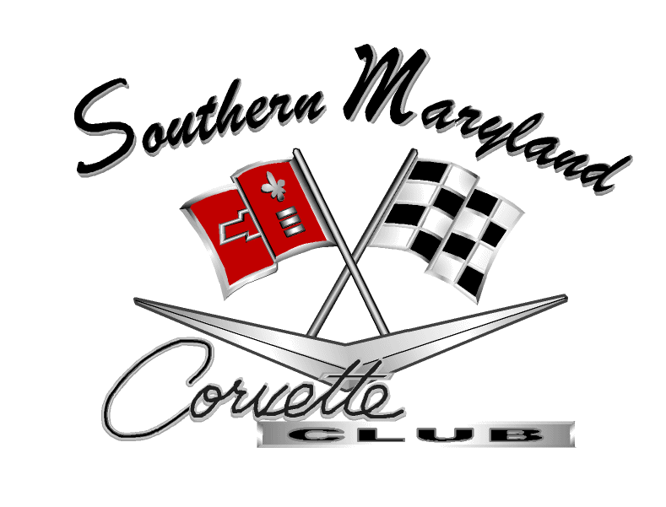
"New friends, old cars; New cars, old friends"

Southern Maryland Corvette Club
P.O. Box 2402
Leonardtown, MD 20650
Contact us:

http://southernmarylandcorvetteclub.org

smcc@md.metrocast.net


Join us monthly: 2nd Mondays @ 7:00pm

Leonardtown Commissioners Office
61660 Courthouse Drive
Leonardtown, MD 20650

MEMBERSHIP BENEFITS

♦ Share enthusiasm of Corvette ownership
♦ Develop friendships
♦ Share technical insight
♦ Support local charities and schools
♦ Participate in community events
♦ Coordinate functions with other car clubs
- Social gatherings
- Enjoy sponsor discounts

Our sincere thanks to our sponsors below for their ongoing support:

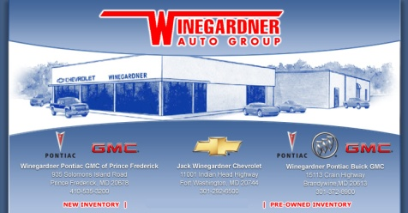

We are continuing to expand our connections and welcome others to join our network! Spread the word!

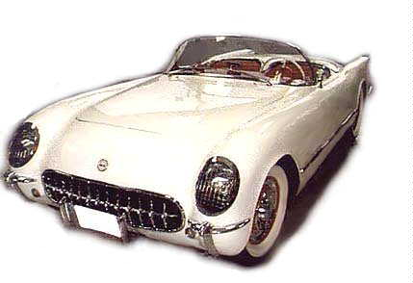

1953 Corvette: The Beginning of the Legend

OUR MISSION

SMCC was established September 10th, 2001 to promote the enthusiasm, camaraderie and fellowship associated with the pride of owning the iconic Chevrolet Corvette. We aim to share these values within the Club and in the community at large.

One of the most valuable benefits of club membership is the opportunity to meet other Corvette enthusiasts locally and nationally. If you’re looking to exchange ideas, restore classic Vettes, share experiences/stories, or just have fun, SMCC is a trusted and unified network that has proven to be invaluable to our members and non-members alike. We invite you to come and join us.

2013-2015 OFFICERS & CHAIR PERSONS

President: Tom Santangelo
Vice President: Chris LaQuay
Secretary: Patrice Hopkins
Treasurer: Susie Mendoza
Immediate Past President: Ben Mendoza
Activities Chair: Mike Doncevic
Membership Chair: Ben Mendoza
Merchandise Chair: Jim Jacobs
By-Laws Chair: Karen Jacobs
Web Master: Rick Davis

ACTIVITIES & EVENTS

- So MD Mid-Week Cruz-in is every Wednesday night, from March through October (DST), at the Arby’s Restaurant in the Leonardtown Shopping Center starting at 5:00 p.m.

From Calvert County, take Rt.4 South to Rt.5. Turn right onto Rt.5 North (Point Lookout Road) approximately 2 miles. Arby’s Restaurant is on the left.

From Charles County, take Point Lookout Road (Rt.5 South) into Leonardtown. Arby’s is on the right side.

- Car Shows: Spring Fling, Leonardtown Beach Party and Crab Festival
♦ Veteran’s Day Parade
- Special SMCC events - Anniversary Dinner, Valentine’s Day Brunch, Sam Lupi Memorial Cruise and Christmas Party
- Gas-N-Goes and other spur-of-the-moment Cruz’n or events supporting other car clubs

Gas-N-Goes are random events generated by anyone desiring to share an experience (mostly food). We usually meet at Wildwood or Leonardtown Shopping centers and typically go for a drive and then stop for food. However, a spur-of-the-moment or a short notice Gas-N-Go to any destination may occur at any time. Notification is by email and posted on the website.
You do not have to be a member to come out and enjoy these events.

