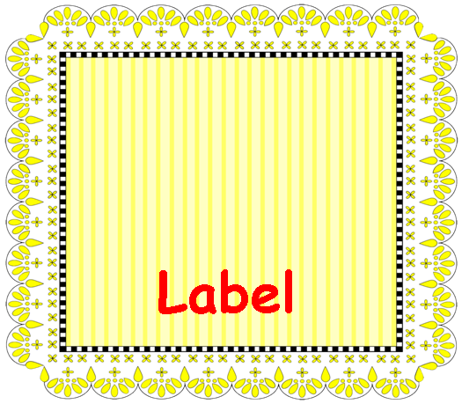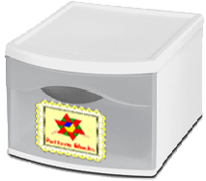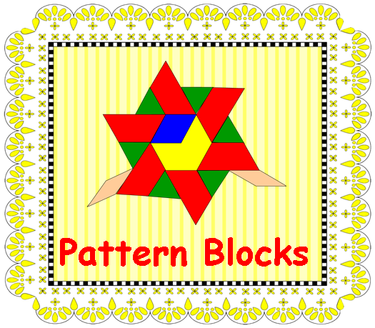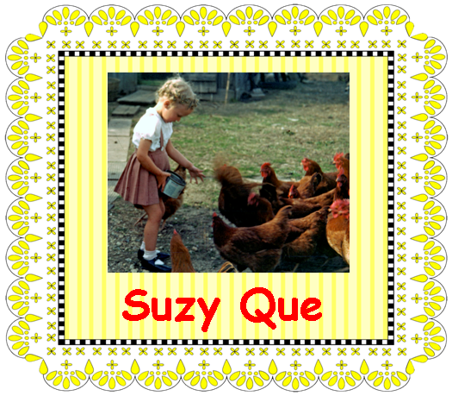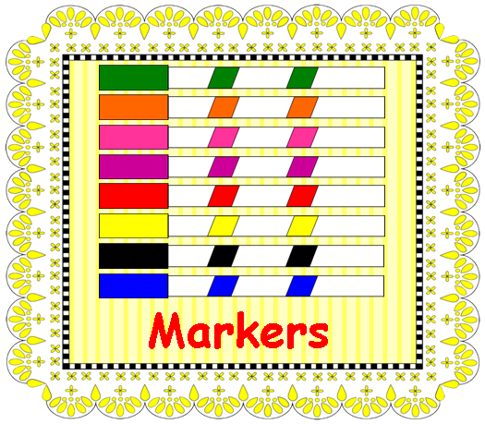
The Artful Classroom

Classroom
Labels
Use this template for creating labels for your classroom bins, library books, cubbies, or anything else you need labeled around your classroom.

Preparation:
1. Double click “Label” and type in your own word.
2. Insert an image, if you wish—just click in the box above the label, and go to Insert > Picture.
3. Print them on Avery ® 5164 or any other shipping label with 6 labels per page.
4. OR print them on tag and laminate.

Suggestions for Use:
• Use the labels for library book bins.
• Add student names and photographs to label cubbies, folders, pencil boxes, coat hangers, or other personal items.
• Number the labels and attach them to plastic shoe boxes to make science kits for each team.
• Scan in images of manipulatives and label each box or drawer.
• Label drawers in your dramatic play center.
Copyright © 2011 Integreat! Thematic Units
Copyright © 2013 Integreat! Thematic Units
Copyright © 2011 Integreat! Thematic Units
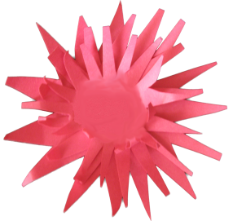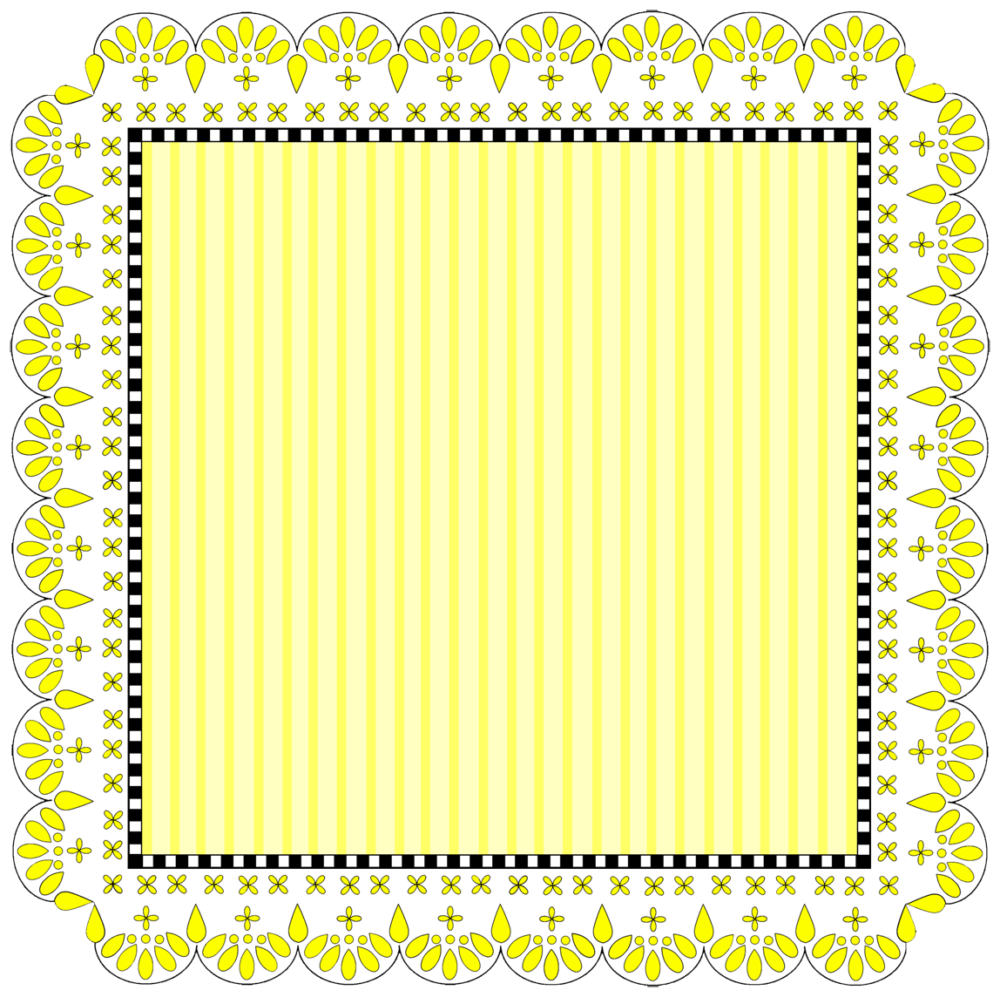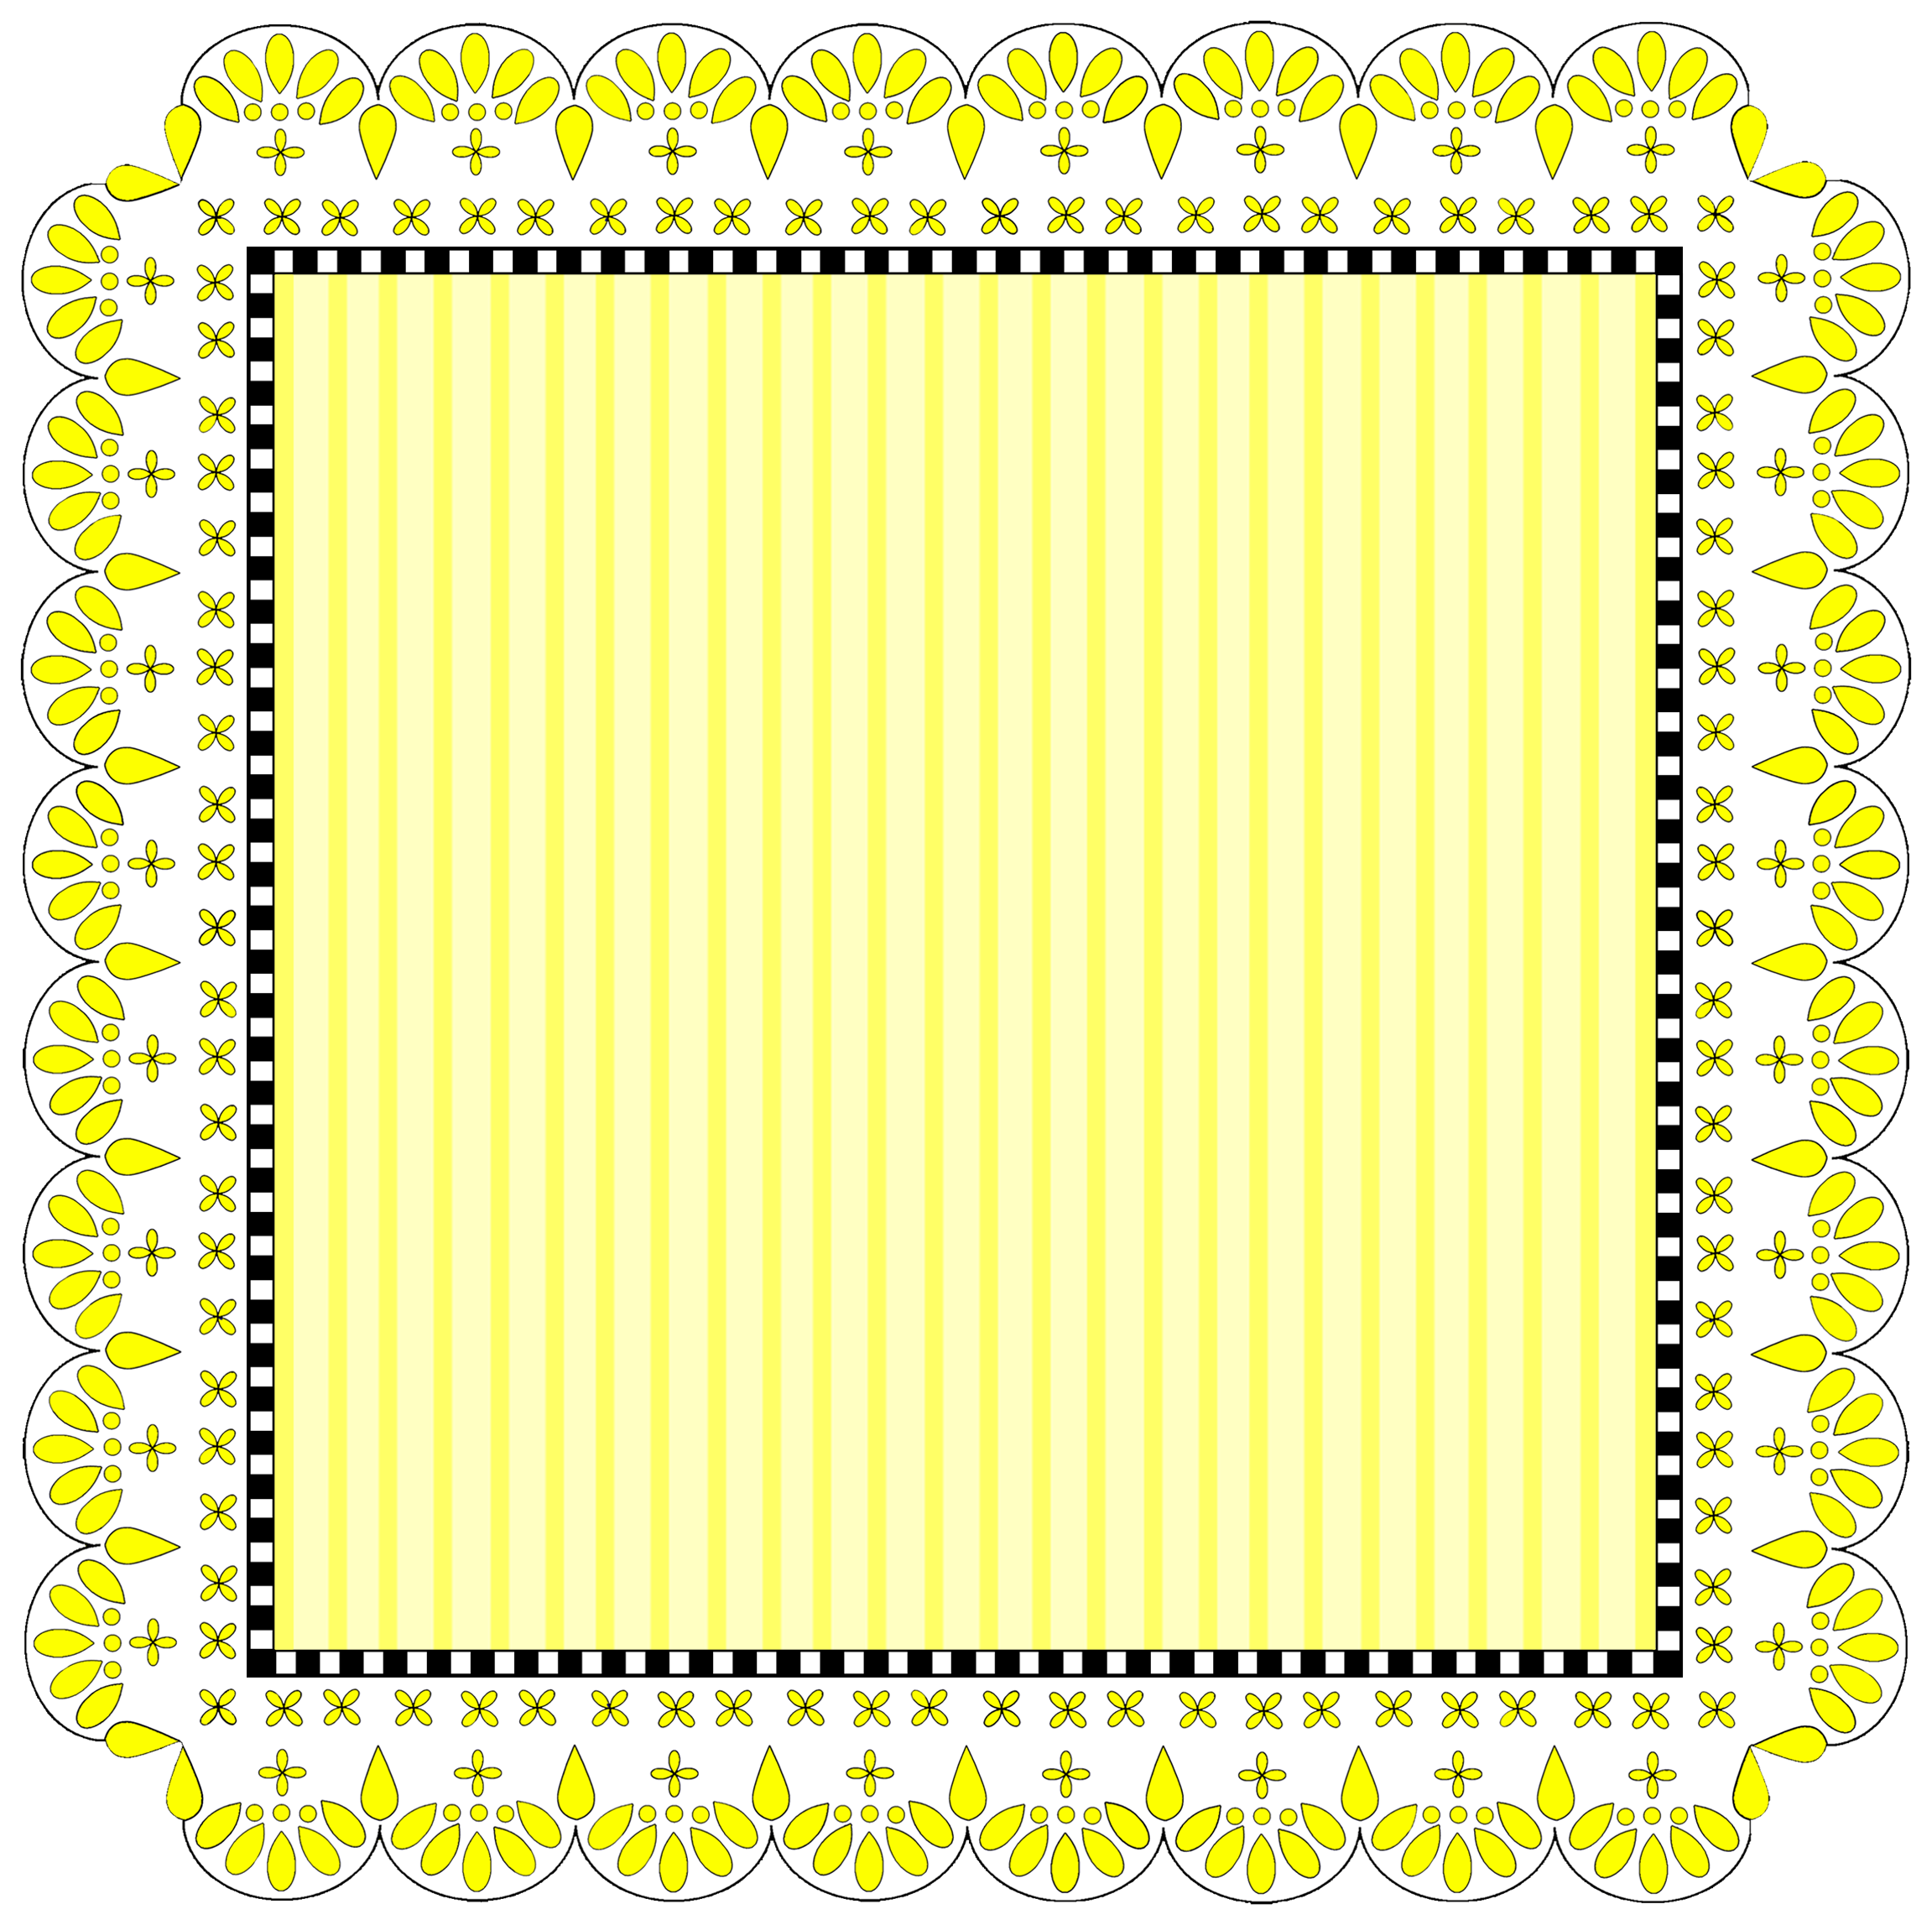

Label
Name
Label

Label

Label

Label

Label

Copyright © 2011 Integreat! Thematic Units
Copyright © 2011 Integreat! Thematic Units

