**The Artful Classroom**

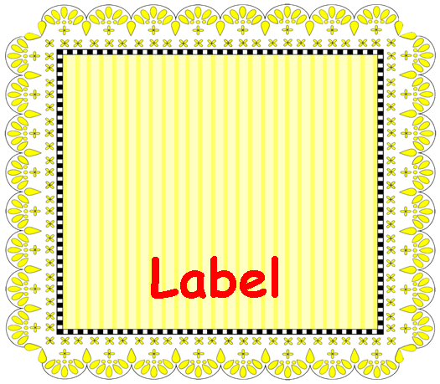

**Classroom**

**Labels**

Use this template for creating labels for your classroom bins, library books, cubbies, or anything else you need labeled around your classroom.

**Preparation:**

1. Double click “Label” and type in your own word.

2. Insert an image, if you wish—just click in the box above the label, and go to **Insert** > **Picture**.

3. Print them on Avery ® 5164 or any other shipping label with 6 labels per page.

4. OR print them on tag and laminate.

**Suggestions for Use**:

• Use the labels for library book bins.

• Add student names and photographs to label cubbies, folders, pencil boxes, coat hangers, or other personal items.

• Number the labels and attach them to plastic shoe boxes to make science kits for each team.

• Scan in images of manipulatives and label each box or drawer.

• Label drawers in your dramatic play center.

Copyright © 2011 Integreat! Thematic Units

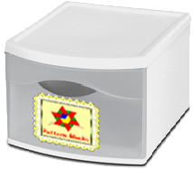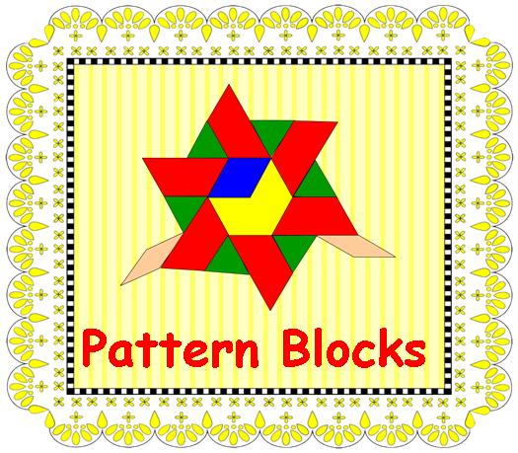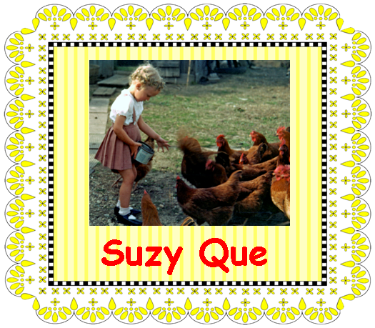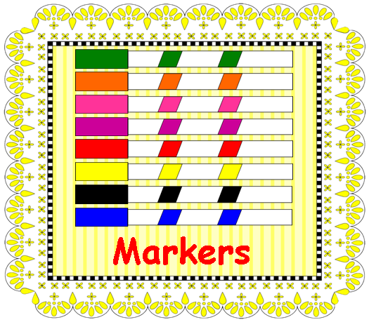

Copyright © 2013 Integreat! Thematic Units

Copyright © 2011 Integreat! Thematic Units

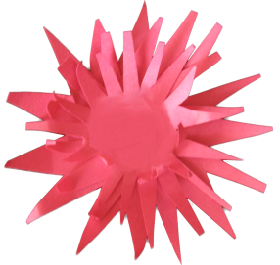

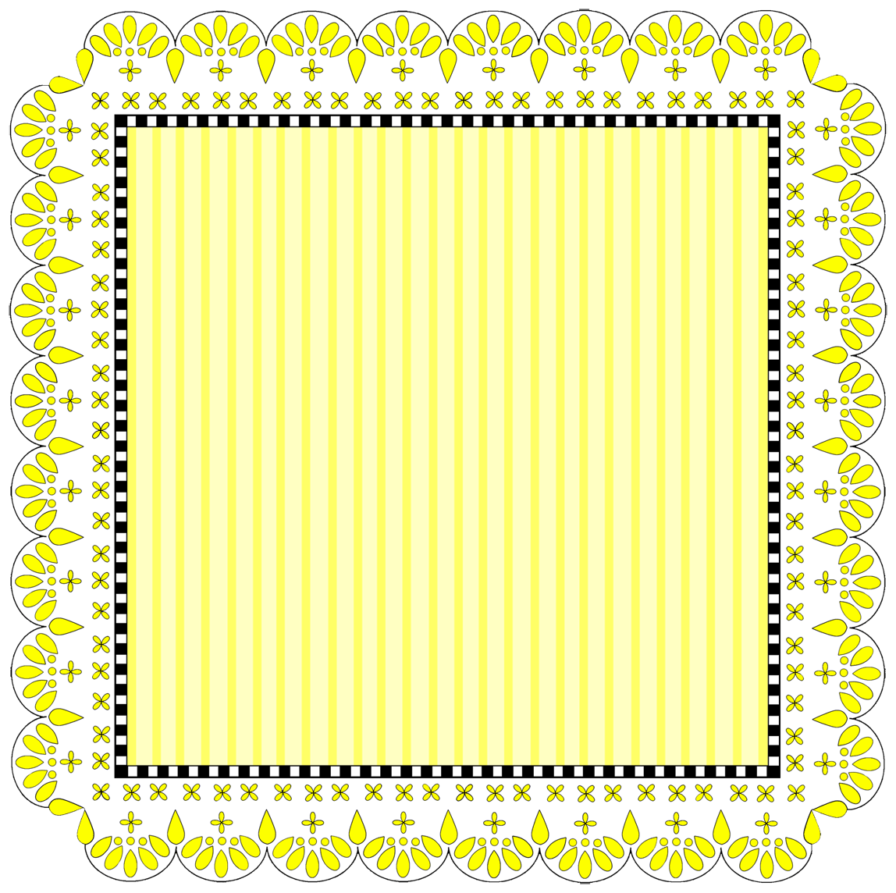

**Label**

**Name**



**Label**



**Label**



**Label**



**Label**

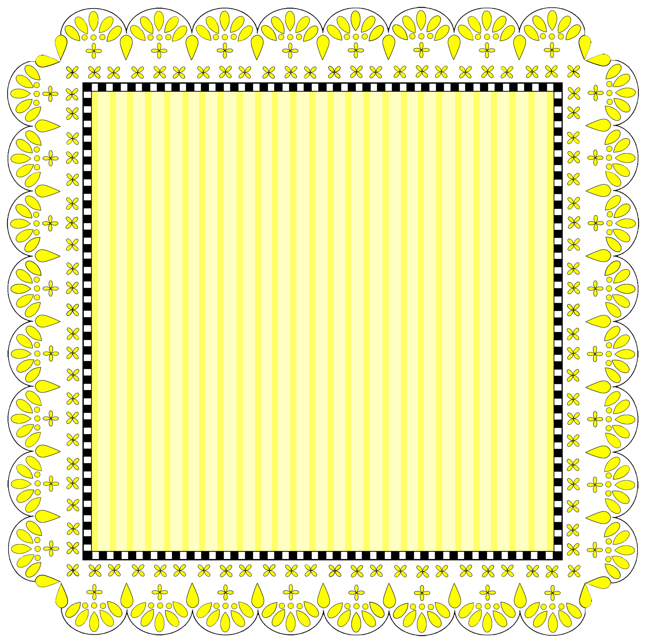

**Label**

Copyright © 2011 Integreat! Thematic Units

Copyright © 2011 Integreat! Thematic Units