FOR IMMEDIATE RELEASE

6.27.2018

Contact: Heather Franzoni, Public Relations Officer
Shippensburg Area EMS
711 E Orange Street
Shippensburg PA 17257
717-491-4357
h.franzoni@sa-ems.org

Shippensburg Area EMS Fights to Assist In the Opioid Crisis

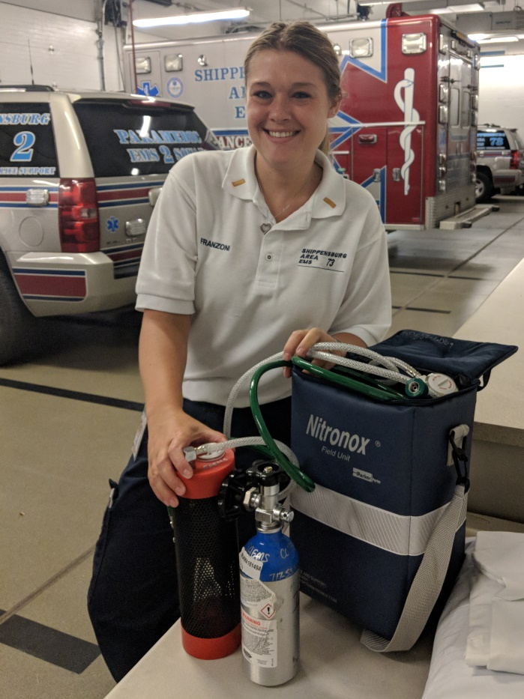
sHIPPENSBURG aREA ems advanced life support providers just recently finished their training, and protocol review on the medication Nitrous Oxide. Nitrous Oxide is a medication that will be used as an alternative method to pain medication to combat the current opioid crisis. Nitrous Oxide is a medical gas that provides a patient with both sedative and analgesic effects during their time of need. Nitrous Oxide is preferred by many patients, because the relief is quick, IV access is not required, and they can administer the medication themselves by using the delivery mask. In a pre-hospital setting the patient will be assessed by the Advanced Life Support provider to ensure they meet all the criteria listed into the protocol for the administration of the medication. Research has showed that the administration of Nitrous Oxide has shown effective in pain reduction with patients’ experiencing, but not limited to: kidney stones, burns, fractures, and dislocations. Shippensburg Area EMS Operations Staff hopes this new medication, and equipment can help ensure we continue to deliver high quality emergency medical care to our beloved Shippensburg community. If you are interested in helping out Shippensburg Area EMS and their fight against the opioid crisis, please contact a supervisor at 717-532-6069 Ext: 123 and let them know you would like to help support the “Nitrous Oxide” Project. We were only able to purchase one unit due to the cost, but our intentions are to have one on each ALS unit. We thank the Shippensburg community for their continued support as we serve you 24/7.

Photo Credit: SAEMS; Lt Franzoni pictured with the Nitrous Oxide System

Lt Heather Franzoni with Shippensburg Area EMS Newest Nitrous Oxide System

