KFM A460 Interceptor Cylinder Head
The Interceptor is a high-flowing port option for the Trick Flow A460 racer. The enlarged intake runner has a unique angle to closely match the angle of the intake valve for optimized flow. The CNC programs for the intake port, exhaust port and combustion chamber are designed to achieve performance exceeding the normal limitations of the Trick Flow A460 without welding or valve relocation.
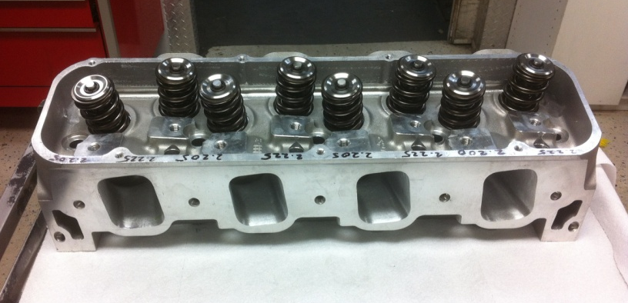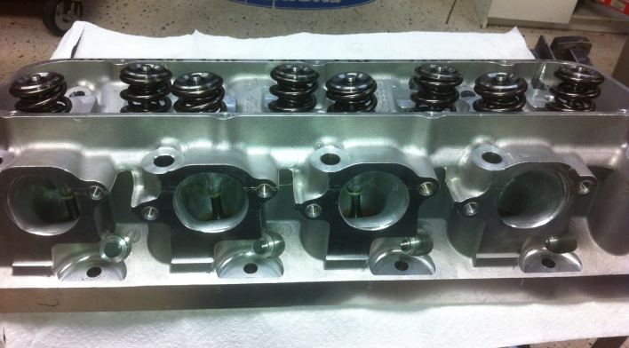
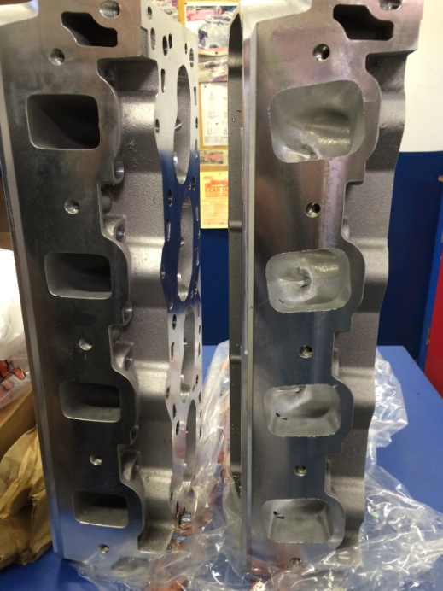

CNC machining is performed on Centroid 5-axis and Cincinnati Milacron 4-axis equipment.
Valve seat and guide installation and machining are performed, using Sunnen equipment.
Basic Package
Trick Flow 18-bolt castings
KFM Interceptor CNC machining of intake and exhaust ports
Installation of stainless steel tubing in any head bolt holes exposed to exhaust port
Optimization of oil drain back channels
Installation of valve guides
Installation of beryllium/copper intake and exhaust valve seats for 2.50” intake and 1.82” exhaust valves
Machining of seats and hand blending to port and chamber
Hand finishing of port entrance as required
Valve job and additional blending as required
Flow bench validation of ports and chamber
Combustion chamber volume test and deck surface machining
Price – $5488.00
Flow Result s @ 28” on 4.650 bore and exhaust with 2 ¼” pipe
Intake CFM Exhaust CFM
.200” 151 113
.300” 235 164
.400” 319 221
.500” 393 278
.600” 435 314
.700” 462 342
.800” 490 358
.900” 510 365
1.00” 528 366
1.100” 535 368

Assembled Package
The entire Basic Package plus:
Ferrea or Victory titanium intake and exhaust valves
Valve spring seats – ID locators
Manley titanium retainers
Manley 10 degree bead type valve locks
Viton positive type valve seals
PSI 1249 valve springs
Final assembly
Total Assembled Price - $8690.00

Interceptor heads are available at Engine Systems Racing Engines.
Call Ted Fischer at 770-491-0583 for details.

