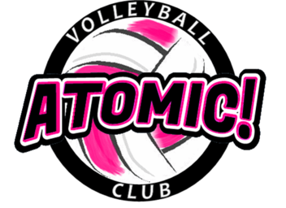
Atomic! Volleyball Elementary Program
1st – 5TH GRADE GIRLS
6 Sundays from Jan 6th – Feb 17th, 2019
____________( no clinic on Jan. 27) ______________________

Location of Program: Brownstown Sports Center
Address: 21902 Telegraph Rd, Brownstown, MI 48183

Program Details: This is the 6th season of the elementary program. It is designed to teach the fundamentals of volleyball in a fun, player-centered atmosphere. The program is a great way to introduce volleyball to the novice player as well as continue the development of young individuals who have already started playing the world’s greatest team sport.

The athletes will be placed with other athletes of similar ability and grade level.

Please bring: Court shoes, knee pads (if possible) and workout clothes, water bottle, good attitude.

Cost: $75 includes a t-shirt (payable to Atomic! VBC)

Coaches:
Coach Dennis Yack, Atomic! Volleyball Director Coach Halee Dorn, Atomic! 12u Coordinator/Coach
- Former head Varsity VB coach at Woodhaven HS * Former 4 year Varsity VB player at Riverview HS
- 22 years coaching experience at HS/MS/AAU * 1 year coaching experience at the AAU level
- 26 years playing competitive volleyball * Plays VB at Henry Ford College
- 10 years Middle School Math teacher

Time: 4:00PM - 5:00PM

Mail Registration form and check to: Atomic! VBC, P.O. Box 1381, Southgate, MI 48195

Questions: atomicvbc@gmail.com or call/text Coach Yack at 734-934-4064
Like us on facebook

----------------------------------------------------------------------------------------(keep to portion for your records)------------
Registration Form Atomic! Elementary Program (January 6 – February 17)

Athlete’s Name: ______________________________Phone ______________________

Address:_____________________________________ City, Zip: ____________________

Phone: ____________________ Email (print clear) : _______________________________

Grade Level (Fall of 2018) ______School Name: ______________________________

Emergency Contact Phone______________________ Shirt Size (youth) _____
I hereby authorize the staff of the Atomic! VBC to act on my behalf according to their best judgment in any emergency requiring medical attention if I cannot be reached. I, further, waive and release the Atomic! VBC and its staff from any and all liability for the injuries or illnesses incurred while involved in this camp. I have no knowledge of any physical impairment that would keep the above named athlete from full participation in this camp.
Parent or guardian signature ___________________________________Date __________________
Parent Name (Printed) ___________________________

2018 Fall Elementary Clinic
