April 2019 Breakfast 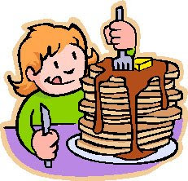
Sunday | Monday | Tuesday | Wednesday | Thursday | Friday | Saturday
Week 5 | 1  Breakfast Pizza  Applesauce  Milk  Juice | 2  Cereal – Kix, Cheerios  Milk  Juice | 3  Biscuits and Gravy  Peaches  Milk | 4  Sausage/ Cheese Sandwich  Milk | 5  French Toast  Banana  Milk  Juice | 6
7  Week 6 | 8  Eggs w/Cheese  Toast  Peaches  Milk | 9  Cereal  Strawberries  Milk  Juice | 10  Breakfast Pizza  Pineapple  Milk  Juice | 11  Cinnamon Apple Muffin  Milk  Juice | 12  Oatmeal  Milk  Juice | 13
14  Week 7 | 15  Biscuits w/Jelly  Strawberries  Milk  Juice | 16  Cereal – Cheerios  Milk  Juice | 17  Breakfast Burrito  Pineapple  Milk  Juice | 18  Yogurt Parfait  Strawberries  Milk  Juice | 19  CLOSED  GOOD FRIDAY | 20
21  Week 8 | 22  Eggs w/Cheese  Toast  Peaches  Milk | 23  Cereal – Kix  Juice  Milk | 24  French Toast  Banana  Milk  Juice | 25  Biscuits and Gravy  Oranges  Milk | 26  Oatmeal  Strawberries  Milk  Juice | 27
28  Week 1 | 29  Breakfast Burrito  Pineapple  Milk  Juice | 30 Cereal – Cinnamon Toast Crunch  Milk  Juice

