MAKPAK, LLC

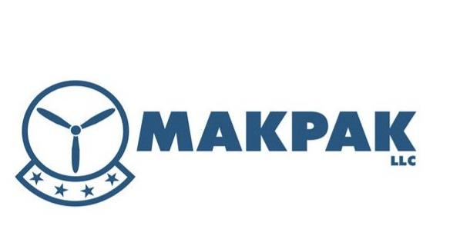

YOUR PARTNER FOR HVAC/R EQUIPMENT, PARTS AND SUPPLIES. SOu SUPPORTING THE WARFIGHTER THEN AND NOW

CAPABILITIES:

When you need heating, air conditioning, ventilation, and refrigeration equipment, parts and supplies, turn to Pennsylvania’s best wholesale distributor: MakPak, LLC.

MakPak has been directly and indirectly delivering cost-effective HVAC/R supplies and solutions to government and contractor customers since 1948. We provide outstanding world-wide customer mission support, 24/7/365.

We are authorized distributors not “pass throughs” for manufacturers which allows us to work closely with our customers to solve problems and supply their most challenging material requirements. Our management team has 20+ years of military service and government contracting experience. We provide consistent product quality and customer service with quick quote turn around.

Jack Makdad, President/Owner
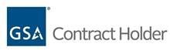814-943-6293
jmakdad@makdad.com or gsa.orders@makpak.us

Service Disabled Veteran
Owned Small Business

NAICS Code (s):
325120, 325211, 352612,
333413, 333414, 334519,
339999, 423720, 423730,
423740, 562112, 562119

GSA Contracts:

73/375 351 (47QSWA18D000W)
66/66 619 (47QSWA18D0010)

CAGE: 7ECU3

DUNS: 079875947

Six convenient Pennsylvania locations:

Altoona Johnstown State College DuBois Harrisburg Williamsport

www.Makpak.us

