

**SUMMER 2023 SEASON**

**2023**

**Precision Shooting Cup**

19 Players took part this year, one more than last year with some new players taking part which is good to see.

Five separate disciplines are undertaken in the Precision Shooting with a maximum available score of 100 points, although the world record is 67 achieved by Christophe Sevilla in July 2011.

After Round 1 the scores were as follows:

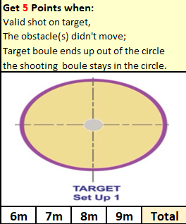

|  |  |
| --- | --- |
| Andrew Bellamy-Burt | 0 |
| Andrew Limbrick | 1 |
| Branden De La Haye | 0 |
| Brian Harris | 0 |
| Callum Stewart | 9 |
| Cassie Stewart-Le Gallais | 6 |
| Daniel Deveau | 3 |
| David Ibitson | 0 |
| Gary Cowburn | 0 |
| Geoffroy Buffetrille | 0 |
| Jean Stewart | 0 |
| Keith Pinel | 0 |
| Keith White | 0 |
| Matt Pinel | 8 |
| Paul Bell | 3 |
| Ross Payne | 6 |
| Tim Jackson | 0 |
| Toby Northern | 0 |
| Wendy Ritzema | 0 |

An impressive start for Callum with 9 points and Matt with 8, but shows the importance of starting off well with several players failing to score.

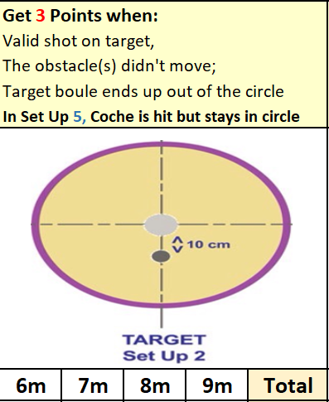

|  |  |  |
| --- | --- | --- |
|  | Round 2 Score | Total |
| Andrew Bellamy-Burt | 3 | 3 |
| Andrew Limbrick | 5 | 6 |
| Branden De La Haye | 0 | 0 |
| Brian Harris | 0 | 0 |
| Callum Stewart | 3 | 12 |
| Cassie Stewart-Le Gallais | 0 | 6 |
| Daniel Deveau | 1 | 4 |
| David Ibitson | 0 | **0** |
| Gary Cowburn | 0 | 0 |
| Geoffroy Buffetrille | 1 | 1 |
| Jean Stewart | 0 | 0 |
| Keith Pinel | 0 | 0 |
| Keith White | 0 | 0 |
| Matt Pinel | 3 | 11 |
| Paul Bell | 0 | 3 |
| Ross Payne | 6 | 12 |
| Tim Jackson | 0 | 0 |
| Toby Northern | 6 | 6 |
| Wendy Ritzema | 6 | 6 |

A good score of 6 points for a number of players in this round with a much more difficult shot required.

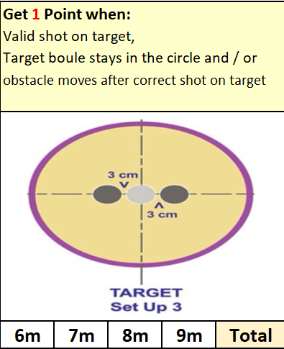

|  |  |  |
| --- | --- | --- |
|  | Round 3 Score | Total |
| Andrew Bellamy-Burt | 0 | 3 |
| Andrew Limbrick | 0 | 6 |
| Branden De La Haye | 0 | 0 |
| Brian Harris | 3 | 3 |
| Callum Stewart | 4 | 16 |
| Cassie Stewart-Le Gallais | 0 | 6 |
| Daniel Deveau | 0 | 4 |
| David Ibitson | 3 | **3** |
| Gary Cowburn | 4 | 4 |
| Geoffroy Buffetrille | 3 | 4 |
| Jean Stewart | 0 | 0 |
| Keith Pinel | 5 | 5 |
| Keith White | 0 | 0 |
| Matt Pinel | 1 | 12 |
| Paul Bell | 6 | 9 |
| Ross Payne | 4 | 16 |
| Tim Jackson | 0 | 0 |
| Toby Northern | 3 | 9 |
| Wendy Ritzema | 1 | 7 |

Callum and Ross were tied after the third round but Paul Bell had the best score on this one.

|  |  |  |
| --- | --- | --- |
|  | Round 4 Score | Total |
| Andrew Bellamy-Burt | 0 | 3 |
| Andrew Limbrick | 3 | 9 |
| Branden De La Haye | 0 | 0 |
| Brian Harris | 1 | 4 |
| Callum Stewart | 3 | 19 |
| Cassie Stewart-Le Gallais | 0 | 6 |
| Daniel Deveau | 0 | 4 |
| David Ibitson | 0 | **3** |
| Gary Cowburn | 4 | 8 |
| Geoffroy Buffetrille | 3 | 7 |
| Jean Stewart | 3 | 3 |
| Keith Pinel | 1 | 6 |
| Keith White | 0 | 0 |
| Matt Pinel | 1 | 13 |
| Paul Bell | 3 | 12 |
| Ross Payne | 1 | 17 |
| Tim Jackson | 0 | 0 |
| Toby Northern | 3 | 12 |
| Wendy Ritzema | 0 | 7 |

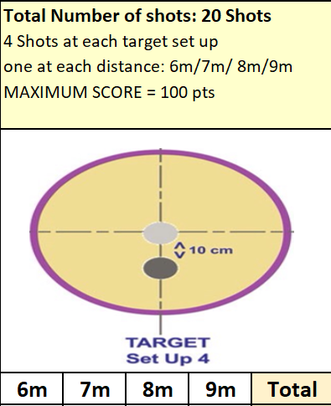

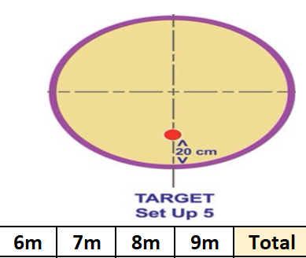Probably the most difficult one of the five disciplines saw low scores but Callum and Ross made the required score to go through with still the cochonnet to go.

|  |  |  |
| --- | --- | --- |
|  | Round 5 Score | Total |
| Andrew Bellamy-Burt | 8 | 11 |
| Andrew Limbrick | 0 | 9 |
| Branden De La Haye | 0 | 0 |
| Brian Harris | 5 | 9 |
| Callum Stewart | 0 | 19 |
| Cassie Stewart-Le Gallais | 5 | 11 |
| Daniel Deveau | 5 | 9 |
| David Ibitson | 0 | **3** |
| Gary Cowburn | 0 | 8 |
| Geoffroy Buffetrille | 5 | 12 |
| Jean Stewart | 0 | 3 |
| Keith Pinel | 0 | 6 |
| Keith White | 0 | 0 |
| Matt Pinel | 0 | 13 |
| Paul Bell | 5 | 17 |
| Ross Payne | 0 | 17 |
| Tim Jackson | 0 | 0 |
| Toby Northern | 0 | 12 |
| Wendy Ritzema | 0 | 7 |

Andrew Bellamy-Burt was the cochonnet master hitting 2 to score very well in this round with 8 points to recover some pride with 11 in total. Some half decent scores from a few players with Daniel Deveau getting 9 points on his first ever go having just started playing. Some disappointing scores though with Matt Pinel, Geoffroy Buffetrille and last years winner Keith Pinel all surprisingly failing to get the minimum required. Several players one hit away from getting through though.

So this year 3 players qualified for the knockout stage compared to just one player last year with Callum going straight to the final with the highest score of 19. Paul Bell and Ross Payne both with 17 played off in their semi-final.

Ross lead 4 – 3 after round one but a 6 – 1 score in Paul favour in round two gave him a 9 – 5 lead which extended to 10 – 5 after round three. Round 4 went Paul way as he moved to 13 – 5 but Ross hit the first cochonnet scoring three to move within 5 points of Paul but no further hits were recorded so Paul made the final with Ross taking third place.

The final was incredibly low scoring with Callum leading 3 – 0 after round 2 and 4 – 0 after round 3.

Paul then won round 4, 3 – 0 to make it 4 – 3 to Callum going into the final round, but just one hit as Callum hit the 7m cochonnet to make it a final score of 7 – 3 to Callum who lifts the trophy for the first time.

**Winner**

Huge thank you to Geoffroy Buffetrille, Matthew Pinel and for helping run the event, very much appreciated by all those taking part.

**NEXT WEEK - SINGLES LEAGUE**

Club email address - [liberationpc@gmail.com](mailto:liberationpc@gmail.com)

Club Website - [www.liberationpetanque.co.uk](http://www.liberationpetanque.co.uk)

Kind Regards

Toby Northern

Chairman

Liberation Petanque Club