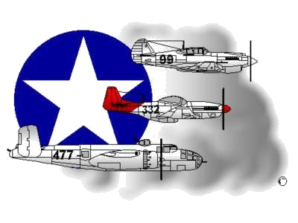
BIOGRAPHY
__________________________________________________________
A DOCUMENTED ORIGINAL TUSKEGEE AIRMAN

Tuskegee Airmen Inc. Public Relations, P.O. Box 830060
Tuskegee, AL 36083

Emmett Taylor Hayes

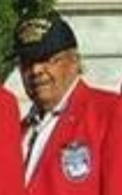
Emmett Hayes was born December 19, 1924, in Roselle, NJ. He grew up in Buckingham, PA with 7 brothers and 1 sister. His grammar and high school education all occurred in Pennsylvania.

After graduating from high school in 1943, he entered the US Army Air Corps. He was assigned to Tuskegee Army Airfield for Basic Training and upon successful completion, reassigned to the 477th Bombardment (Medium) Group (B25 Aircraft) as an Engineer/Gunner with a crew of 5-other Airmen. From 1944-1945, he trained at Godman Field, KY, with the expectation of being deployed to the Pacific Theatre of Operations to defeat Japan. In August 1945, however, the US Armed Forces in the Pacific dropped the atomic bomb ending the war. As a direct result, his unit was not used in the invasion of Japan in WWII. After the Japanese surrendered, SGT Hayes was deployed to the Pacific Theatre to participate in the occupation of the defeated Japan. A year later, he returned to the states and was reassigned to the 332nd Composite Group at Lockbourne AFB, OH.

During the period 1946-1948, SGT Hayes served as a Flight Engineer on B26 and B25 aircrafts. In 1949, he was assigned to Langley AFB (LAFB), VA, as part of the integration of personnel in the newly designated USAF, to a B26 organization as an Engineer/Gunner. In August 1950, his unit, the 162nd Tactical Reconnaissance Squadron was deployed to Korea. Soon thereafter, the unit was redesignated as the 12th Tactical Reconnaissance Squadron and in the Spring of 1951, moved to Kimpo AB (k-14) where the unit remained until the war ended. Upon his stateside return, Technical Sergeant Hayes was promoted to Master Sergeant and assigned to the 84th Bomb Squadron (Light Jet) at LAFB, VA.

From 1952 –1954, he deployed to the United Kingdom at Skulthorpe RAF Station, England as a Flight Engineer/Gunner on the B45 Jet Bomber (Medium). He returned to LAFB, VA until his reassignment to Nellis, AFB, NV (1956-1960) where he served as Line Chief of the Research and Development section of the Fighter Weapons School. In the spring of 1961, he was reassigned to the 1503 Air Transport Wing as Non-Commissioned Officer In-Charge of the Maintenance Standardization Section where he received his final promotion to Senior Master Sergeant. He ultimately served as Flight Engineer on C-130 and C-135 aircrafts and flew on missions to Okinawa and the Philippines. From 1962-1967, SMSgt Hayes was assigned to various locations in Vietnam and Thailand and he was reassigned to Hickam AFB, Hawaii from 1967-1973 to serve as Shift Chief for all transit aircraft arriving and departing Hickam AFB.

SMSgt Hayes retired in Virginia and served as a member of the Tidewater Chapter – Tuskegee Airmen Inc. Speakers Bureau. He was an avid Golfer and outdoorsman…enjoying hunting, fishing and camping. He was survived by 2 daughters, 6 grand-children and 1 great-grandson. Two grandsons, SSgts Phillip and Matthew Lucas, currently serve in the U.S. Air Force.

To learn more about SMSgt Emmett T. Hayes, the Tidewater Chapter’s Speakers Bureau and other activities that he participated in, please visit the Tidewater Chapter’s Website at the following location: www.TAI-TidewaterChapter.Com.

