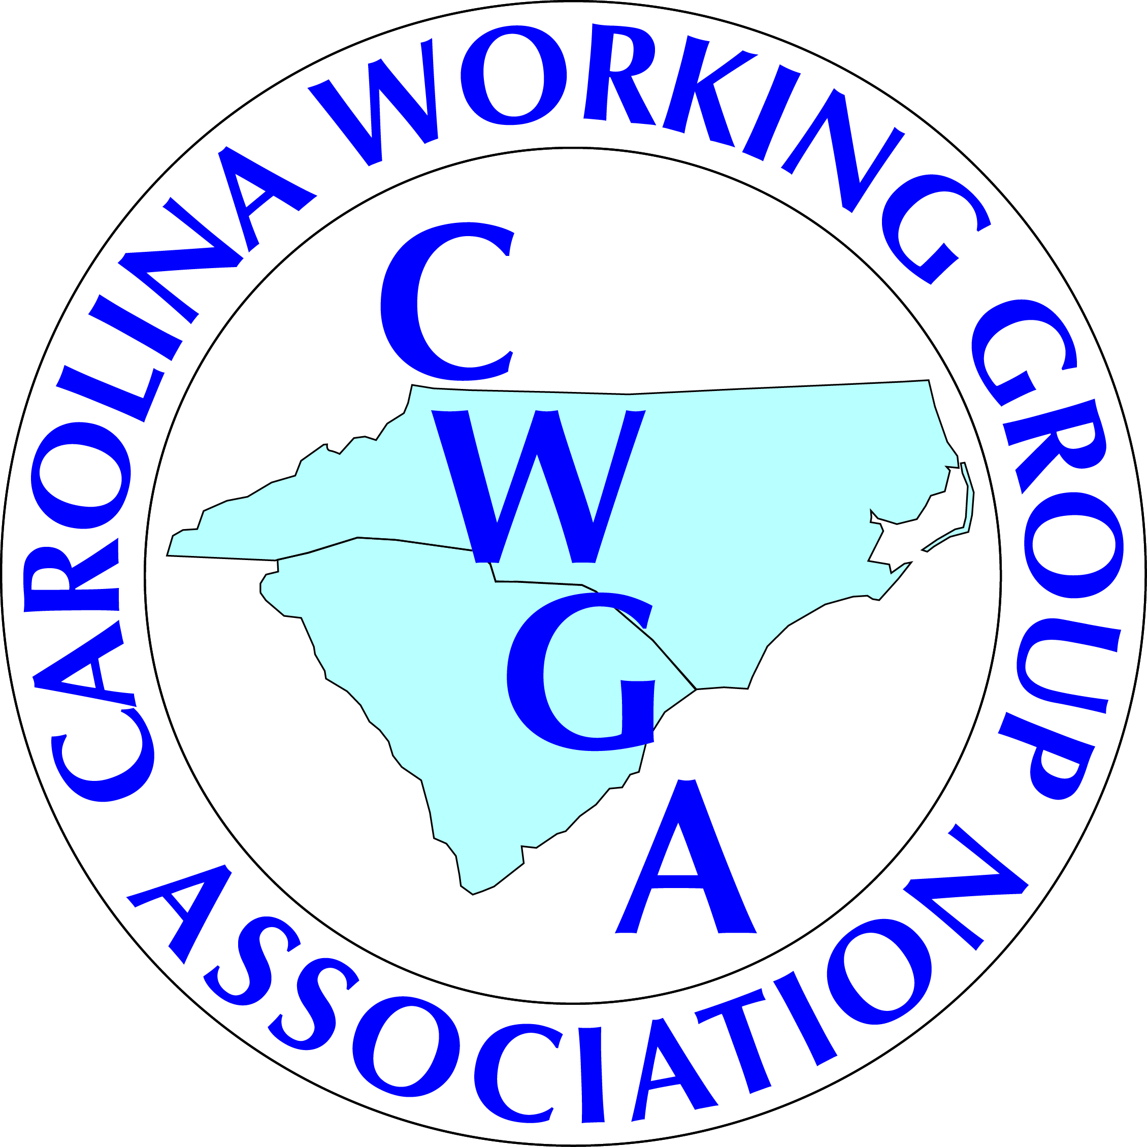
CAROLINA WORKING GROUP ASSOCIATION
CLUB PROPOSAL FORM

The Carolina Working Group Association welcomes and appreciates your request for the Carolina Working Group Association to join your show weekend. Please complete the following questions and submit to our Club.
Name of your Cluster______________________________________________________
Dates of Cluster__________________________________________________________

Name of the Clubs and President of said Club involved in your Cluster.

1. Club Name____________________________________________________________
President’s Printed Name and Signature_____________________________________
2. Club Name_____________________________________________________________
President’s Printed Name and Signature______________________________________

3. Club Name_____________________________________________________________
President’s Printed Name and Signature______________________________________

PROPROSAL QUESTIONAIRE

1. Please explain in detail why your club/cluster is interested in adding the Carolina Working Group Association to your show weekend. Please include in this answer
A. Why is it beneficial to CWGA for CWGA to join your show weekend?
B. Why is it beneficial to your combined clubs for CWGA to join your show weekend?
C. Please expand on “What can you do for the Carolina Working Group Association?”
D. Please include from the past three years the working dog entry for the first day only of your cluster.

2. Please include a projected plan of exactly how CWGA will fit into your show weekend.
A. Which day of the cluster will CWGA hold their show?
B. What proportion of the cost for the rental of the show site are you planning for
CWGA to be responsible?
C. Will CWGA be included in the contract with the Superintendent, Judges, Ring Stewards, Photographer/s, Clean-up etc.? What proportion are you expecting CWGA to be responsible? Please give an estimated amount.
D. Will other Clubs be holding Specialties, Obedience Trials, Agility Trials, etc at the same time and in the same facility as CWGA? If so,
1. How much area/ring space will CWGA have to give its show?
2. Will there be adequate Grooming and Crating Space?
3. Will chairs and tables be available at no cost to CWGA?
4. Will you at no cost to CWGA supply individual breed meeting rooms?
E. Will working dog judges from your judging panel be made available to judge the CWGA show at no cost to CWGA? From these judges, CWGA will make the assignments for the working breeds.
F. How are you planning to divide the combined entry fees or does CWGA keep the entry fees for the CWGA show?
G. Obviously if you are inviting CWGA to join your show weekend you are probably a member of CWGA. At this point, there is no permanent show chair or show committees for CWGA, how are you planning to address this issue?
H. What is our share of the cost for Security and EMT?
I. Are there hotels in the immediate area that are willing to accept dogs? What are the room rates and pet fees?
J. What is the availability of restaurants in relation to the show site?

4. Is your show site capable of housing RV’s? If so, how many________?
A. Do you have electric hook ups available?
50 amp hookups Yes____ No____ If Yes approximately how many?_____
30 amp hookups Yes____ No____ If Yes approximately how many?_____
110 volt hookups Yes____ No____ If Yes, approximately how many?____
B. Do you have water or connections available?
C. Do you have sewage connections or disposal?

What Percentage Of The RV Camping Fees Does CWGA Receive?
Is the area that houses the RV’s safe?
Is there someone that controls the proper parking of the RV’s?
Is there a club/cluster member that will be on the grounds and available to the campers in
case of an emergency, or just basic camping needs?

5. Are there day parking fees and if so what portion of these does CWGA receive?

6. What duties are expected of CWGA members before, during and after the shows? Please explain in detail.

If there is anything that we have not addressed please fill free to address those issues.

Thank you again for submitting a request for us to join your show weekend.

The Members of the Carolina Working Group Association

