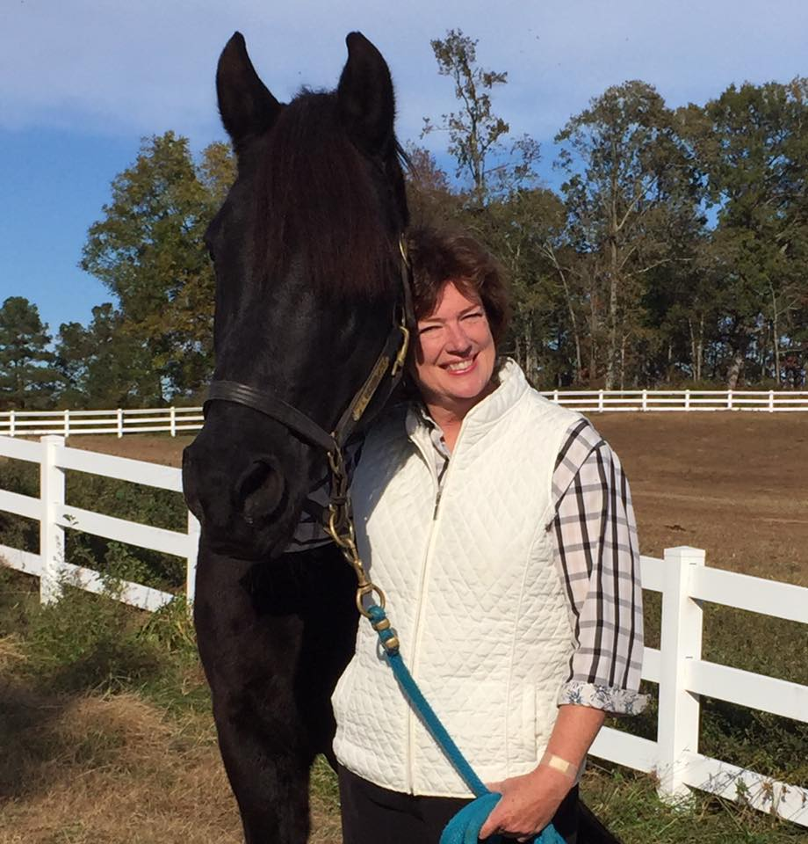
HORSE OF THE MONTH:
Secret’s Red Eagle “Secret’
BREED: Tennessee Walking Horse
AGE: April 15, 2001
DAM: Where Eagles Dare
SIRE: Our Favorite Secret

I, Secret, am proud to accept the JRF Equestrian horse of the month award. I was born in Michigan on a beautiful spring morning. The vet thought that I was an adorable little bay just like my mom. But I showed my true colors and developed into a handsome 16.3 hands, black gentle giant. I do nod a tribute to my mom in the summer and fade to a sort of bay color. I’ve had four owners and I must admit that this last one is pretty good so far. I’ve trained her to bring peppermints, carrots and apples to me on a regular basis. If she spoils me enough then I will give her a pretty good trail ride. My owner tells me she lost her fist TWH, Smokey, way too young. She searched for a new horse and with help from some super smart TWH Trainers, she found me! I am happiest when on the trails but I will do a little arena work when pushed. Thank you again for this prestigious award! I won’t let you down (or fall off).

