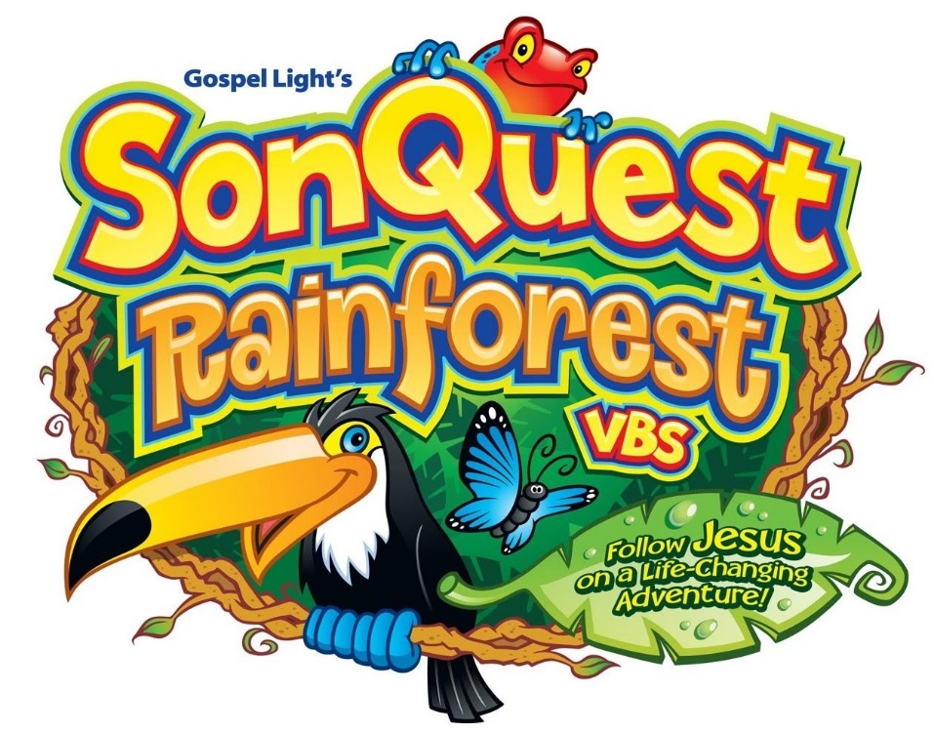
You are Invited to…

At Lone Pine Christian Church
July 10-14
9am to noon

Classes for children through 6th grade… older children are invited to help! Adults are always welcome to stay and help too.
If you are interested in helping please contact the church at 724-267-4512
Please feel free to fill out the enclosed registration form and bring it with you!
MISSION PROJECT
We are asking the Children to bring school supplies to fill backpacks again this year. These backpacks are donated to Avis Arbor, The Washington Women’s Shelter, and Fresh Start

