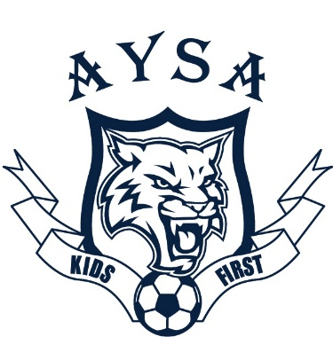
ACUSHNET YOUTH SOCCER ASSOCIATION
P.O. BOX 30089
ACUSHNET, MA 02743

Dear Business Owner/Friend:

The Acushnet Youth Soccer Association (AYSA), has held a proud tradition in our community.

AYSA could not be where it is today without the support and dedication of our sponsors, volunteers, families, and coaches. This community-based non-profit organization is committed to providing a high-quality youth soccer program for children at all skill levels. We have both a recreational (AYSA) and a competitive travel program (Acushnet FC) for children in our community.

The recreational program has instructional divisions from U6 thru U10 and competitive divisions U12 & U15. The primary goal is to expose children to organized sports by teaching values of teamwork, sportsmanship, and community, while fostering a love for the game.

Our organization is funded through player registrations, fundraising, and sponsorships. We strive to keep our registration fees affordable. We are able to reach these goals through collaborations with businesses such as yours. Please consider sponsoring one of our teams. In return, we would like to support your business/company and offer an opportunity for marketing and promotion of your services.

$300 Company name on a set of team jerseys, your business listed on the AYSA webpage with a link to your website. Your business promoted on our social media page (Sponsor Shoutout)

$150 Company name on a 18”x24” field sign posted throughout the duration of the Fall Rec Season.

Your tax-deductible sponsorship will go toward the cost of running a quality soccer program, which includes field maintenance, referees, balls, nets, and lower player registration fees. Enclosed you will find a sponsorship form.
On behalf of the AYSA, I would like to thank you in advance for your generosity.

Sincerely,
Chris Medeiros
AYSA Sponsor Director

Like us on FACEBOOK www.Acushnetyouthsoccer.com
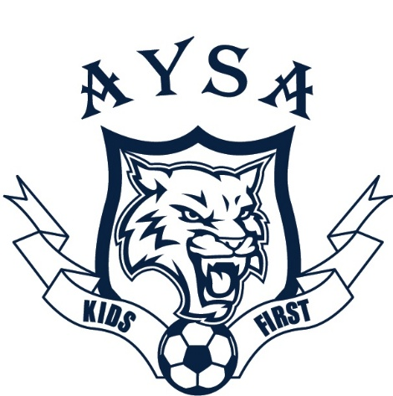

Acushnet Youth Soccer Association
Sponsorship Form

☐Premium Sponsorship ($300)

☐ Standard Sponsorship ($150)

Name of Business: __________________________________________________

Signature: _________________________________________________________

Print Name:________________________________________________________

If you have a child in league please request division you would like to sponsor below.
Child’s Name: _________________________ Division/Coach: ______________

Please attach business card if possible. Thank You!

Checks should be made payable to: Acushnet Youth Soccer Association.
Sponsorship payment deadline is August 1, 2023

