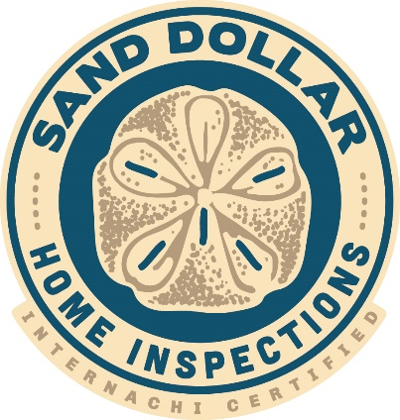
PRICE LIST
Professional Inspections

Wind Mitigation - $100.
4 Point up to 3000 total sq. ft. - $100.
Wind Mit/4 Pt. Combo - $150.
Full Home Inspections – Starting at $275.
(add $50. each for Wind Mit & 4-Pt)
Termite Inspection & WDO Certificate $150.
Citizens Roof Certificate - $75.
Pool Inspection - $100.
Reinspection - $50.

Reports within 24 hours
randy@sanddollarinspections.com
727-422-9550
Sanddollarhomeinspections.com
Serving Clearwater, St Petersburg, Tampa
and surrounding areas

