THE HOWLING DAWG
16th Georgia Volunteer Infantry, Company G
"The Jackson Rifles" September 2013 Newsletter

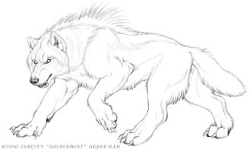

READY FOR THE 150TH CHICKMAUGA
Georgia's River of Death
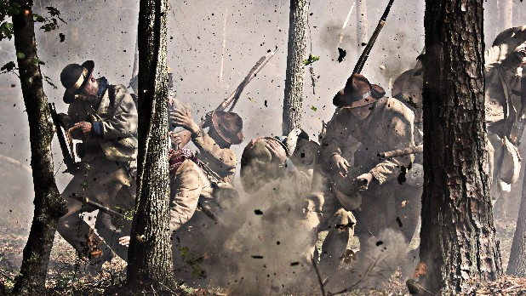
Photo by Contributed Photo /Chattanooga Times Free Press.
"Sunday morning of that September day, the sun rose over the eastern hills clear and beautiful. The day itself seemed to have a Sabbath-day look about it. The battlefield was in a rough and broken country, with trees and undergrowth, that ever since the creation had never been disturbed by the ax of civilized man. It looked wild, weird, uncivilized." Co. Aytch
-1-
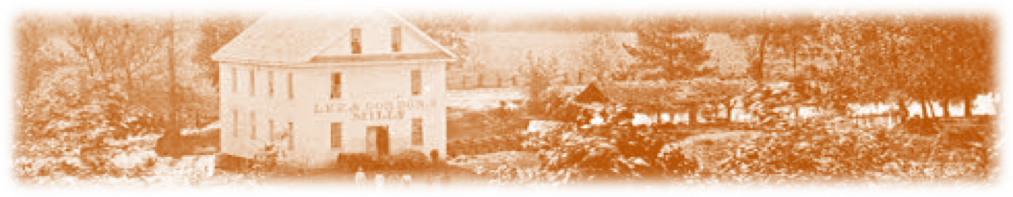
"O LORD, THIS WAR IS A TERRIBLE THING"
Our Corps (Polk's) was in the engagement the day before, so we were held in reserve. We could see couriers dashing back and forth; hear orders given to the brigades, regiments and companies; watch them go forward in line of battle with flags waving, hearing their charge. Then came the shock of battle, the shot and shell all sizzling, zipping, thudding, screaming, roaring, bursting, and passing right over your heads. Soon we saw the litter corps bringing back the wounded, and heard them tell how their command was being cut to pieces, and that every man in their regiment was killed … and we saw a cowardly Colonel, of Longstreet's Corps, dashing to the rear, the very picture of terror, exclaiming, "O, men, for God's sake go forward and help my poor boys! They are being cut to pieces! We can't hold our position." To which one of our fellows asked, "What regiment is it and why ain't you with them, you coward!" Such things can demoralize, and intimidate a soldier. We were moved from one position to another, always under fire, our nerves strung to their utmost, listening to the battle in our front, hearing it rage, then dim until it seemed to die out entirely, then abruptly break out again. At any minute you think you will be ordered into action, then you double-quick to another portion of the field. General Leonidas Polk rode up and stopped in our front, so some of the boys hollered out, "Say, General, what command is that which is engaged now?" The general kindly answered, "That is Longstreet's Corps. He is driving them this way, and we will drive them that way, and crush them between us." Turning to General Cheatham, Polk said, "General, move your division and attack at once." Everything is suddenly set in motion, and General Cheatham gives the boys a good send-off, saying, "Forward, boys, and give 'em H--L." General Polk added, "Do as General Cheatham says, boys."(Polk was a preacher and wouldn't curse.) After marching in solid line, obliqueing right and left …"guide center and close up; commence firing -- fire at will; charge and take their breastworks!" Our pent-up nervousness and demoralization was suddenly gone. We raised one long, loud, cheering shout and charged right upon their works. They poured their deadly missiles into our advancing ranks from under their head-logs but we did not stop to look around to see who was killed and wounded. Pressing right up to their breastworks, and planting our battle-flag upon it, they wavered, broke and ran in every direction, when General John C. Breckinridge's division, which had been supporting us, marched up and passed us in full pursuit of the routed and flying Federal Army. We remained upon the battlefield of Chickamauga all night. Everything had fallen into our hands; countless prisoners and small arms, and many pieces of artillery with wagons of provisions. The Confederate and Federal dead, wounded, and dying were everywhere scattered over the battlefield. And those dead, wounded and dying horses, their heads and tails drooping. They seemed to be so intelligent as if they comprehended everything . I felt like shedding a tear for them. One scene I remember happened when a detail of us were passing over the field near Lee and Gordon's Mill, with lanterns, looking wounded among the dead. We came across a group of ladies, searching for a loved one, when one of them asked if we had seen such and such a fellow. I am sorry I cannot recall the name. We had almost passed on by when one of them cried out, "Here he is! It is him - he's … dead …dead! " She ran to the slain man, raised his head and placed it on her lap and began to rock back and forth kissing him and weeping. "They have killed him Mama. What am I going to do Mama? He's dead. They've killed him Mama. What am I going to do? He's dead ….. dead." I could witness this scene no longer and as I turned to walk away, there stood William A. Hughes, looking toward Heaven, tears streaming down that weathered face. I heard him say, "O Lord, this War is a terrible thing." All through that long September night we continued to carry off our wounded. When sun rose over the eastern hills, the order came to march to Missionary Ridge.
Adapted by jwd from Co. Aytch

-2-

SEPTEMBER 19-22, 2013 - 150TH CHICKAMAUGA - Blue Gray Alliance
Event Address is 838 Dougherty Gap Rd. Chickamauga. GA
Registration fees, effective immediately:
$25 per person 14 and older (August 6, 2013 to September 1, 2013)
$30 per person 14 and older (September 1, 2013 to September 10, 2013)
As always, anyone under the age of 14 is admitted free.
SCHEDULE
Thursday, September 19, 2013
4:00 p.m. Tactical on Pigeon Mountain (Campaign style, camp on arms overnight).
NOTE: The plan is to leave camp at 4PM Thursday to sleep on arms up on Pigeon Mountain. All participants will be required to carry their own gear. One-night Rations will be issued, but all participants must pay an additional $10 for rations and register accordingly to be placed on the campaign list. Activities include dusk skirmishes, night Battles and Friday dawn battle. We will be back in static camp by 10:00 a.m. Friday NOTE TO US: General Jack King has stated that his Division will not participate in the Thursday overnight march and bivouac.
Friday, September 20, 2013
4:00 p.m. Battle of Reed's Bridge/Jay's Mills fight
4:00 p.m. Battle of Alexander's Bridge (Yes at the same time)
Saturday, September 21, 2013
10:00 a.m. Cavalry Battle around Crawfish Springs
4:00 p.m. Stewart's assault/Viniard Farm Battle/Ditch of Death scenario
8:00 p.m. Cleburne's/Cheatham's Night Battle
Sunday, September 22, 2013
2:00 p.m. Longstreet's Breakthrough/Snodgrass Hill/Forrest's Attack on Steedman
To 16TH GA, Co. G - When registering, enter 16th GA CS Infantry, GA Volunteer Battalion, period military camping as per the Summer Drill meeting of July 13.enter the proper affiliation when registering. On line, your registration will be processed using the PayPal system. If you choose not to pay with a major credit card you may print the registration form by hitting "print screen" and mail it in with a money order or personal check. Please be advised that it may take a few days for checks to clear and mail in registrations to be posted. Please mail your registration to: Cleburne's Division Attn: 150th Chickamauga P.O. Box 6359 Navarre, FL 32566.
IMPORTANT: Each vehicle through registration will be issued a card to be filled out and placed on your dash. Any vehicle that enter the camps that fails to place said card on your dash will be TOWED at owners expense! Also said owners will be given only ONE warning before being towed offsite. This is for ALL participants. No Exceptions!
CS & US camps close Friday noon to all vehicles, No Exceptions! All Participants arriving after noon Friday must plan to use the shuttle systems to get your gear to camp.
-3-


SEPTEMBER 21 - SCV EVENT AT THE DUBLIN, GA VA
OCTOBER 5-6 - ANDERSONVILLE
OCTOBER - BATTLE @ IRWINVILLE - POC - LEE MURDOCK @ 478-986-5290.
NOVEMBER 1-3 - BATTLE OF ATLANTA - Re-enactor registration for both November 1-3, 2013 and September 19-21, 2014 is now open. The registration fee for 2013 and 2014 is $15.00 per person until October 15, 2013. After October 15th, the walk on fee is $25.00. The registration fee of $15.00 per person for 2014 is good until September 1, 2014. After September 1st, the walk on fee is $25.00. Children under 12 are free for both re-enactments but they must register.
NOVEMBER 9 - CANNONBALL HOUSE APPARITIONS PROGRAM - Tours start at 5pm. Reservations required.
NOVEMBER 23 - GRISWOLDVILLE 149th ANNIVERSARY COMMEMORATION
DECEMBER 14 - A CANNONBALL HOUSE CHRISTMAS - 6pm.
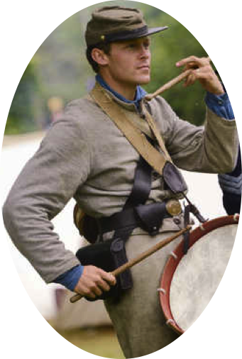
16TH GA Co. G. “Jackson Rifles”
Brig. Gen. Herbert Burns - 478-668-3598
Capt. Wm.“Rebel”Bradberry–404-242-7213
1 Lt. Noah Sprague – 706-491-9755
1st Sgt. Kevin Sark – 478-731-8796
2nd Sgt. Nathan Sprague – 478-320-8748
Adjutant John Wayne "Duke” Dobson 478-731-5531
1st Corp. Alan "Cookie" Richards 478-308-9739
2ndCorp. Chas."Goodtime"Whitehead 478-986-8943
3rd Corp. Lee "Pappy" Curtis -478-365-6785
Lead Chaplain – Joel Whitehead, Jr. - 478-986-8798
Hon. Chaplain Ronnie “Skin” Neal – 478-994-0958
Assistant Chaplain – Charles Hill – 770-845-6878
Treasurer - Pvt. Earl Colvin – 478-214-0687
Honorary Colonel J. C. Nobles - 478-718-3201
Musician - Landon Allen - 478-294-9870
Musician - Jacob Thompson – 478-214-0687
Musician - Aaron Bradford – 302-668-8029
Musician - Oliver Lummus – 302-668-8029

ON FACEBOOK:"JACKSON RIFLES" - 2,168 FRIENDS (as of August 9) - guess we lost a couple of dozen somewhere. All 2011-12 issues of The Howling Dawg are available @ (scvcamp1399.org), thanks to
Steve Scroggins
NEWEST 16TH GA MEMBERS
We heartily welcome our newest members Musician/Riflemen Aaron Bradford (pictured above) and Oliver Lummus (picture not currently available) . We are both proud and pleased to have them as part of our brotherhood.
-4-

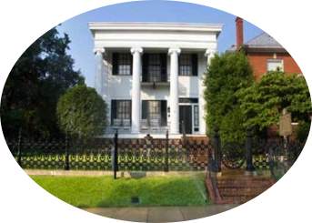
THE CANNONBALL HOUSE LIKE YOU'VE
PROBABLY NEVER SEEN IT
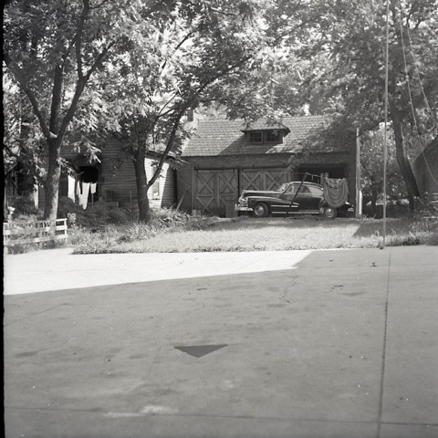
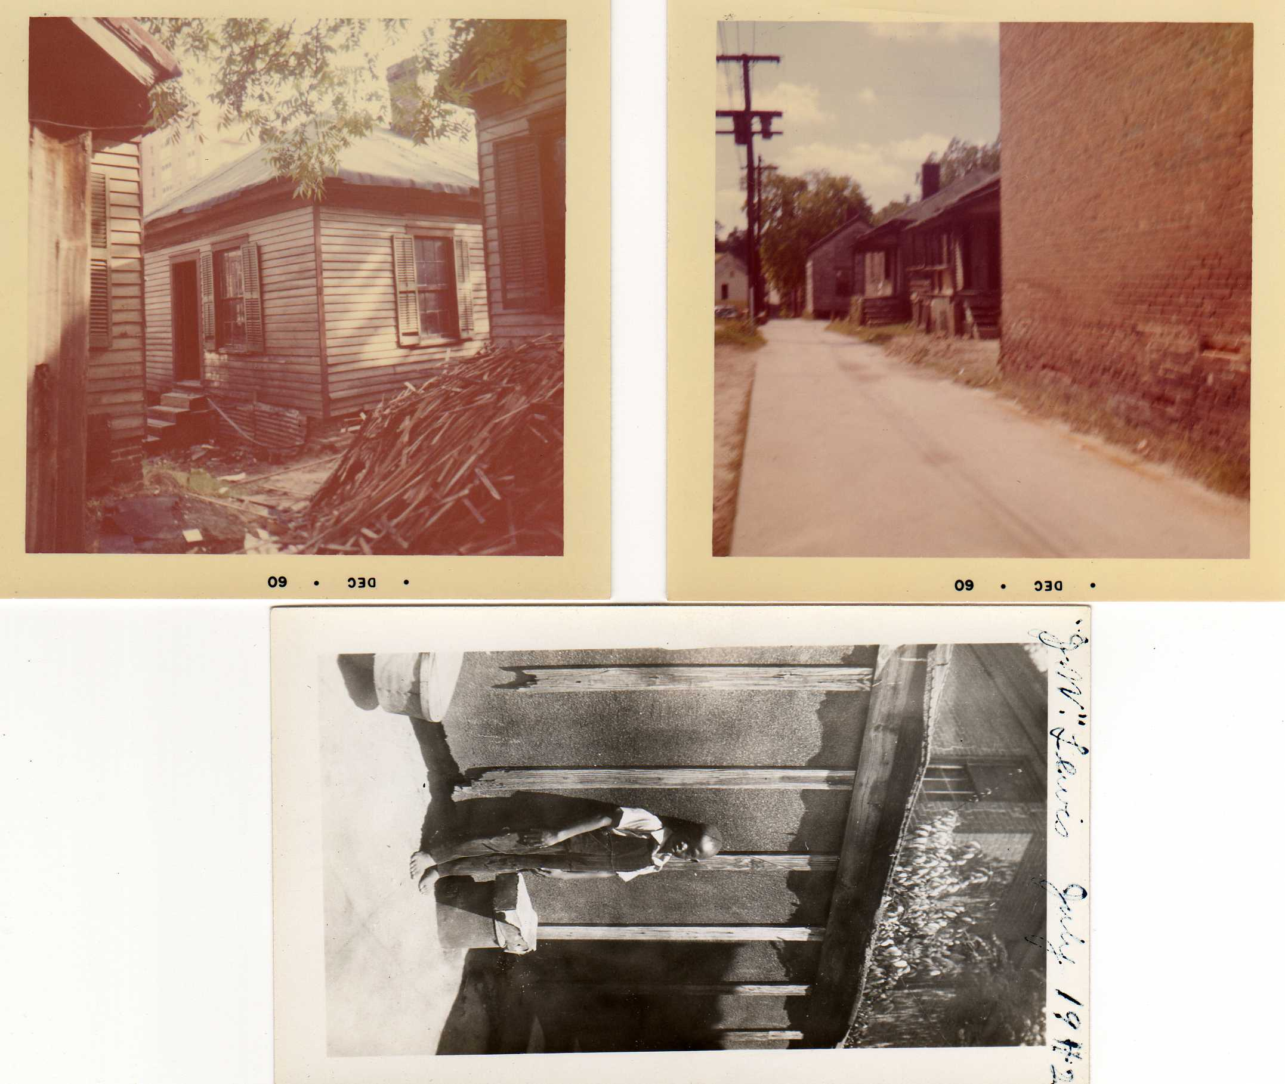
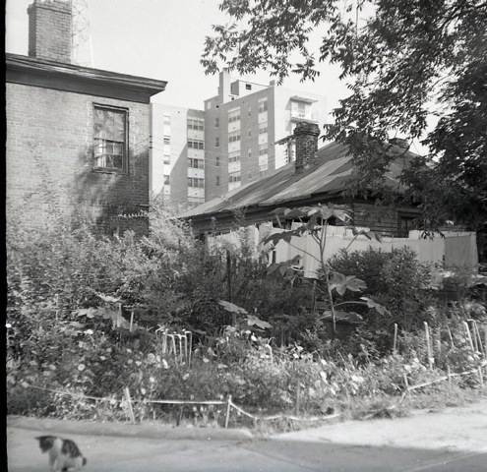
In the years when the Cannonball House in Macon, GA was being transformed from a private residence to a historic home, some buildings out back were torn down to make parking spaces. The aging frame structures were, likely, constructed by Judge Asa Holt around the time the main house was built for his servile population. In the photo to the left, at least 3 dwellings are seen. This area is roughly the current rear parking lot. The image on the right shows another house apparently at the right rear of the brick kitchen. And the picture (lower left) is of the carriage house (next door to the Cannonball House) which still stands. A long-since demolished wooden structure is attached to it. This, too, is the area of the current main rear parking lot on the left. These buildings, of course, were of great historic significance but were victims of "progress."
*****
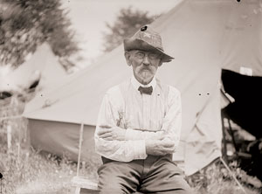
Our 1st National Military Park - In September 1889, veterans of the Army of the Cumberland and the Army of Tennessee gathered in Crawfish Springs, Georgia, to hold a grand barbeque in commemoration of the 26th anniversary of the Battle of Chickamauga. With thousands in attendance, the governor of Georgia welcomed the former soldiers of both armies as guests and declared the event to be a celebration of both sides’ deeds and their renewed and eternal bonds of brotherhood. Pictured is Chickamauga Veteran J.J. Dackett, wearing a hat with bullet holes received during the battle. (Library of Congress)

-5-

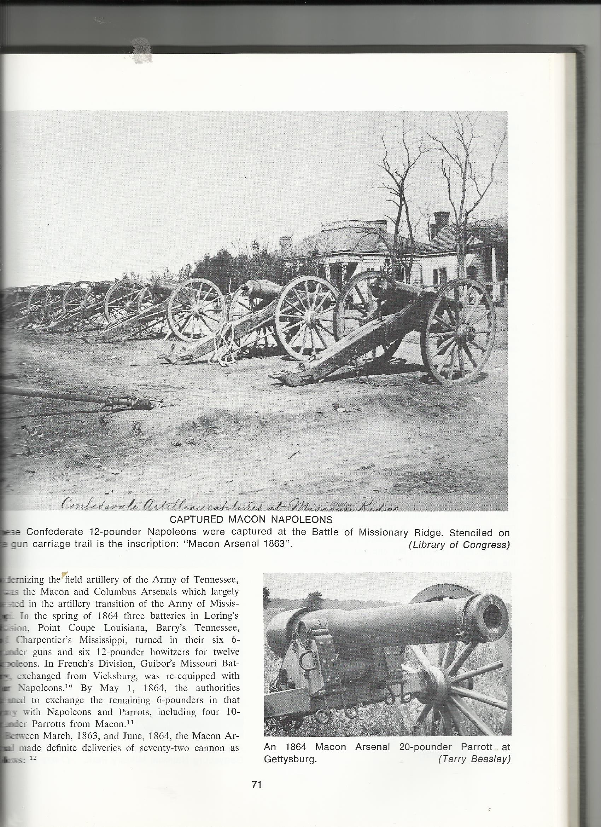
CAPTURED MACON NAPOLEANS
This Library of Congress photograph shows a group of Confederate 12 pound Napoleons, captured at Missionary Ridge/Chattanooga on November 25, 1863. Stenciled on the gun carriage trails is the inscription: "Macon Arsenal 1863" The Macon foundries produced 70-80 pieces of artillery during the course of the War, and several dozen still exist. They ranged in variety from the guns pictured to 6 pound field guns, 10 and 20 pound Parrot guns, 12 pound howitzers and the 3.67" Brooke Rifle. The first Napoleon they cast still guards Lee's Hill at Fredericksburg, fourteen are at Gettysburg, one at Kennesaw and ol' number 41 is on The Cannonball House lawn.

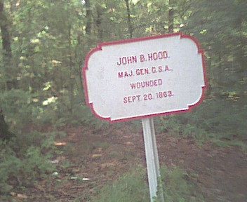 | CHICKAMAUGA Grave Sites: Only two soldier's headstones are on the battlefield. The first is that of Pvt. Ingraham, a local boy of the 1st Confederate Regiment of Georgia Volunteers, who was killed during the first day's battle. He was found by friends and relatives and buried where he fell in the area where 1st/27th Tennessee saw action on the same ground. The second marker is that of Pvt. Bull, located on Horseshoe Ridge on the right hand side of the trail just below York's Georgia Battery. He was an unfortunate soldier of the 3rd Tennessee who was killed the day before his 21st birthday in an action which cost Gregg's Brigade over 44% casualties.

DUES
If your annual dues were not paid at Old Clinton War Days, please see the Treasurer about this as soon as you can. Thanks

MORE THAN ANYTHING … PRAYER

RAY CROSS (Alan Richards' step father)
TIM PILGRIM GA State SCV Adjutant - surgery August 13
RICKY SMITH - surgery recovery
TIM FOWLER - surgery recovery
BRITANY THOMPSON (WATCHDOG'S DAUGHTER) - surgery recovery RUBY & SEVERAL OTHERS - Duke

-6-
SHERMAN, A HERO?
Reading a recent piece by Victor David Hanson on heroes, he includes William Tecumseh Sherman in his pantheon of heroes for "making Georgia howl."
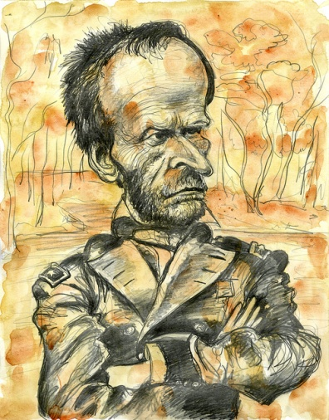
Let me get this straight. Anyone in wartime who leads an overwhelming army of plunderers, rapists, and assassins through almost undefended civilian territory encompassing three states, expressly targeting civilians, infrastructure, churches and nunneries, devastating and burning a 60-mile swath, leaving the displaced population little food, shelter or transportation in wintertime ... is a hero in Hanson's book. Depredations on women and children, frail and elderly, are perfectly all right with Mr. Hanson. Colorblind cruelty visited on civilian whites, slaves and free blacks alike is heroic, according to Mr. Hanson. As long as the end (preservation of union and freedom of slaves) is seen by Mr. Hanson to be good, no death toll is too high, extreme suffering by civilians is totally warranted, scorched earth is an approved tactic. He never questions there might have been a better way to free the slaves, as was found in every other slave-holding country.
This, my friends, is the result of using education to brainwash even our best and brightest. They do not even know they are brainwashed. Betty Zeitz
http://www.nationalreview.com/article/354701/needed-tragic-hero-victor-davis-hanson
*****
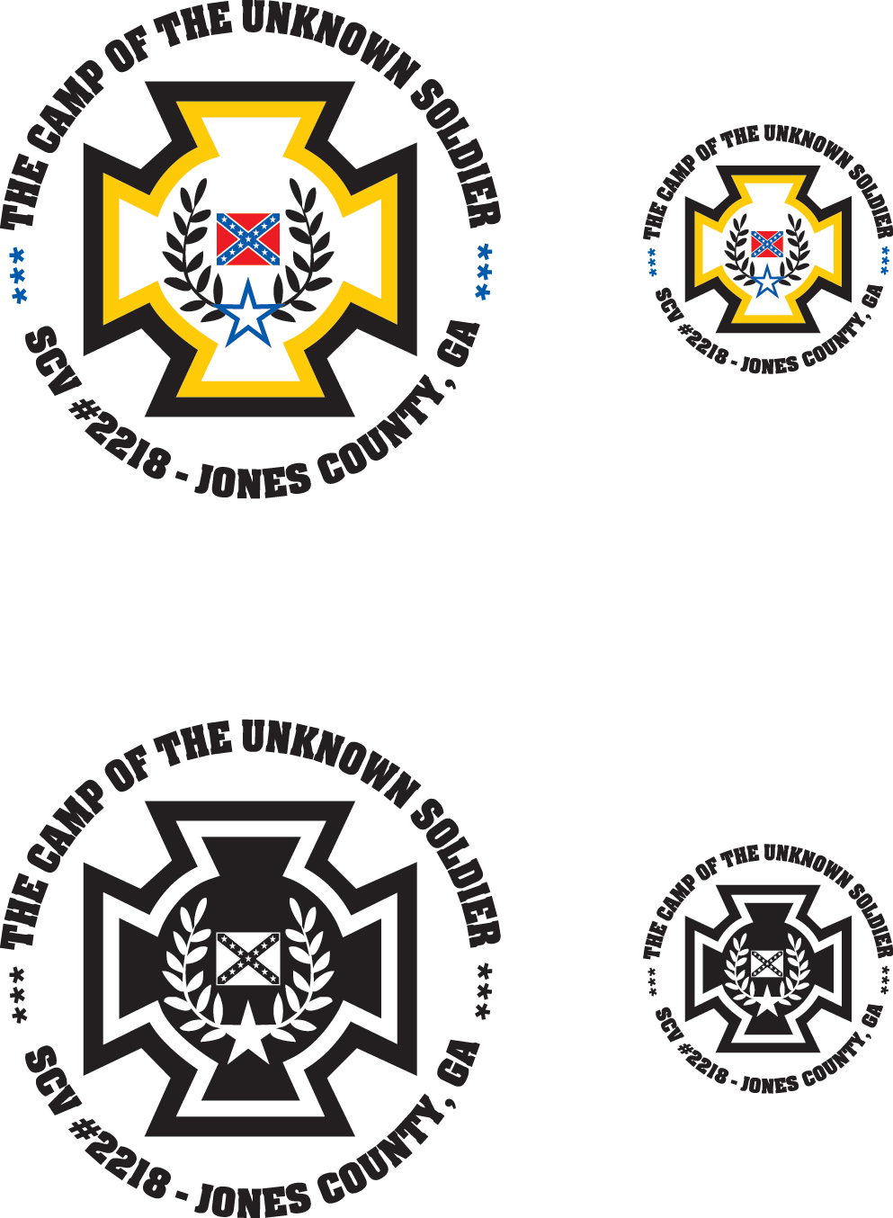
The Camp of the Unknown Soldier, # 2218 of Clinton, Jones County, Georgia, has scheduled their August 22nd meeting at Chevy's Café on Hwy. 49 in Jones County, where they plan to enjoy hearing about General Moxley Sorrel from Compatriot Lee Murdock and induct James Thompson and David Dunning into the fellowship of Camp 2218. September and October will possibly be the last two meetings dates at Chevy's as we may hold our November meeting at Griswoldville (November 23) and forego a December session. January might see us in a new location. We ask that all members have their dues in by the September 26th meeting, allowing enough time to process and distribute them before the October deadline. Thanks so much.
GRISWOLDVILLE BATTLE COMMEMORATION
The Jarrell Plantation Historic Site and the 16th Georgia Volunteer Infantry,
Co. G, "The Jackson Rifles", cordially invites one and all to the annual
Griswoldville Battle Commemorative Service on Saturday, November 23, 2013
A living history program will begin at 9:30am with the commemoration at 12:00 noon.
Our guest speaker will be: Alan Richards of the 16th Georgia Infantry, Co. G and the Logan E. Bleckley SCV Camp #1998 GPS: 32°52′00″N 83°28′10″W

JUST TOO MUCH DAWG?
Has "The Dawg" become too long? Back when we mailed all copies, we had to keep it to 4 pages (8sides) because of the 1st-class postage limit. The unit no longer funds those costs as e-mail is "free" and we get so many great pictures now so we need more space. I know many of you read it on hand held devices (I don't see how) and that may be difficult. Even desk computers may have file limits. I have always written with one thought in mind - "if the subject matter is of interest to me, it might just be of interest to someone else." That's not conceit, just the only guideline I have. I am not looking for compliments but real input - Let me know, is "The Howling Dawg" what you want?
-7-
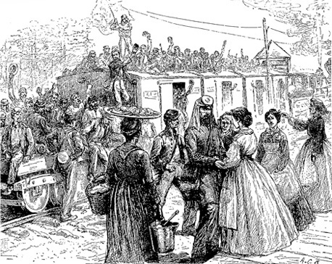
The 16th Georgia "at" Chickamauga, 1863
It all commenced with a train ride with Georgian Lieutenant General James Longstreet, and ended with a battle that came the closest to the annihilation of a major army, North or South, as seen during the War. The two day battle of Chickamauga, fought in mid-September of 1863, was for Longstreet, a case of leading a command he barely knew, over ground he had never seen before, and with virtually no assistance or support from his immediate superior, but he still managed to send all but the extreme left of the Federal army streaming in a complete panic towards Chattanooga. In May of 1863, Confederate corps commander James Longstreet first proposed that units of the Army of Northern Virginia be used to reinforce those of Braxton Bragg to inflict a crushing defeat on Federal forces in mid-Tennessee. Longstreet's forces had not participated in the Rebel victory at Chancellorsville, and Longstreet suggested that they could be better utilized in a rapid transfer west. In a letter to Senator Louis Wigfall, Old Pete confided that "If I remain here, I fear that we shall go, little at a time, till all will be lost. I hope that I may get west in time to save what there is left of us . . ." By August, Longstreet was still hurting from the memories of Gettysburg and requested a transfer west, urging that the Army of Northern Virginia reinforce the Army of Tennessee. He was concerned that unless something were done to wrest the initiative away from the Federals, the enemy would soon be marching through Georgia. Finally, on September 6, Lee gave the orders to make preparations to move the I Corps to the West. The journey through the States from Virginia was a "continuous ovation to the troops", wrote a member of Longstreet's staff. A colonel in an Alabama regiment recalled, "At many places, the good ladies, prepared abundant and excellent lunches for us." However, a trip that should have taken two to three days had the route been directly to Knoxville now took nearly three weeks to complete. By travelling through the Carolinas, into Georgia and Atlanta, and finally north towards Chattanooga, the trip covered over 900 miles and used a staggering 16 separate railroads. Some units never made it to the fight, as was the case with General McLaws and two brigades of infantry, of which the 16th Georgia was a part. From the Army of Northern Virginia, as ordered with Longstreet, briefly into the Army of Tennessee, they were there, but not engaged.
KEEPING IN TOUCH
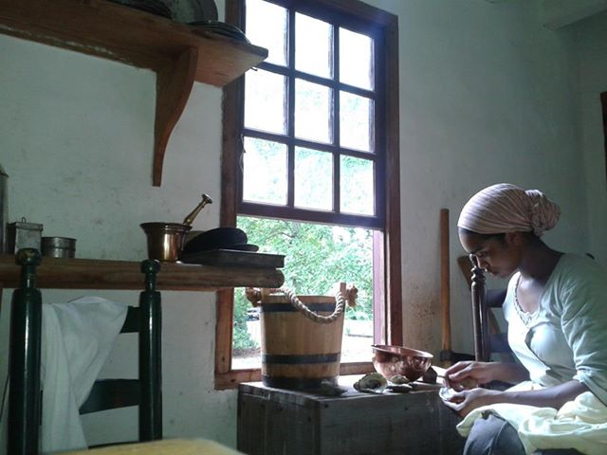
As our readers know, Mia McKie recently started work at Colonial Williamsburg. Most every day there must hold the promise of a new experience. In a photograph that she made available, she is seen shucking oysters. In other news Duke, Ms. Brenda and Kellie explored in a westward direction til they found water too deep to ford and came on back.
-8-

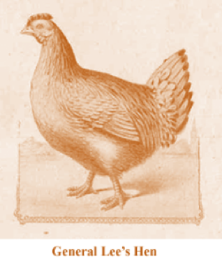
THE WAR CHICKEN

For some folks it is downright hard for them to imagine that General Lee had a chicken for a pet. Yet, I seem to recall that he also had a pet bobcat and rattlesnake when he was in Mexico. This chicken, however, was a small, black hen, that had arrived in Lee’s camp, sometime in early 1862, with a shipment of chickens sent to the Army of Northern Virginia for food. She escaped to Lee's tent and began laying eggs under his cot. The fact that Lee enjoyed a fresh egg for breakfast spared the life of “Nellie,” the little black hen. She freely roamed the camps unmolested, bivouacked with the General, himself, and traveled in the baggage wagon when the Army moved. In July, 1863, Lee and the Army of Northern Virginia was, of course, at Gettysburg. As the southern army was preparing to return to Virginia, Lee suddenly realized that Miss Nellie was missing from her usual spot. “Where is the hen?” he asked, in a concerned tone. By this time, the soldiers knew about the hen, and her absence caused much concern. The retreat came to a halt as the men looked for Nellie. The General himself joined in the hunt. Finally she was found. Those reading this who have an animal (especially a cat) will know exactly how Lee felt when she was finally discovered–perched safely in an ambulance on an impromptu nest, where she had probably been all along. Only then could the retreat from Gettysburg continue. Little Nellie the Hen travelled with the Army of Northern Virginia for over two years, laying an egg for General Lee almost daily to earn her keep and safe haven. No doubt she brought solace and a memory of home in Arlington to the General with her faithful eggs and friendly clucking. But, to the approximately 11,400 Confederate casualties from the Battle of the Wilderness, there must be added one more: Nellie Hen. On May 4, the eve of the fighting, General Lee invited some people over for dinner. According to the memoirs of William Mack Lee: "On dat day–we was all so hongry and I didn’t have nuffin ter cook; I was jes’ plumb bumfuzzled. I didn’t know what to do. Marse Robert, he had gone and invited a crowd of ginerals to eat wid him, an’ I had ter git de vittles. Dar was … Marse A. P. Hill, and Marse D. H. Hill, and Marse Wade Hampton, Gineral Longstreet, and Gineral Pickett and sum others." William Lee had planned to serve flannel cakes (soft, fluffy pancakes), tea and lemonade, but he “allowed as dat would not be enuff fo’ dem.” Swallowing hard, he went out to catch “de little black hen, Nellie.” He found her, dispatched her, and plucked her. She was served to the guests with bread stuffing mixed with butter and was a culinary hit, but General Lee was suspicious. Just where had such a plump little chicken come from? Surely not from foraging! Upon questioning, William admitted to the deed. After hearing the sad truth, Lee asked, “William, now that you have killed Nellie, what are we going to do for eggs?” “I jes’ had ter do it, Marse Robert,” William replied. But General Lee kept up the pressure. “No, you didn’t, William; I’m going to write Miss Mary about you. I’m going to tell her you have killed Nellie." "Marse Robert kep’ on scoldin’ me mout dat hen. He never scolded ‘bout naything else. He tol’ me I was a fool to kill her whut lay de golden egg. Hit made Marse Robert awful sad ter think of anything being killed, whedder der ‘twas one of his soljers, or his little black hen." Rest in peace, Miss Nellie Hen. You, too gave your last full measure, as a true War Chicken should.
-9-

WHAT DO YOU EXPECT FROM YOUR PRAYERS ?
"…we have no might … neither know we what to do: but our eyes are upon Thee."
- II Chronicles 20:12
At the Olustee event of 1994 I poked at a campfire and talked to my friend, Jose Menderos. Despite his familiar broad smile, I could tell he was uneasy, so I asked if everything was okay. He shook his head, looked down and said quietly, "it's my father … they found cancer." I never know what to say at such times - my words always sound inadquate - but I assured him I would remember that sitation in constant prayer. In passing I mentioned that my Daddy had not been doing too well - lupus, they thought, so we made a pact that we would pray for each other's circumstances. Jose never made but a few events per year so the next time I saw him was at Jonesboro in October 1995. Down the muddy road, he almost bounded toward me; the bright smile flashed and his eyes had lost their burden - I knew. He bubbled over in the way people do when they have good news they can't wait to share. Sure enough, his father's cancer was in remission. We rejoiced together and thanked God for a sure answer to OUR prayers. "Oh, yeah," Jose asked, "how's your Daddy?" I felt like a man that was choking - my throat would barely let words pass and I have never tried to hide tears so hard in my life as I nodded and said, "he got well, too." I meant what I said even though Daddy had gone to be with the Lord on May 21, 1995 - and it hurt; I felt hollow inside and wondered was I just putting a good face on an unanswered prayer. My Daddy had, on that Sunday morning of his death, instantly, become more well than he had ever been, yet a big part of me wished he was still here on earth, with me, like Jose's father.
It was already blistering hot around Memorial Day of 2007 and our musical group Simple Heritage was to play on Saturday at the Jarrell Plantaion. I got dressed that morning, packed the car then walked across the street to check on my mother before I left. She had now endured almost 12 years without Daddy, turned 78 in March and, lately, had just not been doing well. As I opened the door and stepped into that small, familiar kitchen, she was fixing a bite of breakfast and offered me a half bananna. I quickly swallowed it and we talked about our plans for the day - I guess - I really wish I remembered those words … exactly. Anyway, I had to go so I was soon out the door and heading toward Jones County. The group had not been playing very long when a phone call came from my sisters - they had taken Mama to the hospital. In the time that passed unitl June 7 when she died, I never got to have another conversation with her. We prayed - hard, even when they moved her into hospice. I, now, try to recall what I asked God to do and what I expected Him to do when I prayed for her - and for Daddy. I guess my supreme wish would have been that they be restored to the health they enjoyed at middle age. I do not see how I could have believed that would happen or even what I felt God would do. In the back of my mind, especially on that afternoon they moved her to hospice, I knew what the eventual outcome would be despite what I had prayed. How about you - have you ever prayed for someone with a termminal illness? How did that work out? Have you even asked God for an outright miracle but deep inside did not give it much of a chance. That is about the same faith a person has when they buy a lottery ticket. However, we can approach a loving God of reason by declaring "not my will but Thine". Some would call that a "cop out", "hedging a bet" or like you never prayed at all. Depending on how you say "not my will …" and mean that, you are gaining more expectation than ever. If God loves you more than anyone - and He does - you can simply trust Him to do what is best for you when you surrender your will to His. God hears and answers prayers. Certainly He can change things (and often will) after hearing your prayer - your side of it, but you do not have His perspective and He does know what is best - you either trust Him or you don't or. Thus, your very best expectation is for His will to become your own, even when outcomes are not what you would have chosen. jwd
-10-
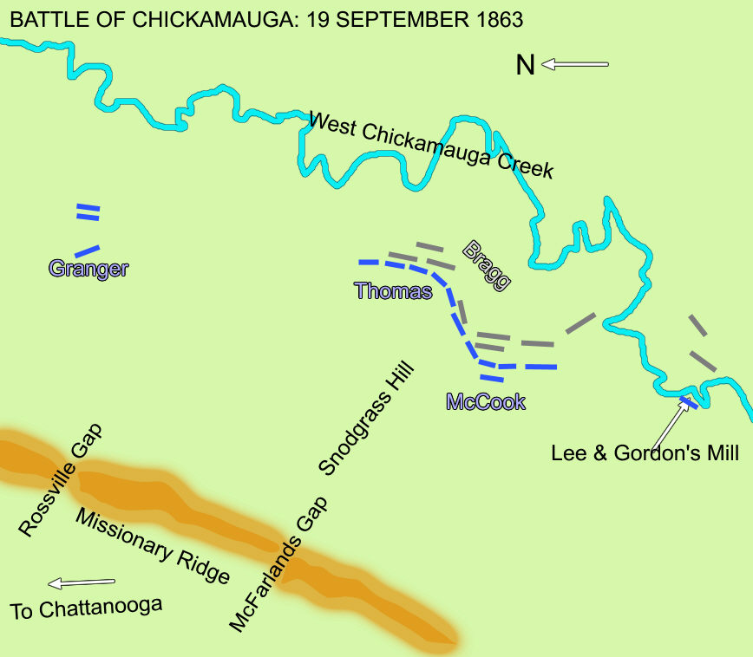

-11-
MORE ABOUT CHICKAMAUGA
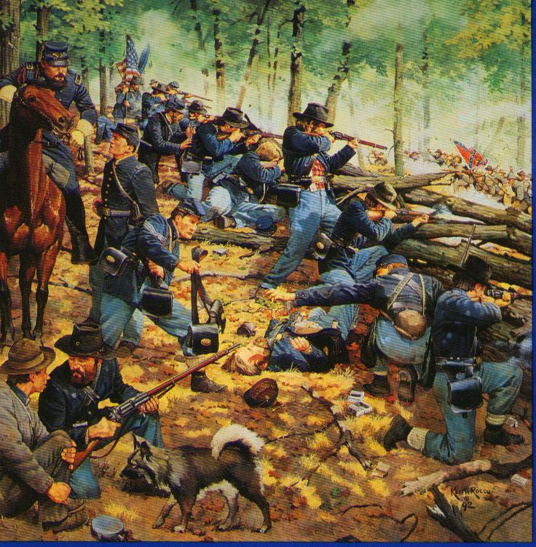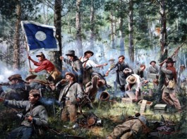
"To the Last Round" - Keith Rocco "Cleburne at Chickamauga" - Don Troiani
21st Ohio at Horseshoe Ridge 2nd Tennessee Regiment
Single Union line armed with Colt General Patrick Cleburne and staff
repeating rifles stalls Confederate charge distribute ammunition to his men
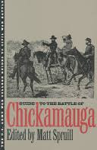
up Snodgrass Hill

Guide to the Battle of Chickamauga
University Press of Kansas - 1993 - Paperback - 290 pages - ISBN 0700605967
This guide uses first-hand accounts to illustrate how this skirmish, only two days long, turned into one of the bloodiest battles of the Civil War with 34,000-plus Union and Confederate soldiers killed, wounded, or captured.
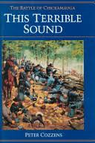
This Terrible Sound: The Battle of Chickamauga - By Peter Cozzens
University of Illinois Press - 1992 - Hardback - 675 pages - ISBN 025201703X

When North and South met among the desolate mountains of northwestern Georgia in 1863, they began one of the bloodiest and most decisive campaigns of the Civil War. The climactic Battle of Chickamauga lasted just two days, yet it was nearly as costly as Gettysburg, with casualties among the highest in the war. In this study of the campaign, the first to appear in over thirty years and the most comprehensive account ever written on Chickamauga, Peter Cozzens presents a vivid narrative about an engagement that was crucial to the outcome of the war in the West.

-12-
Horseshoe Ridge runs west from one high point at Snodgrass Hill southwest of the Snodgrass cabin to another high point perhaps 1000 yards away. Between the two high points lies a saddle whre the ridge is often narrow, with relatively steep slopes falling away to both sides. The 21st Ohio held part of the Union line along this saddle, at the focal point of Confederate assaults. Armed with Colt revolver rifles, the 21st Ohio could produce a high volume of fire that staggered Confederate troops and broke their formations. Repeated attempts to carry the 21st Ohio’s position failed.

