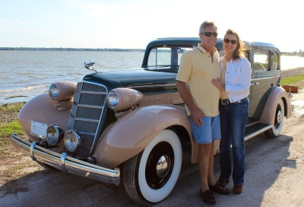
Real Restorations
By Pistorius Collectible Autos

With my last article, your car was ready to be painted. Depending on the era of your car, you can go 2 ways. Either a single stage or base coat clear coat. Which one to choose depends on a few factors. The first factor is what year is your car. It was only in the 80’s that base coat was commonly used on cars. I hear the question often “What paint did you use?” when showing my cars at a car show event. To be authentic you should use single stage for most of the cars built before 1980.
Now let’s add another crinkle to our dilemma. When can you use metallic in your paint, and still be authentic? Metallic was discovered by accident in the late 1920’s by Cadillac. Somehow they got their gas tank paints (which were metallic) mixed up with the car paint, and voila a new paint structure was discovered.
Your decision on what type of paint will be decided on the following basis:
- Do you want to keep your car 100% authentic?
- Do you want a perfect job with the least effort?
- Is the end result just a personal look that you are after?

Here is the major difference between single stage and base coat/ clear coat… If you choose single stage, be prepared for a lot of wet sanding and a lot of buffing afterwards.
Metallic versus solid paint… If your car was built after 1928 you can use metallic. The one drawback with metallic paint is that fixing chips becomes very difficult and could be costly if you want repairs done.
So in a nut shell, good luck with choosing your paint!
Next time we will talk about applying the paint of your choice on your car.
Cheers!
Brando & Joanne Pistorius

