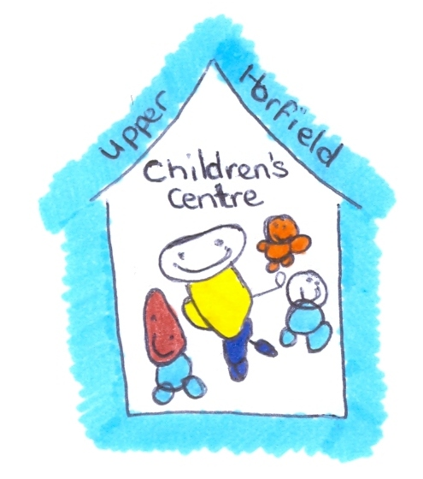
Upper Horfield Children’s Centre and Community School
Food and Nutrition Guidance
February 2015

Guidance on Food and Nutrition

Good nutrition in the early years is vital. Children’s early experiences of food play an important part in shaping later eating habits, and good eating habits support healthy growth and development. Giving positive messages about food in the early years setting will also help to stress the importance of a good diet to children’s families.

A varied and nutritious diet and regular physical activity are very important to ensure healthy growth and development in young children. In the short term, they not only improve growth but also improve concentration and support children’s learning. There are longer term health benefits as well, as poor eating habits in childhood can lead to the development of obesity and anaemia as a result of iron deficiency. Even more importantly, a good diet in childhood can help to prevent the risk of serious diseases common in later in life, such as cancer, cardiovascular disease, diabetes and osteoporosis.
Nutritional Guidance for Early Years 2006

Good Eating Habits at Upper Horfield Children’s Centre

- Children will be encouraged to experiment: a variety of foods will be offered and children will be repeatedly introduced to new foods from an early age as this encourages children to experiment and accept different tastes and textures.

- Snack and meal times will be planned: young children need to have structure to their day and this applies to planning times for eating and drinking. Children differ in their responses to food being made available: most children enjoy food and usually welcome an opportunity to take a snack or drink when they are hungry or thirsty. However some children are less interested, may be distracted while playing and can ‘forget’ or be ‘too busy’ to choose to eat or drink. This can result in children becoming ‘over’ hungry or thirsty, leading to difficult behaviour. Therefore, staff will organise snack time so that every child has a chance to eat and drink. Snack time will provide an excellent opportunity for children to: practise personal hygiene by washing their hands before eating/drinking; learn about healthy snacks and drinks; and learn to try new foods and chat to the staff about their likes and dislikes. Children are more likely to try new foods if they see other children eating them. For all these reasons, a timetabled snack time, supervised by the staff to ensure that every child’s needs are met, is regarded as current best practice.

- Children will be allowed plenty of time: children will be given enough time to finish eating and drinking – once they have started to eat, this may take around 15 minutes for a snack and 30 minutes for a meal. Children need to eat regularly and it is recommended that they be offered something to eat at least every 3 hours. Snacks will be given well before or after meal times to avoid spoiling the appetite for the next meal.

- Children will develop social skills: when children sit down together to eat and drink this provides an excellent opportunity for them to learn good social skills and behaviours associated with eating and drinking. For example: chatting to other children and the staff, developing good table manners, offering and sharing food, learning to respect others, tasting and trying foods from different cultures.

- The staff will be a good role models: children often model their behaviour on others. Therefore, encouraging good food choices and eating habits in the adults, brothers and sisters, and friends around children is important in reinforcing the right messages.

Staff will follow the procedure below:

- Before a child starts to attend the Centre, information will be gathered from the parents regarding their children's dietary needs, including any allergies.
- A record of the children’s dietary needs will be kept and parents will sign to signify that it is correct.
- The staff will regularly consult with parents to ensure that the records of their children's dietary needs - including any allergies - are up-to-date.
- Individual children's dietary needs will be kept in the kitchen of the classroom, on display, to ensure that there are no accidents regarding food.
- Menus will be planned in advance, involving children and parents in the planning where possible.
- The Centre/third party catering, will provide nutritious food at all meals and snacks, avoiding large quantities of fat, sugar and salt and artificial additives, preservatives and colourings.
- The Centre will include foods from the diet of each of the children's cultural backgrounds, providing children with familiar foods and introducing them to new ones.
- Through discussion with parents and research reading by the centre, information will be obtained about the dietary rules of the religious groups, to which children and their parents belong, and of vegetarians and vegans, and about food allergies.
- The staff will organise meal and snack times so that they are social occasions in which children and adults participate.
- Meal and snack times will be used to help children to develop independence through making choices, serving food and drink and feeding themselves.
- Children will be provided with utensils which are appropriate for their ages and stages of development and which take account of the eating practices in their cultures.
- Fresh drinking water will be constantly available for the children. Children will be informed about how to obtain the water and that they can ask for water at any time during the day
- All children will be provided with the same set meal; however this may vary if the child has an allergy or cultural need.
- The Centre and staff will always be vigilant to children’s welfare and ensure that all children receive a well-balanced and nutritious offer of food during their session.

