REGULAR MEETING

JULY 18, 2019

A Regular Meeting of the Town Board of the Town of Hampton, County of Washington and the State of New York was held at the Town Hall, 2629 State Route 22A, Hampton, New York on the 18th day of July 2019.

PRESENT: David K. O’Brien------------Supervisor

Tamme Taran----------------Councilwoman

Donald Sady-----------------Councilman

Andrea Sweeney------------Councilwoman

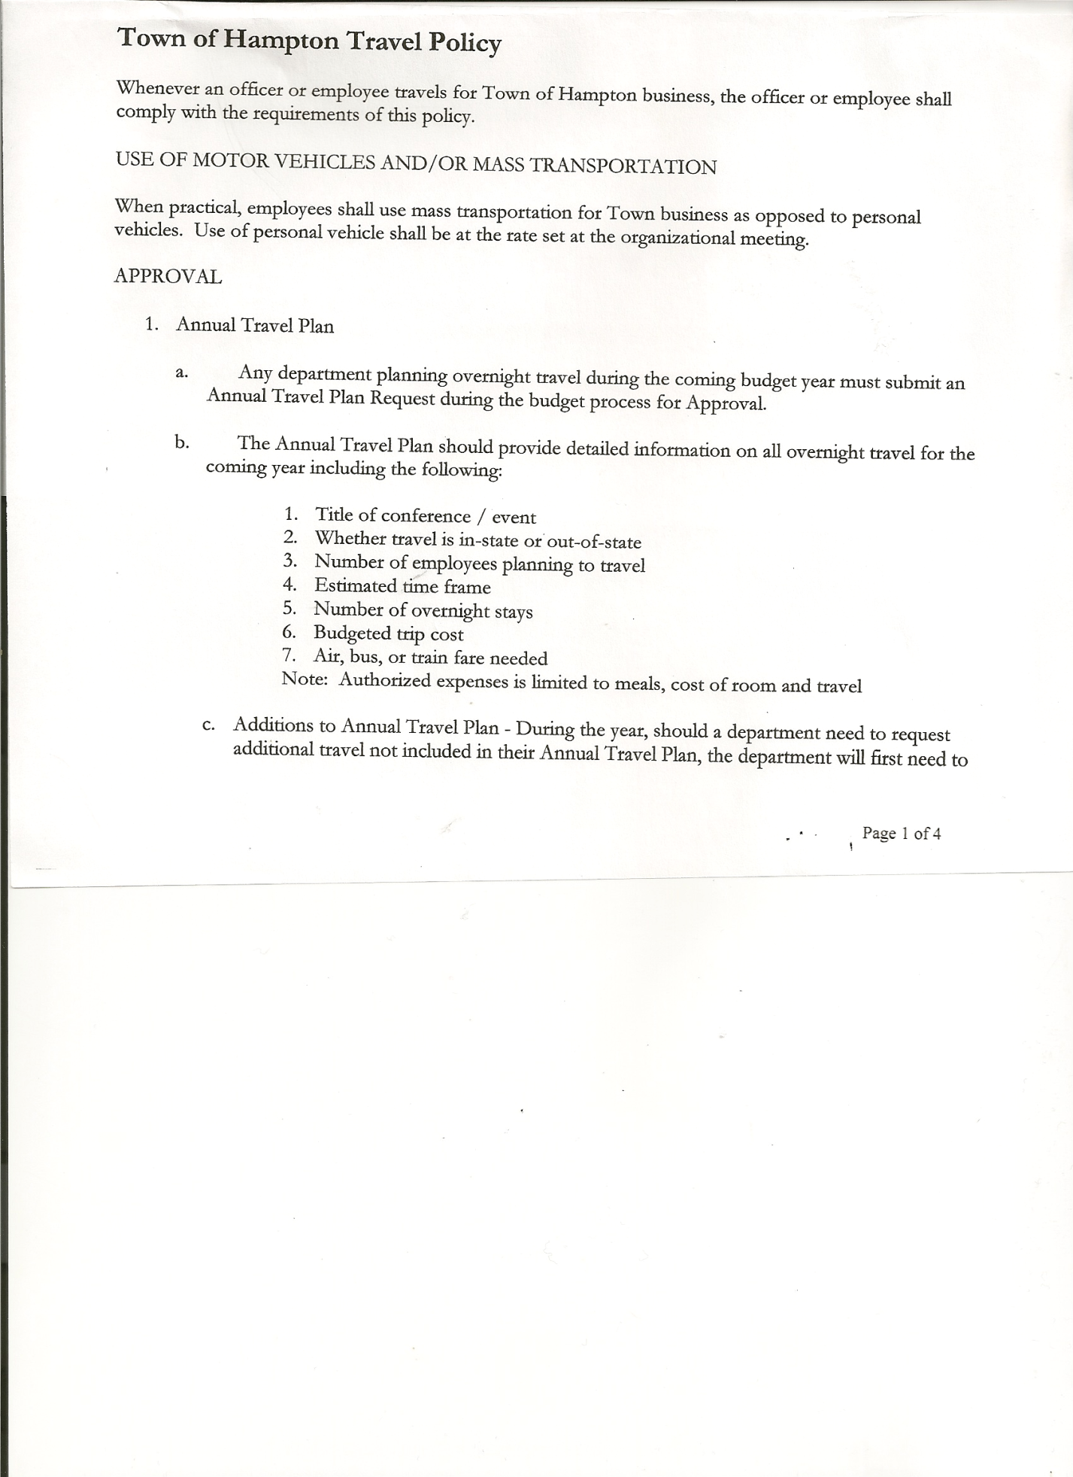 Roger Weeden---------------Councilman

Rebecca Jones---------------Town Clerk

Camilla Shaw----------------Tax Collector/Deputy Town Clerk – came at 7:45pm

Herbert Sady, Jr.-------------Highway Superintendent

Planning Board Member(s): Bonnie Hawley, Chair and Matthew Pratt

Also present: Ed Longley, Highway Employee, William Nikas, Artie Pratt and Leonard Reed

The Regular Meeting was called to order by Supervisor O’Brien at 7:30pm, followed by the Pledge of Allegiance. Location of Fire Exits were given. Quorum of board members present.

**RESOLUTION NO. 63-2019**

**APPROVAL OF THE MINUTES**

On a motion of Councilwoman Taran, seconded by Councilwoman Sweeney, the following resolution was ADOPTED: Ayes 5 O’Brien, Sady, Taran, Sweeney, Weeden

Nays 0

RESOLVED, that the Regular Town Board Minutes for June 20th, 2019 are approved.

**PERMITS/SUBDIVISION**

William Nikas came before the board regarding a Lot Line Adjustment between himself and Mark and Patricia Goodrich.

**RESOLUTION NO. 64-2019**

**SHORT ENVIRONMENTAL ASSESSMENT FORM/NEGATIVE DECLARATION**

On a motion of Councilman Sady, seconded by Councilwoman Taran, the following resolution was ADOPTED: Ayes 5 O’Brien, Sady, Taran, Sweeney, Weeden

Nays 0

RESOLVED, that the Short Environmental Assessment Form is complete and to adopt a negative declaration and finding that there will be no adverse environmental impacts and to consider it a minor subdivision, therefore waving the public hearing.

**RESOLUTION NO. 65-2019**

**APPROVAL OF LOT LINE ADJUSTMENT**

On a motion of Councilman Sady, seconded by Councilwoman Sweeney the following resolution was ADOPTED: Ayes 5 O’Brien, Sady, Taran, Sweeney, Weeden

Nays 0

RESOLVED, to approve the Nikas/Goodrich Lot Line Adjustment.

Leonard Reed, Agent for Doran and Yvonne Pratt, came before the board regarding a Subdivision of 4.87+/- acres.

TOWN BOARD MEETING

JULY 18, 2019 PAGE 2

**RESOLUTION NO. 66-2019**

**SHORT ENVIRONMENTAL ASSESSMENT FORM/NEGATIVE DECLARATION**

On a motion of Councilwoman Taran, seconded by Councilman Sady, the following resolution was ADOPTED: Ayes 5 O’Brien, Sady, Taran, Sweeney, Weeden

Nays 0

RESOLVED, that the Short Environmental Assessment Form is complete and to adopt a negative declaration and finding that there will be no adverse environmental impacts and to consider it a minor subdivision, therefore waving the public hearing.

**RESOLUTION NO. 67-2019**

**APPROVAL OF SUBDIVISION-PRATT**

On a motion of Councilwoman Taran, seconded by Councilman Sady the following resolution was ADOPTED: Ayes 5 O’Brien, Sady, Taran, Sweeney, Weeden

Nays 0

RESOLVED, to approve the Pratt subdivision.

Camilla Shaw, Tax Collector - Zero balance. Submitted a Bank Statement to the Board for review and signatures.

Larry Carman, Dog Control Officer…no report

Supervisor O’Brien advised the Board that Larry recently had knee surgery, therefore he (Supervisor O’Brien) would be acting Dog Control Officer until Larry is able to return.

Planning Board Report…

* Working on Farm Land Ag Protection Plan. Trying to set up a timeline for the plan
* Next meeting will be August 14th, 2019 @ 7:00pm at the Town Hall

Discussed William Miller Cemetery…regarding the celebration being planning in October, would like to build a parking lot, need approval for a driveway off from County Route 11, this needs to be obtained from the County.

Supervisor O’Brien suggested that the people that own the William Miller property might like to take ownership of the Miller Cemetery. Following a discussion, Supervisor O’Brien will check with Johnathan Braun, the individual that donated the additional property which adjoins the current cemetery to the Town, about giving ownership to the William Miller folks.

**HIGHWAY INFO**

Highway Truck Grant still in the process.

Discussed the interest amount of $2771.00 for the BAN (Bond Anticipation Note) this is the amount we owe for one year if we pay off early or not. Second discussion regarding setting up a CD for the Grant money, this is to try and earn some interest to recoup the interest we have to pay.

We have not received the money yet, the following Resolution is being made now, so that when the money is received it can be immediately placed in the CD.

TOWN BOARD MEETING

JULY 18, 2019 PAGE 3

**RESOLUTION NO. 68-2019**

**SET UP CD**

On a motion of Councilman Weeden, seconded by Councilwoman Taran the following resolution was ADOPTED:

By Roll Call Vote: Supervisor O’Brien AYE

Councilman Sady AYE

Councilwoman Taran AYE

Councilman Weeden AYE

Councilwoman Sweeney AYE

RESOLVED, to set up a CD for the Grant money, when it is received.

**FIVE YEAR PLAN**....Highway Superintendent Sady and Councilman Weeden are meeting next week to continue to work on a plan.

**WEX CARD**….to be used to purchase diesel fuel and gas. Municipalities don’t pay taxes/ receive wholesale prices. Local Stations that could be used are: Dunkin Donuts/Stewarts/Maplefield and Macs. Following a discussion on how much it would cost to replace existing tanks versus applying for a WEX card, the following Resolution was introduced.

**RESOLUTION NO. 69-2019**

**WEX CARD APPLICATION**

On a motion of Councilwoman Taran, seconded by Councilman Weeden the following resolution was ADOPTED: Ayes 5 O’Brien, Sady, Taran, Sweeney, Weeden

Nays 0

RESOLVED, to authorize Supervisor O’Brien to apply for WEX card(s).

Ed Longley, Highway Employee suggested to upgrade the “transfer tank” to a 100 gallon tank. This is used to fill other equipment at the Town Garage.

Herbert Sady, Jr., Highway Superintendent submitted his report, copy of which, is attached.

Received communication from NYS Department of Transportation that the Extreme Winter Recovery (EWR) Program was included in the final budget for 2019-20. The Town of Hampton will be receiving $8,424.47. Based on this info, an additional “Agreement To Spend Town Highway Funds” was submitted to the Board.

**RESOLUTION NO. 70-2019**

**AGREEMENT TO SPEND TOWN HIGHWAY FUNDS-ADDITIONAL**

On a motion of Councilwoman Taran, seconded by Councilman Weeden the following resolution was ADOPTED:

By Roll Call Vote: Supervisor O’Brien AYE

Councilman Sady AYE

Councilwoman Taran AYE

Councilman Weeden AYE

Councilwoman Sweeney AYE

RESOLVED, to accept the Agreement to Spend Town Highway Funds as submitted. (Copy is attached).

TOWN BOARD MEETING

JULY 18, 2019 PAGE 4

Councilman Weeden started a discussion in regards to the Highway Superintendent position. Brought up if the position should be an appointed or elected one. Pros and Cons were discussed.

Board will discuss further at a future meeting.

**RESOLUTION NO. 71-2019**

**APPROVAL OF SUPERVISOR’S MONTHLY REPORT**

On a motion of Councilman Sady, seconded by Councilwoman Sweeney, the following resolution was ADOPTED: Ayes 5 O’Brien, Sady, Taran, Sweeney, Weeden

Nays 0

RESOLVED that, the Supervisor’s Monthlyreport be accepted as submitted for **JUNE**

5/31/19 06/30/19

ACCOUNT BALANCE RECEIPTS DISBURSEMENTS BALANCE

General Fund $ 69,417.81 $ 1,012.96 $ 8,364.29 $ 62,066.48

Highway Fund $231,458.51 $ 93,844.41 $ 206,742.52 $ 118,560.40

Equipment Reserve $123,677.57 $ 4.31 $ 93,835.00 $ 29,846.88

Fire #1 $ 41,616.00 $ 0.00 $ 20,808.00 $ 20,808.00

Fire #2 $ 7,756.00 $ 0.00 $ 3878.00 $ 3,878.00

Cemetery $ 1,717.87 $ 2.10 $ 0.00 $ 1,719.97

Totals $475,643.76 $ 94,863.78 $ 333,627.81 $236,879.73

All Board Members present signed Supervisor’s Report.

**NEW BUSINESS**

Present Town Assessor, Mary Ellen Hill-Pierce has informed Supervisor O’Brien that she will be resigning from her position at the end of her term, which is September 30th, 2019. Mary Ellen has recommended Victoria Hayner for the position. Supervisor O’Brien shared Victoria’s letter of interest and resume with the board. Following a discussion, the following resolution was introduced.

**RESOLUTION NO. 72-2019**

**TOWN SOLE ASSESSOR POSITION**

On a motion of Councilman Sady, seconded by Councilwoman Sweeney, the following resolution was ADOPTED: Ayes 5 O’Brien, Sady, Taran, Sweeney, Weeden

Nays 0

RESOLVED, to interview Victoria Hayner for the position of Sole Assessor for the Town of Hampton at the August 15th, 2019 Town Board Meeting.

Reassessment/Revaluation of Hampton properties was discussed. Board will discuss further after hiring a new Town Assessor.

Health Insurance for employees has been renewed, the cost is up 1% for the current plan.

Building Permits… regulations have changed over time, residents should call Code Enforcement in Fort Edward if they have a questions on if they need a permit or not. Town of Hampton has two additional forms for residents to complete, one is for the Assessor and the other is a Construction Use Verification Form, which is used to track if construction is residential or commercial. Following a discussion combining the Town’s two forms into one, the following resolution was introduced.

TOWN BOARD MEETING

JULY 18, 2019 PAGE 5

**RESOLUTION NO. 73-2019**

**CONSTRUCTION QUESTIONNAIRE**

On a motion of Councilman Sady, seconded by Councilwoman Sweeney, the following resolution was ADOPTED: Ayes 5 O’Brien, Sady, Taran, Sweeney, Weeden

Nays 0

RESOLVED, to combine the above two forms for the Town of Hampton.

Portable Book Library….Camilla Shaw, resident and Tax Collector brought before the board a request to build a Portable Book Library outside at the Town Hall. It would be donated by the Mashak family in memory of Millie and Larry Mashak. Following a discussion, the following resolution was introduced.

**RESOLUTION NO. 74-2019**

**PORTABLE BOOK LIBRARY**

On a motion of Councilwoman Taran, seconded by Councilman Weeden, the following resolution was ADOPTED: Ayes 5 O’Brien, Sady, Taran, Sweeney, Weeden

Nays 0

RESOLVED, to have a portable book library built outside of the Town Hall, donated by the Mashak family.

The Town Clerk’s report for June 2019 was submitted to the Board. The Town Clerk had Board Members review and sign bank reconciliation statements for the Town Clerk Account and Special Town Clerk Account dated June 30th, 2019.

**RESOLUTION NO. 75-2019**

# **AUDIT OF CLAIMS**

On a motion of Councilwoman Taran, seconded by Councilman Sady, the following resolution was ADOPTED: Ayes 5 O’Brien, Sady, Taran, Sweeney, Weeden

Nays 0

RESOLVED that the bills have been reviewed by the Town Board and are authorized for payment in the following amounts.

General Fund No. 106 through No. 114 $ 1,955.57

Highway Fund No. 67 through No. 76 $ 9,134.85

Total both funds $ 11,090.42

On a motion of Councilwoman Taran seconded by Councilman Sady, the meeting adjourned at 9:26pm All in favor Aye.

Respectfully submitted,

Rebecca S. Jones, RMC

Town Clerk