Last name : __________________________ First Name:__________________ Middle initial: _____

Preferred Name: _____________________ Email:______________________________________

Birthdate: _____________________ Sex: ___________ Single/Married/Divorced/Widow

Address:______________________________________________________________________

City: __________________ State: _________________________Zip: __________________

Phone: _________________________ Social Security No: _________________________

Occupation:___________________________ Employer: ______________________________

Emergency contact: _______________________________ Phone: _______________________

Relationship:_____________________________________

**Medical Care Information**

Name of family Doctor: _________________________________ Date of last visit: _________

Have you been to a chiropractor: Yes/No Date of Last visit:___________________________

Name of Chiropractor: __________________________________________________________

Present Illness/Conditions:_______________________________________________________

Pregnant: Yes/No

Please mark on the picture where you have had symptoms according to the indicated codes

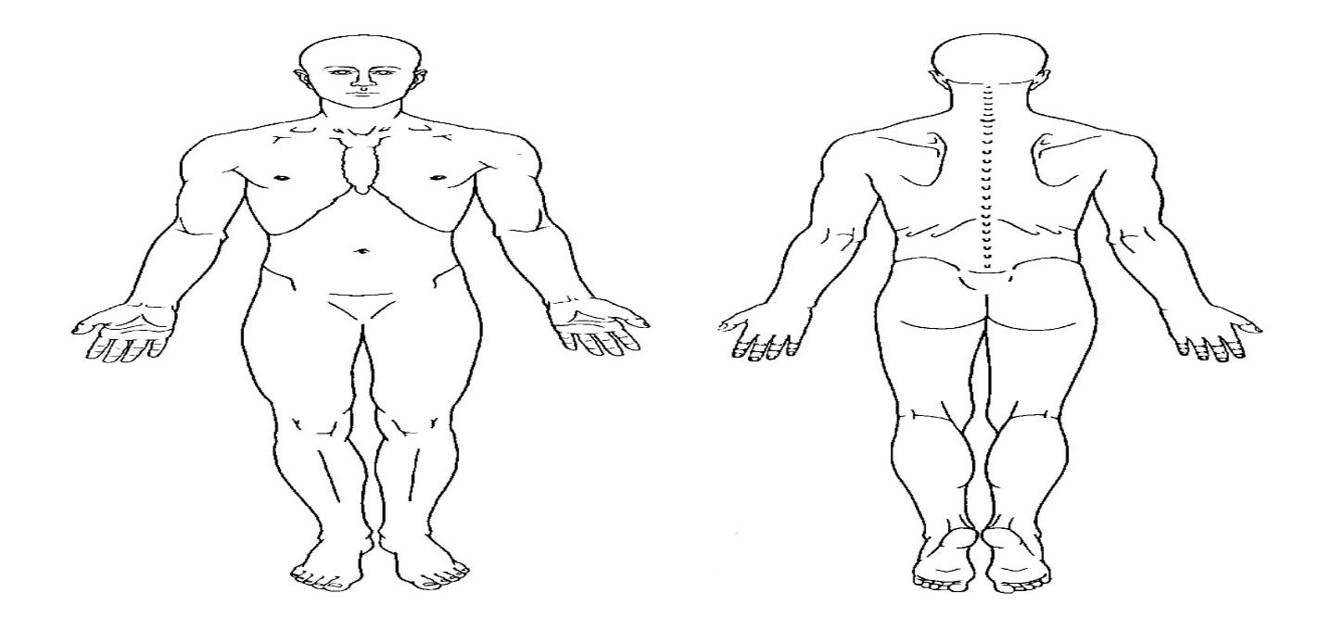 S= Stiffness A= Aching P= Pain N= Numbness T= Tingling B= Burning

Have you had any surgeries in the last 5 years: Yes/No If yes, Last Surgery Date:____________

Reason for surgery: ____________________________________________________________

**Listed below are common symptoms. If you have ever had a listed symptom in the past or present please check that symptom in the appropriate column.**

**Past Present Past Present Past Present**

____ Abnormal Heart Rate _____ ____ Shortness of Breath _____ _____ Skin Itching ____

____ Swelling _____ ____ Cough _____ _____ Ulcer ____

____ Poor Circulation _____ ____ Sinus Infections _____ _____ Heart Attack ____

____ Low Blood Pressure _____ ____ Heartburn _____ _____ Stroke ____

____ High Blood Pressure _____ ____ Abdominal Pain _____ _____ Bladder infection ____

____ Low Appetite _____ ____ Diarrhea _____ _____ Cancer ____

____ High Appetite _____ ____ Constipation _____ _____ Prostate Troubles ____

____ Weight Loss _____ ____ Skin Rashes _____ _____ Breast Troubles ____

____ Weight Gain _____ ____ Eczema _____ _____ HIV / AIDS ____

____ Menstrual Cramps _____ ____ Painful Urination _____ _____ Depression ____

____ Irregular Menses _____ ____Loss of Bladder Control_____ _____ Anxiety ____

____ Menopause Symptoms_____ ____ Frequent Urination _____ _____ Insomnia ____

____ Bed wetting _____ ____ Dizziness _____ _____ Ear Noises ____

____ Headaches _____ ____ Hand Numbness _____ _____ Eye Pain ____

____ Ear Pain _____ ____ Feet Numbness _____ _____ Fatigue ____

**Please mark on the line the pain level (0-10) that most accurately represents your pain:**

**Right Now _________ At Best _________ At Worst ________**

(Pain Scale)

**(NO PAIN) 0 1 2 3 4 5 6 7 8 9 10 (UNBEARABLE PAIN)**

**List any MEDICATIONS:**



**None:**

**List:**

**Allergies:_____________________________________________________**