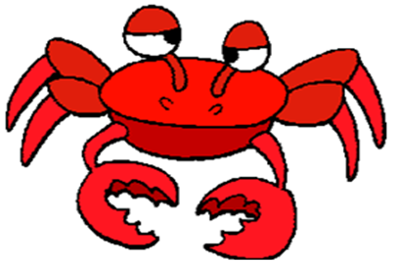
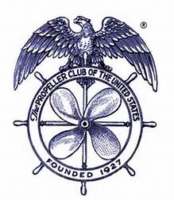
TACOMA PROPELLER CLUB
ANNUAL CRAB FEED
SATURDAY, FEBRUARY 11, 2023
SLAVONIAN HALL
2306 NORTH 30TH STREET
5:00 – 9:00 PM

SPONSORSHIP LEVELS AND VALUES

DUNGENESS - $800
Reserved Table
8 Event tickets & 8 Drink tickets
2 Bottles of wine (1 each red & white) on table
Signage
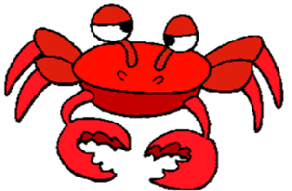
Recognition at event

KING - $500
4 Event tickets & 8 Drink tickets
Signage
Recognition at event

SNOW - $300
2 Event tickets & 4 Drink tickets
Signage
Recognition at event

