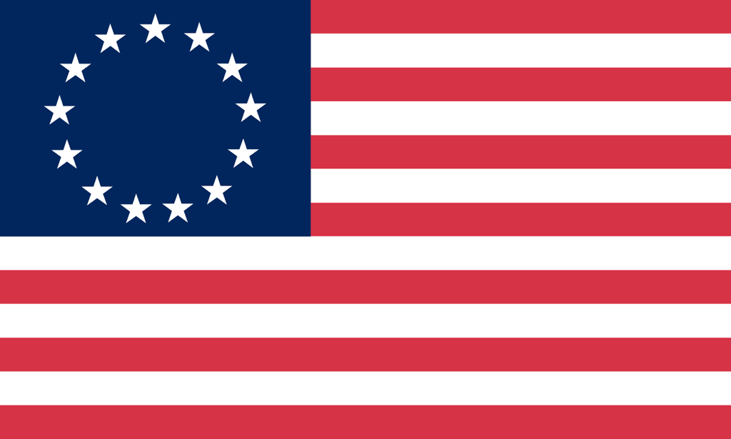U.S. History with Mr. Brown Name _______________________________ Period _____
Constitution Vocabulary Quiz

Directions: Write the correct vocabulary term for each definition below

1) _________________________ People in the government are not above the law

2) _________________________ how each branch can check the others to keep the power balanced

3) _________________________ Power comes from the people

4) _________________________ People elect representatives to vote for them

5) _________________________ Protections in the Bill of Rights

6) _________________________ How power is shared between the state and national governments

7) _________________________ how power is divided into the three branches of

8) _________________________ Search and seizure

9) _________________________ Right to a speedy public trial

10) _________________________ Quartering of troops

11) _________________________ Powers left to the states

12) _________________________ Religious and political freedom

13) _________________________ Cruel and unusual punishment

14) _________________________ Rights of the people

15) _________________________ Trial by jury in civil cases

16) _________________________ Right to bear arms

17) _________________________ Rights of the accused

