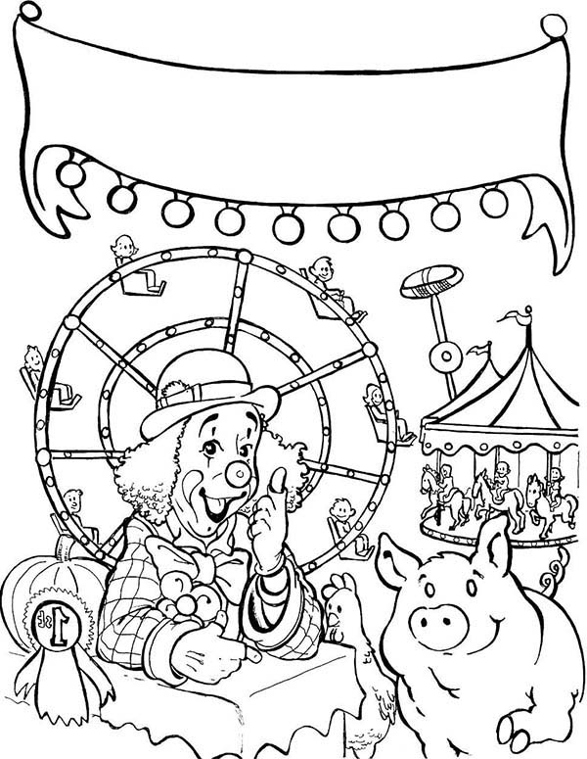

Northeast Montana

Fair 2017