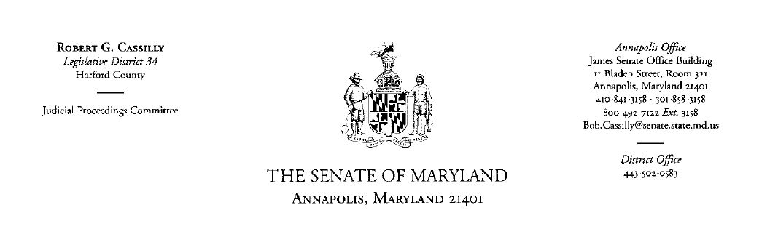

Senatorial Scholarship Application
2018-2019
(Please print clearly or type)

Do not mail your application until ALL of the following have been included:

- Completed application questionnaire
- FAFSA for the year of application (go to your online FAFSA, log in, print copy and include with your application)
- Minimum of two (2) letters of recommendation
- Most recent year of official transcripts

Name_____________________________________________________________
Last First MI

Birthdate __________ Marital Status____________ Maiden Name ___________
(If applicable)

Home Address __________________________________________________________
Number and Street (Apt or other if applicable)

__________________________________________________________ ______________________________City, State, Zip

Do you live in Sen. Cassilly’s legislative district (District 34)? To find your election district, visit www.mdelect.net: ________________

Are you a registered Maryland Voter? ___________________________________

Home phone _____________________ Email ____________________________

Have you received a Senatorial Scholarship previously? If so, when and for what amount? _________________________________

Are you applying as an undergraduate or graduate student? ____________

Maryland Colleges/Universities you have applied to ___________________________________,
_______________________________ , ______________________________________
(Senatorial scholarships may only be used in Maryland public institutions)

Current school _____________________ Current GPA _________

Full or part time status ____________ Credit hours/ semester ______________

Degree desired ____________________ Major ____________________________

Have you been granted Unique Major status by MHEC? __________

Current employer (If applicable)
__________________________________________________________

Hours per week _____________________ Job Title __________________________

Will you work during the academic year for which you are applying for a scholarship? ____________________________

If so, how many hours per week? _____________________________

If you reside with parents or guardians, please complete the following:

Father or Guardian first and last name: _________________________
Father or Guardian occupation and employer: _________________________

Mother or Guardian first and last name: _________________________
Mother or Guardian occupation and employer: _________________________

How many siblings do you have living in the household? ____________________

Ages _____________________ Are they enrolled at the college level? __________

******************************************************************

List all school activities, sports, clubs, honors and offices you have held
______________________________________________________________________
______________________________________________________________________
______________________________________________________________________
______________________________________________________________________

List all community, church or club activities in which you participate
________________________________________________________________________________________________________________________________________________________________________________________________________________________________________________________________________________________________

List special interests or talents
________________________________________________________________________
________________________________________________________________________
________________________________________________________________________
________________________________________________________________________

List all loans, scholarships, grants, awards or any other financial aid and amounts you have been awarded for the 2017-18 academic year OR any previous year, from whom and how much:
________________________________________________________________________________________________________________________________________________

Please explain any additional information you believe the scholarship committee should be aware of when considering your application:
________________________________________________________________________________________________________________________________________________________________________________________________________________________________________________________________________________________________
__________________________________________________________________

Please state why you feel you should receive a Maryland Senatorial Scholarship:
____________________________________________________________________________________________________________________________________________________________________________________________________________________________________________________________________________________________________________________________________________________________________________________________________________

Signature Date

Please return to my office by April 1, 2018.

If you have any questions, you may contact my office at 410- 841- 3158 or email Bob.Cassilly.District@Senate.state.md.us

