5/13/2017 Happening Today 5/13/2017 and Tomorrow

Many timelines are coming to culmination in 2017 and 2018.

We are currently in the 500th year of Protestantism. On October 31, 1517, Martin Luther attached his 95 Thesis to the door of a Cathedral in Germany. The 500th year from 10/31/1517 will end on 11/9/2017.

The reason that the 500 years from 1517 will end on 11/9/2017, and not on 10/31/2017, is that 10 days were dropped from the Roman calendar in 1582 AD in order to bring the seasons back on track. Appropriate leap days (1 additional day every 400 years) were added to the Roman calendar at that time to keep the calendar synchronized with the seasons of the year through the centuries.

Below is a copy of the 1582 calendar showing the 10 missing days.
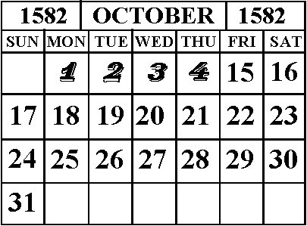

May 13th and 14th 2017

The 100th anniversary of the Fatima Visions that began on 5/13/1917 will occur on 5/13/2017. The very next day, 5/14/2017, will be the 69th anniversary of the establishment of the State of Israel on 5/14/1948. That day, 5/14/2017, will also be the 1st day of the 70th year of modern Israel's statehood.

Below is a graphic showing some timing relationships that were revealed to me by YaHuWaH Elohim on 5/12/2017.

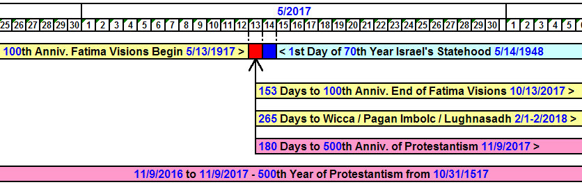

1. The 100th anniversary of the beginning of the Fatima visions is 5/13/2017.

2. The 1st day of the 70th year of Israel's statehood will occur the very next day, 5/14/2017.

3. The end of the Fatima visions occurred on 10/13/1917 with a miraculous event known as "The Miracle of the Sun", exactly 153 days after the visions began on 5/13/1917.

In ancient Greek culture the number 153 was known as "the measure of a fish". It was a geometric symbol formed by the intersection of two circles and used to establish certain mathematical relationships that were used to determine what we call today "the cube root". The cube root in mathematics is used to determine the diagonal measurement between the opposite corners of a cube.

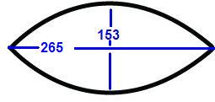
In ancient Greece the Vesica Piscis was used to derive the ratio of 265/153 = 1.732, known in mathematics as the cube root.

The quantity of "153 great fish" is mentioned in John chapter 21. The fish symbol later became a symbol of Christianity because of its relationship with John chapter 21.

Note in the timeline further above that the 100th anniversary of the end of the Fatima visions will occur on 10/13/2017, 153 days from the 100th anniversary of the beginning of the Fatima visions on 5/13/2107.

Note also that 265 days from the beginning of the 100th anniversary of the Fatima visions will bring us to 2/1 - 2/2018, the Wiccan High Day of Imbolc.

YaHuWaH Elohim is now revealing to us that the Fatima visions have a relationship with Wicca, which is Witchcraft.

4. There are 180 days from the 100th anniversary of the beginning of the Fatima visions to the 500th anniversary of Protestantism on 11/9/2017. The 180 days are exactly 1/2 of a prophetic 360 day year, the length of a year in Noah's day.

The numbers 500, 100, 70, 153, and 180 have biblical relevance.

We know that Pope Benedict, who announced his resignation on 2/11/2013, was the 265th Pope. That number, 265, would have signaled a completion the Christian "fish" symbolized by the ratio of 265/153. This means that Pope Francis, the current Pope, is the 266th Pope, and is symbolically "outside the fish".

Indeed Pope Francis is the very first Jesuit Pope. He's different in that respect from all previous Popes. He's also a communist.

The Roman Catholic Jesuits are a military order who have taken oaths to subvert governments by any means necessary, including murders, in order to rule the world. In this respect, the Jesuits are like the Muslims, advancing their religion by instilling fear in society. Both Jesuits and Muslims utilize fear, deceit, lying, and murders to accomplish their goals.

In the timeline above we see representations of three women. One woman is the Mother of Harlots, identified as the Roman Catholic Church. Another woman is her harlot daughter, identified as Protestantism. The third woman is Israel, the wife of YaHuWaH Elohim, who will commence her 70th year of associating with the harlots on 5/14/2017. The harlots want to help Israel out by dividing her land.

Two of the women identify YaHuWaH Elohim's Son YAHUSHUA as their husband, but they memorialize pagan deities each Sunday and at the Feast of Ishtar each year.

YaHuWaH Elohim has set aside appointed days, the weekly Shabbat and the annual Feast Days, for us to enjoy social intercourse with Him and His Son, but church councils had a "better" idea.

YaHuWaH Elohim reveals the timelines and signs in these articles so that we might believe that He actually exists, and that He has the ability to work in the vastness of the heavens and on the earth, in the affairs of governments, and in the intimacy of each of our lives. When we come to the realization that He has abilities beyond human comprehension, then we need to pay attention to what He has to say. He will definitely have better ideas and plans than any human, so why not follow His plans? His ways work.

