REGULAR MEETING
MARCH 16, 2023

The Regular Meeting of the Town Board of the Town of Hampton, County of Washington and the State of New York was held at the Town Hall, 2629 State Route 22A, Hampton, New York, on the 16th day of March 2023.

PRESENT: David K. O’Brien------------Supervisor
Donald Sady----------------- Councilman
Tamme Taran----------------Councilwoman
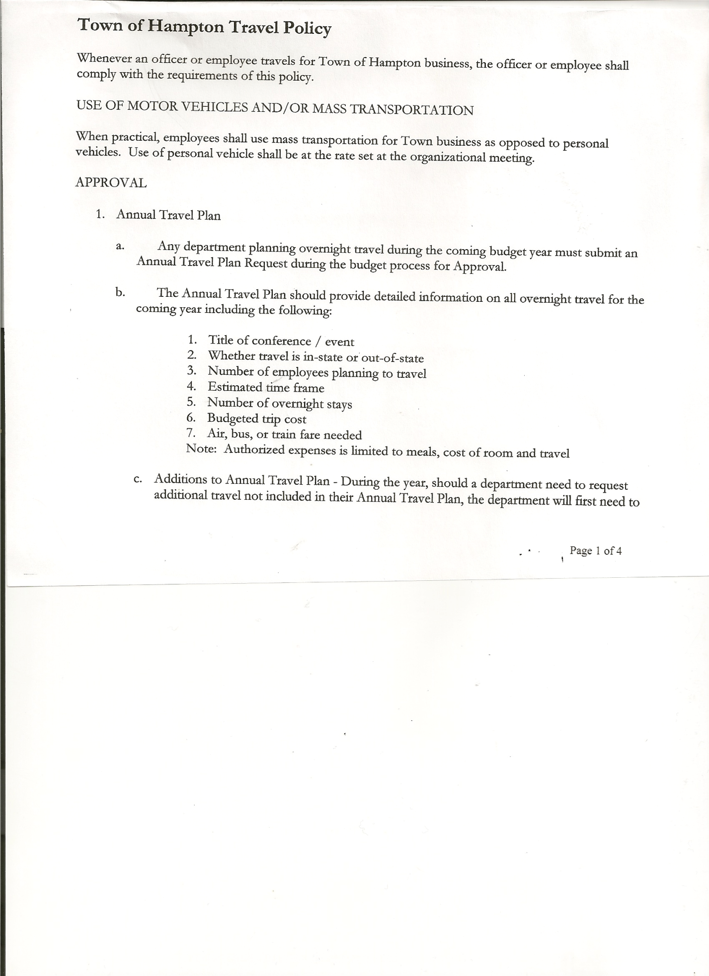
Michael Pietryka------------Councilman
Andrea Kugler---------------Councilwoman
Rebecca Jones---------------Town Clerk
Camilla Shaw----------------Deputy Town Clerk
Tyler McClure---------------Highway Superintendent

Planning Board Member (s):…Bonnie Hawley, Chair; Richard Cole, Matthew Pratt and Renee Rountree
Others present at the Town Hall: see attached sheet

The Regular Meeting was called to order by Supervisor O’Brien at 7:30pm, followed by the Pledge of Allegiance. Location of Fire Exits were given. Quorum of board members present.

Supervisor O’Brien asked for a moment of silence in memory of Nancy Thomas (Matt Thomas’ mom)

RESOLUTION NO. 32-2023
APPROVAL OF THE MINUTES
On a motion of Councilwoman Taran, seconded by Councilman Pietryka, the following resolution was ADOPTED: AYES 5 O’Brien, Sady, Taran, Pietryka, Kugler
NAYS 0
RESOLVED, that the Regular Town Board Meeting Minutes for February 16, 2023 are approved.

Richard Cole resigned as Dog Control Officer effective March 10, 2023. The Board thanked Richard for his service.
Rachel Brown is interested in the Dog Control Officer position. She’s a canine officer with the Dept. of Corrections, has connections and support from Mohawk Hudson Humane Society. Dept. of Ag & Markets sending info on some seminars, they have no “manual”. A resident asked if a manual could be “created” from past situations? Rachel is willing to help write one with help from Mohawk Hudson Humane Society.
The following resolution was then introduced.
RESOLUTION NO. 33-2023
APPOINTMENT OF DOG CONTROL OFFICIER
On a motion of Councilwoman Taran, seconded by Councilwoman Kugler, the following resolution was ADOPTED: AYES 5 O’Brien, Sady, Taran, Pietryka, Kugler
NAYS 0
RESOLVED to, appoint Rachel Brown as Dog Control Officer.

TOWN BOARD MEETING
MARCH 16, 2023 PAGE 2

Tax Collector Report for February was given and copy is attached. Second notices were sent out for 122 parcels. Payments have been slow coming in.

Bonnie Hawley, Chair Planning Board…copy of the notes of their meeting held March 8th, 2023 are attached. Next Planning Board meeting is planned for April 12th, 2023.

Tyler McClure, Highway Superintendent submitted his report, copy of which, is attached.
Supervisor O’Brien has applied for Congressional Member Items funding for money for our roads. The funding in the amount of $650,000.00 is for road improvements mainly to work on some of our unpaved roads. No guarantee that we will receive the funding. The process is long and it could potentially be December or January before we hear whether funding will be provided.

SUPERVISOR’S REPORT/ COUNTY UPDATES/ COMMUNICATIONS

RESOLUTION NO. 34-2023
APPROVAL OF SUPERVISOR’S MONTHLY REPORT
On a motion of Councilman Sady, seconded by Councilwoman Taran, the following resolution was ADOPTED: AYES 5 O’Brien, Sady, Taran, Pietryka, Kugler
NAYS 0
RESOLVED that, the Supervisor’s Monthly report be accepted as submitted for FEBRUARY
01/31/23 02/28/23
ACCOUNT BALANCE RECEIPTS DISBURSEMENTS BALANCE
General Fund $160,343.87 $ 334.68 $ 77,625.42 $ 83,053.13
Highway Fund $401,950.60 $ 6.48 $ 62,239.09 $ 339,717.99
Equipment Reserve $114,958.49 $ 35,002.99 $ 0.00 $ 149,961.48
Fire #1 $ 0.00 $ 46,371.00 $ 0.00 $ 46,371.00
Fire #2 $ 0.00 $ 15,361.00 $ 0.00 $ 15,361.00
Cemetery $ 1,765.91 $ 0.09 $ 0.00 $ 1,766.00
Totals $679,018.87 $ 97,076.24 $139,864.51 $ 636,230.60
All Board Members present signed Supervisor’s Report.

RESOLUTION NO. 35-2023
END OF YEAR AUDIT FOR CHIEF FISCAL OFFICER (BOOKKEEPER)
On a motion of Councilwoman Taran, seconded by Councilwoman Kugler, the following resolution was ADOPTED: AYES 4 Sady, Taran, Pietryka, Kugler
NAYS 0
ABSTAIN 1 O’Brien
RESOLVED, to accept the Chief Fiscal Officer (Bookkeeper) Audit for 2022.

Grievance Day…..due to our Town Assessor having multiple towns, the date for the Board of Assessment Review needs to be rescheduled. The following resolution was introduced.

TOWN BOARD MEETING
MARCH 16, 2023 PAGE 3

RESOLUTION NO. 36-2023

MOTION BY: Councilman Donald Sady
SECONDED BY: Councilwoman Tamme Taran

TITLE: RESOLUTION INTRODUCING PROPOSED LOCAL LAW TO
RESCHEDULE THE DATE FOR HEARING COMPLAINTS BY
THE BOARD OF ASSESSMENT REVIEW

WHEREAS, pursuant to Section 512 of the Real Property Tax Law of the State of New York, the Town Board (the “Board”) of the Town of Hampton (the “Town”) has the authority to adopt a local law rescheduling the date for hearing complaints by the Board of Assessment Review pursuant to Real Property Tax Law Section 512; and

WHEREAS, the Board finds that this law is necessary to coordinate the hearing date with the schedule of the Town’s Assessor who also works with neighboring municipalities in Washington County; and

WHEREAS, a local law has been drafted to reschedule such date for hearing of complaints.

NOW, THEREFORE BE IT RESOLVED by the Town Board of the Town of Hampton as follows:

Section 1. A public hearing shall be scheduled for the consideration of the proposed
Local Law to be held by the Town Board April 20th, 2023 at 7:20pm

Section 2. The Town Clerk is directed to post and publish a notice of said public hearing
in the Manchester Newspapers at least five (5) days before the hearing.

Section 3. This resolution shall take effect immediately.

DATED: March 16, 2023 Supervisor O’Brien AYE
Councilman Sady AYE
Councilwoman Taran AYE
Councilman Pietryka AYE
Councilwoman Kugler AYE

RESOLUTION NO. 37-2023
COUNTY ROADSIDE MOWING CONTRACT
On a motion of Councilman Sady, seconded by Councilwoman Kugler, the following resolution was ADOPTED: AYES 5 O’Brien, Sady, Taran, Pietryka, Kugler
NAYS 0
RESOLVED that, Tyler McClure, Highway Superintendent, be authorized to sign the Washington County Mowing Contract for 2023.
TOWN BOARD MEETING
MARCH 16, 2023 PAGE 4

PUBLIC COMMENTS/COUNCIL COMMENTS
Skenesborough EMS Service…..their costs are escalating, requesting help from the Towns they serve. Supervisor O’Brien suggested $2500.00 for their service. No further action was taken.

Richard Cole, President of Hampton Fire Co….update on the Donation of the Fire Truck to the Indian Reservation in South Dakota….reported they have raised over $10,000 in cash, plus $100,000.00 worth of new and used equipment. A trucker has offered to take the fire truck to South Dakota for cost of fuel, leaving the second week of April. Channel 13 news story helped a lot with obtaining donations.

RESOLUTION NO. 38-2023
AUDIT OF CLAIMS
On a motion of Councilwoman Taran, seconded by Councilman Sady, the following resolution was ADOPTED: AYES 5 O’Brien, Sady, Taran, Pietryka, Kugler
NAYS 0
RESOLVED that the bills have been reviewed by the Town Board and are authorized for payment in the following amounts.
General Fund No.23 through No. 40 $ 3,196.99
Highway Fund No.21 through No. 36 $ 19,610.03
Total both funds $ 22,807.02

The Town Clerk’s report for February 2023 was submitted to the Board. The Town Clerk had Board Members review and sign bank reconciliation statements for the Town Clerk Account and Special Clerk Account dated February 28th, 2023.

RESOLUTION NO. 39-2023
MEETING ADJOURNED
On a motion of Councilman Sady, seconded by Councilwoman Taran, the following resolution was ADOPTED: AYES 5 O’Brien, Sady, Taran, Pietryka, Kugler
NAYS 0
RESOLVED that the meeting adjourned at 9:11pm.

Respectfully submitted,

Rebecca S. Jones, RMC
Town Clerk

