PRIVATE
Swimming
Lessons
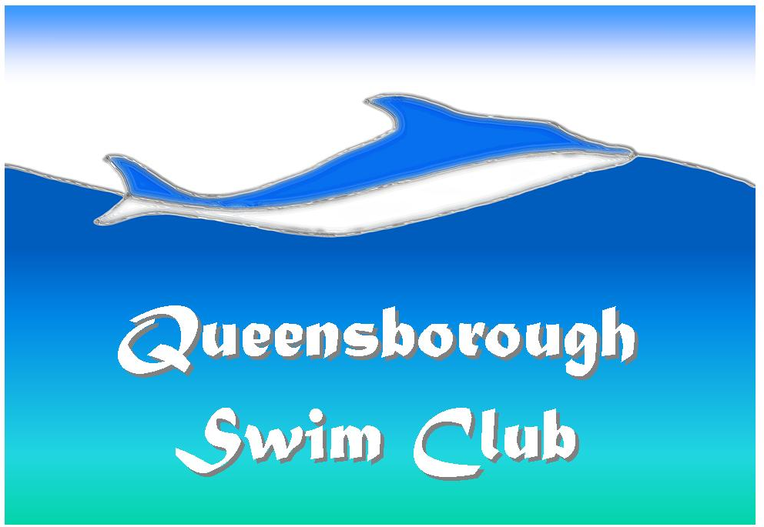
Queensborough Swim Club is located at 1138 Miller Ave., San Jose, CA 95129
Between Rainbow & Bollinger
Who: Ages 2 years to 99 years
What: Learn to Swim
Where: 1138 Miller Ave., San Jose, CA 95129
When: We will accommodate your day/time needs
Cost: PRIVATE: Members: $30/half hour, $50/hour
Non-Members: $40/half hour, $70/hour
SEMI-PRIVATE (2-3 students/lesson):
Members: $20/half hour, $30/hour
Non-Members: $25/half hour, $40/hour
For Complete Registration Information, email us at info@QBPool.org or call us at 408-446-3921.

