If you are going into 6th grade, read one of these books over the summer.
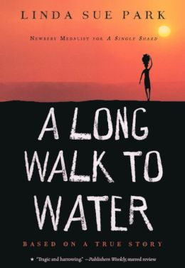
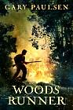
Woods Runner
By Gary Paulsen
$8.00
A Long Walk to Water
By Linda Sue Park
$8.00

If you are going into 7th grade, read one of these books over the summer.
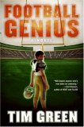
Football Genius
By Tim Green
$7.00
11 Birthdays
By Wendy Mass
$7.00

If you are going into 8th grade, read one of these books over the summer.
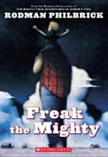
Freak the Mighty
By Rodman Philbrick
$7.00
This Dark Endeavor
By Kenneth Oppel
$11.00

