Application Instructions

Please fill out ONLY the following on each page.

-Page 1 is a truck and driver requirements page

-Complete all of the Application, Previous Employment, and Accident Record to the best of your ability. (pages 2-5)

-All four lines of page 6.

-Fill out driver name, date of employment, license number, state and expiration. Also fill out conviction/violations portion, if any, date and sign. Leave bottom portion of this page blank. (page 7)

-Date and sign and print (page 8)

-Fill out the first 4 lines only on Request from Previous Employer page. (page 9)

-Driver’s signature and SSN only on Request for Drug-Alcohol Results page. (page 10)

-Print, sign, SSN and date Consumer Report Disclosure and Drug Release page. (page 11)

-Answer yes or no, sign and date CDL Applicants page. (page 12)

-Sign, print, and date Zero tolerance policy. (page 13)

-Fill out vehicle information. (page 14)

-Fill out all of W-9. (page 15)

**Send us the completed application via email fax at 260-768-4953 or by mail to

MDZ Trucking, LLC
9270 W US Hwy 20
Shipshewana, IN 46565

MDZ Trucking, LLC
9270 W US Highway 20
Shipshewana, IN 46565
Phone: 260-768-2030
Fax: 260-768-4953

All Driver Requirements:
- Minimum of 2 years commercial verifiable driving experience.
- Required to pass a mandatory Company Drug Screening. (Driver pays)
- Photocopy of Social Security Card.
- A for hire or commercial driver license.
- Photocopy of DOT Physical. (Long form & card)
- Signed request for MDZ, LLC to acquire MVR for prospective driver. Need recertification yearly with Safety Department.
- No DUI or DWI Convictions in the past 5 years.
- No more than (2) moving violations in a (2) year period.
- No more than (2) accidents in the last (2) years. (Regardless of fault)
- No more than (3) active points on driving record for last 24 months.
- Minimum of 23 years of age.
- Must have satisfactory work history.

Equipment Requirements:
All trucks must be leased to MDZ Trucking only!
- Permanent MDZ signs are required. (1st set supplied by MDZ)
- Minimum of ¾ ton truck with 8 foot bed.
- Truck no more than 10 years old.
- Certificate of Insurance.
Must have unladen liability of $1,000,000 on declaration page with expiration dates and collision.
- Current vehicle registration with suggested weight of 22,000# - 26,000#.
- Annual DOT Truck Inspection.
- Required to have 5th wheel plate rated at 20,000 lbs. or more.
- Minimum of Class 4 or 5 receiver hitch rated at 10,000 lbs. or more with equalizer bars. Hitch must be between 18-22 inches high.
- Required to have 2” and 2 5/16” ball hitch.
- Trucks are required to have the following installed:

  - RV style mirrors
  - Electric brake control
  - Bargman 7-prong electric hook-up
  - Mud flaps 6” from the ground
  - Spare fuses
  - Marine battery and box
  - ¾, 13/16, & 7/8; ½ in drive sockets
  - ½ in drive torque wrench
  - Gauged fire extinguisher (mounted)
  - Jack
  - (3) Emergency triangles
  - 6’ Safety Chain with hook on each end
  - Camera/Phone
  - Electronic Toll Transponder

- MDZ requires all drives to log to their destination and the return trip. Logs must be turned in current. Fuel receipts are required to be turned in with driver logs.
- Outbound tolls (Provided the route is stated on a PC miler), washes and permits are reimbursed.
- Driver is responsible for the first $2,000 of accidents, $1,000 put in escrow at 10% of the settlement.
- We recommend that you also have additional hitches to help with backhauls.

  - Gooseneck
  - Pintle Hook

MDZ Trucking, LLC
9270 W US Hwy 20
Shipshewana, IN 46565

Independent-Contractor Driver’s Application
(Please print)

Applicant Name _____________________________________Date___________________
Last First Middle

Social Security Number _____/_____/_____ Date of Birth _____/_____/_____

Current Address _______________________________ City________________________

State_______ Zip Code_____________ How Long? _______ Phone # ________________

Email: _________________________@____________.com DL #______________________

List Addresses for previous 3 years. Use additional sheet if necessary.

______________________________________________________ How long? _________
Street City State & Zip

______________________________________________________ How long? _________
Street City State & Zip

______________________________________________________ How long? _________
Street City State & Zip

Do you have the legal right to work in the United States? ___________________________

Have you worked for this company before? ______ If so when? From_______ To _______

Position Held ____________________ Reason for leaving _________________________

Have you ever been convicted of a felony? ________ If yes, please explain in detail on a separate sheet of paper. Conviction of a felony is not an automatic denial of becoming an Independent-Contractor. All circumstances will be reviewed and considered.

Education
Last Grade Completed _____________ College__________ Additional Training________

Last School Attended ___________________________ City ___________ State _______

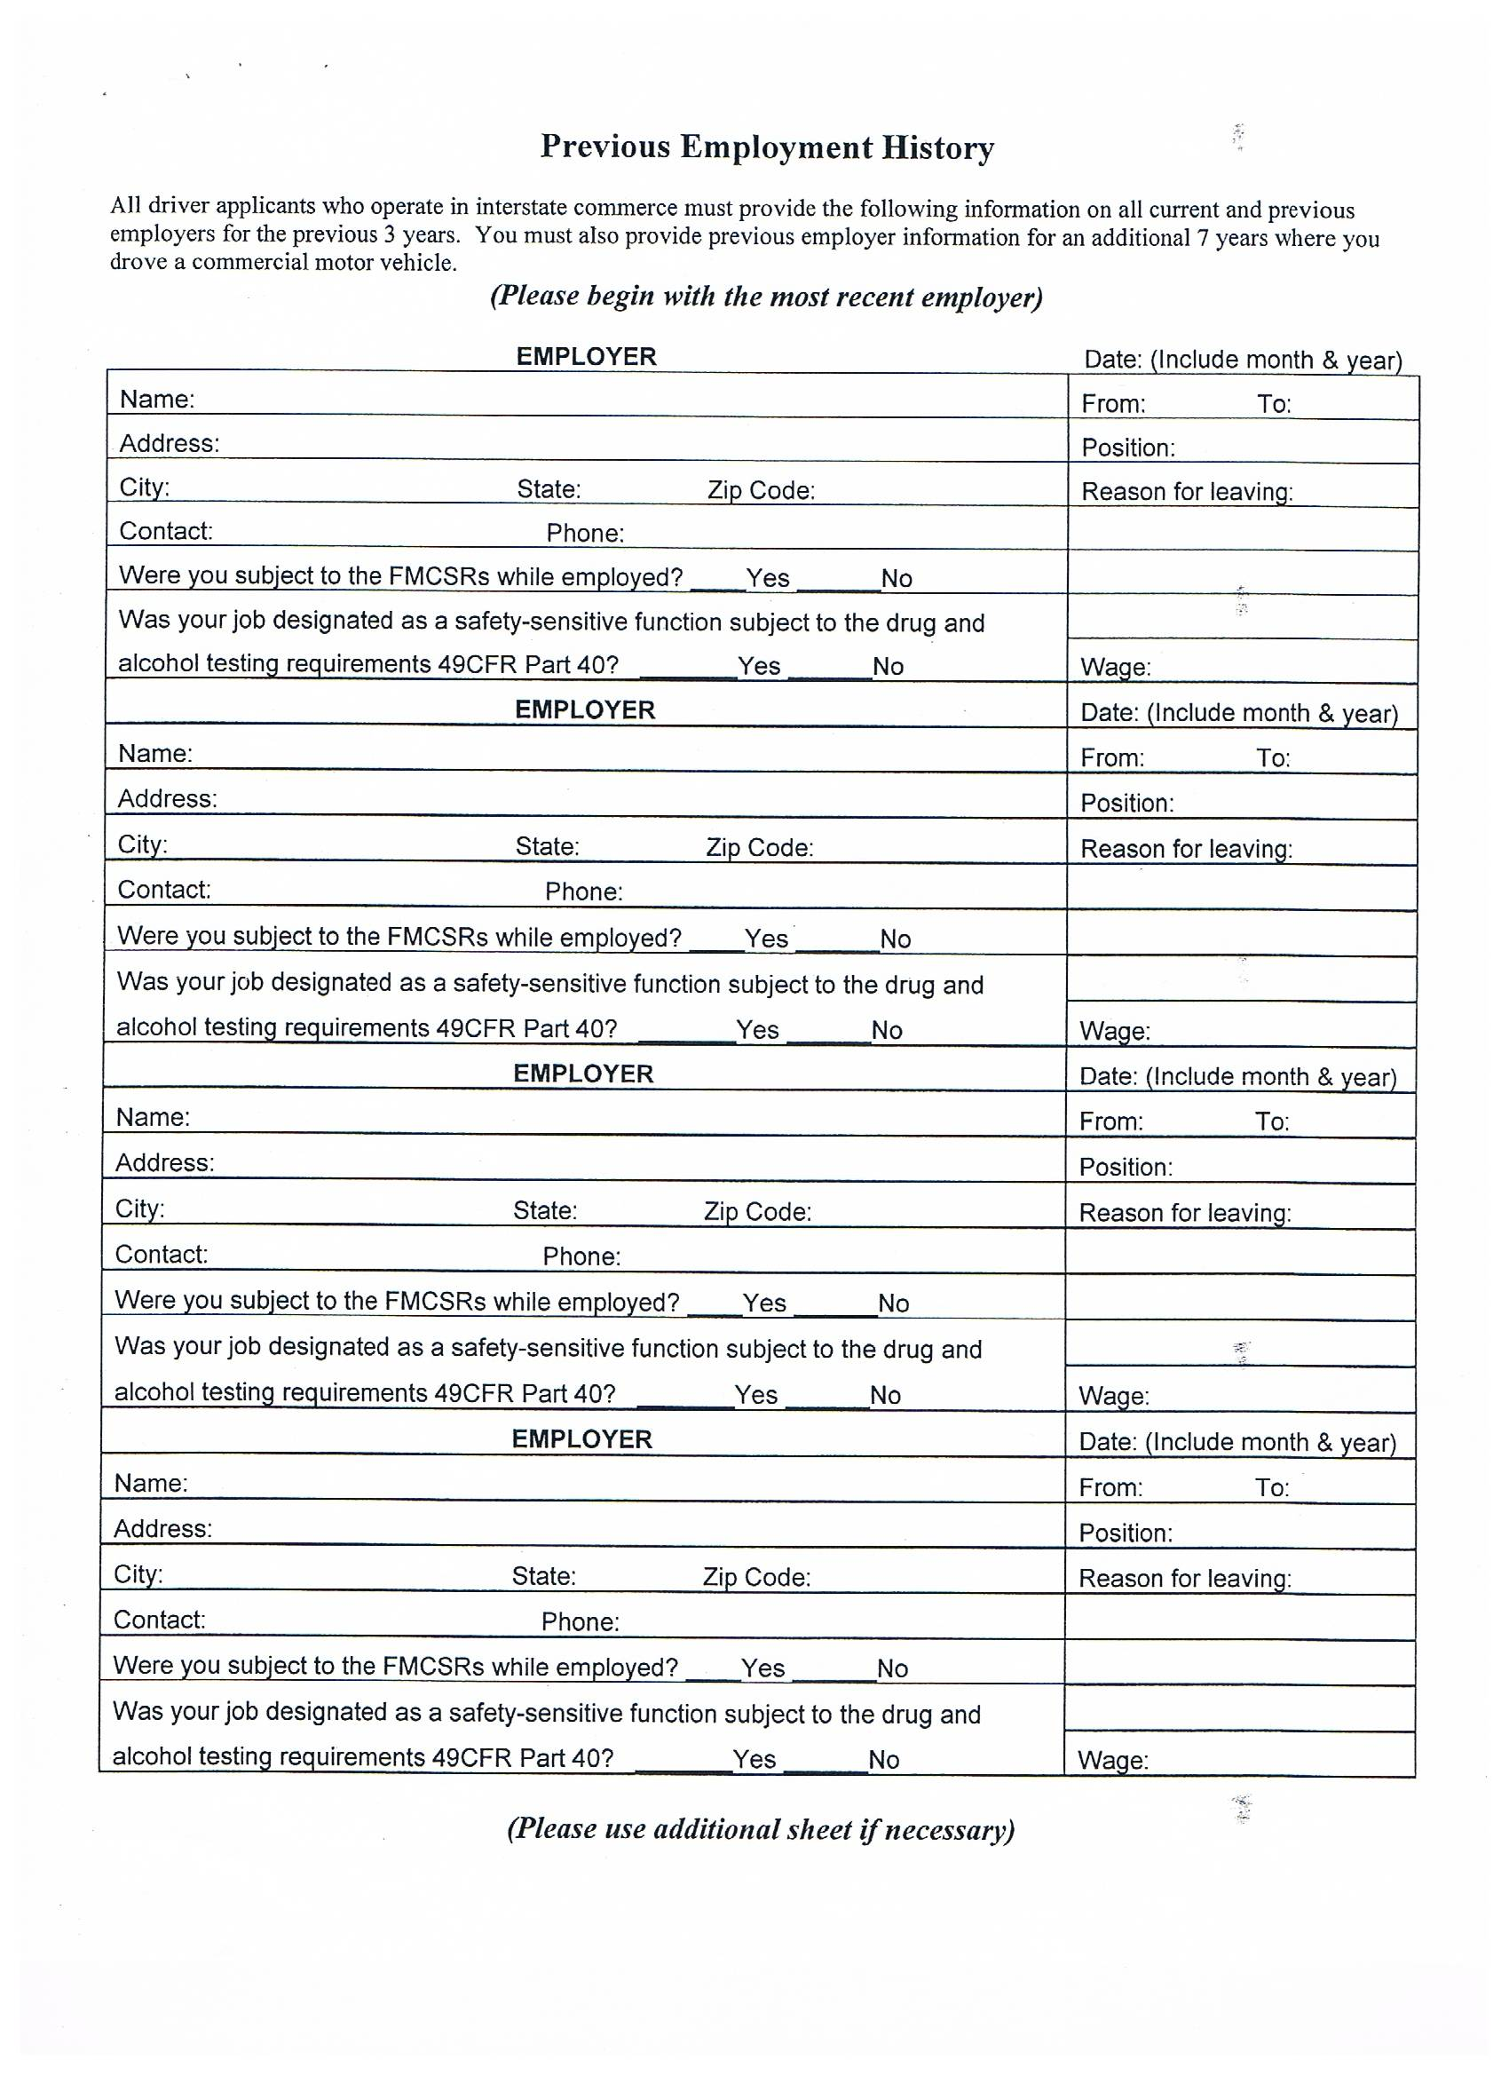

DECLARATION OF EMPLOYMENT STATUS

I understand that I must provide my complete employment history for the past 3 years, and all CDL required employment for the 7 years preceding that. Any gaps in employment longer than 1 month are explained as follows:

From: ________________ to ____________
Date Date

During this time, I was engaged in the following activity:

________________________________________________________________________________________________________________________________________________________________
________________________________________________________________________________________________________________________________________________________________
________________________________________________________________________________________________________________________________________________________________________________________________________________________________________________________________________________________________________________________________________________________________________________________________________________________________________________________________________________________________

In addition:

_______ I was not employed by any company or individual

_______ I was not convicted of any criminal act involving the use of a commercial motor vehicle or while driving a commercial motor vehicle

Signature: ________________________ Date: _____________________

***Please compete a separate form for each employment gap***
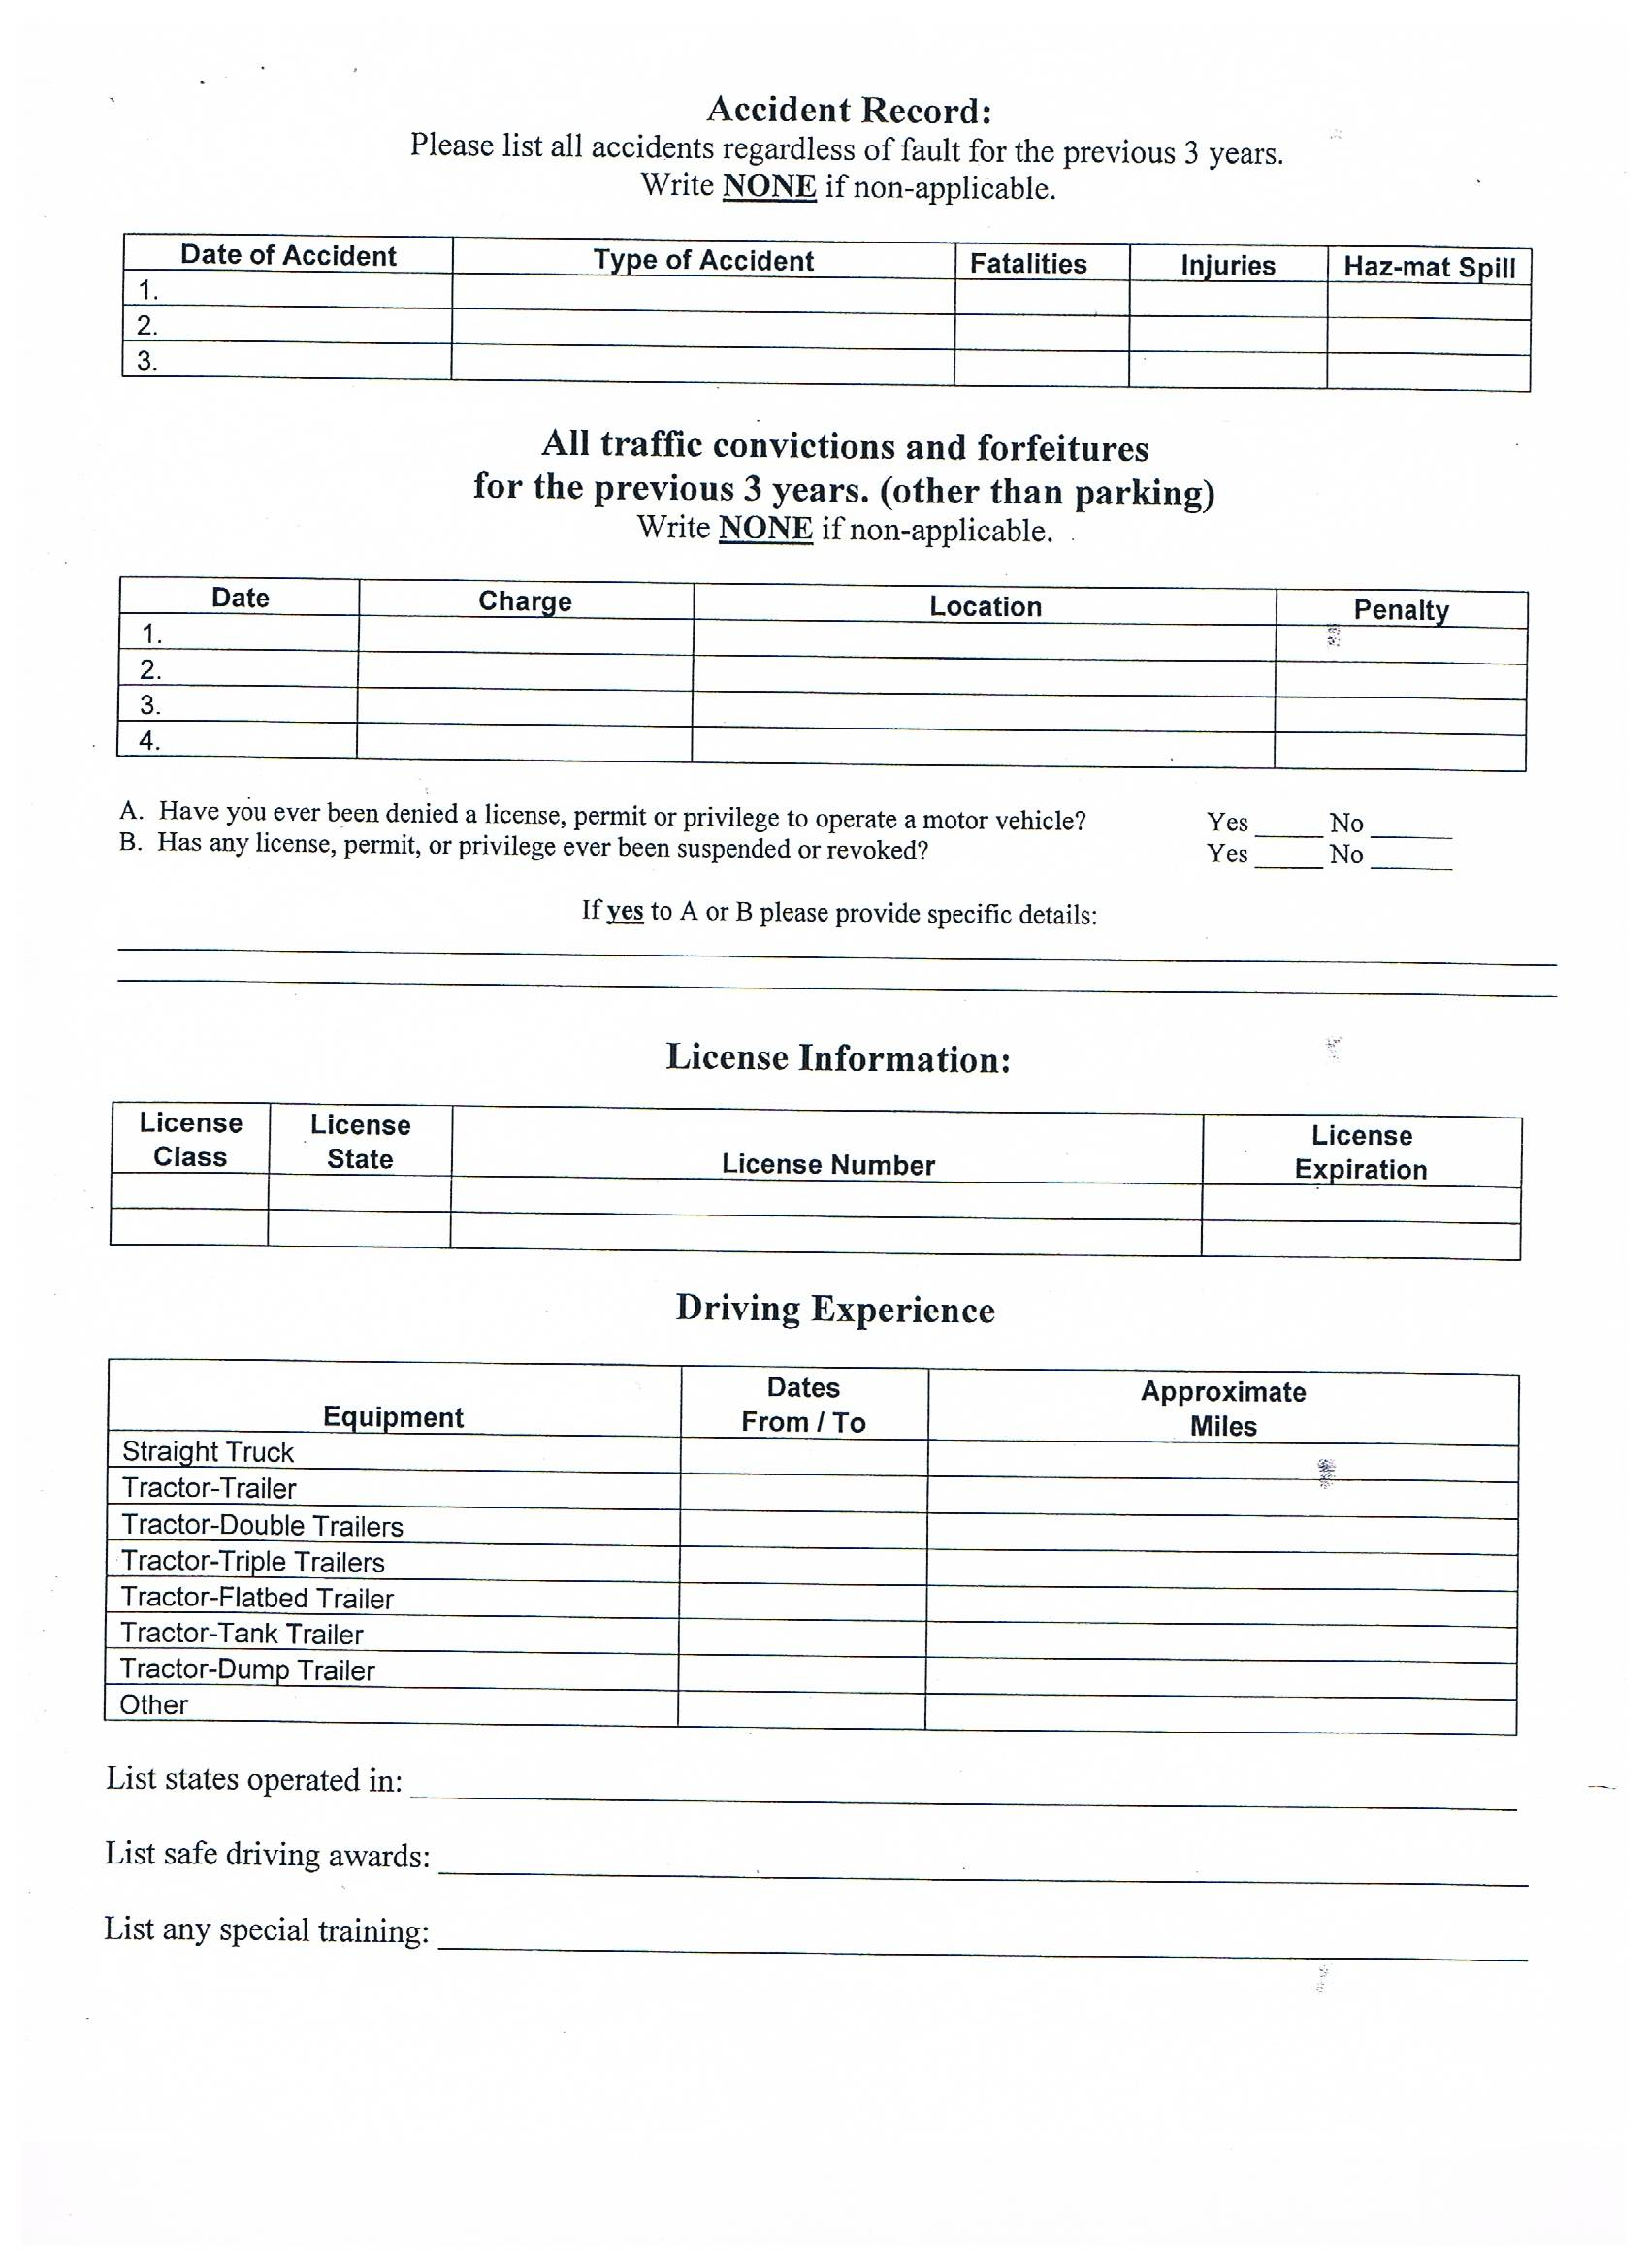
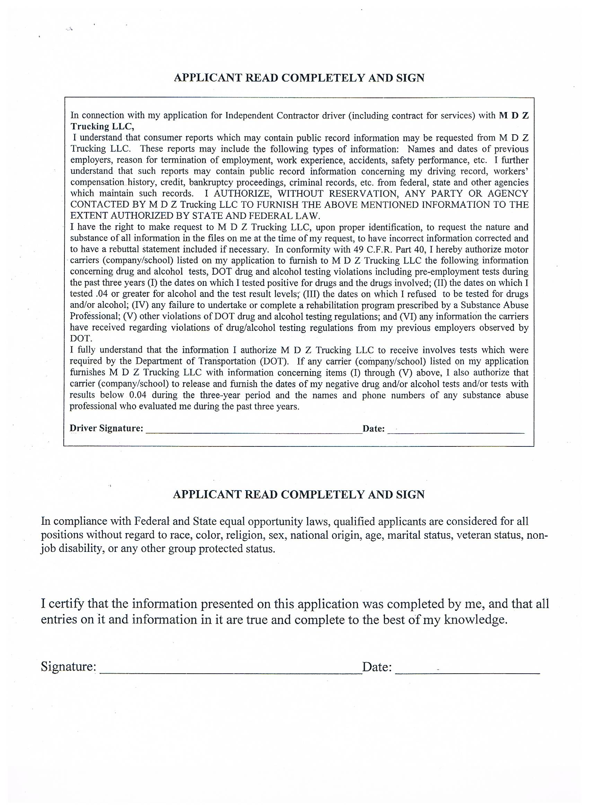
MOTOR VEHICLE DRIVERS
Certification of Violations/Annual Review of Driving Record
CERTIFICATION OF VIOLATIONS-COMPLETED BY DRIVER

Driver Name (please print)  First Middle Last |  | Date of Employment
Home Terminal (City/State)  Shipshewana, IN | Driver’s License Number |  | State | License Expiration

I certify that the following is a true and complete list of traffic violations (other than parking violations) for which I have been convicted or forfeited bond or collateral during the past 12 months.

Date of Conviction Offence Location Type of Motor Vehicle Operated
___________________ _______________ ________________ ____________________________

___________________ _______________ ________________ ____________________________

___________________ _______________ ________________ ____________________________

___________________ _______________ ________________ ____________________________

If no violations are listed above, I certify that I have not been convicted or forfeited bond or collateral on account of any violation required to be listed during the past 12 months.

Date of Certification: ______________________ Driver’s Signature: ________________________

COMPLETED BY MOTOR CARRIER-ANNUAL REVIEW OF DRIVING RECORD

MOTOR CARRIER: Each motor carrier shall, at least once every 12 months, require each driver it employs to prepare and furnish it with a list of all violations of motor vehicle traffic laws and ordinances (other than violations involving only parking) of which the driver has been convicted or on account of which he/she has forfeited bond or collateral during the preceding 12 months. (FMCSR 391.27)

I have hereby reviewed the driving record of the above names driver in accordance with section 391.25 and find that he/she check one:

Meets minimum requirements for safe driving Is disqualified to drive a motor vehicle pursuant to Section 391.15

Does not adequately meet satisfactory safe driving performance

Reviewed by: ____________________________ Date: ____________________

Printed Name: ___________________________ Title: ____________________
MDZ Trucking, LLC

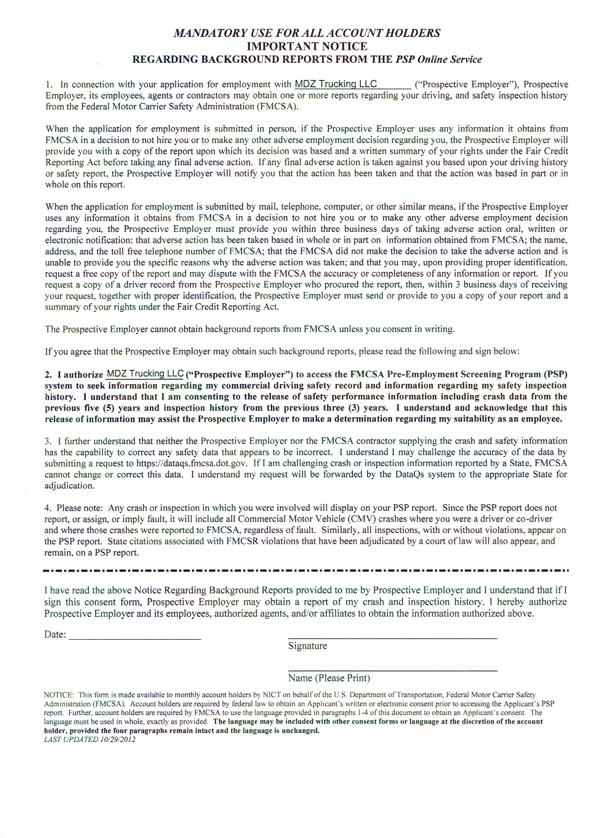
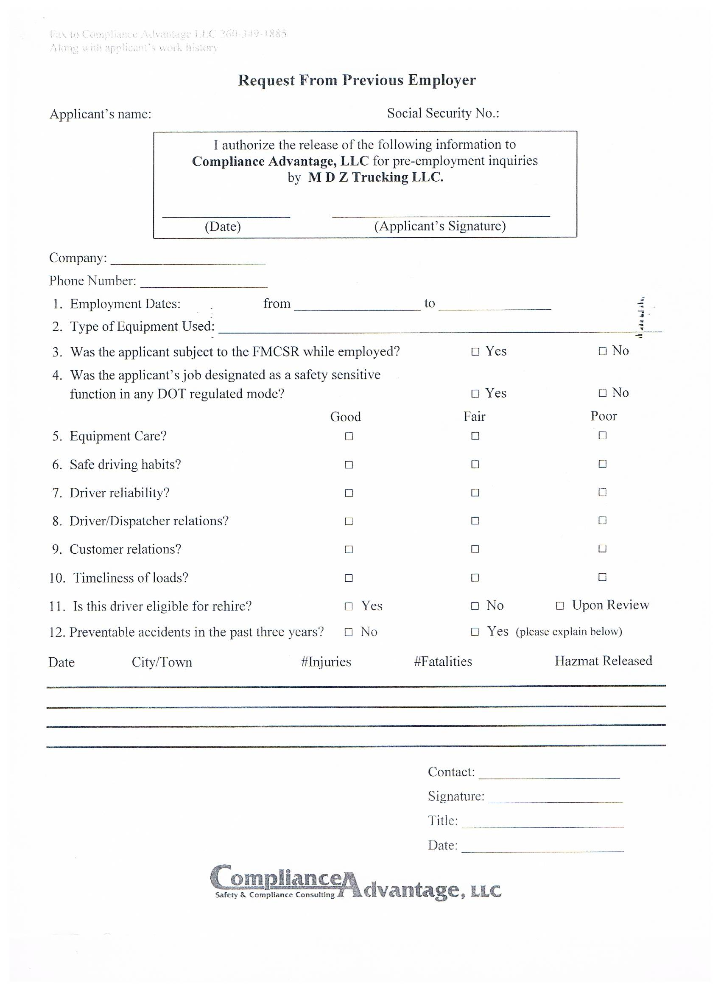
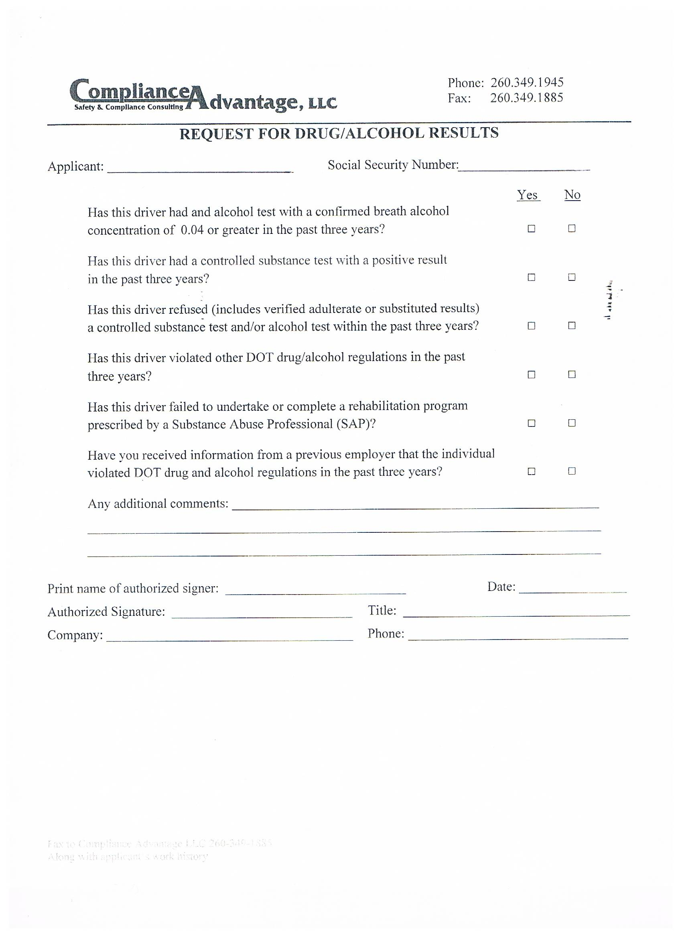
CONSUMER REPORT DISCLOSURE AND DRUG RELEASE

In connection with my application for employment (including contract for services) with MDZ Trucking
LLC,
I understand that consumer reports which may contain public record information may be requested from Compliance Advantage, LLC. These reports may include the following types of information: Names and dates of previous employers, reason for termination or employment, work experience, accidents, safety performance, etc. I further understand that such reports may contain public record information concerning my driving record, workers’ compensation history, credit, bankruptcy proceedings, criminal records, etc. from federal, state and any other agencies which maintain such records. I AUTHORIZE, WITHOUT RESERVATION, ANY PARTY OR AGENCY CONTACTED BY COMPLIANCE ADVANTAGE TO FURNISH THE ABOVE MENTIONED INFORMATION TO THE EXTENT AUTHORIZED BY STATE AND FEDERAL LAW.
I have the right to make a request to Compliance Advantage LLC, upon proper identification, to request the nature and substance of all information in the files on me at the time of my request, to have incorrect information corrected and to have a rebuttal statement included if necessary. I also understand that Compliance Advantage LLC forwards all information obtained on me to the carrier listed below and does not retain information in their files for future reference. I hereby consent to your obtaining the above information from Compliance Advantage, LLC.
In conformity with 49 C.F.R. Part 40, I hereby authorize the carriers (company/school) listed on my application to furnish to Compliance Advantage LLC on behalf of the Company listed below the following information concerning drug and alcohol tests, DOT drug and alcohol testing violations including pre-employment tests during the past three years (I) the dates on which I tested positive for drugs and the drugs involved; (II) the dates on which I tested .04 or greater for alcohol and the test result levels: (III) the dates on which I refused to be tested for drugs and/or alcohol; (IV) any failure to undertake or complete a rehabilitation program prescribed by a Substance Abuse Professional; (V) other violations of DOT drug and alcohol testing regulations; and (VI) any information the carriers have received regarding violations of drug/alcohol testing regulations from my previous employers observed by DOT.
I fully understand that the information I authorize Compliance Advantage LLC to receive involves tests which were required by the Department of Transportation (DOT). If any carrier (company/school) listed on my application furnishes Compliance Advantage LLC with information concerning items (I) through (V) above. I also authorize that carrier (company/school) to release and furnish the dates of my negative drug and/or alcohol tests and/or tests with results below 0.04 during the three-year period and the names and phone numbers of any substance abuse professional who evaluated me during the past three years.

Company City State

MDZ Trucking, LLC Shipshewana IN

By signing below, I certify that I have read and fully understand the release.

Print name: __________________________ Signed: ___________________________
(Applicant signature required)

SSN: _______-______-_________ Date: _____/_____/_____

MDZ Trucking, LLC
9270 W US Hwy 20
Shipshewana, IN 46565

CDL Driver Applicants for Hire:

§40.25 (j) of the Federal Motor Carrier Safety Regulations requires a motor carrier to
ask if you have ever tested positive, or refused to test on any pre-employment drug
or alcohol test administered by an employer to which you applied for, but did not obtain,
safety-sensitive transportation work covered by DOT agency drug and alcohol testing
rules during the past two years?

Ye Yes: ________ No: ________

Signature: _______________________ Date: _____/_____/______

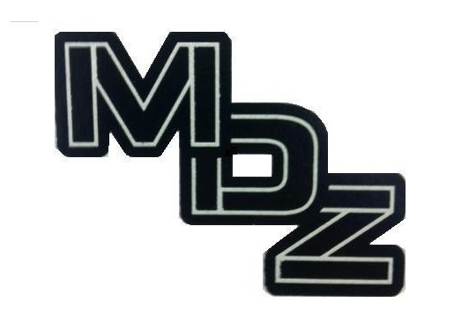
MDZ Trucking, LLC
9270 W US Hwy 20
Shipshewana, IN 46565

MDZ Trucking, LLC has a zero tolerance policy on drug use. If you test positive for narcotics during the pre-employment process you will not be hired. There will be no exceptions. MDZ strives to provide a safe and drug free environment.

______________________ Signature

______________________ Print Name

______________________ Date

______________________ MDZ Representative

Vehicle Information

Pick Up Truck
Year __________________
Make __________________
Model _________________
VIN ___________________

Haul & Tow
Year __________________
Make __________________
Model _________________
VIN ___________________
Bed Length _____________

Tractor
Year __________________
Make __________________
Model _________________
VIN ___________________

