WHO SHOT DOWN MALAYSIAN AIRLINE MH17?

**By**

**Marguerite dar Boggia**

On July 17, 2014 a Boeing 777-200 passenger plane, operating Malaysia Airlines Flight 17, crashed east of Donetsk in the Ukraine. All 298 on board were killed. The flight departed from Amsterdam-Schiphol Airport, The Netherlands at 12:14 PM hours local time (10:14 AM UTC) bound for Kuala Lumpur, Malaysia.

It is helpful if one understands the history and the psychology of the people that were involved in this tragedy. Ukraine had been under the cruel rule of Stalin's Russia for many years. Stephen Bandera, a patriot of Ukraine, wanted freedom for Ukraine from Russia. He teamed up with Hitler and had Jews, Poles and Russians killed by the thousands.1 He was mistaken in the belief that Hitler would aid him to establish an independent Ukraine. He is idealized by the Neo Nazis. Later the name of their party, Neo-Nazi was changed to Svoboda. The Right Sector Militia is even more violent. Their support is from 10% of the population.

Viktor Yanukovych was a candidate to be president. The election was set for February, 2014. The EU handed him a package and an agreement for him to sign in order to become a part of the EU. However, the economic terms offered by the EU were not favorable at all, so when Putin offered better financial terms, he accepted them. That was when organized violence and shooting on the streets began with snipers on the roofs, killing police, Neo Nazis, and people on the street. Members of President Yanukovich’s ruling party, the Party of Regions, have been shot, had arrest warrants issued for them, have experienced home invasions and physical threats, and **resigned in droves** in hopes of saving the lives of themselves and their families. The prosecutor’s office in the Volyn region (western Ukraine) had been ordered by ultra-nationalists to resign en masse. Jewish synagogues and Eastern Orthodox Christian churches were attacked.2 Then the Neo Nazis placed themselves in positions of power: security, defense, the armed services, Intelligence, police force, etc. They had orders to kill everyone in Yanukovych's party. Yanukovich was frightened and fled to Russia. The Crimeans were frightened and asked Vladimir Putin for protection. Putin sent Russian soldiers. Later the Crimeans voted to be part of Russia.

On May 2nd, 2014, the Neo-Nazis, Right Sector Militia and football players burned the Trades Union building in Odessa, causing people inside, to be BURNED ALIVE. Those who tried to escape from windows were shot and some were strangled. All this was seen on Russian TV. The U.S. never called for an investigation3. Then there was an election in June 2014, but Eastern Ukraine was NOT represented. Petro Poroshenko, the chocolate billionaire, was elected.

This is a picture of the MH17 which appeared on the internet right after the crash, when it was immediately withdrawn, but Luftshansa pilot Peter Haisenko made a copy of it to study.

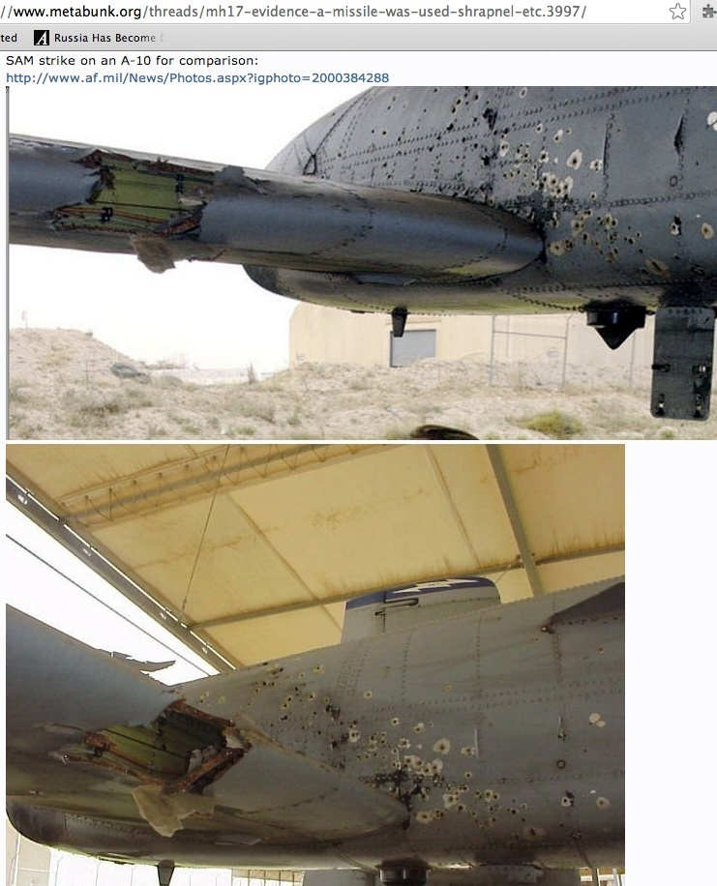

On July 17th, 2014 an order was given to the Ukraine air traffic controller to change the flight path of MH17. This placed the aircraft closer to Donetsk, where there was fighting. When the plane crashed, the air traffic controller, Carlos, a citizen of Spain, tweeted that two fighter jets, escorting the airliner, caused the crash. He and his family have received death threats. He was deported from Ukraine. In Spain he gave further details: There was conflict between the Ministry of Interior and the Ministry of Defense. The Ministry of Interior is controlled by the Neo Nazis.4 Evidence is now conclusive for this mass murder: Two fighter jets brought down the MH17.5

The CORPSE OF THE PILOT IS BEING HIDDEN EVEN FROM HIS FAMILY. It might show bullet holes.6 Netherlands, Belgium, Australia and Ukraine formed the Investigative Commission. Later they included Malaysia, after it complained. After a year and four months an investigative report was made in 12/15. It concluded that a buk missile caused the crash. That a high energy object hit the plane. They never interviewed the air traffic controller who saw two fighter jets escorting the airliner, and they never considered the picture of the cockpit with bullet holes, which first appeared on the internet. Luftshanser Pilot Peter Haisenko had made a copy of it. He posted an extremely high-resolution image from that photo. And here it is: <<http://www.anderweltonline.com/fileadmin/user_upload/PDF/Cockpit-MH017.pdf>>. It shows unequivocally that some of the bullet-holes were inbound while others of them were outbound: No high-powered missile (or shrapnel therefrom) hitting the airliner could possibly have produced firing into the cockpit from both sides of the plane. It had to have been a hail of bullets from both sides, that brought the plane down. You can’t have projectiles going in both directions — into the left-hand-side fuselage panel from both its left and right sides — unless they are coming at the panel from different directions. This is what rules out any ground-fired missile.

In June, 2015, President Poroshenko was so frightened, that he asked the Supreme Court of Ukraine to declare that his predecessor, Viktor Yanukovitch, as the legal representative and that his administration was a COUP. The Nato Nations placed NUCLEAR warheads directed at Russia in Ukraine.7 He cannot control the neo-Nazis in his government. Poroshenko realizes that it will be Ukraine that will be decimated by a nuclear war; and all this, for the purpose of regime change in Russia?

The data for the chart is 7/17/2014, 12:14 PM -02:00 (EET) 004E07; 52N03' (10:14 UTC)



We have a tragic grand cross in cardinal signs involving the ascendant, the ruler of the ascendant, the MC, the ruler of the MC, planets in the 10th house. The ascendant signifies the passenger aircraft MH17. The Midheaven denotes the government of Ukraine, the country where it crashed. The 7th house signifies 'open enemies'. The 4th house denotes the owners of the passenger airline. Venus, (ruler of Libra ascendant) denotes the passengers and crew. Venus is in the 10th house under the domination of the Ukraine government. (A planet within 5 degrees of the following cusp can be considered in the next house.) Venus (passengers & crew) squares the ascendant (MH17). This is a self against self aspect. The passengers are doomed. Their fate is sealed. Venus (passengers) is besieged by the Moon, the ruler of the MC (the government). They are to be martyrs to the plans of the government (MC and Moon). The Moon opposes the ascendant. The MH17 (ascendant) is attacked by the Ukraine government (Moon).

**There is conflict within the government**. The Ministry of defense disagrees with the Ministry of the Interior. The Neo Nazis and the extreme right sector in the Ministry of interior are denoted by Mercury. Mercury represents 'youth' and/or the possibly inexperienced in government policies. It conjoins the MC. That makes it extra strong. The Ministry of Interior dominates. They have the guns and they make the decisions. The Midheaven (government) squares the ruler of the MC (Moon). This is a self against self aspect. It signifies CONFLICT in the government between themselves. They both symbolize leadership. Conflict is said again with Mercury (Neo Nazis) square the Moon (government). The Neo-Nazis are at a divergence with government officials (Moon). Saturn (Authority) sesquisquares the MC (Government). This reinforces conflict in the government between themselves. The Sun in the 10th house also signifies the government. It squares Mars, the ruler of the 7th house of opposing enemies. The enemies of Ukraine are the Neo Nazis, the extreme right sector and The U.S.

Mercury conjoins Venus. Suddenly the Neo Nazis (Mercury) have money (Venus). The U.S. gave 5 Billion dollars7a to the Neo Nazis and to the extreme right sector to create a coup through street violence. Their hatred of Russia is intense. The motto of one of the parties is "kill all the Russians". Mercury squares the ascendant. The Neo-Nazis (Mercury) attack the (MH17). They are convinced that with the help of the major Media, the demise of the MH17, will bring victory over the Russian Eastern rebels.

The No. Node conjoining Mars gives it extra ferocity. The So. Node conjoins Uranus. It endows it with greater hostility. Both besiege the Sun, which is in a T square . The life (Sun) of the plane is sucked out when the bullets cause depressurization of the aircraft causing the plane to split apart. Mars, ruler of the 7th house of open enemies, trines Venus. The enemies of the airliner and also of Ukraine (the Neo Nazis, the extreme right sector parties and the U.S.) have money (Venus) to wit: Five billion dollars.

Uranus inconjuncts Saturn in the 2nd house of money. Saturn signifies the government. An inconjunct connotes a change of some kind. Uranus in the 7th house of open enemies, denotes the Neo Nazis and the U.S. The Neo Nazis (Uranus in 7th house) through violence cause a sudden change (inconjunct aspect) in government (Saturn) with the help of $5 billion dollars (2nd house).

Saturn and Pluto are in mutual reception. Saturn is in Scorpio and Pluto is in Capricorn. Saturn semi-squares the ascendant. The government's (Saturn) fighter jet attacks the MH17 (ascendant). If Saturn and Pluto change places, then Pluto is the other fighter jet. It decimates the plane.

Sun conjoins Jupiter in the 10th house of government. This suggests that the government (10th house) desires good fortune, foreign trade and business. (Jupiter). Jupiter in the 10th house sextiles the ascendant. The government (10th house) wants good fortune for the MH17 (ascendant). The Moon trines Jupiter. This again signifies that the government (Moon) desires foreign trade (Jupiter). Saturn trines the Sun in the 10th. Saturn is in the 2nd house of finance. The government (Sun in 10th) aspires to financial success (2nd house).

The 4th house signifies the owners of the airliner. Mercury (the Neo Nazis) opposes Pluto, in the 4th house (the owners). The owners sustain a loss in reputation (opposition aspect), however there are very favorable aspects to Pluto in the 4th house. Neptune is the ruler of the 12th house of secret enemies. The Global Elite through the U.S. (secret enemies) working through the investigation committee, probably financially compensated the owners of the airliner to consent that it was a buk missile that caused the crash. Neptune sextiles Pluto, co-ruler of the 2nd house of income and Pluto sextiles Saturn in the 2nd house of 'money'. These favorable aspects indicate that the owners were 'paid off' with money.

The major Media is controlled by the GLOBAL ELITE8 who make the decisions for the world. They are preparing the public, through their Media, for a nuclear war with Russia possibly starting in 2023 or early 2024. They want regime change in Russia.

The world now has the internet. They see the corruption of representatives in their government voting for the bills requiring the public to bail out a failed bank gambling with QUADRILLIONS in derivatives exchange.9

Whenever a negative polarity, i.e. corruption, is predominant, as it is today, it attracts a positive polarity to balance it. That positive polarity is the Head of the spiritual hierarchy of our planet. He is the World Teacher, the Avatar, whom all religions have been awaiting.

On page 211 of the book *A Treatise on Cosmic Fire*, by Alice A. Bailey, under footnote…the World Teacher…is the following: “. . . **. The Buddha held office prior to the present World Teacher and upon His illumination His place was taken by the Lord MAITREYA whom the Occidentals call the Christ.”10**

In June 1988 the Lord Maitreya suddenly appeared at a healing gathering of thousands of people in Nairobi, Kenya. The editor of the newspaper was present and took this picture of Maitreya.

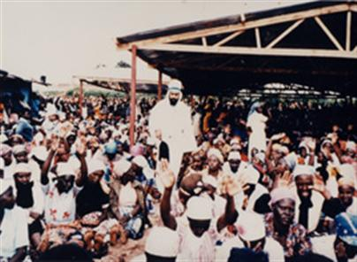

Maitreya spoke in Swahili to the people for 17 minutes. For more information on Maitreya and on miracles happening all over the world, see: [*www.share-international.org*](http://www.share-international.org)

The major Media conceals this information. The Global Elite does not want change, which the Lord Maitreya will bring for the benefit and welfare of all of humanity.

We are destined to have the Golden Age. It will just take longer to manifest. Humanity has so many blessings in store for it as soon as the Lord Maitreya can make His presence known through the major Media. Then, all 49 Ashrams of the Masters which includes their Initiates and disciples, will externalize on the material plane. Their vibrations are so potent. It means that the spiritual Kingdom will now be on earth. In addition great Devas (angels) will teach men how to heal with color and sound, how to nourish the body and to draw from the surrounding ether the necessary food.11

**∆ ∆ ∆**

*Marguerite dar Boggia* presently serves as Secretary and Membership Chairperson of ISAR (the International Society for Astrological Research). She formerly served as publisher of Kosmos, the ISAR Journal and as Secretary and Director of ISAR and UAC, (the United Astrology Congress). She was a co-founder of UAC. Her articles are published in the ISAR journal and in other publications. They are on her website, which she created at the age of 90**:** [**www.FreePythagorasTeachings.com**](http://www.FreePythagorasTeachings.com)At this time she offers **FREE** of charge **three pages weekly online** of the Ancient Wisdom Teachings as was known by **Pythagoras.** She can be contacted through her website for these esoteric teachings.

References:

1[**Stepan Bandera: The Legacy of Self-Loathing Nazi's in ...**](http://www.globalresearch.ca/stepan-bandera-the-legacy-of-self-loathing-nazis-in-america/5424749)

**2**[**Ukrainian Neo-Nazis Declare that Power Comes Out of the ...**](https://www.google.com/url?sa=t&rct=j&q=&esrc=s&source=web&cd=2&cad=rja&uact=8&ved=0CCQQFjABahUKEwjlx4m-kbbHAhXLnYgKHfz-BpM&url=http%3A%2F%2Fwww.globalresearch.ca%2Fukrainian-neo-nazis-declare-that-power-comes-out-of-the-barrels-of-their-guns%2F5371126&ei=UPvUVeXfI8u7ogT8_ZuYCQ&usg=AFQjCNEAV47Qral5p4dbox_wW0Y0uJo6_g)

### 3[Odessa Slaughter: How A Vicious Neo-Nazi Mob Burnt Anti ..](https://www.google.com/url?sa=t&rct=j&q=&esrc=s&source=web&cd=1&cad=rja&uact=8&ved=0CB4QFjAAahUKEwimut-dp7HHAhVRlYgKHV3MAjU&url=http%3A%2F%2Fwww.globalresearch.ca%2Fodessa-slaughter-how-a-vicious-neo-nazi-mob-burnt-anti-government-activists-alive%2F5380403&ei=B3PSVeaaKdGqogTdmIuoAw&usg=AFQjCNFRIX0EQ9Kf6-Jo2m9RsJ46Oh7rGA)

### 4[Spanish Air Controller @ Kiev Borispol Airport: Ukraine ...](https://www.google.com/url?sa=t&rct=j&q=&esrc=s&source=web&cd=1&cad=rja&uact=8&ved=0CB4QFjAAahUKEwjGhIDAnbbHAhWLOYgKHSByBCY&url=http%3A%2F%2Fwww.globalresearch.ca%2Fspanish-air-controller-kiev-borispol-airport-ukraine-military-shot-down-boeing-mh17%2F5391888&ei=6QfVVYbsM4vzoASg5JGwAg&usg=AFQjCNHpSk6_B-1nx9yFEYXSpNx4O_jnqA) 1

## 5[Evidence Is Now Conclusive: Two Ukrainian Government ...](http://www.globalresearch.ca/evidence-is-now-conclusive-two-ukrainian-government-fighter-jets-shot-down-malaysian-airlines-mh17-it-was-not-a-buk-surface-to-air-missile/5394814)

## 6[The MH17 Pilot’s Corpse: More on the Cover-Up](http://www.globalresearch.ca/the-mh17-pilots-corpse-more-on-the-cover-up/5467351)

**7**[**Ukraine's President Poroshenko Says Overthrow of ...**](https://www.google.com/url?sa=t&rct=j&q=&esrc=s&source=web&cd=1&cad=rja&uact=8&ved=0CB4QFjAAahUKEwistZfpi7PHAhXFO4gKHRn4DGs&url=http%3A%2F%2Fwww.globalresearch.ca%2Fukraines-president-poroshenko-says-overthrow-of-yanukovych-was-a-coup%2F5457631&ei=uWLTVez0CcX3oASZ8LPYBg&usg=AFQjCNEn3tUUsgqgp8PT_IMiKrEyL08PFA&bvm=bv.99804247,d.cGU)

[**www.globalresearch.ca/ukraines-president-poroshenko-says.../5457631**](http://www.globalresearch.ca/ukraines-president-poroshenko-says.../5457631)

7a[American Conquest by Subversion: Victoria Nuland's Admit](https://www.google.com/url?sa=t&rct=j&q=&esrc=s&source=web&cd=1&cad=rja&uact=8&ved=0ahUKEwjm8py6jLfLAhUP0GMKHUOKCeIQFggcMAA&url=https%3A%2F%2Fcounterinformation.wordpress.com%2F2014%2F02%2F07%2Famerican-conquest-by-subversion-victoria-nulands-admits-washington-has-spent-5-billion-to-subvert-ukraine%2F&usg=AFQjCNHqtlpDw0Qpj9gmd5634arUrTJJfQ&bvm=bv.116636494,d.cGc)s

http://www.globalresearch.ca/american-conquest-by-subversion-victoria-nulands-admits-washington-has-spent-5-billion-to-subvert-ukraine/5367782 Feb 7, 2014 **...** “After three visits to **Ukraine** in five weeks, **Victoria Nuland** explains that in ... has spent five **Billion dollars** ($5,000,000,000) to subvert **Ukraine**, ...

8[World Bank Whistleblower Reveals How The Global Elite ...](https://www.google.com/url?sa=t&rct=j&q=&esrc=s&source=web&cd=1&cad=rja&uact=8&ved=0CB4QFjAAahUKEwjIopzBn7bHAhVIW4gKHa71B_Q&url=http%3A%2F%2Fwww.globalresearch.ca%2Fworld-bank-whistleblower-reveals-how-the-global-elite-rule-the-world%2F5353130&ei=BQrVVYiMEci2oQSu65-gDw&usg=AFQjCNFWFWycs-tAjp9xAZy1b0TE8Uzhfg)

9[**Russian Roulette: Taxpayers Could Be on the Hook for ...**](http://www.globalresearch.ca/russian-roulette-taxpayers-could-be-on-the-hook-for-trillions-in-oil-derivatives/5420960)

**10Bailey, Alice A. *A Treatise on Cosmic Fire*, Lucis Publishing Co. 1967, P. 211**

**11Bailey, Alice A. *Esoteric Psychology I*, Lucis Publishing Co. N.Y. 1975, p. 124**