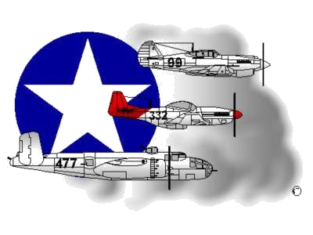
BIOGRAPHY
__________________________________________________________
A DOCUMENTED ORIGINAL TUSKEGEE AIRMAN

Tuskegee Airmen Inc. Public Relations, P.O. Box 830060
Tuskegee, AL 36083

Mr. Utha “Sonny” Knox

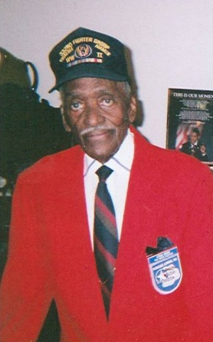
Staff Sergeant Utha “Sonny” Knox was born 31 January 1919, in Toccoa, GA. He graduated from the Spingarn Vocational School, Washington, DC, with an emphasis in aircraft maintenance. On August 22, 1942, he was drafted and went to Columbus, MS for Basic Ttraining.

After successfully completing Basic Training, Staff Se rgeant (SSG) Knox was placed in Technical

School Squadron 917, Tuskegee, AL, where he studied to become an aircraft mechanic technician,

specializing in propeller maintenance, repair and replacement. Upon graduating from Propeller

Mechanic’s school, SSG Knox was relocated to Selfridge Field, near Detroit, MI, where he learned to t

roubleshoot the propeller of the P-40 War Hawk aircraft.

In January 1944, SSG Knox left Selfridge Field, MI, to receive three months Army maneuvering training in Oscoda, MI. Following successful completion of his training, SSG Knox was relocated to Camp Patrick Henry, Newport News, VA, where he immediately departed on a Naval Ship bound for Taranto, Italy. While in Italy, he served in a variety of places, including Monte Corvino, Sampalo, Naples, Ramatelli and Termali. While in Taranto, however, SSG Knox was assigned to the 301st and 302nd Fighter Squadrons under the leadership of Squadron Leader Captain Charles DeBow and 332nd Fighter Group Commander Benjamin O. Davis, Jr. SSG Knox served honorably in the first-ever African American Army Air Forces.

As an Aircraft Propeller Mechanic, SSG Knox worked on the P-40 War Hawk, P-39 Bell Aero Cobra, P-47 Thunderbolt and the famous Red Tail P-51 Mustang. In talking with CNN’s Anderson Cooper, and other noted newspaper staff writers, while attending the Presidential Inauguration Ceremony for President Barack Obama, SSG Knox was quoted as saying “we never had a ship [aircraft] that was not able to fly its mission when called on. Even if we had to work all night, we got the ship ready to fly. We were so good and so dependable that bomber groups began to specifically ask for our support. We were proud of that." SSG Knox served honorably and discharged from the U.S. Army Air Corps on 25 September 1945.

SSG Knox was awarded many Military Service Medals. Among them were the Bronze Star, European African Middle Eastern Campaign Medal, World War II Victory Medal, American Defense Medal and the Good Conduct Medal. He was also in attendance and among the Recipients of the group’s Congressional Gold Medal. The ceremony was held at the US Capitol on 29 March 2007 and President George W. Bush conferred this distinct honor on all of the individuals who participated in the Tuskegee Airmen Program. SSG Knox resided in Church Hill, Virginia (near Richmond, VA) and was a member of the Tidewater Chapter – Tuskegee Airmen, Inc. located in Hampton, Virginia. Despite being nearly 100-miles from the Chapter, he frequently participated in the Chapter’s Speakers Bureau program especially when engagements ventured to Richmond, Washington, D.C. and the western parts of Virginia.

To learn more about Mr. Mr. Utha Knox, the Tidewater Chapter’s Speakers Bureau and other activities that he participated in, please visit the Tidewater Chapter’s Website at the following location: www.TAI-TidewaterChapter.Com.

