First United Methodist Day School ^{Start Date} Kindergarten Registration Form

Child’s Name
Last First Middle Goes by
Child’s Address
Street City Zip
month | day | year | age |  | sex
home |  | work |  | cell
Date of Birth

Mom’s Name
Mom’s address
Mom’s phone #s
Mom’s E-mail
Mom’s Employer
Dad’s Name
Dad’s address
Dad’s phone #s
home work | cell
Dad’s E-mail
Dad’s Employer

Person to Contact in emergency, if parent cannot be reached:
Name __________________________________________________________________
Relationship __________________________________________________________________
Address __________________________________________________________________
Phone #s __________________________________________________________________ home work cell
Name __________________________________________________________________
Relationship __________________________________________________________________
Address __________________________________________________________________
Phone #s __________________________________________________________________
home work cell

Doctor Phone #
Address ______________________________________________________________
If this Doctor cannot be reached, what action should be taken:
Hospital:
Address:
Other children in the family and their ages:
Name Age Name Age

Where did you hear about MDS? ___________________________________________

Help Us Get to Know Your Child:

Please list any pets your child has: ______________________________________________

What are your child's favorite activities? ________________________________________

What does your child enjoy doing with Mom? ____________________________________

What does your child enjoy doing with Dad? ____________________________________

Does your child play well alone? ___________________ In groups? __________________

Are there any neighborhood playmates? _______ What ages? ______________________

What are your child's favorite TV shows? _______________________________________

Child's bedtime? ____________________ Child's wake-up time? _____________________

What behavior control do you use with your child? ______________________________
________________________________________________________________________________

Does your child take any medication regularly? ______ Please list: _________________ ________________________________________________________________________________

Does your child have any problems with vision, hearing, or speech? _________ If so, please explain: _________________________________________________________________

Has your child been cared for by someone other than immediate family? If so, who and how often? ________________________________________________________________

Has your child previously attended another preschool or child-care facility?______ If so, which one? ______________________________________________________________

Please list three words that describe your child: ___________________________________

What do you hope your child will learn in school this year? _________________________

__________________________________________________________________________________

__________________________________________________________________________________

Permission to Use my Child's picture:

I, ____________________________ parent/guardian of ____________________________, give Methodist Day School/First United Methodist Church of Terrell permission to use pictures of myself and my child with or without a name in all promotional or informative and for any other purpose deemed necessary. I understand this includes all forms of media including but not limited to print, social and web.

Signature________________________________ Printed name _______________________

Date __________________________________

First United Methodist Day School Medical Form

Child’s Name Birth date Sex
Address

Phone

Family Medical History:
Brothers Age Health
Sisters Age Health

Please list any family history of disease such as tuberculosis, rheumatic fever, convulsive disorder, allergies, etc.

____________________________________________________________________________________
____________________________________________________________________________________
____________________________________________________________________________________
____________________________________________________________________________________

Personal Medical History:
Has your child ever been seriously ill? _______ If yes, please explain in detail:

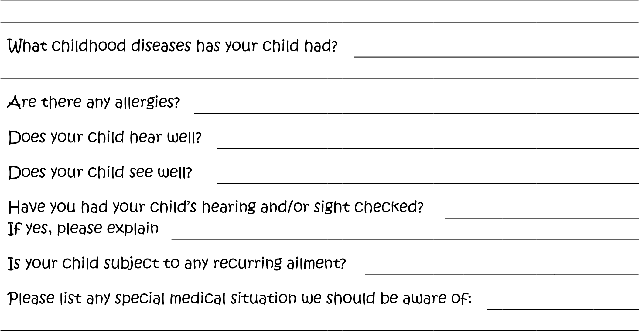

Please list any emotional or behavioral problems we should be aware of:

Physician’s Report:
The general health of the child was found to be

Physician’s Signature:

Date

~Please attach a copy of your child’s immunization record for our files~ First United Methodist Day School.
It must have a physician’s signature, clinic contact information including name and address or name and phone number.

Permission for Field Trips

Children may be taken on field trips. Parents will be notified in advance. All trips are carefully planned and supervised, and the school provides insurance coverage for every child. It will save time and expense of sending and collecting individual notes if you will sign this permission slip as part of your child’s enrollment.

I give my permission to include

Child’s name
in any field trip of Methodist Day School – Terrell

Name of school
planned and accompanied by teachers and parents of the school.

Signature: Date

First United Methodist Day School
Authorization for Child Release

I give permission for the Methodist Day School/First United Methodist Church of Terrell to release my child to the following persons for transportation from school.
____________________________ ______________________________
Name phone Name phone

_________________________________________ _______________________________________________
Name phone Name phone

If your child will be picked up by another person, the school must be notified in each instance before school dismissal time. Please adivise this person to bring picture ID to show the teacher and/or director.

I release Methodist Day School/First United Methodist Church of Terrell from responsibility for my child’s welfare once he/she leaves the school.

Mother _____________________________Father ________________________
Signature Signature

First United Methodist Day School
Emergency Medical Treatment

I authorize the Methodist Day School/First United Methodist Church of Terrell and chaperones to obtain emergency medical treatment as may be necessary during any school activity.

Child’s Name

Parent’s Signature Date

We must have two original copies of this form. One is for your child’s record and one is to take on all field trips.

First United Methodist Day School
Emergency Medical Treatment

I authorize the Methodist Day School/First United Methodist Church of Terrell and chaperones to obtain emergency medical treatment as may be necessary during any school activity.

Child’s Name

Parent’s Signature Date

We must have two original copies of this form. One is for your child’s record and one is to take on all field trips.

First United Methodist Day School
Religious Information

One of the goals of the Methodist Day School/First United Methodist Church of Terrell is to enhance the Biblical Christian education of all the children. In our weekly chapel service, we learn to express our faith through prayer, song and learning. We attempt to make the children aware of God’s grace and love for each of them. Your answers to the following questions will enable us to serve better the needs of your child.

Child’s Name

Does your child attend Sunday School?

Where?

Is your family active in a local church?

Which?

We invite you to visit First United Methodist Church Terrell, if
you are looking for a church home. Pastor Peter McNabb is
available, if you would like to meet with him to learn more or have
spiritual concerns.

Thank you for choosing Methodist Day School to nurture and
grow your child’s education.

