0-

**GSPCI Newsletter Pointer Post November 5, 2012**

**German Shorthair Club of Indiana**

Presidents Message:

Well it has been a busy time since I last had the opportunity to speak with everyone. Your club has been very busy putting together activities that have included a lot of new faces and hopefully fostered new friendships or rekindled old ones. We kicked off the summer with a training seminar presented by Boberosa Kennels that had members learning a few new training methods and from what I saw at the Hunt Test those methods paid off.

In July we had our annual picnic that was attended by various members and I got the opportunity to meet some new faces. The theme of that picnic was twofold fellowship with other club members and we also had fellow member Christy Featherston talk to us about the importance of showing our dogs and how the showing our dogs can contribute to the improvement of our breed.

In August we had our annual skeet shoot at the Indiana Gun Club hosted by fellow member Larry Harris who put on quite a show on how not to miss while I gave a very good demonstration on HOW TO MISS OFTEN.

September 22nd and 23rd were very important dates because it was our Hunt Test and since we did not have one in the spring we had to put on a good show. The hunt test committee did a great job and we were able to have (2) full days of braces plus have a photo taken for all dogs who qualified plus lots of great food that was donated by so many of you. I heard so many compliments from so many people so I think we made a step in the right direction as far as our format for hunt tests is concerned. My thanks to John Kennedy who chaired this event and Lisa Cleveland who took care of the kitchen, and so many others who worked on making this hunt test a good one. Pictures were furnished by Kirk Johnson and then placed on our website by Troy Wood who also made sure that score were taken to Debbie and Brittany Moline who added all scores and then placed them onto official AKC records. It was a great team effort Thanks.

Presently Lisa has sent out several notices about our upcoming elections of officers some of the board has decided to step down and I will formally acknowledge their contributions at another time. For those of you who might be thinking of running for a board position please let Lisa know ASAP through her e-mail [gsprosie@yahoo.com](mailto:gsprosie@yahoo.com)

The commitment is really a small one and the rewards are great so if you want an opportunity to help move this club so that more members get involved please see Lisa.

November 10th at Ron Ferris Farm we will be holding our annual Ladies/Youth Hunt I know several notices have been sent so this will serve as a reminder. Please join us for an afternoon of fun plus an opportunity to hunt some pheasants. Remember there is no charge to the participants. Starting time is 9:00 AM and lunch will be provided at the end.

As I close I want to encourage those of you to try to get a young person involved in this sport we call bird hunting. So many of us were given the opportunity to learn this sport through the guidance of someone who took the time to take us along so pass it on and if you can say thanks to those who gave us the opportunity. (THANKS DAD) I hope to see as many of you as I can at the ladies/youth hunt in November so until then have a great season.

Sincerely Vince

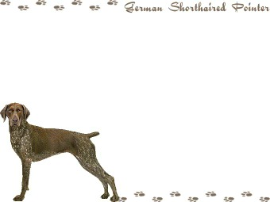

Board Members

**President** - Vincent Guerrini

[guerrini.vince@gmail.com](mailto:guerrini.vince@gmail.com)

**Vice President -** Lisa Cleveland

[gsprosie@yahoo.com](mailto:gsprosie@yahoo.com)

**Secretary/Treasurer** - Debra Moline

[runmom1435@aol.com](mailto:runmom1435@aol.com)

**Board of Directors**

Larry Harris Mark Holzinger Ron Ferris

Kirk Johnson Troy Wood Brent Moline

Chris Weber Giles Hoyt Brittany Moline

Indiana Hunting Seasons

Deer Firearms: November 12th – November 27th Deer Muzzleloader: December 3rd – December 18th Deer Late Archery: December 3rd – January 1st, 2012

Wild Turkey (Archery Only): December 3rd – January 7th, 2012

Squirrel: August 15th – January 31, 2012

**Ruffled Grouse (Privately Owned Lands): October 1st – December 31st**

**Ruffled Grouse (Public Lands): October 1st – November 11th**

**Pheasant (cock only): November 4th – December 18th**

**Quail (North of SR 26): November 4th – December 18th**

**Quail (South of SR 26): November 4th – January 15th, 2012**

Rabbit: November 4th – February 15th, 2012

Crow: December 13th – March 1st 2012

**“B R A G G I N R I G H T S”**

Everyone has done a great job this year training and participating for the hunt tests. Congratulations to everyone who participated in a hunt test this fall. Even if we don’t have your information and photo, you are all an example of the diligence and love we have in this club for the sport of bird hunting. It has been enjoyable seeing those who attended our GSPCI Hunt Test work your dogs and yourselves. There has been a lot learned and still a lot to learn from one another. Thank You and Congratulations again to your all on your achievements!

C:\Users\Laura\AppData\Local\Microsoft\Windows\Temporary Internet Files\Content.IE5\9W9VH1NS\MC900329538[1].wmf

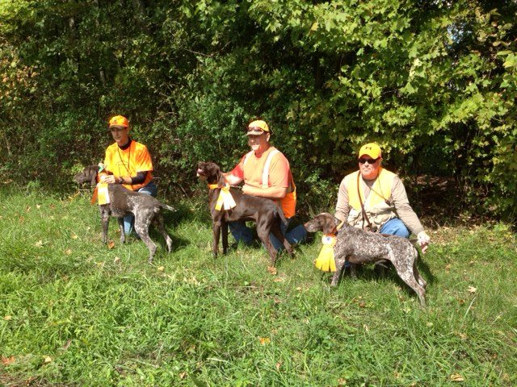

Congrats to Troy Wood ..Emmett finished his Senior Hunter Title Saturday ..Congrats to Kirk, Joe, & Brad ...making Montgomerycreek GSP successful in Senior Runs Today ..! Chris & Falko looking good in Juniors .

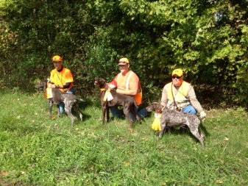

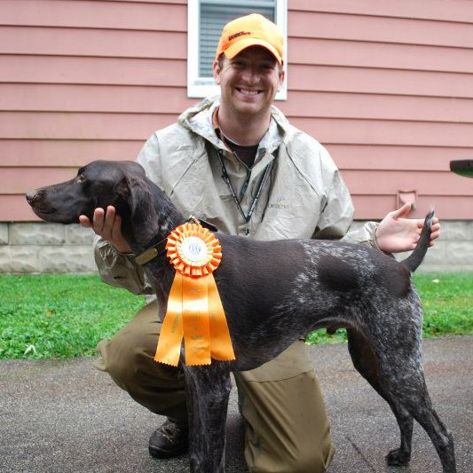

Matt Cosgrove & Rufus. His first leg of his completed JH Title. They were also able to enjoy their 1st Ruffed Grouse hunt this year! Great Job Matt & Rufus!

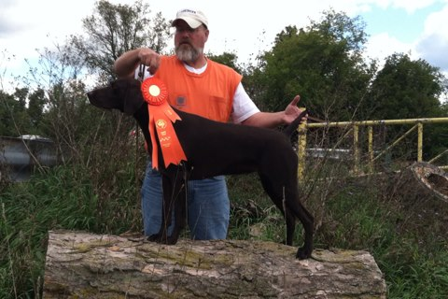

Tim Conley & Lexi finishing her SH Title in just one weekend!

Great day shooting together at the Indiana Gun Club! Thank you Larry for putting this together! Great time had by all, what a group!

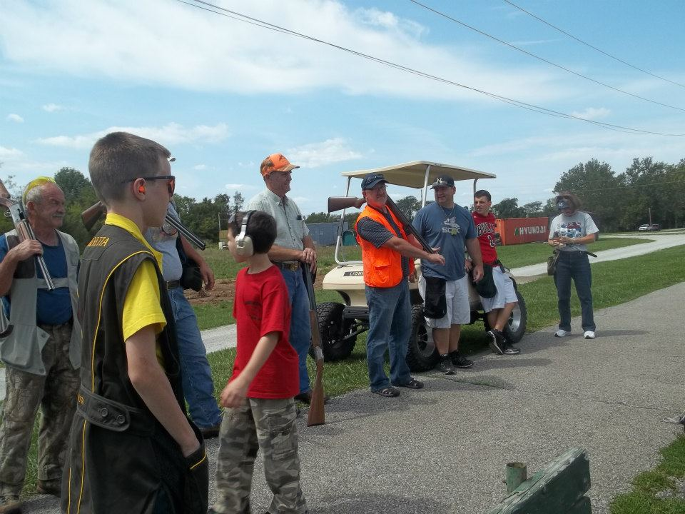

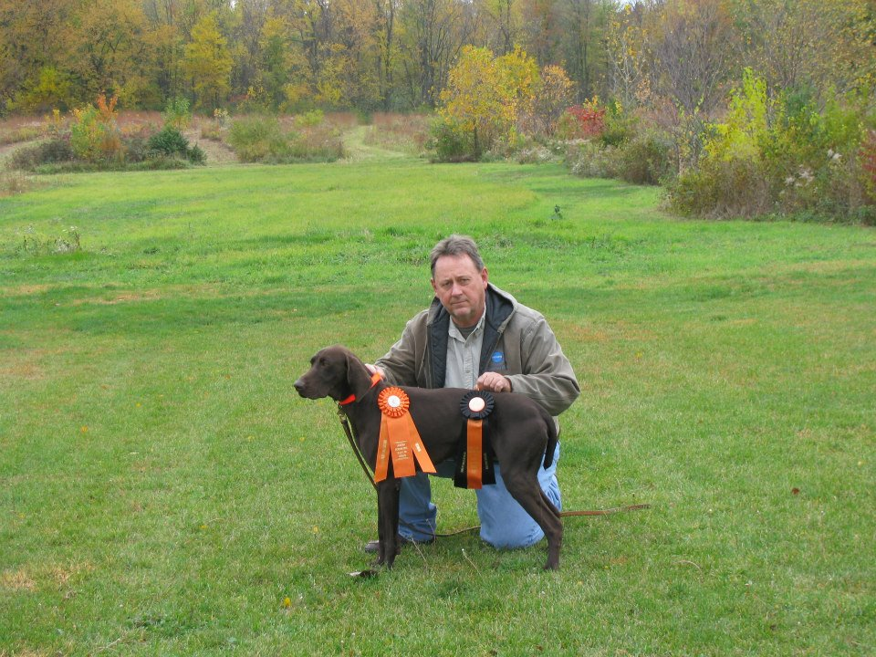

Kosta Vom Ferronhaus “Hutton” has sired his first litter, Oct. 26. Working on his MH Title.

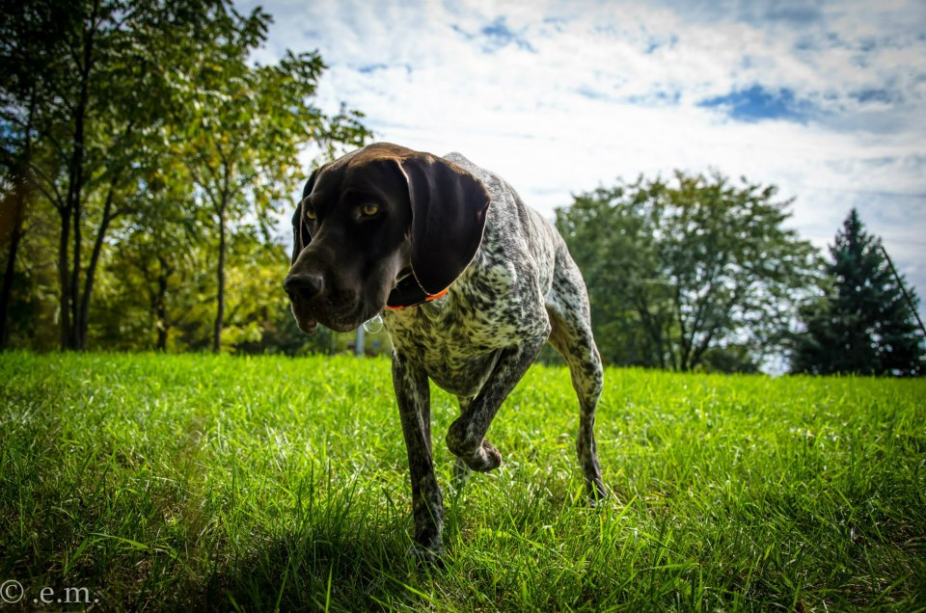

Joe Klase & Hunter He holds JH Title and rec’d 2 SHlegs this fall. Hunter also has his NAVHDA Natural ability prize 2

If you have a bragg that wasn’t included that doesn’t mean you were excluded. Please send any wins or Braggs you would like to have featured please email them to Laura Getzen, Newsletter Editor [markorlaura@comcast.net](mailto:markorlaura@comcast.net).

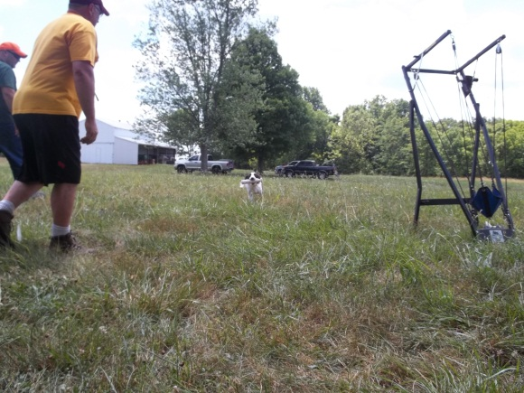

Welcome, Welcome Bird Season!

To all of you…our season has arrived, enjoy this fitting poem while we celebrate our ties!

|  |  |
| --- | --- |
|  | |
|  |

**THE OPEN SEASON FOR QUAIL-SHOOTING**  
  
IT is October morning, the golden, glorious prime  
Of the autumnal season, the sportsman's royal time;   
And now the hoar-frost jewels, all glittering and white,   
Shine o'er the grassy meadows and o'er the upland height;   
And far as eye may wander a filmy vapory veil   
Floats o'er the brimming river that windeth down the vale.   
  
I gaze o'er woods and orchards, resplendent with the hues   
With which the lavish autumn the drooping leaves suffuse,   
Where ivies nnd the woodbines and garlands of the vine   
Are redden'd and embrown'd, with vermilion splendors shine.   
And where the oaten harvests and fields of wheat were spread,   
All bare the russet stubble is crisp beneath the tread,   
And yellow corn-stacks like the tents of armies spread around,   
While in the busy granaries the beating flails resound.   
  
Now by the blue-lake borders, and by the river's edge,   
Where swing the cat-tail clusters, where leans the rustling sedge,   
I see the black-duck squadrons, the wood-duck and the teal;   
I see the ambush'd fowler, I hear his volleying peal.   
  
And as I skirt the thicket edge, or through the stubble pass,   
I see the bevies of the quail spring from the faded grass;   
In every weedy tussock, in every swale, they hide;   
And as they sail o'er hedges, in winnowings far and wide,   
The sportsman's heart exulteth with promise of the joy   
When first the " open season" his gun and dog employ.   
  
For not until November its earliest dawn shall bring   
May shot be fir'd in coppices where quail burst on the wing;   
For then from morn tiil evening the echoes shall repeat   
The gun's report in open field or in the green retreat.   
  
Till then the speckled flocks may feed and fly at will,   
May range the sumptuous stubbles, may sweep o'er plain and  
hill;   
When comes that day relentless, ahtheu, poor flocks, beware!   
Swift be your flight or ye may leave your " little lives in air."   
  
  
McLellan, Isaac. Poems of the Rod and Gun. New York: Henry Thorpe, 1886

Closing Club Notes

GSPCI Hunt Test

Our hunt test was a success. Several members came to place legs or finish their dogs. Congrats to all of your and thank you for your participation! A Big “THANK YOU” to all our judges and staff for your hard work.

**Our Annual Meeting**

Our meeting will be just around the corner soon enough! We are scheduled for. Please come if you can, a great time enjoying food and stories from throughout the year. Also, a great time to pay those dues to get it out of the way!

Ladies & Youth Hunt

Ladies and Youth Hunt will be at Ron Ferris's Farm

Sat. Nov. 10 starting at 9:00 AM Please E-Mail

Vince Guerrini. Hot/dogs/Hamburgers/Drinks will be offered by the club. Side dishes will be gratefully accepted. Ron's Farm is located at 11500 N.600 E. Morristown IN. (Shelby County). Need further directions Call Ron.

.

Happy Holidays!

Some little blurbs to follow us through the rest of this year.

From us to you…. Enjoy.

Thanksgiving and Christmas are just around the corner!

Your board sends our Best Wishes for a Holiday Season filled with love and laughter with the ones you love…… and tolerate!

So far as this hunting season goes we send our prayers of swiftness and safety to you and your dogs. May you be steady and ready to all your prey, be willing and able on your hunting day.

This has been a wonderful year of challenges and obstacles for each of us in some way, because we’re here for each other were still here today!

Have a SAFE & HAPPY Holiday!

Breeders

Please make sure you email Christy Featherson if you have any litters available or coming. Christy is listed on AKC website as a Breeder Referral.

Christy Featherston [artemisgsp@aol.com](mailto:artemisgsp@aol.com)

Volunteers

During the events we host or attend there is always room for help. May be it food, cleaning up, setting up or just offering. Contact is easy to make to offer any assistance where needed. There is no specific list for this, or maybe there is and were all on it!

Give where you can and lets all do our part to help things pull together. We have many members who already help and volunteer for many things we do. So a BIG Thank You to them and lets continue to all support and help with our efforts!

Our Dues are about Due!

The German Shorthaired Pointer Club of Indiana is a club dedicated to the celebration and advancement of the German Shorthaired Pointer. Our club members are made up of people who use their dogs to hunt, hunt test, show, agility, search and rescue, exercise, and have as the family pet. We feel this breed of dogs is pretty special, just ask us! Our club is active and sponsors several events throughout the year. Information to join is listed on this site. We feel the **$25** dues per year aremoney well spent. Application to the club is listed on this site. **Your dues are due in December, lets make it a record year on how fast we can get our dues in!**

Thank you for all the help from each of our members this year.



Thank You to our Sponsers!

Other informative sites; <http://www.bdarn.com/calendar/> <http://www.nstra.org/> <http://www.gspca.org/> <http://www.centralindiananavhda.com/> <http://www.glennsvalley.org/>

Silver Sponsor

of Terra Haute

Gold Sponsor



GSPC of Indiana Calendar

|  |  |  |  |  |  |  |  |  |  |  |  |  |  |  |  |  |  |  |  |  |  |  |  |  |  |  |  |  |  |  |  |  |  |  |  |  |  |  |  |  |  |  |  |  |  |  |  |  |  |  |  |  |  |  |  |  |  |  |  |  |  |  |  |  |  |  |  |  |  |  |  |  |  |  |  |  |  |  |  |  |  |  |  |  |  |  |  |  |  |  |  |  |  |  |  |  |  |  |  |  |  |  |
| --- | --- | --- | --- | --- | --- | --- | --- | --- | --- | --- | --- | --- | --- | --- | --- | --- | --- | --- | --- | --- | --- | --- | --- | --- | --- | --- | --- | --- | --- | --- | --- | --- | --- | --- | --- | --- | --- | --- | --- | --- | --- | --- | --- | --- | --- | --- | --- | --- | --- | --- | --- | --- | --- | --- | --- | --- | --- | --- | --- | --- | --- | --- | --- | --- | --- | --- | --- | --- | --- | --- | --- | --- | --- | --- | --- | --- | --- | --- | --- | --- | --- | --- | --- | --- | --- | --- | --- | --- | --- | --- | --- | --- | --- | --- | --- | --- | --- | --- | --- | --- | --- | --- |
| **~~22 Annual Meeting Brickyard Crossing~~** | |  |  |  |  |  |  |  | | --- | --- | --- | --- | --- | --- | --- | | **~~January~~** | | | | | | | | **~~M~~** | **~~T~~** | **~~W~~** | **~~T~~** | **~~F~~** | **~~S~~** | **~~S~~** | | ~~1~~ | ~~2~~ | ~~3~~ | ~~4~~ | ~~5~~ | ~~6~~ | ~~7~~ | | ~~8~~ | ~~9~~ | ~~10~~ | ~~11~~ | ~~12~~ | ~~13~~ | ~~14~~ | | ~~15~~ | ~~16~~ | ~~17~~ | ~~18~~ | ~~19~~ | ~~20~~ | ~~21~~ | | ~~22~~ | ~~23~~ | ~~24~~ | ~~25~~ | ~~26~~ | ~~27~~ | ~~28~~ | | ~~29~~ | ~~30~~ | ~~31~~ |  |  |  |  | |  | |  |  |  |  |  |  |  | | --- | --- | --- | --- | --- | --- | --- | | **~~February~~** | | | | | | | | **~~M~~** | **~~T~~** | **~~W~~** | **~~T~~** | **~~F~~** | **~~S~~** | **~~S~~** | |  |  | ~~1~~ | ~~2~~ | ~~3~~ | ~~4~~ | ~~5~~ | | ~~6~~ | ~~7~~ | ~~8~~ | ~~9~~ | ~~10~~ | ~~11~~ | ~~12~~ | | ~~13~~ | ~~14~~ | ~~15~~ | ~~16~~ | ~~17~~ | ~~18~~ | ~~19~~ | | ~~20~~ | ~~21~~ | ~~22~~ | ~~23~~ | ~~24~~ | ~~25~~ | ~~26~~ | | ~~27~~ | ~~28~~ | ~~29~~ |  |  |  |  | | **~~14 Valentines Day~~**  **~~20 Presidents Day~~** |
|  |  |  |  |  |
| **~~11 Daylight Savings~~**  **~~17 St. Patrick’s Day~~**  **~~24 & 25 AKC Hunt Test Glenns Valley Conservation Club~~** | |  |  |  |  |  |  |  | | --- | --- | --- | --- | --- | --- | --- | | **~~March~~** | | | | | | | | **~~M~~** | **~~T~~** | **~~W~~** | **~~T~~** | **~~F~~** | **~~S~~** | **~~S~~** | |  |  |  | ~~1~~ | ~~2~~ | ~~3~~ | ~~4~~ | | ~~5~~ | ~~6~~ | ~~7~~ | ~~8~~ | ~~9~~ | ~~10~~ | ~~11~~ | | ~~12~~ | ~~13~~ | ~~14~~ | ~~15~~ | ~~16~~ | ~~17~~ | ~~18~~ | | ~~19~~ | ~~20~~ | ~~21~~ | ~~22~~ | ~~23~~ | ~~24~~ | ~~25~~ | | ~~26~~ | ~~27~~ | ~~28~~ | ~~29~~ | ~~30~~ | ~~31~~ |  | |  | |  |  |  |  |  |  |  | | --- | --- | --- | --- | --- | --- | --- | | **~~April~~** | | | | | | | | **~~M~~** | **~~T~~** | **~~W~~** | **~~T~~** | **~~F~~** | **~~S~~** | **~~S~~** | |  |  |  |  |  |  | ~~1~~ | | ~~2~~ | ~~3~~ | ~~4~~ | ~~5~~ | ~~6~~ | ~~7~~ | ~~8~~ | | ~~9~~ | ~~10~~ | ~~11~~ | ~~12~~ | ~~13~~ | ~~14~~ | ~~15~~ | | ~~16~~ | ~~17~~ | ~~18~~ | ~~19~~ | ~~20~~ | ~~21~~ | ~~22~~ | | ~~23~~ | ~~24~~ | ~~25~~ | ~~26~~ | ~~27~~ | ~~28~~ | ~~29~~ | | ~~30~~ |  |  |  |  |  |  | | **~~6 Good Friday~~**  **~~8 Easter~~**  **~~18-21 GSPCA Nationals~~**  **~~28 & 29 AKC Hunt Test Greater Brittany Club/Farmland~~** |
|  |  |  |  |  |
| **~~13 Mother’s Day~~**  **~~28 Memorial Day~~** | |  |  |  |  |  |  |  | | --- | --- | --- | --- | --- | --- | --- | | **~~May~~** | | | | | | | | **~~M~~** | **~~T~~** | **~~W~~** | **~~T~~** | **~~F~~** | **~~S~~** | **~~S~~** | |  |  |  | ~~1~~ | ~~2~~ | ~~3~~ | ~~4~~ | | ~~5~~ | ~~6~~ | ~~7~~ | ~~8~~ | ~~9~~ | ~~10~~ | ~~11~~ | | ~~12~~ | ~~13~~ | ~~14~~ | ~~15~~ | ~~16~~ | ~~17~~ | ~~18~~ | | ~~19~~ | ~~20~~ | ~~21~~ | ~~22~~ | ~~23~~ | ~~24~~ | ~~25~~ | | ~~26~~ | ~~27~~ | ~~28~~ | ~~29~~ | ~~30~~ | ~~31~~ |  | |  | |  |  |  |  |  |  |  | | --- | --- | --- | --- | --- | --- | --- | | **~~June~~** | | | | | | | | **~~M~~** | **~~T~~** | **~~W~~** | **~~T~~** | **~~F~~** | **~~S~~** | **~~S~~** | |  |  |  |  | ~~1~~ | ~~2~~ | ~~3~~ | | ~~4~~ | ~~5~~ | ~~6~~ | ~~7~~ | ~~8~~ | ~~9~~ | ~~10~~ | | ~~11~~ | ~~12~~ | ~~13~~ | ~~14~~ | ~~15~~ | ~~16~~ | ~~17~~ | | ~~18~~ | ~~19~~ | ~~20~~ | ~~21~~ | ~~22~~ | ~~23~~ | ~~24~~ | | ~~25~~ | ~~26~~ | ~~27~~ | ~~28~~ | ~~29~~ | ~~30~~ |  | | **~~3 First Annual Training Seminar/Glenns Valley~~**  **~~10 Sporting Clays Shoot~~**  **~~17 Father’s Day~~** |
|  |  |  |  |  |
| **~~20 Presidents Day~~**  **~~22 GSPCI Picnic~~** | |  |  |  |  |  |  |  | | --- | --- | --- | --- | --- | --- | --- | | **~~July~~** | | | | | | | | **~~M~~** | **~~T~~** | **~~W~~** | **~~T~~** | **~~F~~** | **~~S~~** | **~~S~~** | |  |  |  |  |  |  | ~~1~~ | | ~~2~~ | ~~3~~ | ~~4~~ | ~~5~~ | ~~6~~ | ~~7~~ | ~~8~~ | | ~~9~~ | ~~10~~ | ~~11~~ | ~~12~~ | ~~13~~ | ~~14~~ | ~~15~~ | | ~~16~~ | ~~17~~ | ~~18~~ | ~~19~~ | ~~20~~ | ~~21~~ | ~~22~~ | | ~~23~~ | ~~24~~ | ~~25~~ | ~~26~~ | ~~27~~ | ~~28~~ | ~~29~~ | | ~~30~~ | ~~31~~ |  |  |  |  |  | |  | |  |  |  |  |  |  |  | | --- | --- | --- | --- | --- | --- | --- | | **August** | | | | | | | | **M** | **T** | **W** | **T** | **F** | **S** | **S** | |  |  | 1 | 2 | 3 | 4 | 5 | | 6 | 7 | 8 | 9 | 10 | 11 | **12** | | 13 | 14 | 15 | 16 | 17 | 18 | 19 | | 20 | 21 | 22 | 23 | 24 | **25** | 26 | | 27 | 28 | 29 | 30 | 31 |  |  | | **12 Sporting Clays Shoot**  **25 Judging Seminar/Wilber Wright Birthplace 8:30am** |
|  |  |  |  |  |
| **~~3 Labor Day~~**  **~~22 & 23 Fall AKC Hunt Test Glenns Valley Conservation Club~~** | |  |  |  |  |  |  |  | | --- | --- | --- | --- | --- | --- | --- | | **~~September~~** | | | | | | | | **~~M~~** | **~~T~~** | **~~W~~** | **~~T~~** | **~~F~~** | **~~S~~** | **~~S~~** | |  |  |  |  |  | ~~1~~ | ~~2~~ | | ~~3~~ | ~~4~~ | ~~5~~ | ~~6~~ | ~~7~~ | ~~8~~ | ~~9~~ | | ~~10~~ | ~~11~~ | ~~12~~ | ~~13~~ | ~~14~~ | ~~15~~ | ~~16~~ | | ~~17~~ | ~~18~~ | ~~19~~ | ~~20~~ | ~~21~~ | **~~22~~** | **~~23~~** | | ~~24~~ | ~~25~~ | ~~26~~ | ~~27~~ | ~~28~~ | ~~29~~ | ~~30~~ | |  | |  |  |  |  |  |  |  | | --- | --- | --- | --- | --- | --- | --- | | **~~October~~** | | | | | | | | **~~M~~** | **~~T~~** | **~~W~~** | **~~T~~** | **~~F~~** | **~~S~~** | **~~S~~** | | ~~1~~ | ~~2~~ | ~~3~~ | ~~4~~ | ~~5~~ | ~~6~~ | ~~7~~ | | ~~8~~ | ~~9~~ | ~~10~~ | ~~11~~ | ~~12~~ | **~~13~~** | **~~14~~** | | ~~15~~ | ~~16~~ | ~~17~~ | ~~18~~ | ~~19~~ | ~~20~~ | ~~21~~ | | ~~22~~ | ~~23~~ | ~~24~~ | ~~25~~ | ~~26~~ | **~~27~~** | **~~28~~** | | ~~29~~ | ~~30~~ | ~~31~~ |  |  |  |  | | **~~8 Columbus Day~~**  **~~31 Halloween~~**  **~~13 & 14 AKC Hunt Test Greater Brittany Club/Farmland~~**  **~~27 & 28 AKC Hunt Test Kentuckian Point/Weim. Club~~** |
|  |  |  |  |  |
| **~~4 BIRD SEASON!~~**  **~~4 Daylight Savings Ends~~**  **10 Ladies & Youth Hunt**  **11 Veterans Day**  **22 Thanksgiving** | |  |  |  |  |  |  |  | | --- | --- | --- | --- | --- | --- | --- | | **November** | | | | | | | | **M** | **T** | **W** | **T** | **F** | **S** | **S** | |  |  |  | ~~1~~ | ~~2~~ | ~~3~~ | **~~4~~** | | 5 | 6 | 7 | 8 | 9 | 10 | 11 | | 12 | 13 | 14 | 15 | 16 | 17 | 18 | | 19 | 20 | 21 | 22 | 23 | 24 | 25 | | 26 | 27 | 28 | 29 | 30 |  |  | |  | |  |  |  |  |  |  |  | | --- | --- | --- | --- | --- | --- | --- | | **December** | | | | | | | | **M** | **T** | **W** | **T** | **F** | **S** | **S** | |  |  |  |  |  | 1 | 2 | | 3 | 4 | 5 | 6 | 7 | 8 | 9 | | 10 | 11 | 12 | 13 | 14 | 15 | 16 | | 17 | 18 | 19 | 20 | 21 | 22 | 23 | | 24 | 25 | 26 | 27 | 28 | 29 | 30 | | 31 |  |  |  |  |  |  | | **24 Christmas Eve**  **25 Christmas**  **31 New Year’s Eve** |