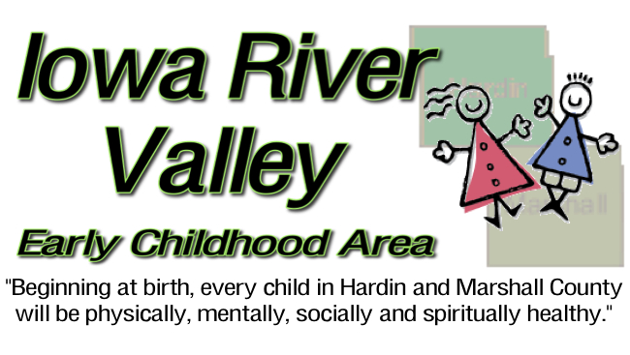
641-648-6575 * iarivervalleyeca@gmail.com
www.iowarivervalleyeca.com
Dear Community Partner –
When Early Childhood Iowa (formerly Empowerment) was first formed, it was on the basis of giving local volunteers the power to impact the lives of children and families in their communities. It’s primary goal, is to “Ensure every child beginning at birth, will be healthy and successful.”
The Hardin and Marshall County Early Childhood Iowa Boards have been independently serving communities for over thirteen years. We are excited to announce that we have merged into one Iowa River Early Childhood Area Board, in order to build a larger and more comprehensive system of serving children age prenatal through five.
Our current board makes a significant impact on the lives of families. We award grants to programs that ensure young children will be healthy physically, mentally, socially and spiritually. We work together because we have a strong commitment to our communities.
The Iowa River Valley Early Childhood Area Board is active in providing preschool tuition scholarships to low income children, improving child care environments, increasing quality child care capacity, preschool transportation services, and family support services…and that is just to name a few!
We are presently seeking volunteer applicants across Hardin and Marshall County who want to make an impact on children. Board Members must live in Hardin or Marshall County, and must not be employed or indirectly receive funds by an agency whose services are paid for with Early Childhood Iowa Funds.
It is my sincere hope that you would consider submitting an application for membership and joining the Iowa River Valley Early Childhood Area Board. If at any time you have more questions, please contact me directly at my office, (641) 648-6575 or (641) 352-5090 or by email at carriekube@qwestoffice.net.
Thank you for your time. I look forward to hearing from you.
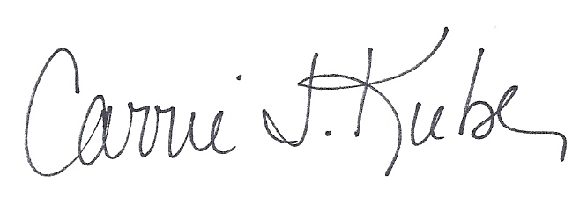
Sincerely,

Carrie J. Kube
Early Childhood Iowa Director for Hardin and Marshall County

