1967 Cessna 310L
N3283X S/N 310L-0133
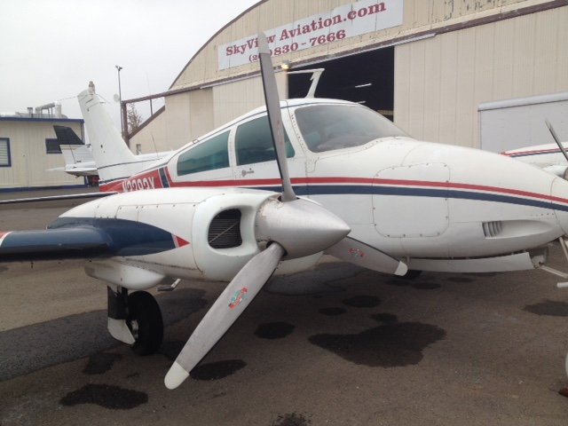
TTAF: 3646 (Tach)
R Continental IO-470 V TTSMOH: #1 Unknown S/N 170188-9-V
L Continental IO-470 V TTSMOH:and S/N #2 Unknown

AVIONICS :
- Narco 128 Nav/com
- Mk 24 Nav/Com
- King KN62A DME
- King KT76 Xpndr
- Collins VHF Comm
- King Nav/gs/loc
- KR85 ADF
- Audio Panel
- Cessna 400 Navomatic Auto pilot

This aircraft has been stored in a hangar and not flown for the past 25 years.
Basic airframe is in decent condition. Interior needs reconditioning, engines may require overhaul. Aircraft currently out of registration, Log Books not available at this time

MAKE OFFER

