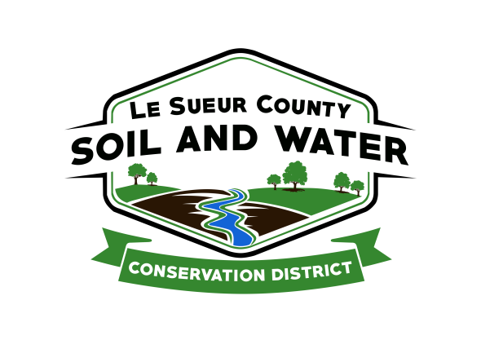

Le Sueur County Soil & Water Conservation District

Le Sueur County SWCD Tel. (507) 419-0365
181 W Minnesota St Website: www.lesueurswcd.org
Le Center, MN 56057

Minutes from October 12, 2021 regular meeting of the Le Sueur County SWCD Board of Supervisors. Le Sueur County Justice Center, Le Center, MN.

Meeting was called to order by Chairman Struck at 9:00 am.

Members present: Chairman, Jim Struck
Secretary, Earle Traxler
PR&I, Glendon Braun

Members absent: Vice-Chairman, Greg Entinger
Treasurer, Cletus Gregor

Others present: District Manager, Mike Schultz
District Technician, Joe Jirik
Ditch Specialist, Nik Kadel
Resource Technician, Karl Schmidtke
Le Sueur Co. Commissioner, Steve Rohlfing
Program Specialist, Sue Prchal
District Conservationist, Steve Breaker

The Pledge of Allegiance was recited.

Secretary’s report from September 14, 2021 was read and approved.

Treasurer’s report for September 2021 was read. Motion by Traxler, second by Braun to approve as read and to pay bills.
Affirmative: All
Opposed: None
Motion carried

Commissioner Rohlfing introduced himself and discussed attending future SWCD board meetings. He talked about the county commissioners getting to know more about the SWCD and the programs it administers.

The board reviewed the Year End 2020 draft audit from Peterson Company. Motion to approve by Traxler, second by Braun.
Affirmative: All
Opposed: None
Motion carried

Motion by Traxler, second by Braun to increase SWCD Board per diem to $100 per half or all day meetings effective August 1, 2021.
Affirmative: All
Opposed: None
Motion carried

Mike updated the board on the Lower MN 1W1P and the Cannon 1W1P. He also discussed the Waterville Flood Study which the DNR will oversee a $500,000 grant to study the watershed.

Motion by Traxler, second by Braun to approve and sign the FY2022 Buffer Law and SWCD Local Capacity Grant in the amount of $152,155.00.
Affirmative: All
Opposed: None
Motion carried

Motion by Traxler, second by Braun to approve and pay Cleveland Township cost-share contract #JG-2021-1 in the amount of $24,516.60 for a grade stabilization structure.
Affirmative: All
Opposed: None
Motion carried

Motion by Braun, second by Traxler to encumber $6873.70 for Tom Helftner cost-share contract #CAP-2020-6 for sediment basins.
Affirmative: All
Opposed: None
Motion carried

Motion by Braun, second by Traxler to encumber $7001.30 for Tom Helftner cost-share contract #1-21 for sediment basins.
Affirmative: All
Opposed: None
Motion carried

There will be a personnel committee meeting prior to the November board meeting which Greg and Jim are on that committee.

Updates were given on the following:
MOU between Le Sueur County and the SWCD
Le Sueur County Clubhouse will be moving out effective December 31, 2021
IT Services, 2022 levy
WCA

The board discussed payroll options for the SWCD. Motion by Traxler, second by Braun to hire Dufault CPA located in Waseca to take over the SWCD payroll.
Affirmative: All
Opposed: None
Motion carried

Motion by Traxler, second by Braun to authorize Mike Schultz to work with the South Central Coop on benefit packages for SWCD employees.
Affirmative: All
Opposed: None
Motion carried

Nik gave the board an update on county ditch projects currently going on. He discussed tree removal, improvements, landowner meetings, beaver dams and buffers.

Steve gave the NRCS report. They are working on sediment basins, a pit closure, a wetland restoration, certifying cover crops, CRP contracts and seedings.

The board reviewed and voted on resolutions which will be discussed at the annual convention.

There being no further business, meeting adjourned at 10:55 am.

_______________________ __________________________________________
Date District Secretary

