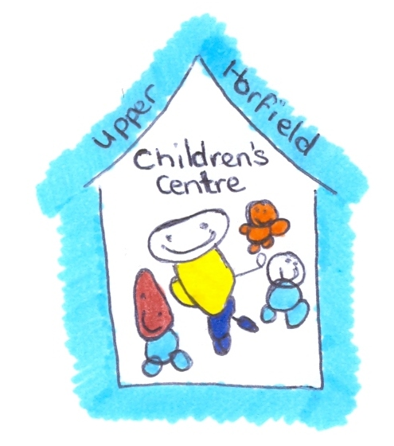
Upper Horfield Children’s Centre and Community School
Bottle Preparation and Feeding Policy
September 2014-15
Preparation:
- The Centre will only accept from parents / carers commercial formula powdered milk in the original UNOPENED container. This needs to be dated when opened and kept for no longer than 1 month.
- Look at chart on fridge for individual baby feed times.
- Wash hands with antibacterial soap and gel.
- Gloves and apron to be worn when preparing bottles
- All bottles to be sterilised before use. Bottles can be left in the sterilizer but once the lid has been removed these bottles will only remain sterile for two hours
- Cartons of milk to be stored and fed to the child according to manufacture instructions.
- Bottles are always prepared and fed to the child following the manufactures guidelines, any differences requested by parents must be accompanied by a Doctors letter.
- Labels should give child’s full name, type of milk and ounces needed.
- Fill the kettle with fresh water – from the cold tap. Bring to the boil. Allow to cool slightly, but is not left to cool for more than half an hour.

Bottle Preparation:
- Remove the sterilized bottles from the steriliser and put correct name tag on
- Follow manufactures instructions for making up bottle
- With bottle standing on a flat surface pour correct amount of water at eye level.
- Add the right amount of scoops of powder to each bottle. Use the scoop provided in the packet. Use a clean knife to level off the powder. Do not pack the powder down in the scoop.
- Replace the sterilised disc and teat on the bottles
- Shake the bottle and test the temperature on the inside of your wrist.

If the temperature is too hot, place the bottle in a jug of fresh cold water. Stand until required temperature is reached. (No longer than 20 minutes)

Feeding the Baby:

- Wash hands and put on correct feeding apron
- Double check label is correct on bottle for the child
- Place a bib loosely around the babies’ neck. Have a piece of muslin to hand.
- Staff will follow the feeding routine as discussed with the parent. (Home Visit) and recorded on individual care plan.

During and After Feed:

- A child will never be left unattended or be allowed to walk around with the bottle.
- If you stop to wind a baby replace the lid and place out of reach of other children until the child is ready to continue feeding.
- Once the feed is finished, replace the lid and place out of reach from other children whilst the child is settled to sleep or an activity. (Made up bottle not to be kept longer than 30 minutes standing.)
- The amount of milk the child has drunk must be recorded and the remaining milk thrown away.

Cleaning Bottles:

- If the bottle is going home with the child. Clean the bottle with warm water and place it in the child’s bag.
- If the bottle stays at the nursery wash the bottle with warm water and washing liquid using the correct brushes for teat and bottle and place in child’s basket in kitchen.

No students or unauthorised staff are permitted to make, give or clean bottles.
Guidelines from the School Milk Service

- Milk supplied in cartons
- Kept in the fridge
- Only use until date specified
- When milk is needed to be used at room temperature, remove from the fridge and store away from direct heat and sunlight. An un-opened carton can then be used during the day. Any unused milk should then be disposed of at the end of the day.

Review date:

Reviewed by:

