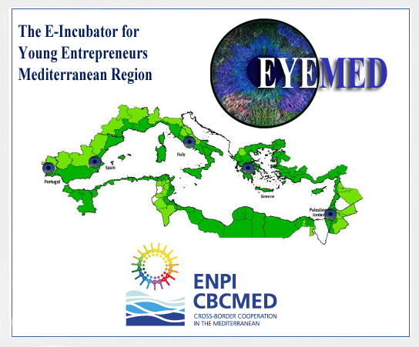
EYEMED PLANNING MEETING
LOCATION: iPortal Community of Practice
DATE: Tuesday, October 31, 2017
TIME: 14h00 Lisbon (GMT/UTC + 00:00 hour) – 1 hour

ITEMS
- Call to Order
- Additions to the Agenda
- Overview of the iPortal: Raichin Rachev
- Introduction of Partners
- Review of Documents Preparation for Participation in Project (downloads at the working website: www.erasmusactions.org/eyemed.html )
- Planning Document 1
- Draft Work Packages
- Requested information
- Social Media Overview
- Budgets
- Application documents from partners (download direct: http://www.enpicbcmed.eu/enicbcmed-2014-2020/submit-a-project-proposal)
- 1.b_partner_statement.doc (Word doc)
- 3_financial_capacity_evaluation (xcel)
- Assessing financial Capacity (pdf)
- Monitoring / Evaluation (Word doc)
- Questions / Answer Segment
- Adjourn
Agenda prepared by Sandra Lund-Diaz, Global Skills Network

