***THANK YOU***

***TO OUR 2018-19 COMMUNITY SPONSORS!***

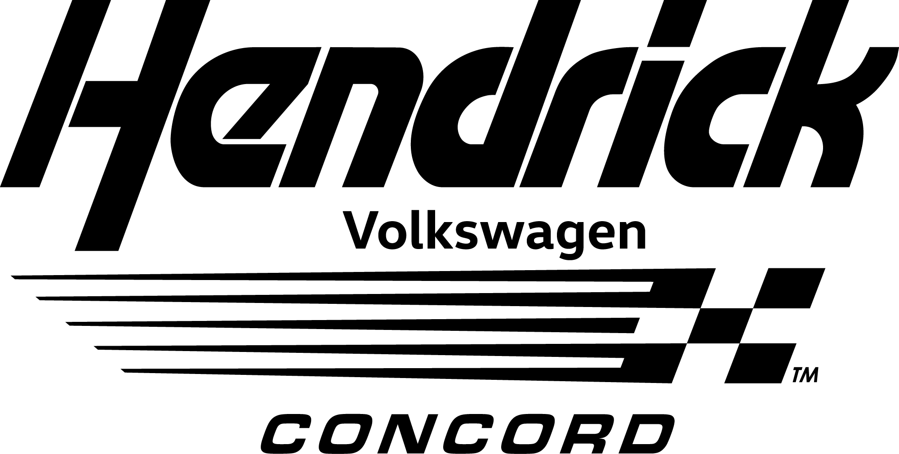

**Hendrick Volkswagon**

**7500 Hendrick Auto Plaza, Concord**

**Platinum Community Sponsor**

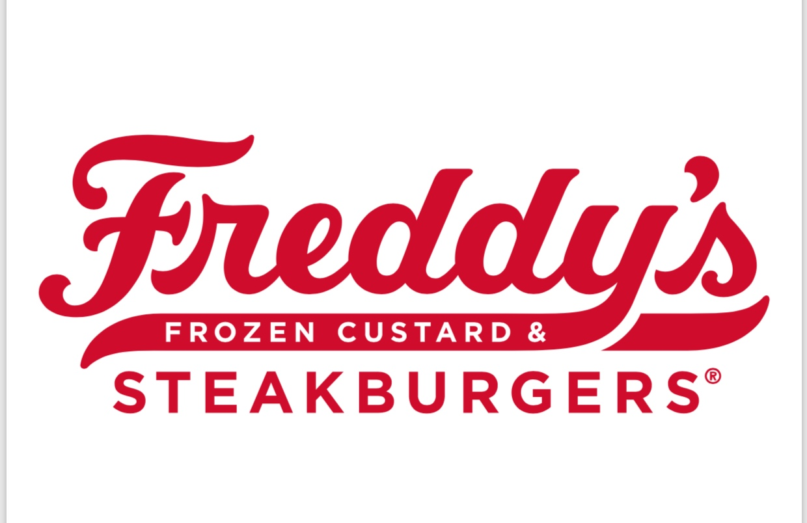

**Freddy’s**

**8475 Pit Stop Court, Concord**

**Platinum Community Sponsor**

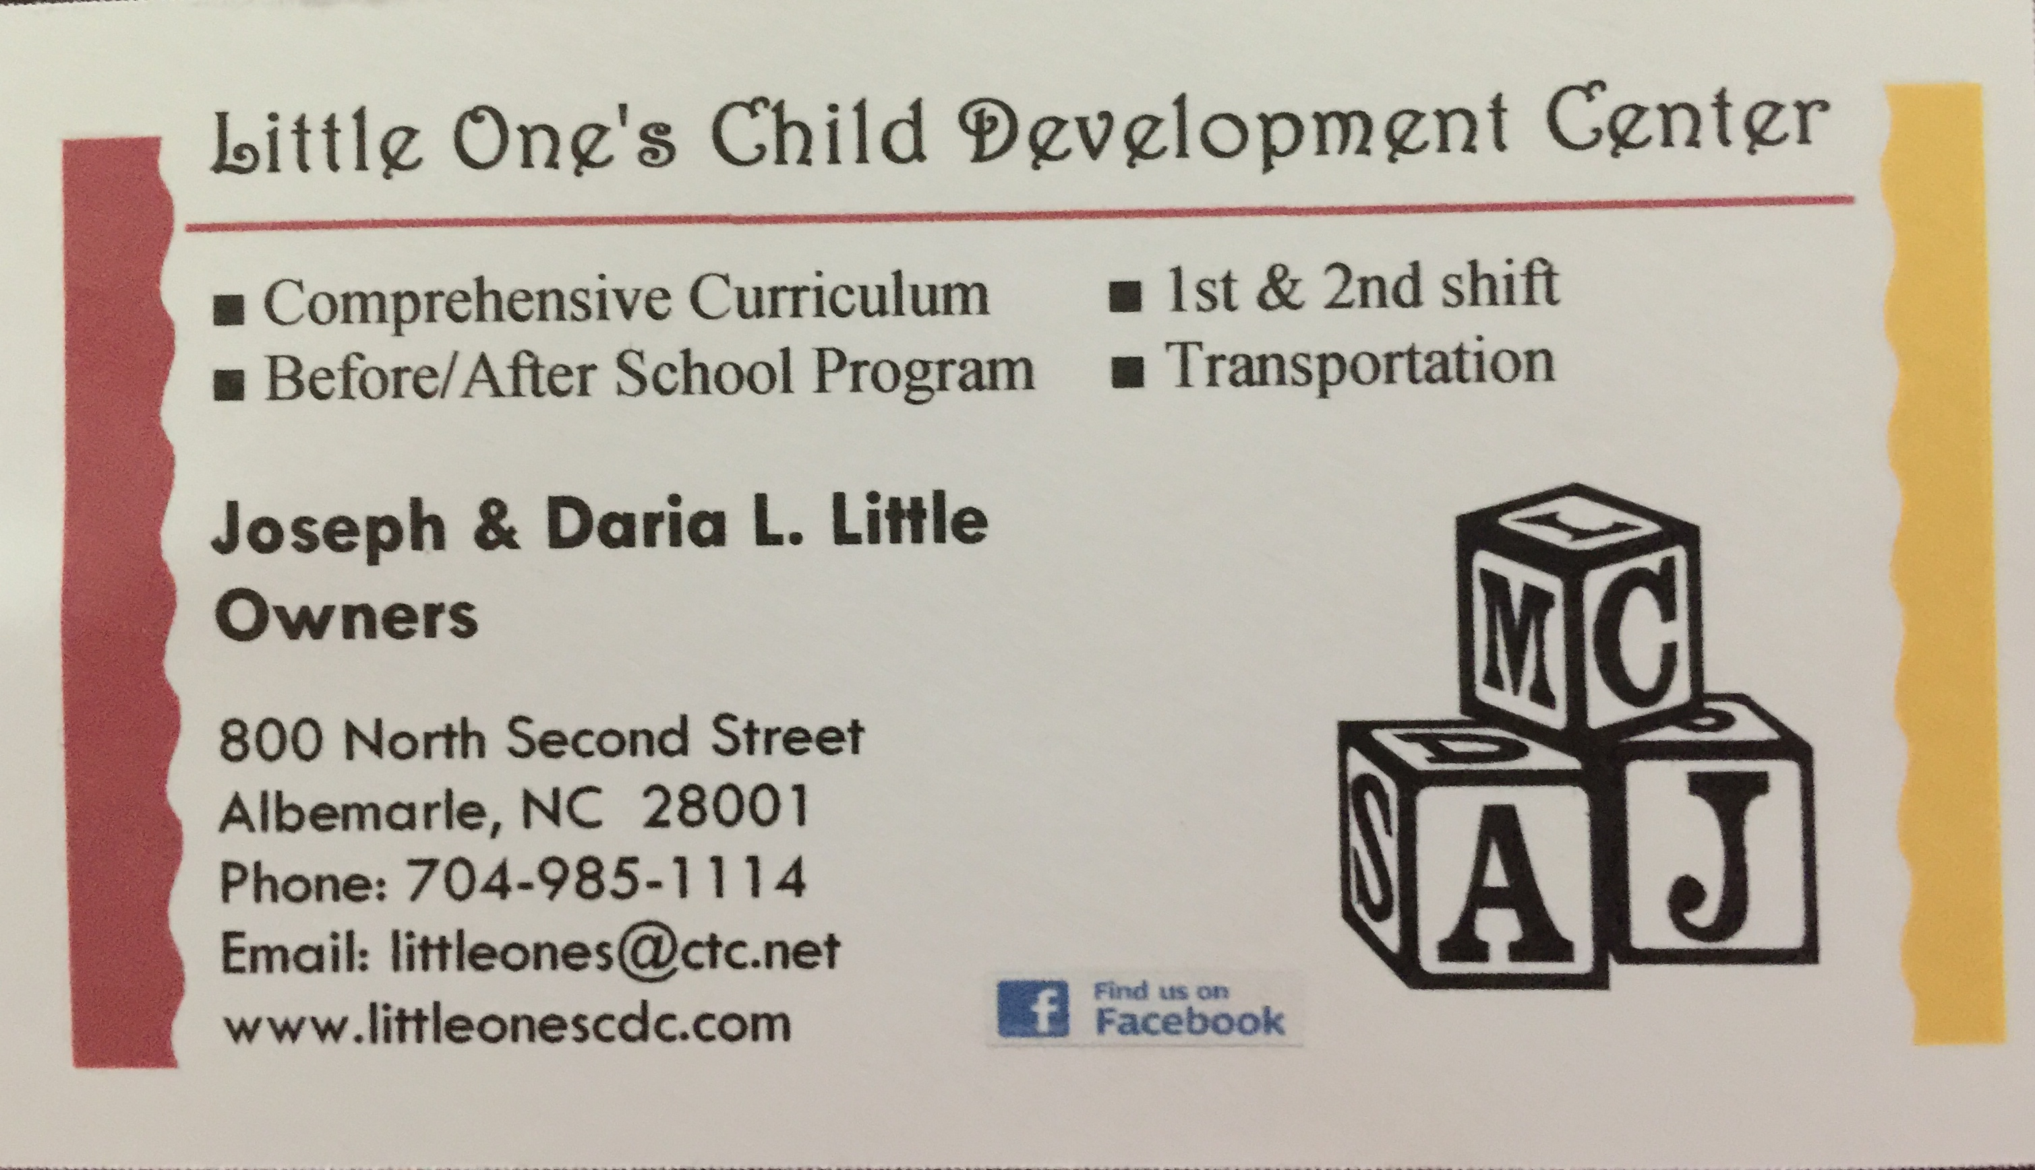

**Little One’s Child Development Center**

**800 North Second Street, Albemarle**

**Silver Community Sponsor**

C:\Users\Stephanie\Pictures\Microsoft Clip Organizer\j0416014.wmfC:\Users\Stephanie\Pictures\Microsoft Clip Organizer\j0416014.wmfC:\Users\Stephanie\Pictures\Microsoft Clip Organizer\j0416014.wmf

#class of the month

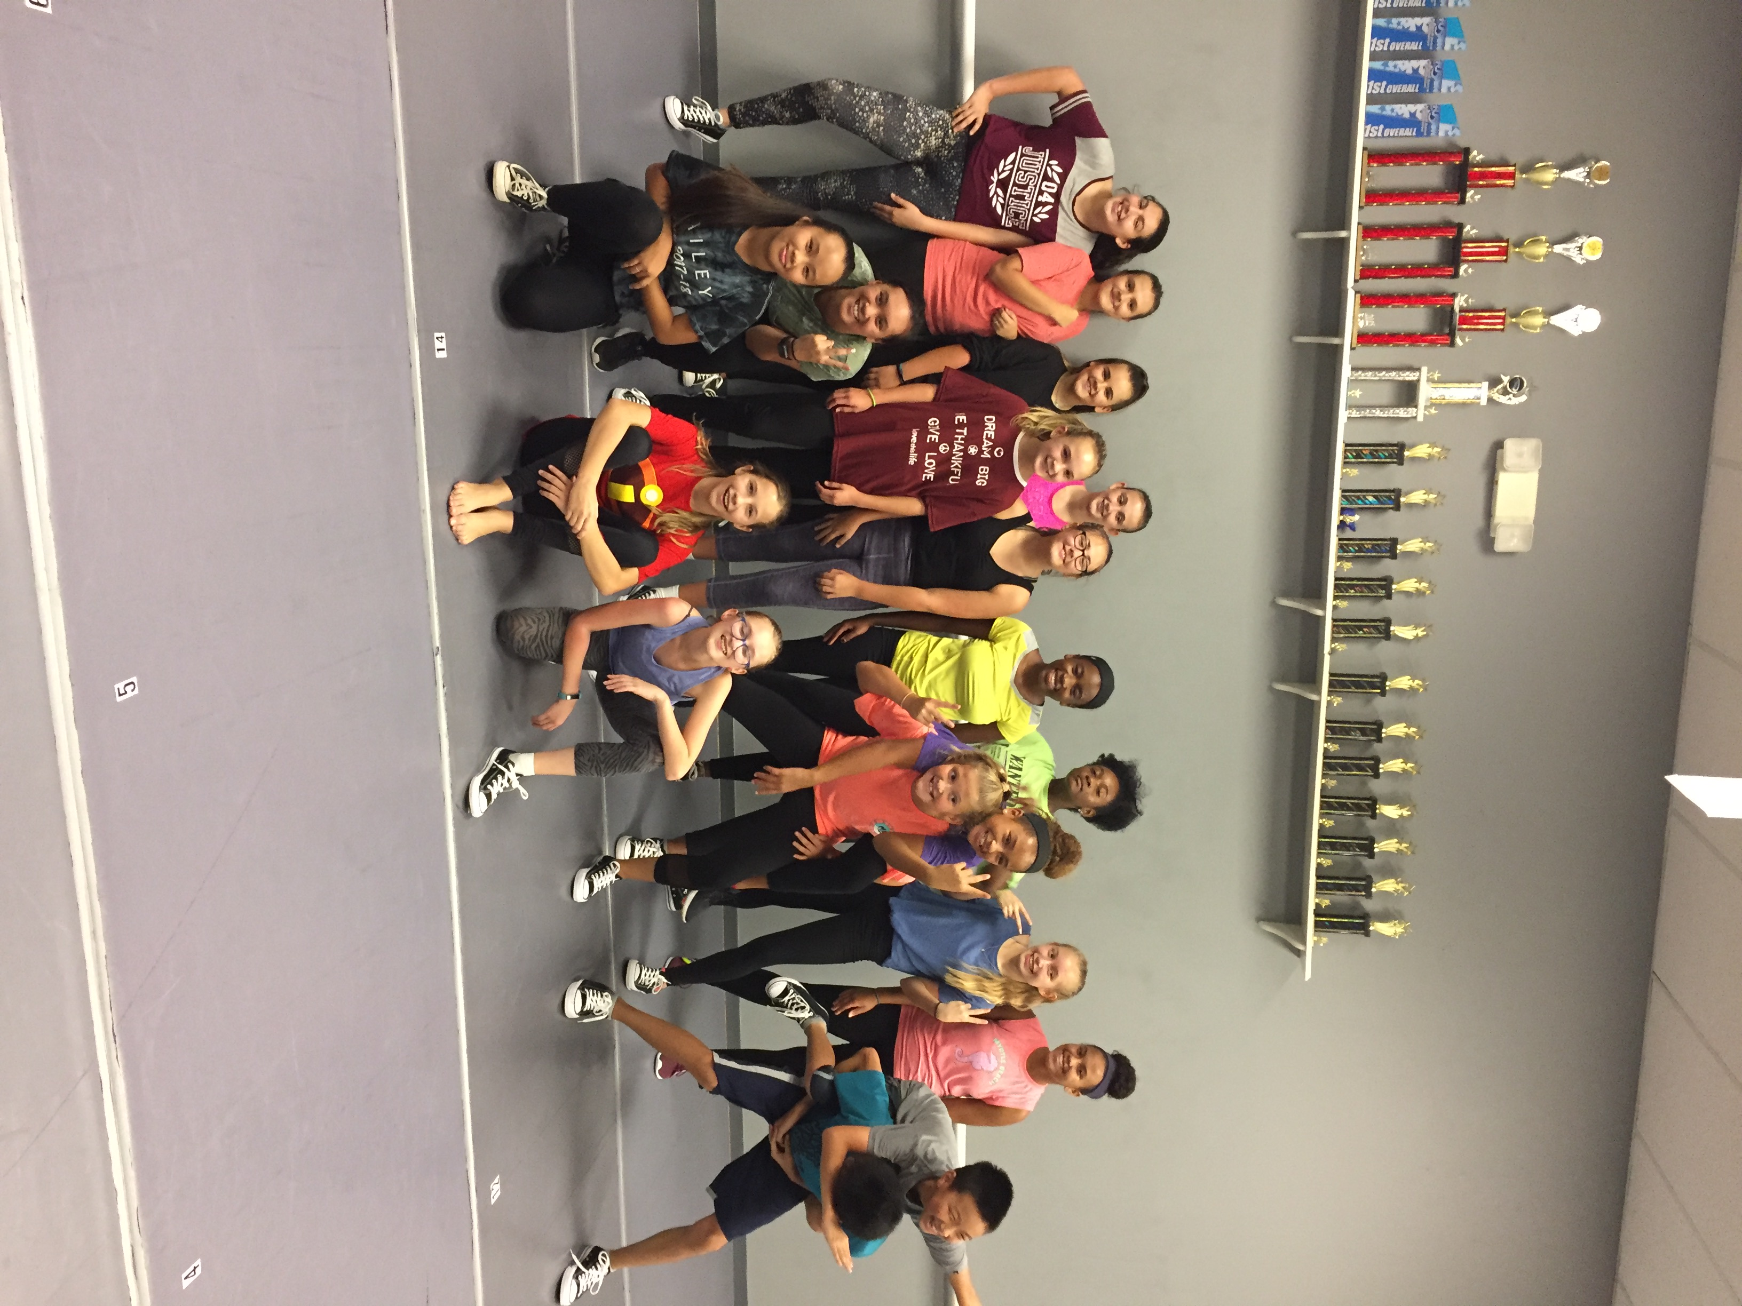

***HIP HOP CLASSES***

Our biggest classes at the studio! Whether you are 2 or 18 come join a class made for you age group. And bring a friend because… #dancefriendsarethebestfriends

INSPIRATION C:\Users\Stephanie\Pictures\Microsoft Clip Organizer\j0416014.wmf

Be Fearless in the Pursuit of what sets your Soul on Fire.

#motivation

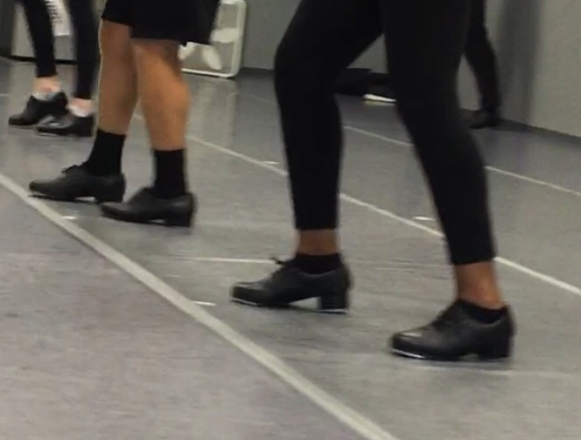

**BALLET 2019**

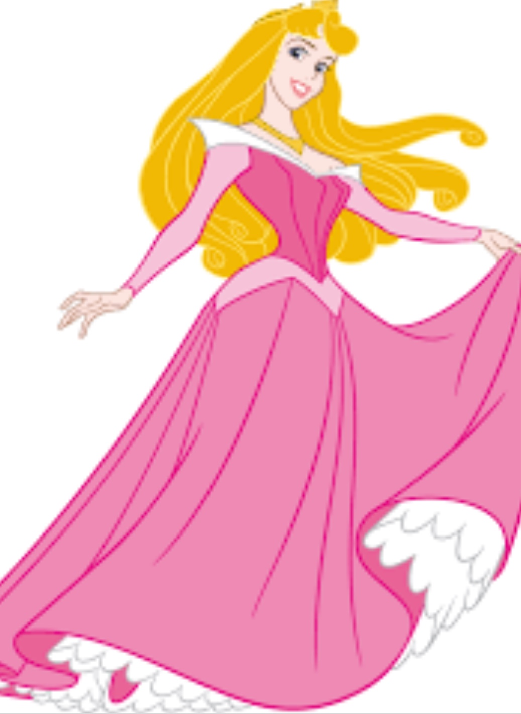

**SLEEPING BEAUTY**

Each year we select a ballet for our annual recital. This year we chose Sleeping Beauty. All of our ballet students, ages 5-18 participate in this fun adaption of the movie (DVD) they know and love. If your younger student has not had the opportunity to view, please make that an assignment for the Thanksgiving break! Telling a story is always exciting both for the students and the audience. See you in the castle☺ Remember our recital is Saturday, June 8, 2019 with dress rehearsal on Friday, June 7, 2019. Both are at Jay M. Robinson High School, 300 Pitts School Road, SW, Concord, NC 28027.

C:\Users\Stephanie\Pictures\Microsoft Clip Organizer\j0416014.wmf C:\Users\Stephanie\Pictures\Microsoft Clip Organizer\j0416014.wmf

Steppin’ into NOVEMBER 2018 with Next Step Dance

[**www.thenextstepnc.com**](http://www.thenextstepnc.com)

**7712 Sossamon Lane, NW Concord, NC 28027 (704) 786-7837 nsdcalendar@gmail.com**

DANCE MASTERS OF AMERICA

November 8th-11th

Greensboro, NC

Miss Teresa, Miss Melissa, and Miss Nora are members of Dance Masters of America and are attending the DMA Convention for further training as they do every year. Remember you never stop learning, pass it on……

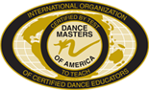C:\Users\Stephanie\Pictures\Microsoft Clip Organizer\j0416014.wmf

**SAVE THE DATE** C:\Users\Stephanie\Pictures\Microsoft Clip Organizer\j0416014.wmf

Star System Intensive 11/4

Costume payment due

11/15

Closed for Thanksgiving-

11/19-11/24

GIFTS FOR THE SEASON

It is always the season for gifts. Check out our jackets, shirts, and other dancewear for a great gift that will be worn all year!

